Wind Turbine Predictive Maintenance Platform
Briefing for Sales & Business Development

————————————————————

Prepared by: Data Engineering & Data Science Team
Date: 2026-09-08
Audience: Sales / Business Development
Classification: Internal

In This Briefing
- The business problem: what unplanned turbine downtime actually costs, in real terms
- What we built, explained without jargon
- Real evidence it works - actual charts from actual turbine failures, not mockups
- What makes this offering different
- Talking points for customer conversations
- Honest status today, and suggested next steps

1. The Business Problem: Unplanned Downtime
Every wind turbine operator faces the same core problem: a major component (gearbox, hydraulics, pitch system, generator, transformer, rotor brake, bearings) degrades silently for days or weeks before it actually fails. Today, most operators only find out when a SCADA alarm fires at the moment of failure - by which point the turbine is already down, a technician has to be dispatched (often to a remote or offshore site), and lost generation is already accumulating.
These are not hypothetical scenarios. Below are real, logged failure events from actual wind turbines (from the public SCADA benchmark dataset this platform was built and validated against) - the exact kind of event this platform is designed to catch earlier.
Component | Real Event (as logged by the operator) | Fault window
Hydraulics | "Hydraulic group" | 7 days
Gearbox | "Gearbox failure" | 7 days
Pitch System | "23020 : Axis 3 not ready-to-operate" | 20 days
Generator | "Generator bearing failure" | 32 days
Transformer | "Transformer failure" | 14 days
Transformer | "Turbine has some issues with overpressure on the main…" | 58 days
Rotor Brake | "We had some failures (störung 24VAC Versorgung…" | 4 days
Bearing | "Turbine is stopped due to a main bearing damage" | 61 days

REAL DATA This platform was built and validated against 36 real turbines across 3 wind farms - 5,242,948 individual sensor readings in total, including 44 real logged failure events. Every chart in this briefing is a real turbine's real data, not a simulation.

2. What We Built, in Plain Terms
Think of it like a modern car's diagnostic system, but for a wind turbine. It does three things:
- "Which part is at risk?" - like a check-engine light that names the actual system (not just a generic warning light), it identifies whether it's the gearbox, hydraulics, pitch system, generator, transformer, rotor brake, or a bearing (via vibration analysis) that's showing early signs of trouble.
- "How much time is left?" - like a fuel gauge, it estimates Remaining Useful Life (RUL) in hours, with a realistic range (not a single falsely-precise number) so maintenance can be scheduled proactively instead of reactively.
- "Where is this heading?" - like a weather forecast, it projects the trend for the next several days so a flagged component's trajectory can be watched, not just its current state.
Under the hood, raw sensor exports (the same 10-minute SCADA data most turbines already produce) are cleaned, organized, and distilled into these signals through a staged data pipeline on AWS and Databricks - no new hardware or sensors required.

3. Real Evidence This Works
The single most important thing to know: every chart below is a real turbine's real sensor data leading up to a real, logged failure - compared against a real normal turbine over the same time window. Nothing here is a mockup.

Example: Hydraulic Group Failure (Wind Farm A)
This turbine's hydraulic system failed after a multi-day lead-up (the dataset's own event timestamps are anonymized per-turbine, so we cite relative timing, not a calendar date). Its oil temperature was already running 10-15°C hotter than a normal turbine's - and stayed elevated for the entire lead-up window, not just in the final hours. This is exactly the kind of early, sustained signal the platform is designed to flag well before a SCADA threshold alarm would ever trigger.
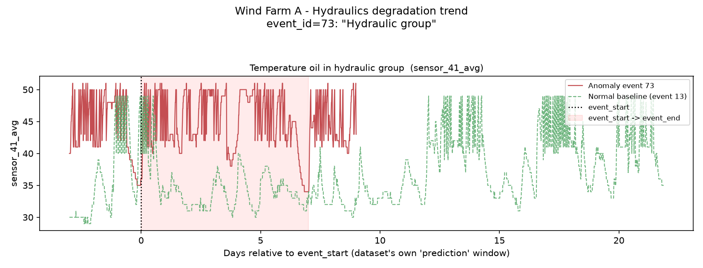
Real sensor data: hydraulic oil temperature, failing turbine (red) vs. a normal turbine (green), in the days surrounding a real logged failure.

Example: Pitch System Fault (Wind Farm C)
This turbine logged "23020 : Axis 3 not ready-to-operate" - note that the fault report names "Axis 3" specifically. Our analysis, run automatically with no manual tuning, independently identified Axis 3's own temperature sensor as the most relevant early-warning signal - landing on the exact same component the maintenance log named. That's a meaningful proof point: the method isn't guessing, it's finding the same physical signal a real technician's diagnosis pointed to.
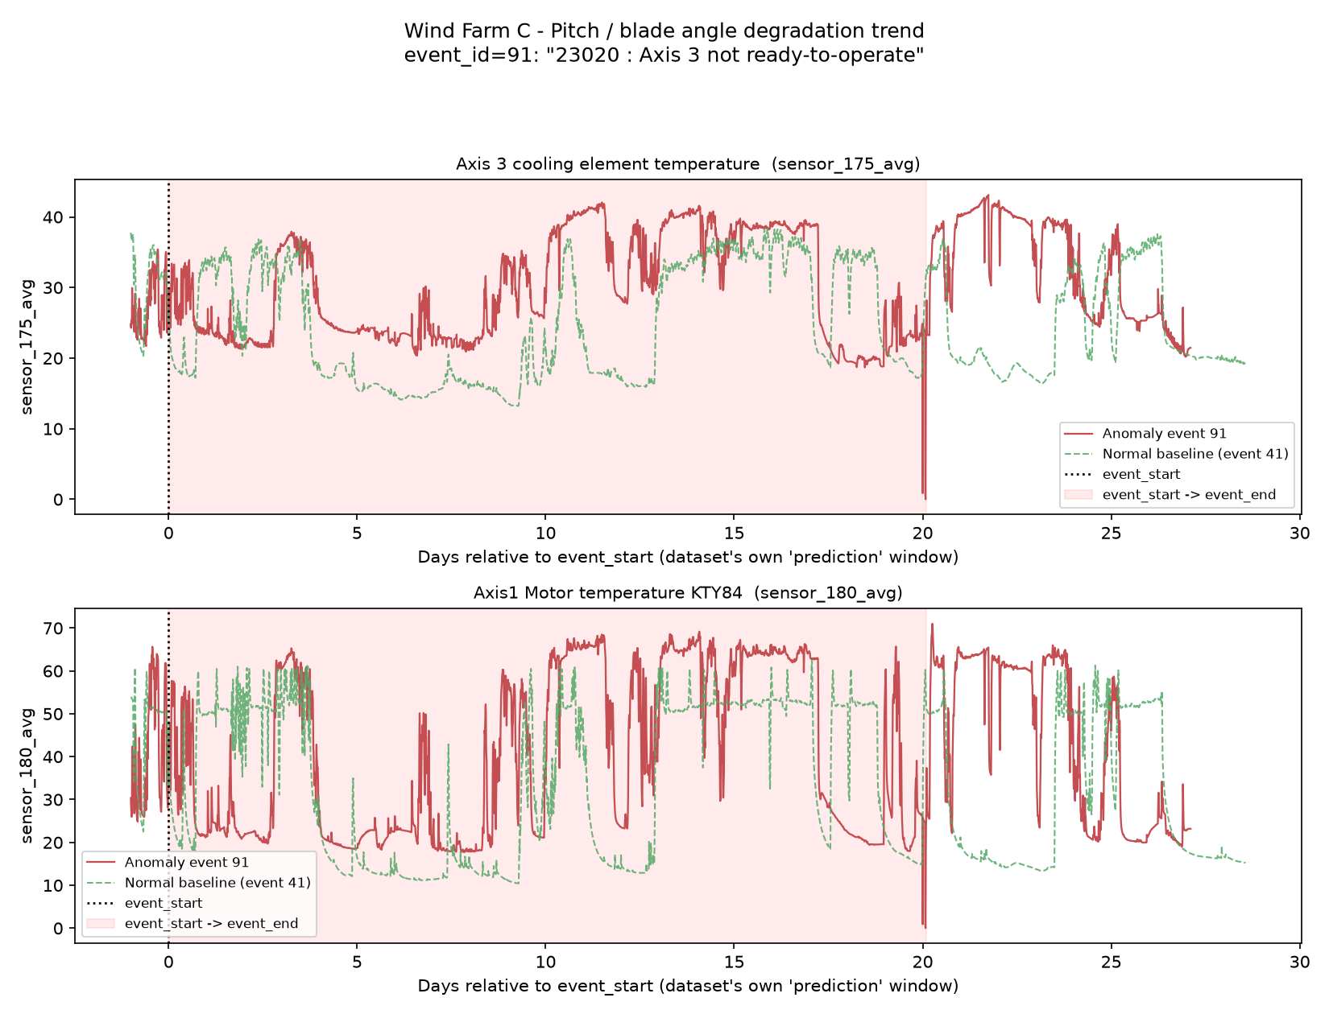
Real sensor data: pitch Axis 3 temperature trending above normal for most of the pre-fault window.

Example: Bearing Failure Detected via Vibration (Wind Farm B)
Worth including precisely because it's not a perfect story: this turbine was "stopped due to a main bearing damage." Vibration monitoring on the tower did pick up a clearly elevated, sustained vibration signature tied to this failure - but for this event, the clearest signal appeared right around the shutdown itself rather than weeks in advance. We show this because it's real and it's honest: vibration monitoring reliably confirms a bearing problem is real and ongoing, and for some failures that confirmation comes with more lead time than others. Setting that expectation correctly with a customer up front builds more trust than only showing the cleanest chart.
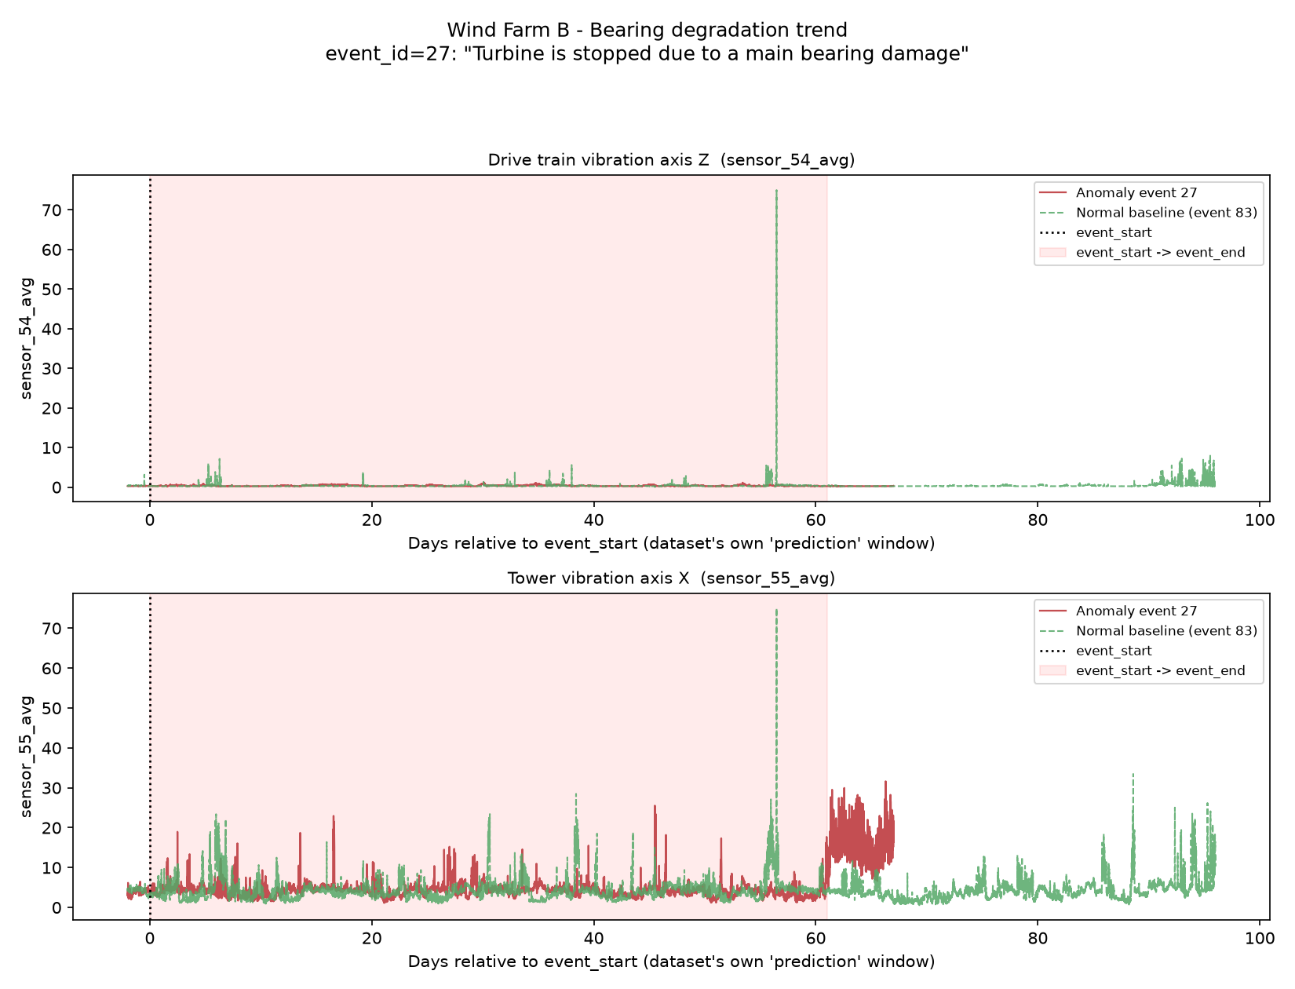
Real sensor data: tower vibration during a real main-bearing failure - elevated sustained activity visible around the failure window.

Fleet-Wide Picture
Across all 3 farms, the real failure history breaks down as follows - hydraulics and pitch-system issues are the two most common named failure categories, which is exactly the kind of pattern a maintenance team can plan around once it's visible early.
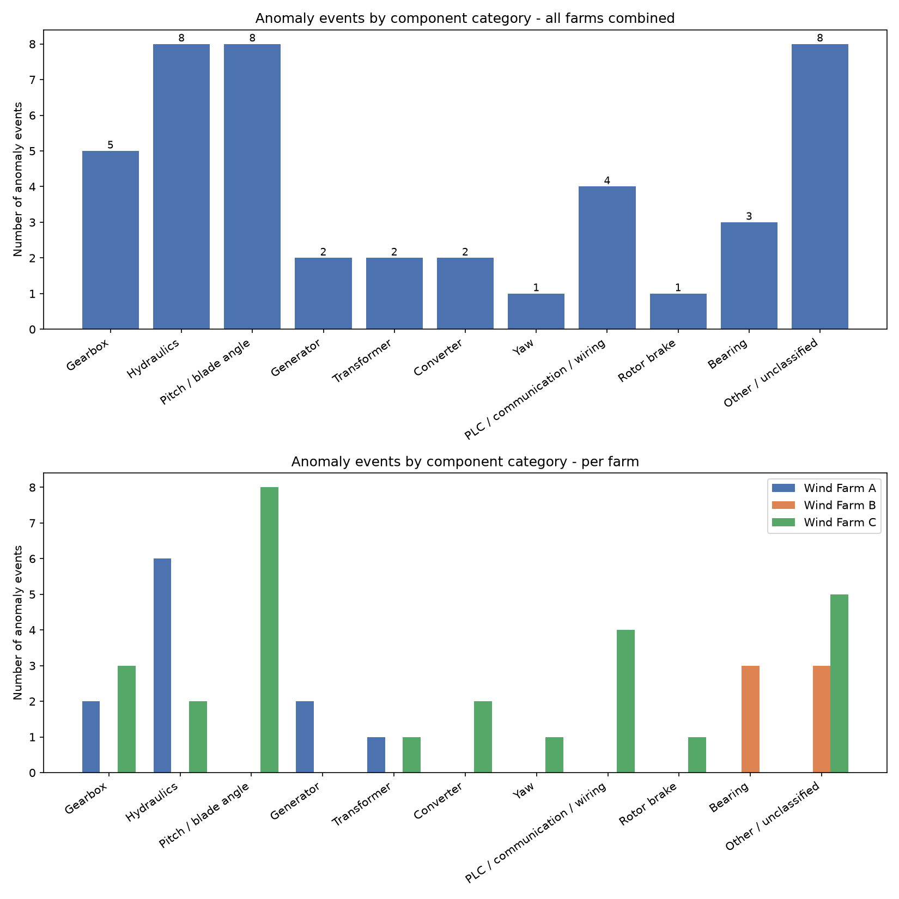
Real failure counts by component and by wind farm, from the platform's own analysis of the underlying maintenance logs.

4. What Makes This Different
- Built and proven on real operating data - 36 turbines, 5,242,948 sensor readings, 44 real failure events - not a synthetic demo.
- Covers 7 major component categories out of the box (Gearbox, Hydraulics, Pitch System, Generator, Transformer, Rotor Brake, and Bearing via vibration analysis), and the method extends to new categories without a rebuild.
- Works across different turbine models and vendors automatically - it matches sensors by their description, not a fixed column layout, which is how it already handles 3 completely different sensor schemas (86, 257, and 957 sensors per farm) with the same pipeline.
- Includes a live visual dashboard with an actual 3D “digital twin” view of turbine health - not just a spreadsheet of numbers.
- Runs in the customer's own AWS account - enterprise-grade from day one, with fully isolated dev/staging/production environments and no shared infrastructure between customers.
- Built as independent services, not one fragile system - an issue in the alerting component, for example, can never take down the live telemetry dashboard.

5. Talking Points for Customer Conversations
Q: What data do you need from us?
A: The same SCADA export most turbines already produce - 10-minute sensor averages and standard operating-status codes. No new sensors or hardware.
Q: Which failures can it catch?
A: Gearbox, Hydraulics, Pitch System, Generator, Transformer, Rotor Brake, and Bearing (via vibration analysis) today, each validated against real failure history - extensible to other components as more data comes in.
Q: How is this different from the alarms our SCADA already has?
A: SCADA alarms fire when a value crosses a fixed threshold - often only once the fault is already underway. This platform watches for sustained trend shifts (like the hydraulics example) that show up days to weeks earlier than a threshold breach.
Q: Is our data safe? Where does it run?
A: It runs entirely inside the customer's own AWS account, with separate, isolated environments for development, staging, and production. Nothing is shared across customers.
Q: Can it handle our specific turbine model?
A: Yes - the platform matches sensors by their real-world description rather than a fixed layout, which is exactly how it already works across three farms with completely different sensor counts and naming.

6. Honest Status Today
IMPORTANT This is a validated architecture and working scaffold, proven against real historical turbine data - it is not yet running on a live customer SCADA feed. Be transparent about this with prospects: the value proposition is proven on real data, and the next step with any customer is a pilot on their own data.

7. Suggested Next Steps for a Prospect
- Data Readiness Check - the prospect sends a sample SCADA export; we produce the same kind of real, sensor-grounded trend charts shown in this briefing, using their own turbines.
- Pilot Dashboard - stand up the live dashboard (Fleet Overview, Asset Detail, Digital Twin) against their historical data so their team can explore it hands-on.
- Production Pilot - connect a live feed for one site and begin real-time alerting alongside their existing SCADA alarms, not replacing them.

Appendix: Glossary
Term | Plain-English meaning
SCADA | The turbine's own sensor/control system - the data source this platform reads from. No new hardware needed.
RUL (Remaining Useful Life) | An estimate of how many hours remain before a component is likely to fail, shown as a realistic range rather than one falsely precise number.
Fault classification | Identifying *which* component is showing early signs of trouble, not just that "something" is abnormal.
Trend forecasting | Projecting a component's health forward in time, like a weather forecast.
Digital Twin | A live, visual 3D representation of a turbine's current health, driven by real sensor data.
Vibration analysis | Listening to a turbine's overall "shake" via accelerometers on the drivetrain, tower, or nacelle - a decades-old, industry-standard way to catch bearing wear before it fails.
Medallion architecture | The staged data pipeline (raw → cleaned → distilled) that turns SCADA exports into the signals above.

