Write a one-page paper describing 3 things you can do with the developer tools in either Chrome or Firefox.  The paper must be at least 500 words in length and include 2 citations.  Failure to include two creditable sources will net you 0 points.

Debugging tools are now built into my web browsers in this day and age. Probably two the most common debugging tools that are used are Chrome and Firefox. For Chrome to find the debugging tool you can press F12, for certain laptops like my own which I only recently found out you must press the (Fn) key and F12 to pull up the debugging window. You can also press Control+Shift+I, Control+Shift+J or Control+Shift+C, depending on your operating system; all of the commands will open the window but you might have to find the appropriate tab to alter things. This will open up a feature on the right, left, in a separate screen or the bottom of the page, you can move this debugger to the bottom or move to the right as you see fit. The first for Chrome is to the very left tab and has an arrow 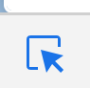This tool allows you to inspect different parts of the page. This can help you know what parts of the page are doing what and when you select that area it will highlight that section of the page for you in the elements tab. The Elements tab allow you to look at the HTML and CSS, you can change the HTML and CSS in the debugger itself and see the results in live time. These changes can even be done on pages that belong to others and allow you to see the effects even though they will not save to that person’s page of course. The next tab is called The Device Toggle Toolbar 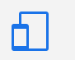, there is device toggle button that looks like a phone or an iPad that allows you to change the screen to display in different screen sizes to let you see what the page might look like. At the top of the screen, you can actually change the device type with the dropdown next to responsive, , which allows you to select some of the most common display devices. You can also manually put in the dimension sizes of height and width. The Sources panel 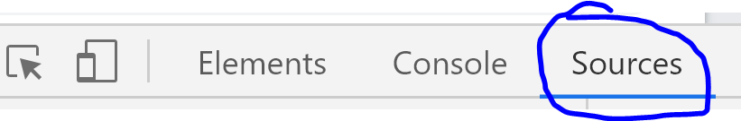 is where you can debug JavaScript. The Source panel has three main parts, at the top left is the file navigator pane, allows you to inspect what files the page uses, if you click on one of those files you can see those pages, documents or images. The second main part is the code editor pane which allows you to change the code. The final pane inside of the source panel is the JavaScript Debugging Pane, this pane has multiple different troubleshooting tools that allow you to find the specific area where an issue occurs and can highlight that specific occurrence.

For Firefox you can get to the development tools by pressing F12, or for many computers the (Fn)+F12 or CTRL+Shift+I. With this tool you can also open put the development tools on the bottom, right, left or a separate window. The Inspector Tab 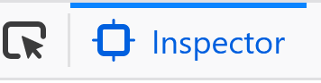allows you to see and alter most of the HTML and CSS in a webpage. As you move your cursor over various parts of the page the HTML and that section will appear in the left panel of the developer tools. You can change the sections in this area. To the left you can see all the CSS and are able to alter and change the CSS as well.

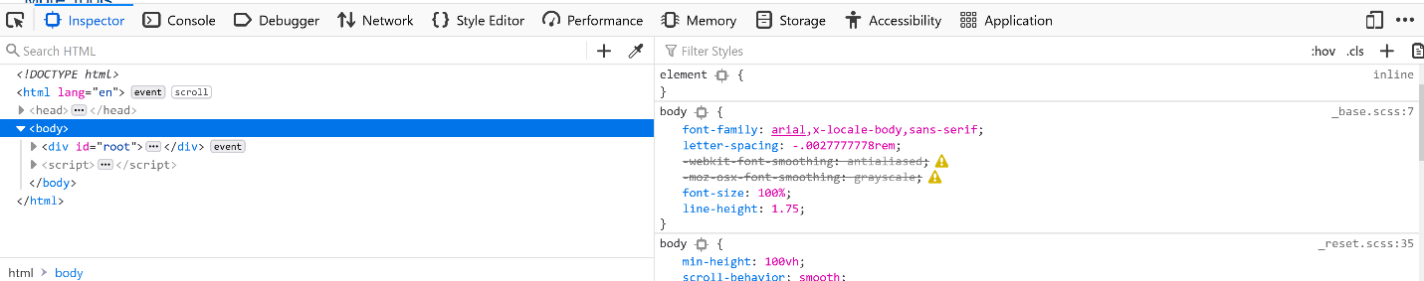

Inspector Tab

Next, we will discuss the responsive Design mode. There is device toggle button that looks like a phone or an iPad that allows you to change the screen to display in different screen sizes to let you see what the page might look like. It is on the right of the developer toolbar. It allows you to change the screen to display in different screen sizes to let you see what the page might look like.



Responsive Design

At the top of the screen, you can actually change the device type with the dropdown next to responsive, , which allows you to select some of the most common display devices or manually change the dimensions.

The console tab allows you to see messages and interact with the JavaScript.

Finally, the Debugger tool allows you to stop, look through and modify JavaScript on the page.

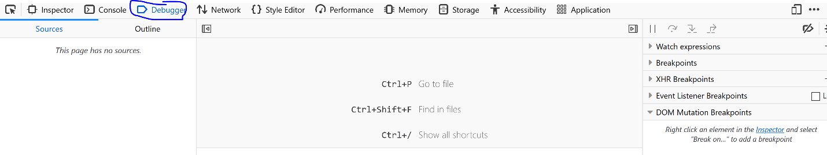

Debugger Console

The Debugger panel has three main parts, at the left is the sources pane, allows you to inspect what files the page uses, if you click on one of those files you can see those pages, documents or images. This particular picture has no sources. The second main part is the code editor pane which allows you to change the code. The final pane on the right is the JavaScript Debugging Pane, this pane has multiple different troubleshooting tools that allow you to find the specific area where an issue occurs and can highlight that specific occurrence.

Github location: https://github.com/sd101/web-231/tree/master/week9

Google. (2017). Get Started with Debugging JavaScript in Chrome DevTools. https://developers.google.com/web/tools/chrome-devtools/javascript/.

Google. (2020). *Chrome DevTools  |  Google Developers*. Chrome Dev Tools. https://developers.google.com/web/tools/chrome-devtools/?utm_source=dcc.

Hawkes, C. (2020, January 15). *Chrome vs Firefox In 2020 for Programmers*. YouTube. <https://www.youtube.com/watch?v=Tv7z-HzkF7U>.

MDN contributors. (2005). *Firefox Developer Tools*. Firefox Developer Tools | MDN. https://developer.mozilla.org/en-US/docs/Tools.

Mozhacks. (2016, December 7). Firefox Developer Tools: debugger overview. https://www.youtube.com/watch?v=QK4hKWmJVLo.

Mozhacks. (2016, November 22). *Firefox Developer Tools: setting breakpoints*. YouTube. https://www.youtube.com/watch?v=P7b98lEijF0.

Mozilla Hacks. (2016, November 22). *Firefox Developer Tools: stepping through code*. YouTube. https://youtu.be/RQBwEk0-xe0.