Tehya Stockman

AI Tool Box

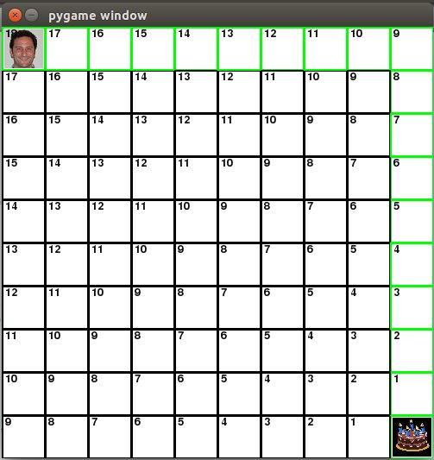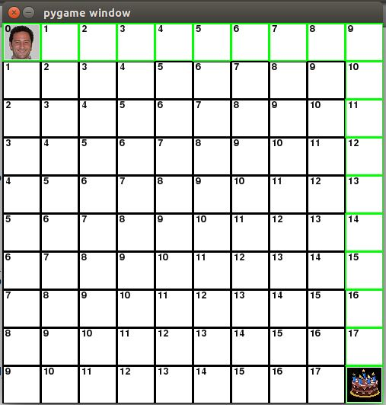

The picture on the left shows H, which is the estimated movement cost from the current square. This is just an estimate. The picture on the right shows G, the cost from where the character is now to the current square. This always increases the farther from the start it is. The picture to the right of this text is F, or G+H, which shows the total cost of choosing a certain path.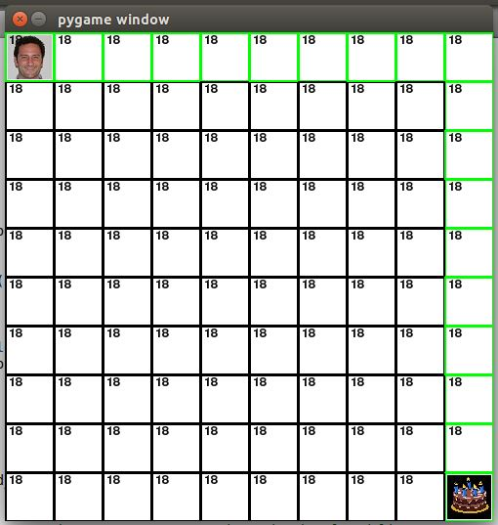

In the final pictur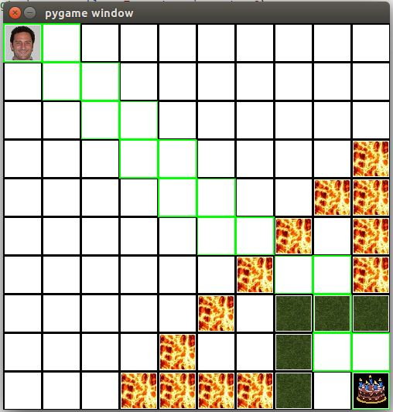e, many different things are in the character's path. Swamp tiles and lava are obstacles in the path. The character cannot go over lava but can go through the swamp (with a 3 point penalty). The character can move diagonally as well (with a 3 point penalty) and can jump over obstacles (with an 8 point penalty). These are factored into the G and H, making a path not possible or have more points than an alternate path. It makes most sense for the character to move adjacently unless an obstacle obstructs its path.