A cell’s G-score is the cost of getting to said cell from the start (1 – g-scores.png).

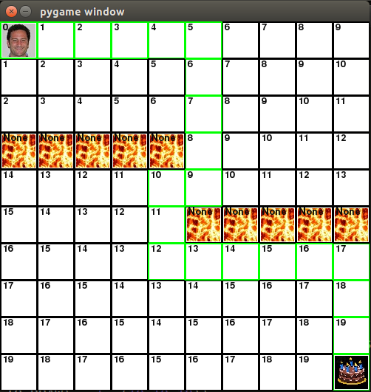

A cell’s H-score is the absolute distance between said cell and the end goal (2 – h-scores.png).

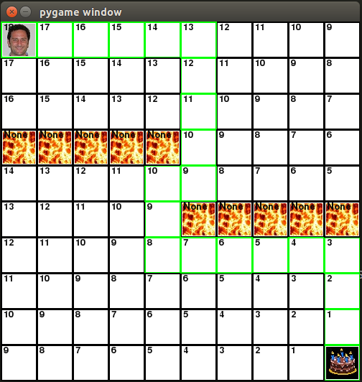

A cell’s F-score is a ‘goodness’ estimate, combining ease of reaching said cell from the start and the absolute distance between said cell and the end goal (i.e. G + H) (3 – f-scores.png).

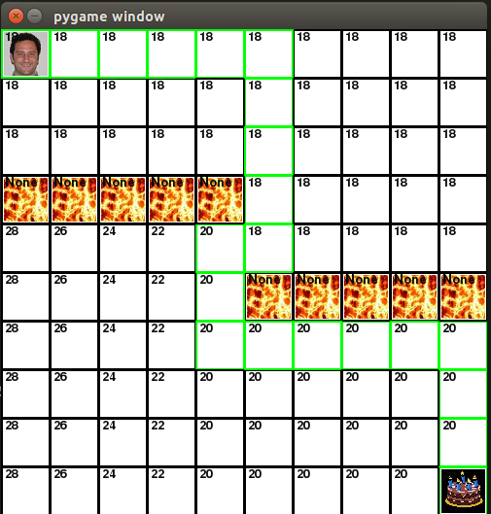

The lava forces Paul to make a diagonal move, increasing the overall cost to reach the goal (4-diagonals.png).

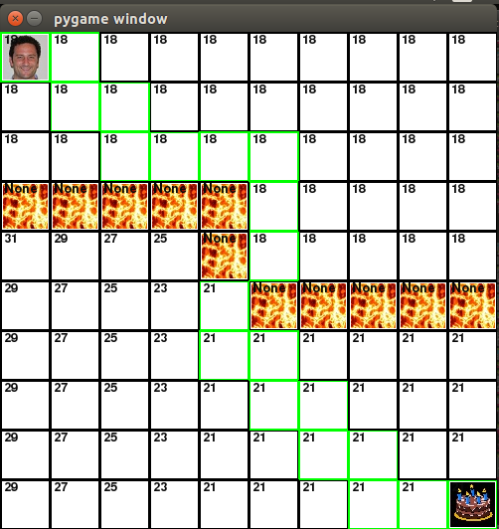

It’s more efficient to just hop over the lava than walk all the way left and then right again, so Paul does that (5-hops.png).

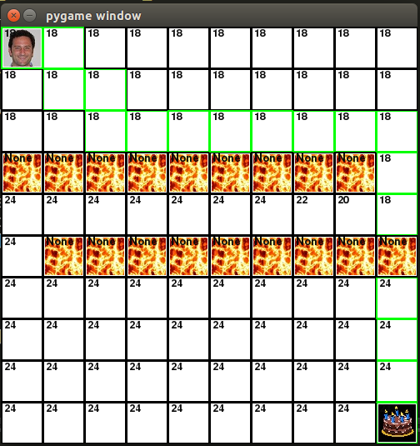

Finally, swamp is just a pain and Paul prefers not to walk on it if he can. He’ll choose to walk on blank tiles unless he has no choice (6 – swamp.png)

