G_Cost:
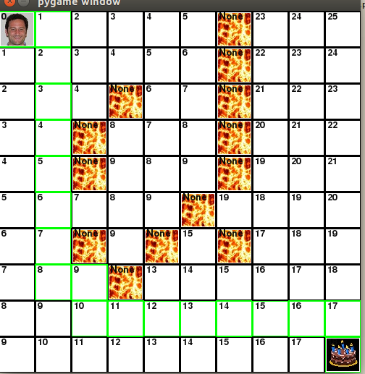

G_cost is displayed in each square and tells how many movements it takes to get to each square on the grid. Moving from one square to another results in a cost of 1.

H_cost:
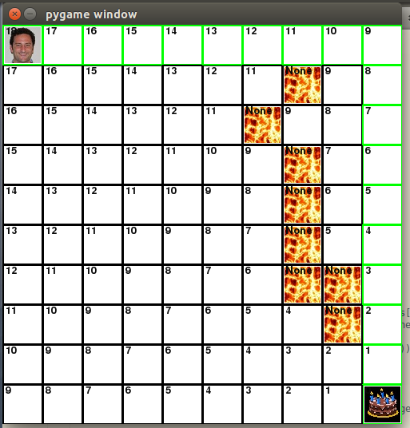

H_cost is displayed in each square and is the predicted cost of movement for Paul to reach the cake, this is calculated without taking into account obstacles.

F_cost:
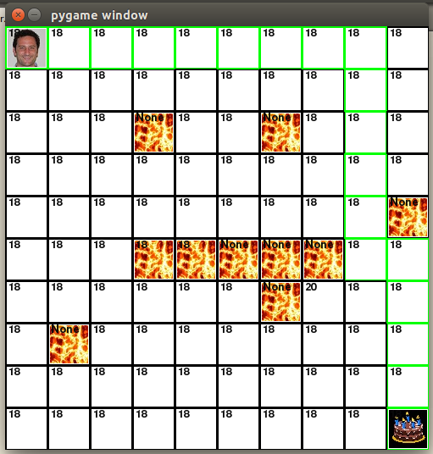

F_cost is the sum of G_cost and H_cost. This can be used to predict the best moves, for instance moving into the square with 20 written in it would be seen as an extraneous move.

