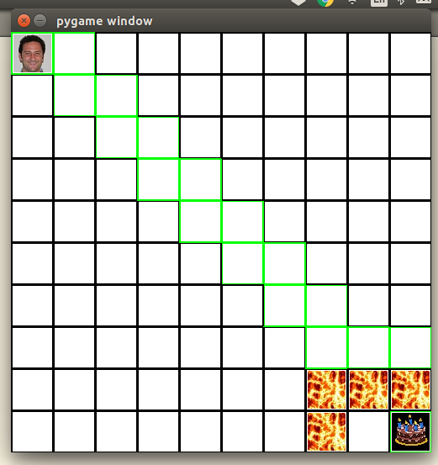
Paul had to jump in order to move to the cake:

Paul had to travel diagonally in order to move to the cake:
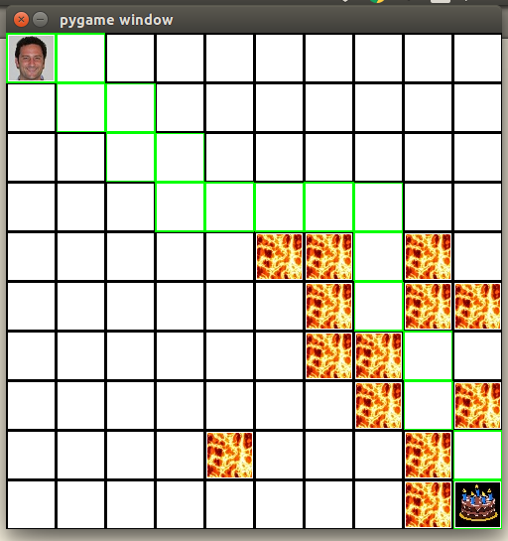

Swamp:
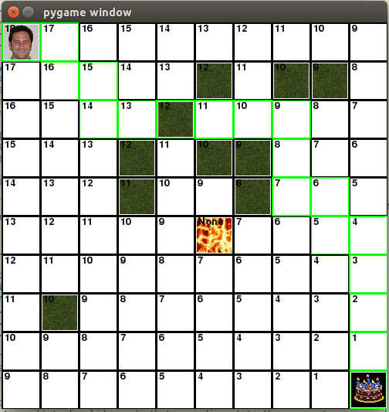

Here Paul goes through a swamp instead of around it.

