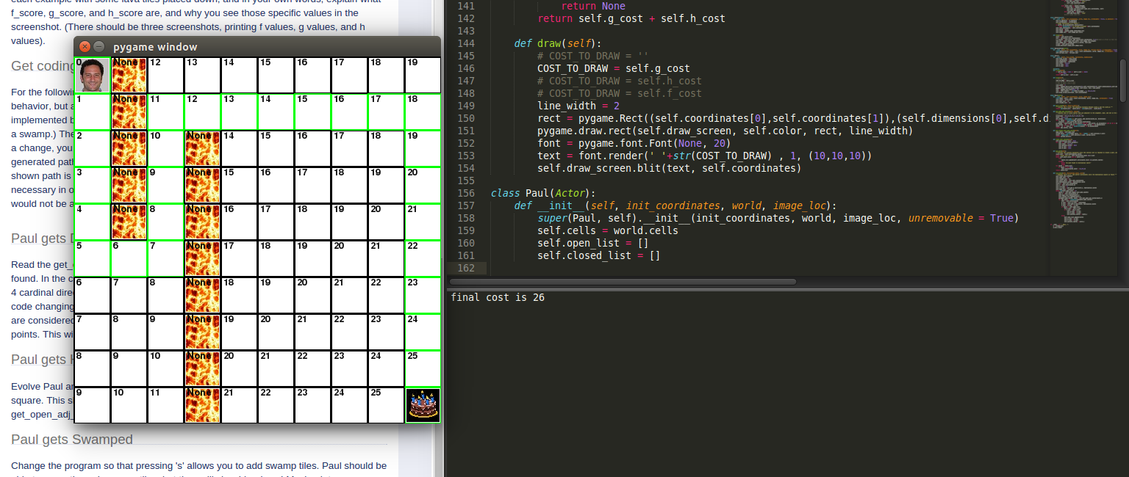
The “g_cost” is simply the number of squares taken to get to the location. In the case above it was 26 squares (you can view the numbers on the picture above).
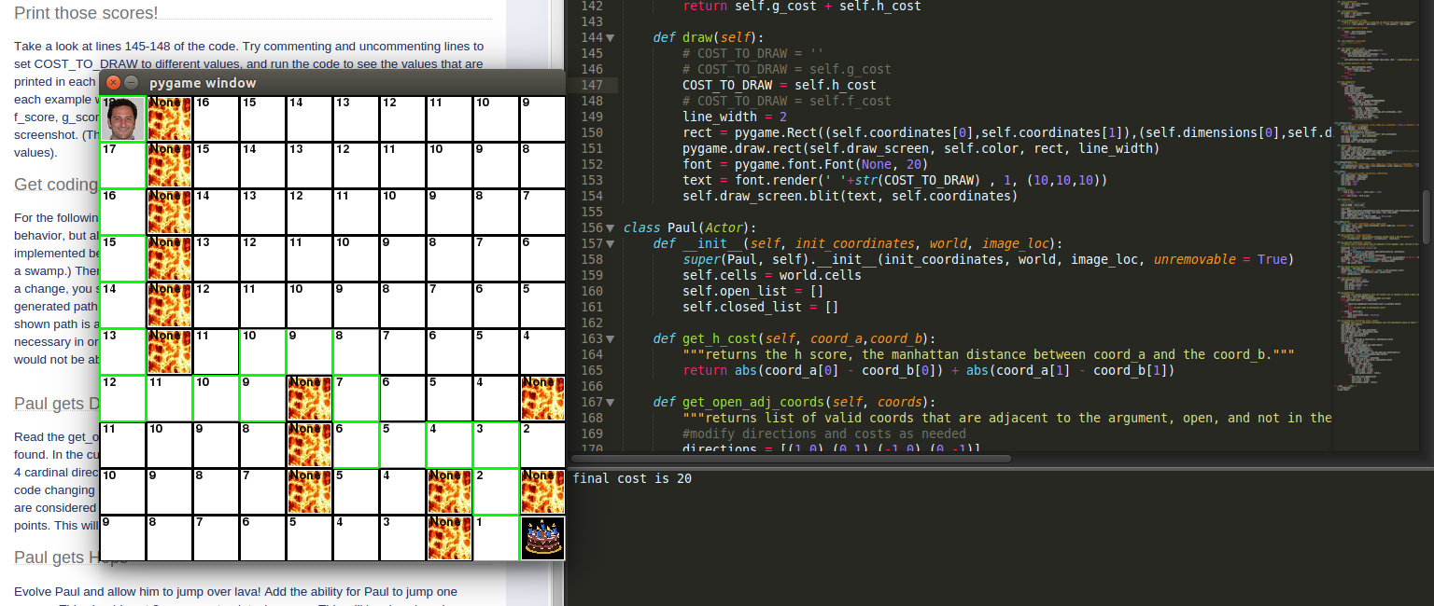
The “h_cost” is the estimated movement cost in the number of squares taken to get to the cake. The “h_cost” is like the estimated version of the “g_cost”. In the picture above, the “h_cost” is slightly off at 20, but still fairly close, meaning that the path shown is similar to the optimal one.

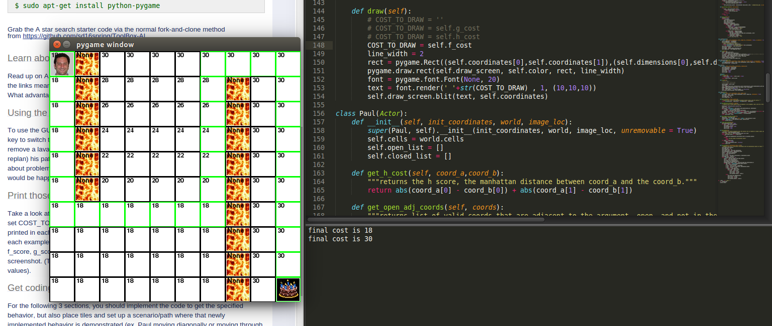
The “f_cost” is the summation of the “g_cost” and the “h_cost”. The “f_cost” is used to find the shortest path through iteration

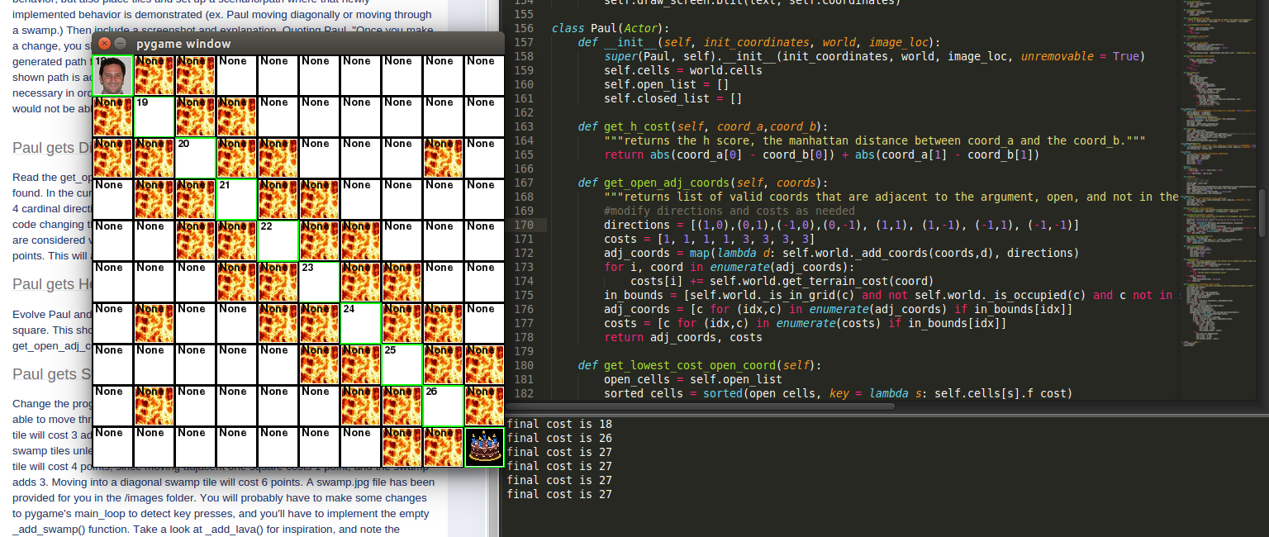
Once diagonal paths are added to the possible movement options, Paul has the option to move diagonal, but it costs more to his final total. In the picture above, the lava formation only leaves the option for Paul to move diagonally.

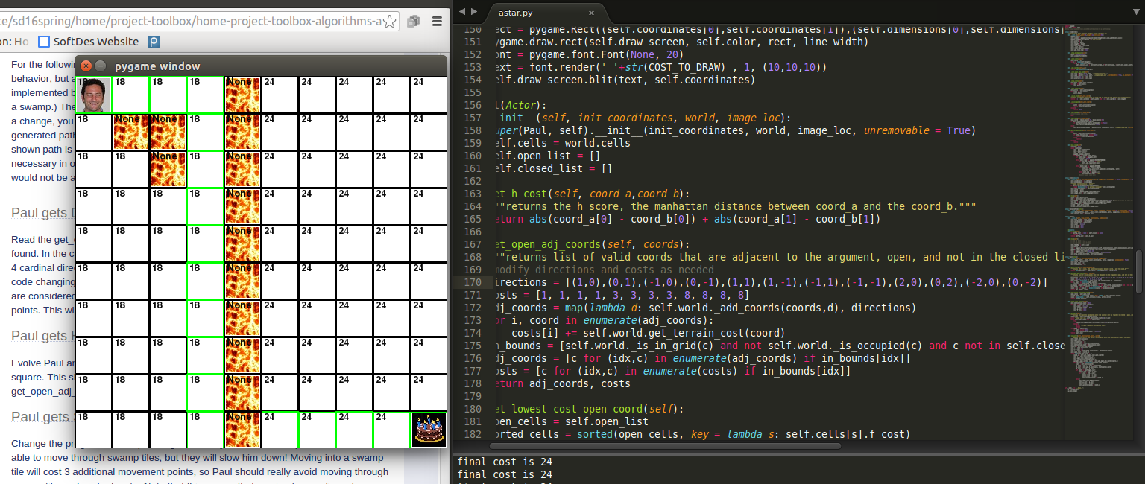
Once the jump option is added to Paul's possible movements, this actions can be demonstrated by putting up a wall of lava, because Paul is forces to jump over at least one block, even though it raises his total cost.
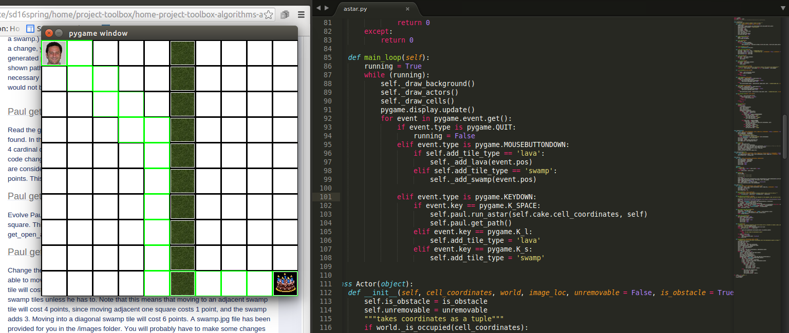
Once the swamp feature is added, as a function and then to the main loop, Paul could move through the swamp at a cost to his final total. In the picture above this action is demonstrated with a column of swamp, forcing Paul to move through at least one swamp tile.

