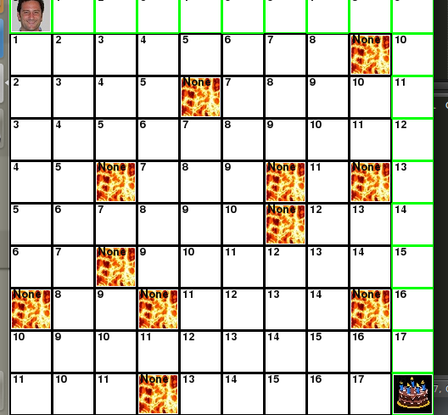
self.g_cost counts up from one for each box moved from Paul to the cake.

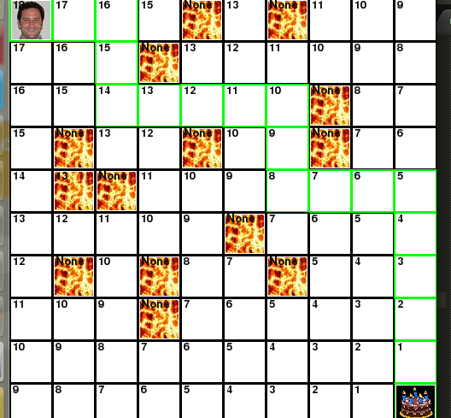
Self.h_cost counts down from the total cost as Paul moves from his starting location to the cake.

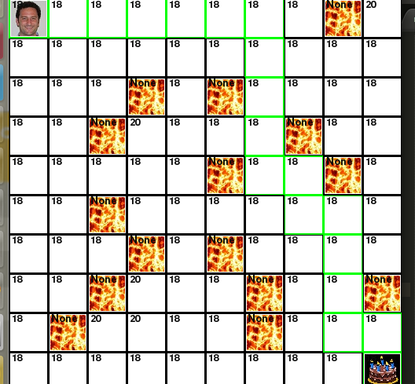
Self.f_cost displays the total cost of Paul going through certain boxes on his path to the cake.

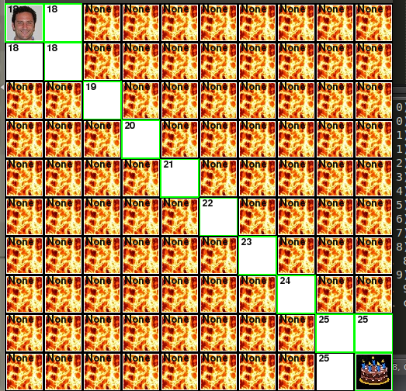
The adjusted get_open_adj_coords with Paul forced to take the diagonal path

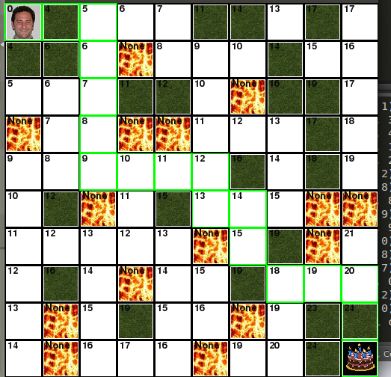
The now added add_lava method and the edited main_loop function create a new obstacle tile that adds an passable swamp picture that costs 3 to pass.

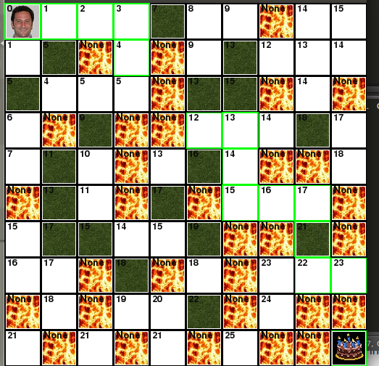
The new get_open_adj_coords can now go in directions twice as far (for cardinal directions as well as diagonals) at the cost of 8.

