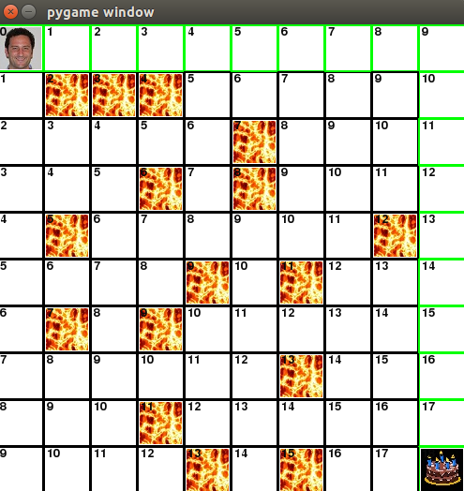
Displaying G_Cost

G_Cost is the movement cost for each square starting from Paul's initial position. Moving from one square to another results in a movement cost of 1.

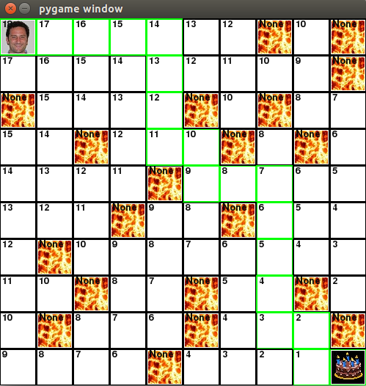
Displaying H_Cost

H_Cost is the predicted cost of movement for Paul to get from his current position to the cake. The number displayed in each square shows the predicted movement cost from that square to the end goal.

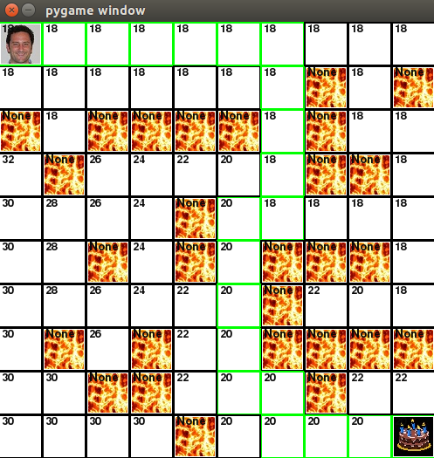

Displaying F_Cost

F_Cost is the result of the sum of G_Cost and H_Cost. The final cost represents how many moves it takes for Paul to reach the cake.

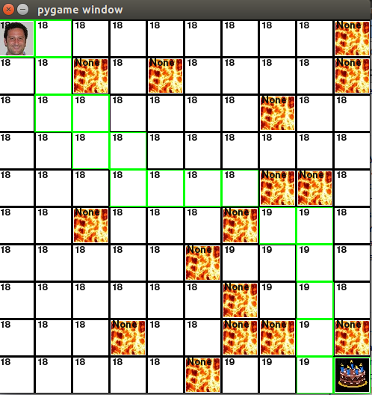

Paul decides to take the diagonal instead of going around the lava

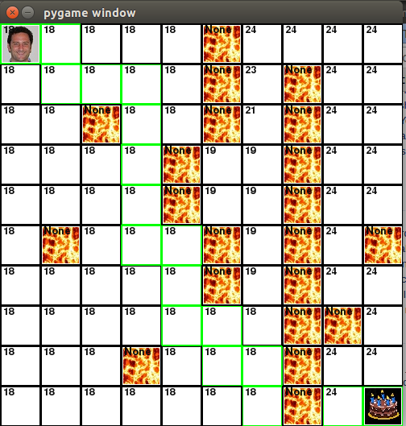

Paul decides it is more cost efficient to jump over the lava instead of walking all the way around the wall of lava.

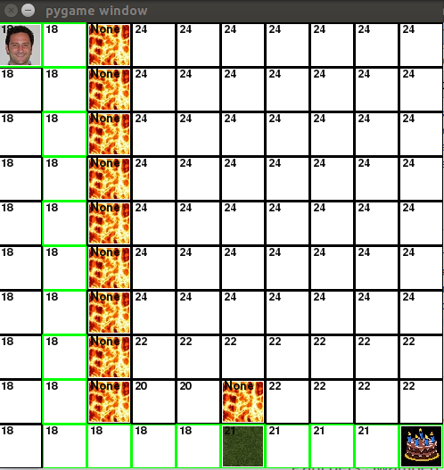
Paul chooses to go through the swamp instead of going around the small wall of obstacles.

