Walking dynamics

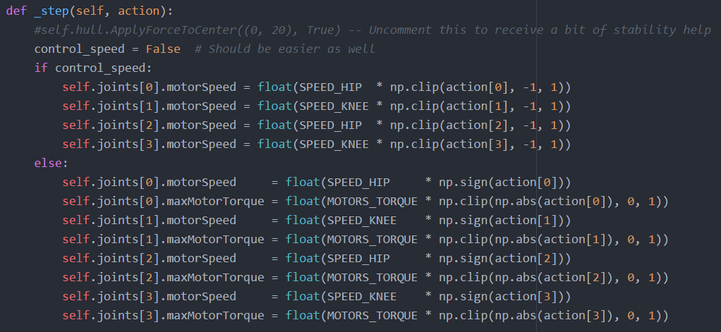

Four actions 0,1,2,3 and four joints 0,1,2,3

Each joint and actions are related with speed_hip / speed_knee

What we can change is randomly generate the order of actions & speed of actions

There is a friction to walk toward.