Project Overview:
I used twitter as my data source for the project. I pulled tweets that had been posted by users. Then I took the tweets and conducted sentiment analysis on them. This allowed to understand the times at which the user’s sentiment fluctuated. I hoped to learn how to interface with the Internet through python as well as how to interface with files. I hope to create a system that I can use to graph a user’s sentiment over time in order to better understand how their sentiment changes with changes of the outside world.

Implementation:
The program that I wrote is split into two files: one that reaches out to twitter and downloads the information and saves it to the hard drive, and one that reads the information and analyzes it. The first function is fairly simple. It uses several keys and secrets that twitter provided me to access information from twitter. The program downloads many tweets from a specific user and then saves this information to a file on the hard drive. The second program then uses this information. It begins by opening the file. It then parses out the tweets and the date at which they were tweeted. It then does some processing to make that information easier to graph, such as converting a date in a month, day, format to a format in which the day is indicated by the number of days after January 1st 2016. This allows graphing the information to be much easier. The tweets are then run through sentiment analysis to find how positive and negative they are. The information is then graphed. Each tweet is a point on a scatter plot, and each point is made up of the positive score minus the negative score to give a holistic look at how positive or negative the tweet is.

One specific design choice was related to changing the date twitter gave to the number of days after January 1st 2016. Twitter gave the date in month, day, and year form, which made graphing difficult, so converting it to days after January 1st 2016 would be a much easier and more useful metric to graph. However, the hard part of this was converting from a month and a day to a day. A more simplistic programming approach would have been to write several if loops which would give the write day value if the month value from twitter matched the month value in the if loop. Instead of that, I made two lists, one for days, and one for months. Then I could use .index() to find the index of the month and reference that index in the day list to find the correct day value to add. This is a much faster and easier way to do then then writing a bunch of if loops.

Results:
For this project, all of Donald Trump’s tweets were pulled from twitter. Once the tweets were pulled, sentiment analysis was run on each of the tweets. To provide a comprehensive analysis of each of the tweets, the tweet’s positive rating was subtracted from the tweets negative rating to give an overall comprehensive score for the tweet. This can be seen on the figure below.
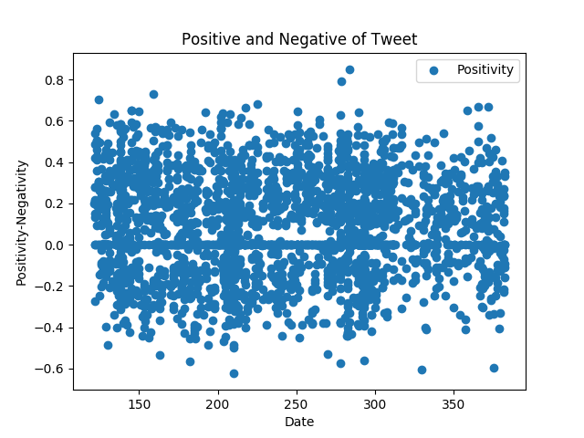
- Negativity
Compound Sentiment score was graphed. It was plotted over time, which was denoted as days after January 1st 2016.

As you can see, this plot is fairly messy. It is a collection of various scores, and it is very hard to make out any sort of pattern. The only pattern that is easily observed is that there are many tweets that have a compound score of either 0 or close to 0. In order to make more sense of the data, more analysis was conducted.

The first analysis that was done was to clean up the clutter. Cleaning up the clutter meant averaging the scores of the tweets, over various time periods. The tweets were then graphed based on an average score over a two week period. This gave a much clearer indication as to the trend of the tweets. This gave information as to the sentiment of Trump’s tweets, but it didn’t give much of an indication as to why this sentiment changed. In order to understand a little more about why the sentiment changed, the sentiment of the tweets were compared against Trump’s political standing at that time. This is seen in the figure below.
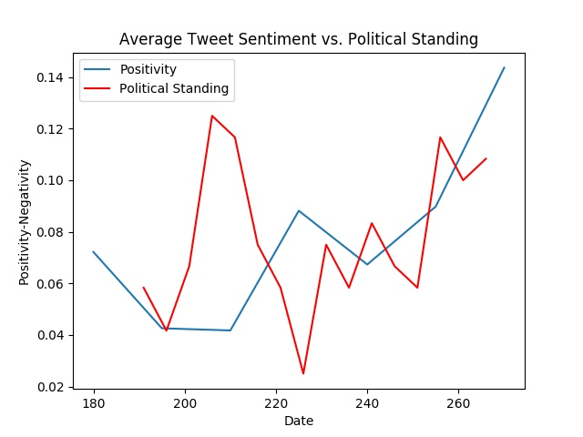
- Negativity

As it turns out, there is a strong correlation between trumps political standing and the positivity of his tweets. In the figure above, Trump’s political standing at weekly intervals was superimposed upon the graph of the compound sentiment of his tweets. At first glance, the compound sentiment of his tweets does not directly follow his standing in the polls, however, there is a much stronger correlation if the graph of Trump’s compound sentiment was shifted to the left by 5-10 days. If this was the case, the compound sentiment would very closely follow the political standings. What the graph shows is that the compound sentiment of Trump’s tweets changed based on his political standing, but with a delay of 5-10 days. This is most likely the case for two reasons. The first reason is that polls are not continuous. They might be conducted on a weekly or even bi-weekly basis, so there could be a delay in the change of his tweet sentiment. Another reason why this may occur is because of uncertainty in polls. For the first few days, Trump may have believed that change in his political standing to be a fluke for a small period of time. This would cause him to wait a few days before changing his sentiment. Overall, the result of this project shows that the sentiment of Donald Trump’s tweets closely follows his political standings with a delay of 5-10 days.

Reflection: From a process perspective, the implementation of the API twitter key went really well. I was able to learn the new information and implement it quickly and easily. I used a combination of online resources and the website to implement this. I could improve upon the concision of my code. After I had already developed a way to parse the input from twitter into tweets and dates through a complex method, I learned that there was a very simple way to do it through the API. I should have researched more about the API in order to better understand how I could do the project in a more concise way. The project also had a good result. I was able to make a real world connection using the information that I gathered, which was very interesting.

