Project Write-up and Reflection

Project Overview

This project is an interactive music visualizer. Taking in songs with the .wav file type, it analyzes the music to identify an average beat per minute value. Using the basis of computational art code, random art is generated at depths from input values and iterated over time to create various frames, in "original" coloring, "inverse" coloring, and "black and white" coloring. These frames are then displayed as movies that repeat to the beat of the song. As the user listens, they can press keys to alternate between color schemes. Additionally, arrow keys can be used to move the image around, while the music continues playing.

Implementation

At a high level architecture level, we had a used the design pattern called Model-View-Controller. For the model, it was the x,y coordinates from the image to display and the color scheme of the images it would display. The defaults were set to 0,0 and the color scheme shown in Illustration 1. The model would be manipulated by the Controller which consisted of the keys Q, W, and E which manipulated the color schemes, and the arrow keys to move around the video. The manipulated model would simply update what was being displayed by pyGame in our 350x350 window which served as our View.

In our implementation, we had the choice of choosing how the video was going to be displayed by pyGame. Our original idea was to have the computational art generator to generate art at the speed that our program was running. Unfortunately, there was a computational bottleneck in terms of how many images we were able to generate per second (not even close). As a result, we pivoted to pre-generating a small number of frames and iterating them at a speed undetectable to the human eye.

Results

For an example music file, "Inside Out" by Britney Spears, a video of random art iterating over time is played, and can be varied in color and location by pressing the "Q", "W", and "E" keys. This song is at 60 bpm, and is the sole example we have running currently. We made good progress on code that could analyze any given song to identify bpm, however due to issues with reading our files, we have only been able to make certain files read and be analyzed for beat per minute values.
Illustration 3: Example image in “black and white” coloring
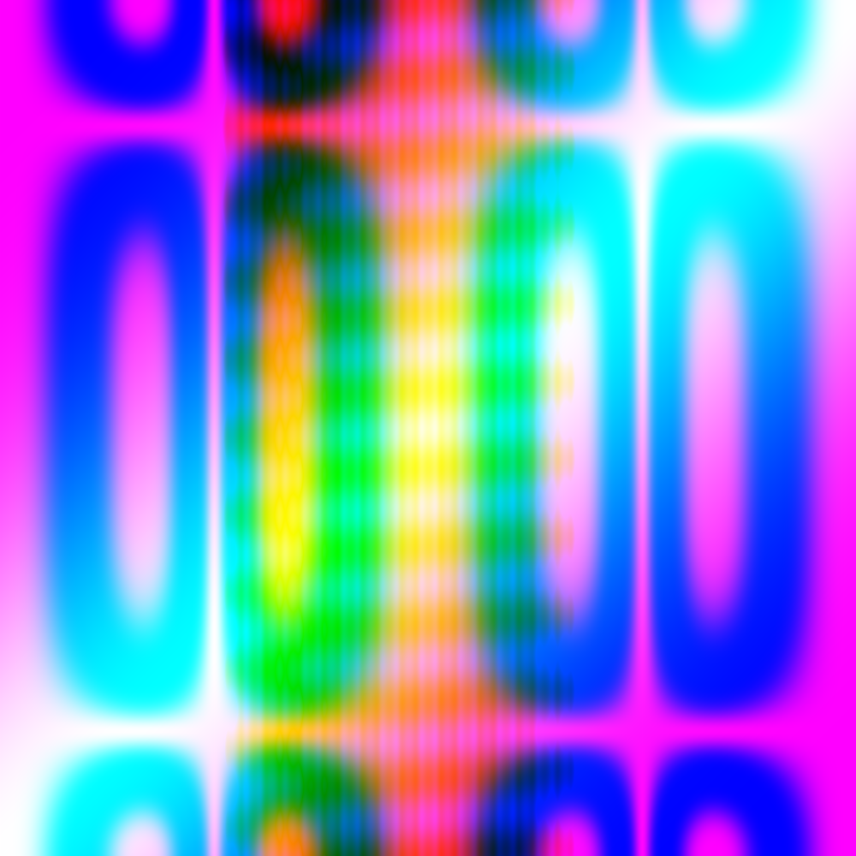Illustration 1: Example art generated using this program in "original" coloring
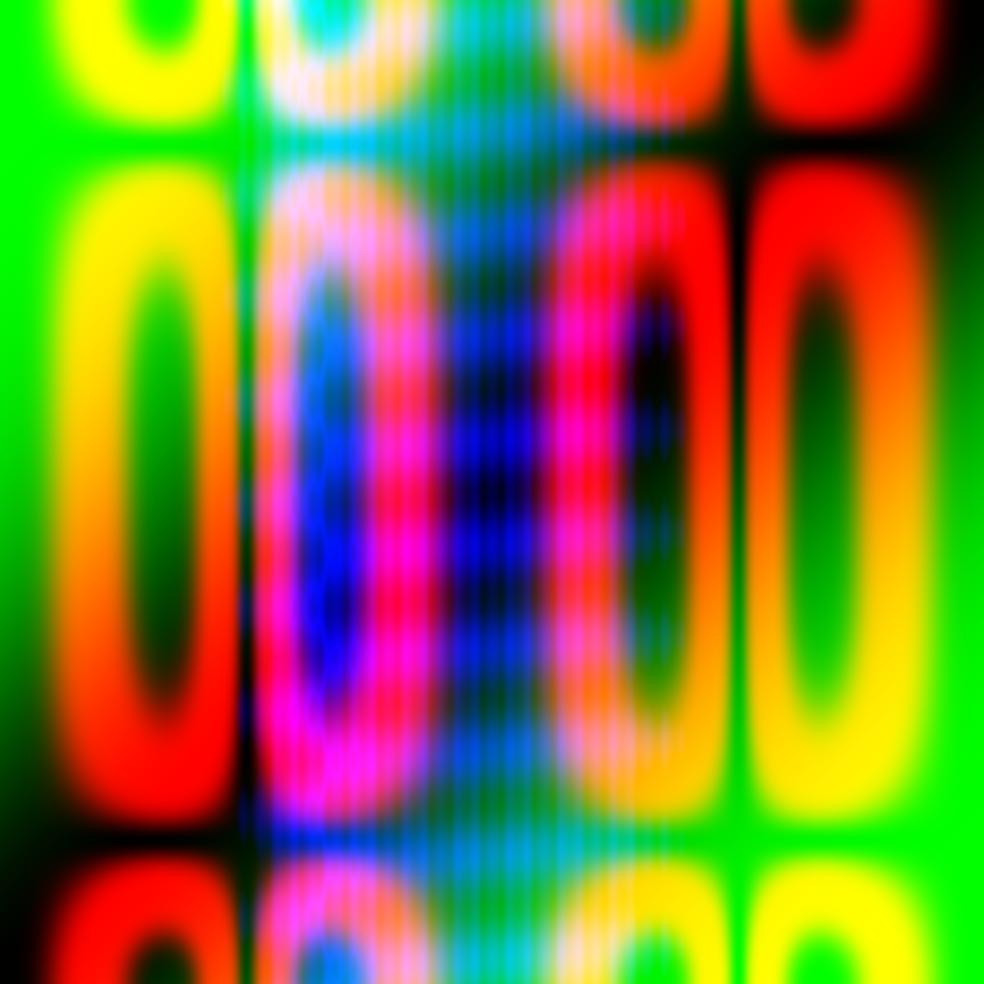Illustration 2: Example image in “inverse” coloring
Our random art generator is built off the basis of the Computational Art Mini Project code from the "Software Design" class at Olin College, along with some modifications. It uses different depth values to create random equations that are then visualized as art. Prior to this project, these equations only took two variables (x and y), however we chose to vary them along a different variable as well (t) in order to create smoothly transitioning "movies".

Reflection

Our process went reasonably well, however our expectation of how much time each task would take was inaccurate. As a team, we worked well together and focused on completing all work in the same space, though with tasks being split up individually. Our project was overscoped for our level of understanding of Python. We believe that if we'd understood our task better at the conceptual level, the project would have ran more smoothly and would have taken less time. We did not have a good plan for unit testing, however we both developed testing skills as we tested our individual components prior to integrating. Moving forward, we will continue to use what we learned about project scoping, the importance of overall understanding, and the ability to divide and conquer, together.

One thing we would like to improve on in the future is our attention to learning goals. When we first started this project, we were excited to work with classes, however going back to our goals today we realized we really didn't spend much time with them. We also started work on this project early, but didn't anticipate how much time each task was going to take, and convinced ourselves we were on schedule when we weren't and ended up turning this project in late. Next time, we will put more work in ahead of time to prepare for each task, however we will continue our method of dividing the work but completing it while in the same space.

