**GeoChat**

Created by Kyle Deak and John Delaney

Users Guide

July 29, 2017

# IntroductionPlaceholder image

The creators of GeoChat developed this web-based application to offer the users the ability to chat with the world around them. In order to provide a visualized world of people in the area and to see the distance between them. The goal of the application is to reach out from any browser and see a whole new interactive world.

## GeoChat

GeoChat is a browser based chat program using the technology of mapping JavaScript libraries and the geolocation of the device that is accessing the program. Users will register and have the ability to upload their own avatar to display on the map as well as select people to have a conversation. Passwords are encrypted with a MD5 salted hash and are non-retrievable.

### 

# Overview of System Features

## Web Interface

Utilizing any mobile or desktop device one can easily navigate to the web site and register and/or login with their credentials. This allows access to the application anywhere in the world with internet.

## Map Library

The mapping library is an open source JavaScript library called Leaflet.js which is used in many applications from Hotel and restaurant locations to weather applications. The ability to expand on this platform to see other overlays in addition to chat user locations makes the library scalable to further implementations.

## Relational Database

The use of MySQL will allow the storage and logging of chat discussions and geo-locations of users as well as the list of friends. Additionally, the credentials will be stored and used for authentication. MySQL is a free and scalable database allowing the growth of the number of users.

# Getting Started with GeoChat

## System Requirements

GeoChat runs entirely in the browser. All that is required to use the application is a modern web browser with internet access, JavaScript enabled, and HTML5 geolocation permissions granted.

## Creating a User Account

The first time you use GeoChat, you will need to register a user account. Navigate to the GeoChat website and click to register as a new user and fill out the form. Now log in with your account to access the application.

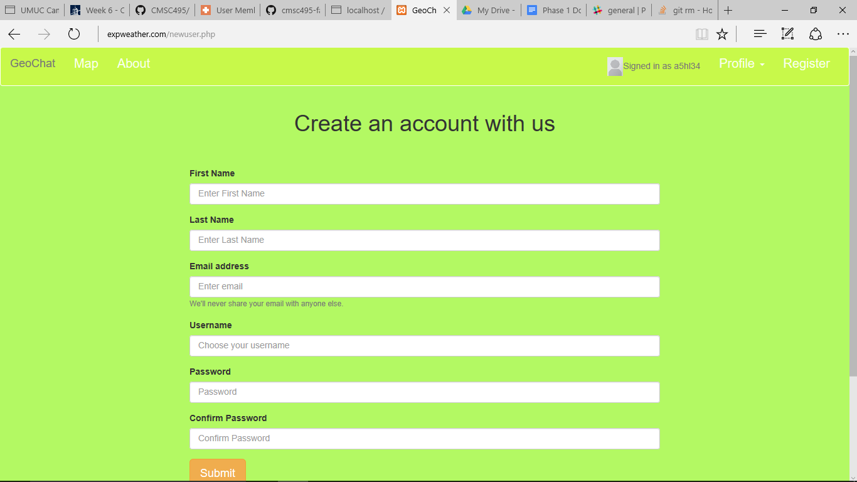

## Login Screen

Logging into the application is like any other website with your username and password, place them into the appropriate fields and click submit. The application will find your avatar and place it in the toolbar and display your username.

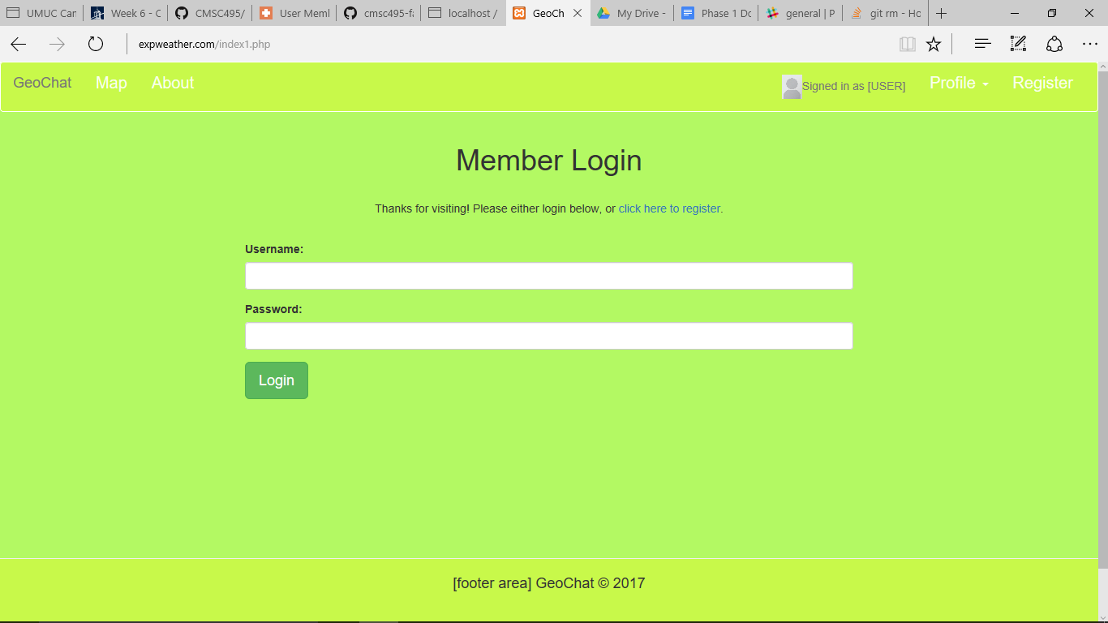

## Upload the Avatar

Customizing the look of your pop-up balloon with an avatar is another option GeoChat provides. Simply upload any 50KB or less jpg, png, or gif and that will be the picture associated with your username.

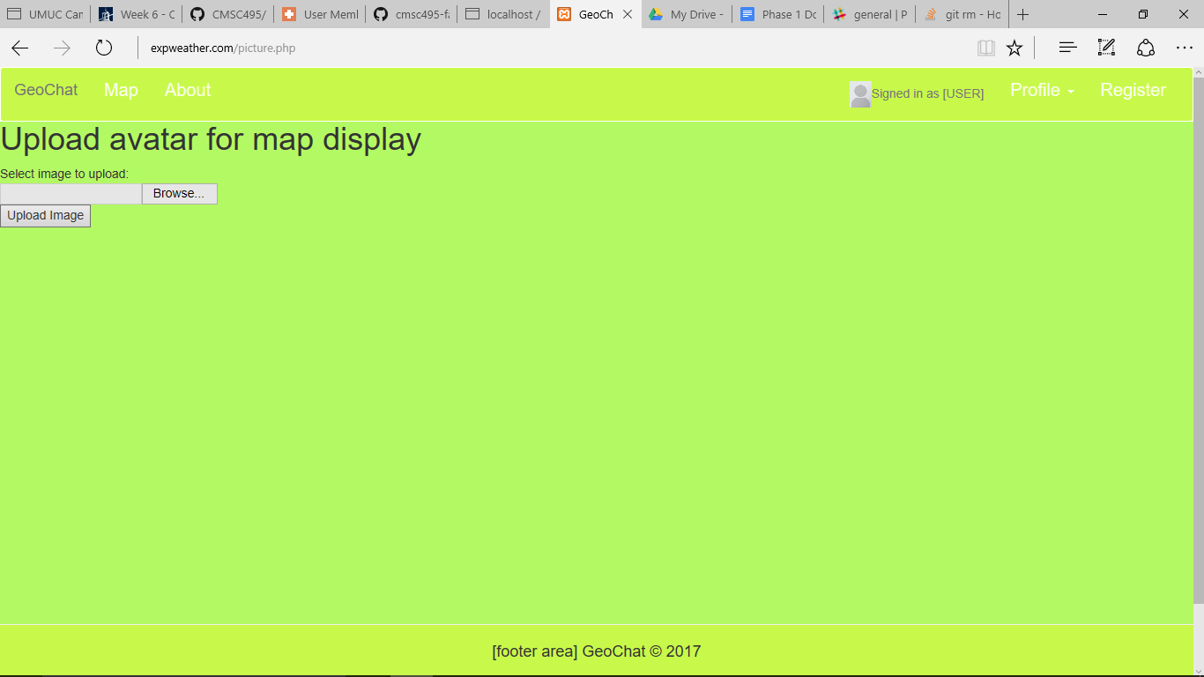

## Viewing and Posting Messages

Login directs to the main page of the application where you can see the interactive map. Scroll and pan around the map to locate messages sent from around the world. If geolocation is enabled in your browser, you can post a message to the map from your location using the text box.

[add image when available]

## Exiting the Application

Don’t forget to sign out! Log out of your account by selecting logout in the user control panel. If you decide to close the browser tab, we will simply terminate your user session.

