SDEV 300 6381 Building Secure Web Applications (2178)

JOHN DELANEY

FALL 2017

9/10/2017

**Description**

The follow lab was to demonstrate the use of html and php to render information on a webpage. The calculation of information, the looping of information and the manipulation of existing data was the goal. There were three tables and each one represents one of these activities. The first one is the calculating of area and perimeter of geometric shapes. The second one is the changing of text and counting text within a large string. The third is the looping and displaying of sequences using counters and alignments.

**Screenshots:**

1. Geometric Shapes and Calculations. The first table showing the four geometric shapes and the results of the calculations for area and perimeter.

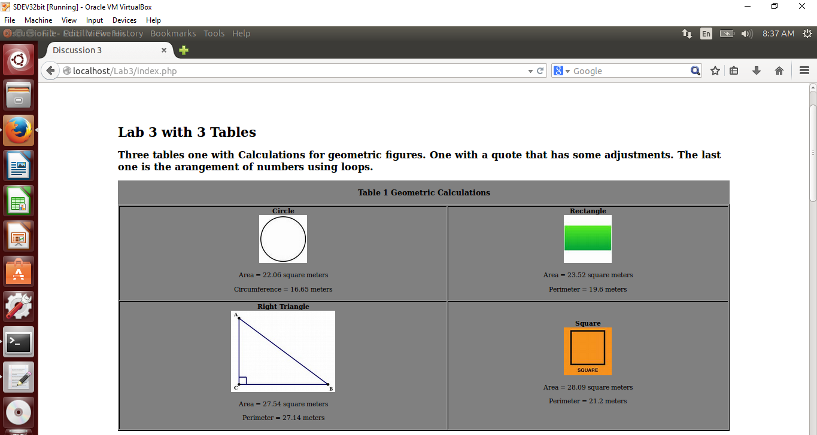

2. Screenshot displaying the quote and the many changes uses PHP. Each cell of the table shows the changes or actions taken to make the display.

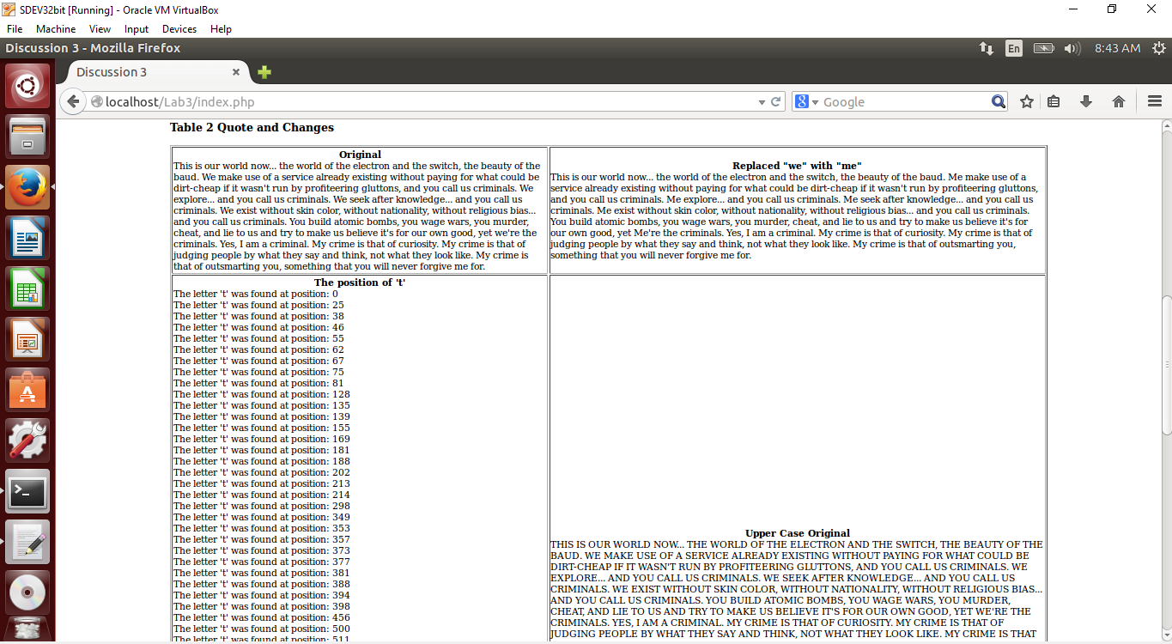

Not all of the table could fit on the screenshot but the majority is shown.

3. The screenshot below is the third table required in the Lab. The table number 3 has the four sequences of numbers that are looped and formatted based on the lab instructions. 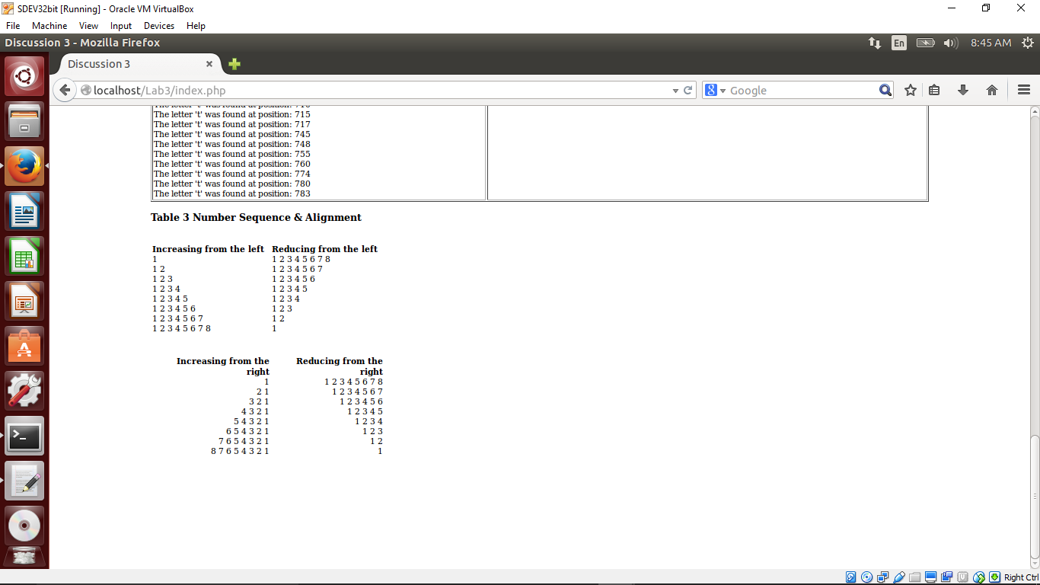

**Lessons Learned**

During the first portion of the Lab, Table 1, the preplanning of all the variables helped make the display in html easier. I feel that I should have written functions for all the calculations and called them as needed. The equations were small enough and only used once in the page that is why I decided to place them with a variable.

In the Table 2 portion of the lab, I choose to set the quotes and changes to those quotes in variable form so the display was easier to follow. For the position of “t” portion, I used “strpos” in a function and returned all the positions found as an array. I then looped through the array and displayed the text and the position number for each instance of “t” found.

In Table 3, the looping through the numbers was a little tricky. The first one was pretty straight forward. The other ones I had to change the order of the counts and move the appending of spaces. A lot of trial and error went into building the last two displays.

**Access Log Analysis**

Most of the entries in the access log show the successful (200 code) retrieving the images and the and a few 304 codes where they have been retrieved before a refresh of the page. The interesting responses in the error.log showed where I made a few mistakes during the loops and using arrays to retrieve data.