SDEV 300 6381 Building Secure Web Applications (2178)

JOHN DELANEY

FALL 2017

10/01/2017

**Description**

The follow lab was to demonstrate to use of MySQL through the command line. The goal was to create tables, use insert, delete, select and update statements to manage the data within the database. Connection through the terminal is a faster and efficient method to tweak data on the fly outside the use of php scripts.

**Screenshots:**

1. The first screenshot is the running of scripts 1-4 and the results from a successful execution of creating the tables.

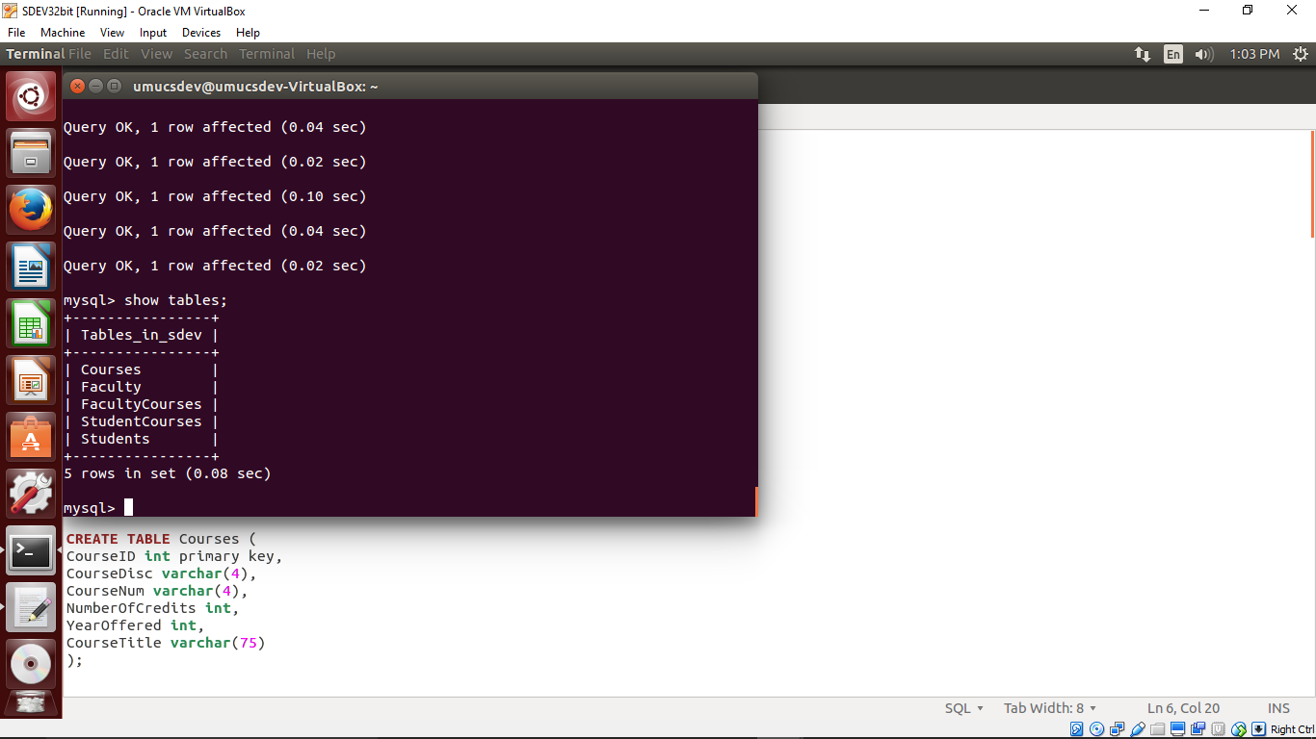

The next couple of screenshots will show the initial data setup in each of the tables created.

a. ‘Courses’ and ‘Faculty’ Tables with column headers and data.

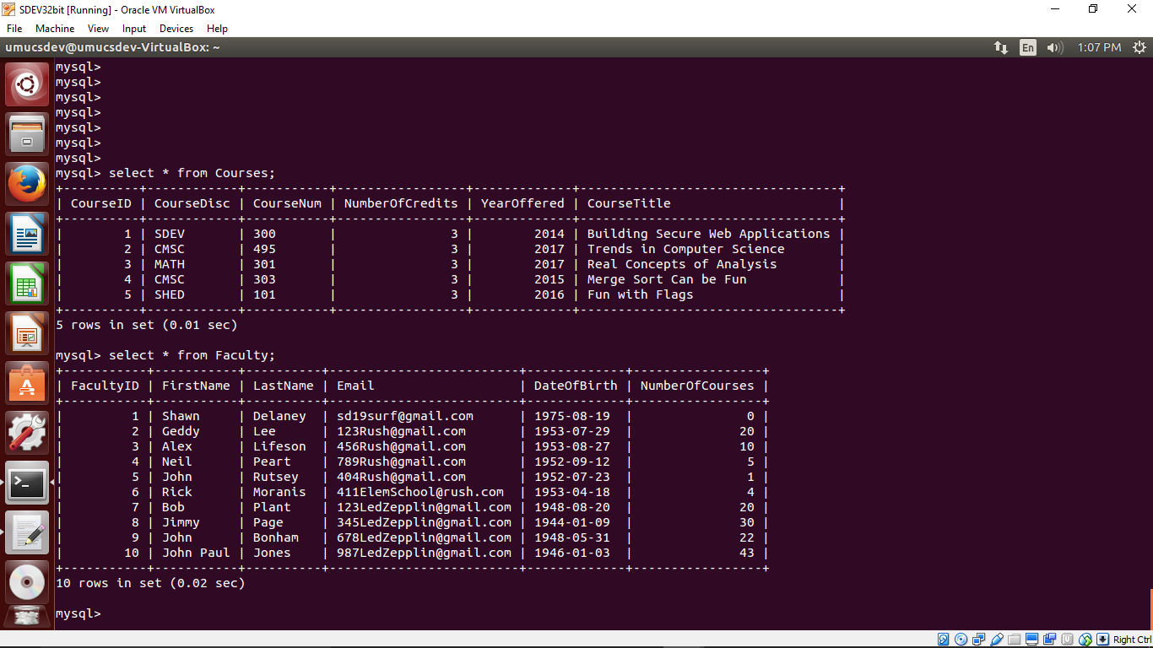

b. ‘FacultyCourses’ Table with 25 entries.

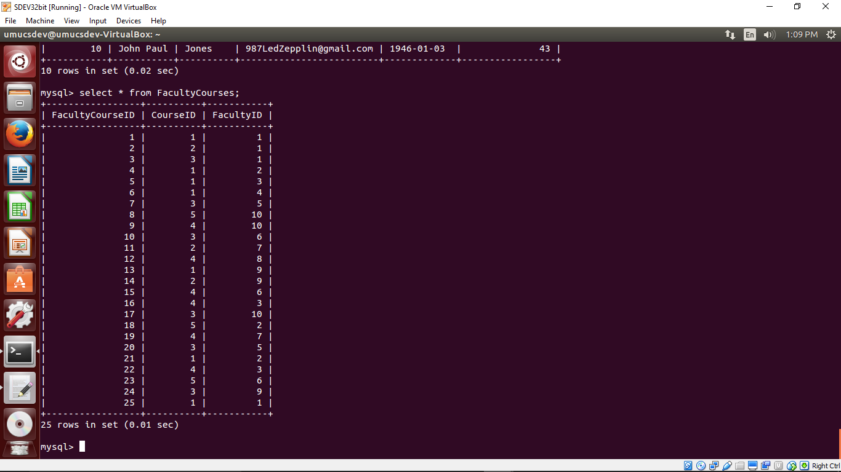

These screenshots were the result of running the Lab6.sql script I created.

2. The screenshot below is the result of an Update Statement and its effect on all the records in the Courses Table.

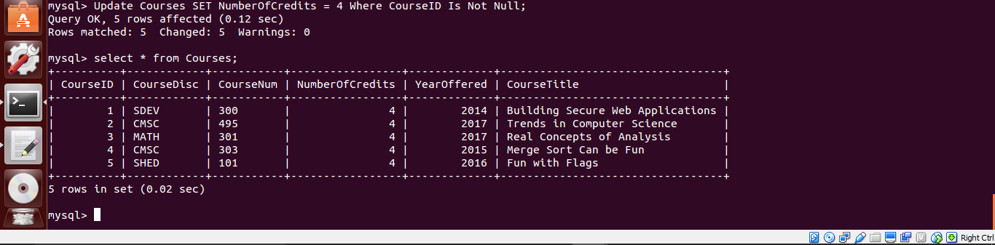

This Query changed all the Number Of Credits from 3 to 4 based on the SQL statement at the top of the image.

3. This query statement changes all my inserted courses taught to anything greater than 4 gets changed to 5. UPDATE Faculty SET NumberOfCourses = 5 WHERE NumberOfCourses > 4;

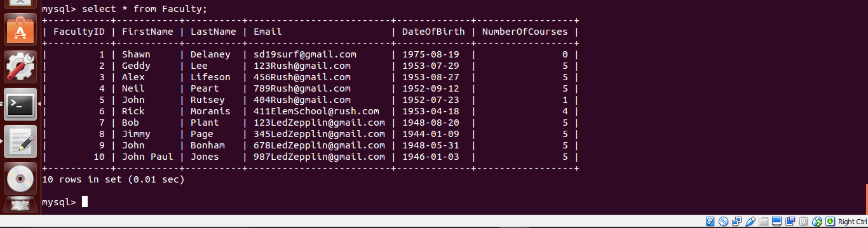

4. Delete any Faculty whose LastName starts with ‘Z’; There were no records that matched the statement but here is the result anyway.

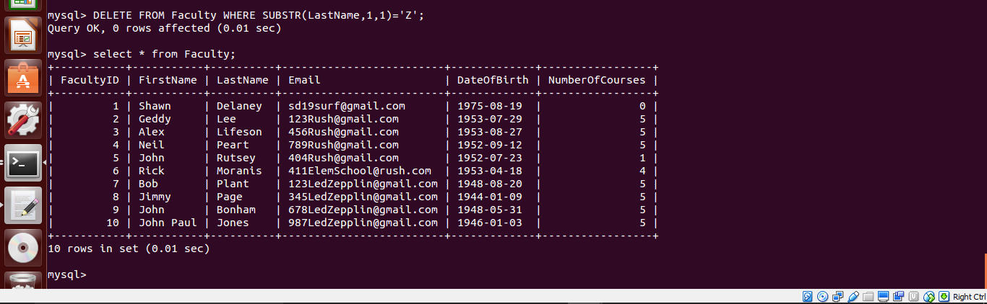

5. Delete any Course that was first offered in 1999. This again will have no rows affected since the data doesn’t have anything that meets that criteria.

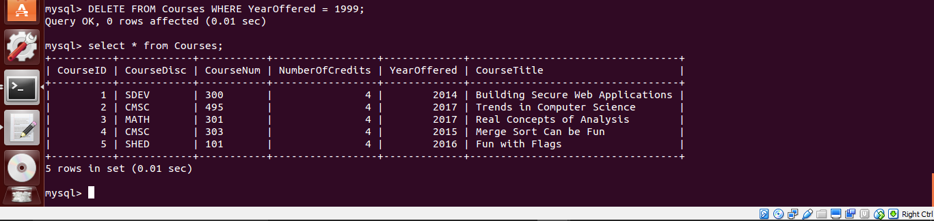

6. Select Statements to display all the records in the all three tables using three select statements and ordering them by last name or course title.

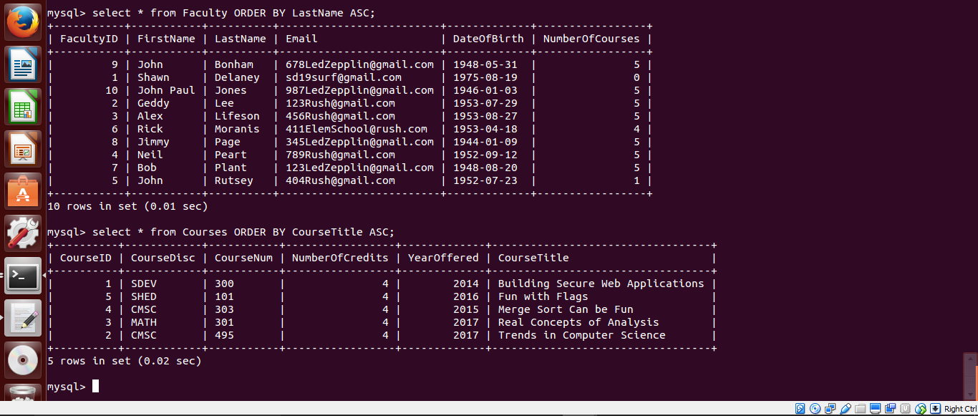

Third Table Ordered by Faculty ID ascending.

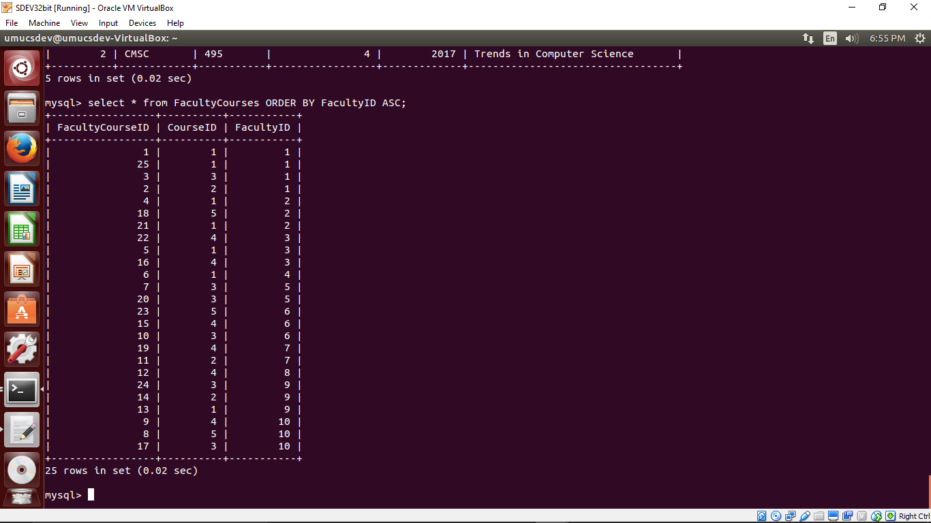

7. Select statements to show all Faculty that did not teach courses.

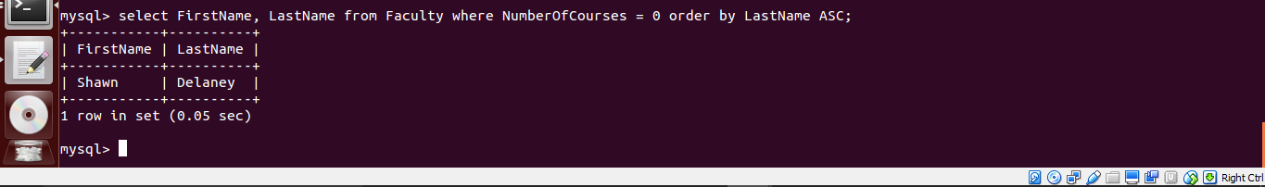

8. Select Statement to display all courses offered before 1984. This will not return any results however the proof is in the screenshot.



9. Select all the columns from the Faculty and Course Tables for each Faculty and Course in the FacultyCourse Table. The entire display could not be captured in a screenshot so to show the results in a clearer manner the column headers were displayed along with a few rows.

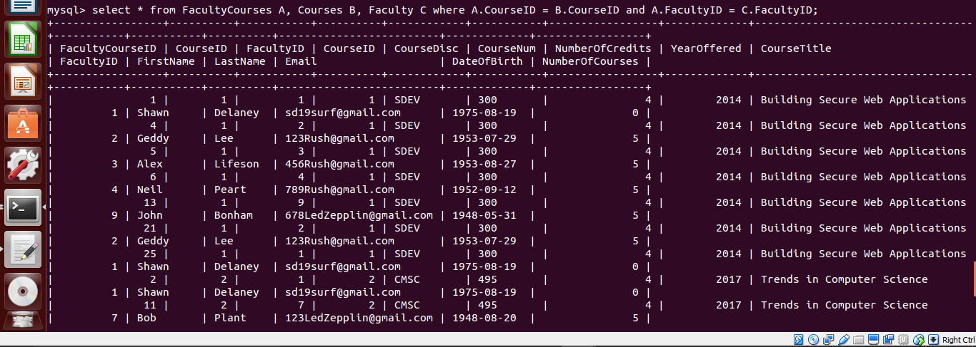

**Lessons Learned**

Interesting difference in the .sql file on Windows and once it was transferred to the Linux box. The MySQL reads the .sql fine regardless of spaces between the ‘—’ and the comment. Linux will error on the line if there is not a space between the ‘—’ and the comment. The joins I found to be pretty interesting. I really enjoyed the use of command line and interacting with the database. The basics of using the database without a GUI is very helpful in the field.