SDEV 300 6381 Building Secure Web Applications (2178)

JOHN DELANEY

FALL 2017

9/03/2017

**Description**

I built a small website that sells Rush albums that are leftover in a warehouse. The YYZ company does not have a complete inventory but there are twelve albums with enough to sell online. The website was built on the LAMPP/XAMPP stack on Linux and Windows. GitHub was the version control system used to share the information between the two servers. The reason it was developed this way was the Virtual Box and Linux image runs very sluggish on my older laptop. All screenshots and testing was conducted on the Linux and LAMPP stack. The GitHub repository is <https://github.com/sd19surf/SDEV300> all changes and updates were committed in the event the virtual system had to be restored or reset. Bootstrap, jQuery, CSS and JavaScript were not used in the creation of this website. Some features are available in HTML5 only and are not currently supported in the Firefox browser. The one feature of note is the date selection for the order form.

**Screenshot 1.**

Index.html – The entry page into the YYZ company. The URL <http://localhost/SDEV300/index.html>. The page is the gateway to the other subpages such as album details and order form.

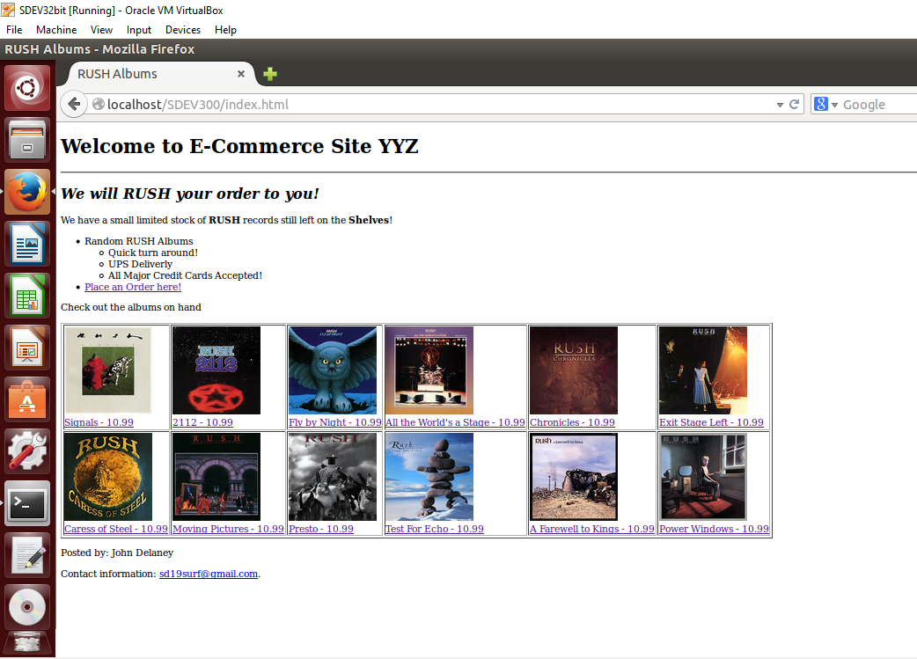

Screenshot 2.

This is the Order form. The link is located on the second main bullet of the index.html. The page was named order.html. The date selector uses a HTML5 tag that is not supported in the FireFox browser. All entries are text input, the select input uses the multi-select attribute which is supported in the Firefox, the radio buttons are linked so only one can be selected at a time. All data is gathered and posted in the URL after submit has been pressed.

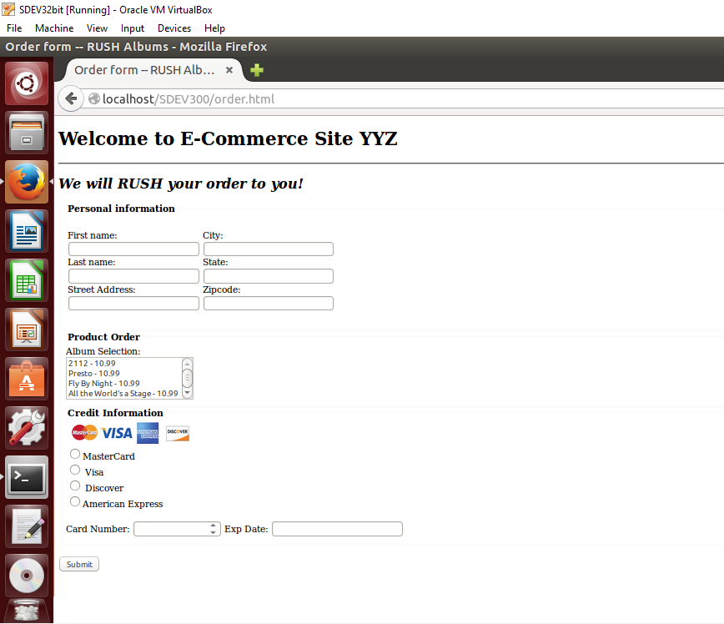

Screenshot 3.

These screenshots are the sub-pages that are linked to the pictures on the index.html. To save time and scrolling smaller screenshots will be used to show all 12 sub-pages used.

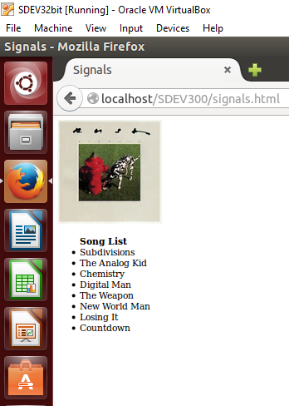 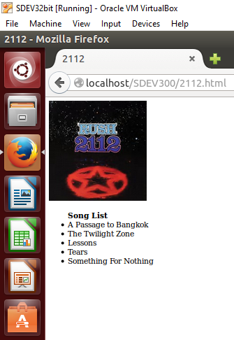 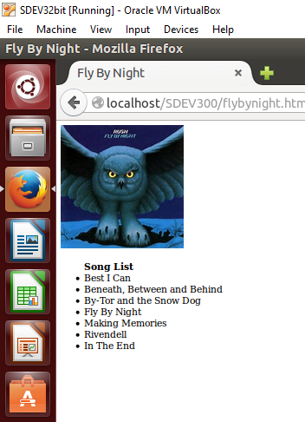 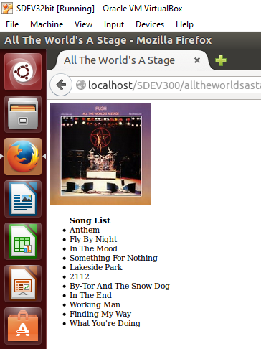

Signals.html 2112.html flybynight.html alltheworldsastage.html

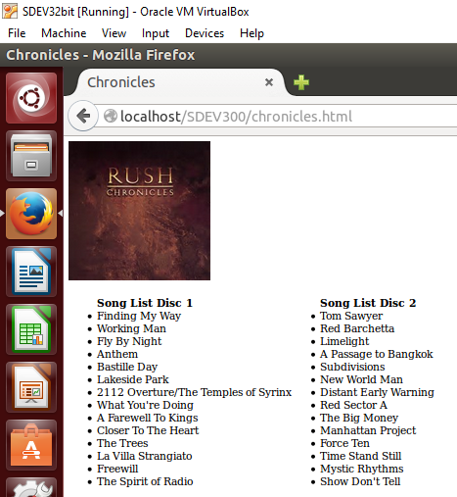 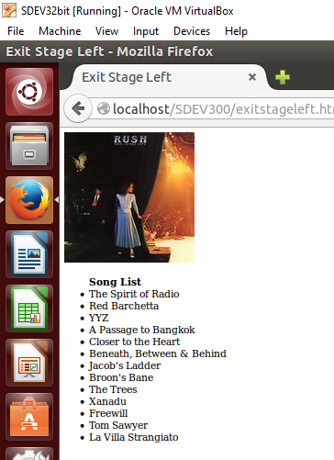 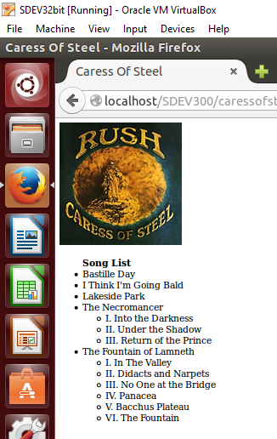 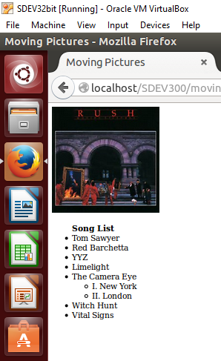

chronicles.html exitstageleft.html caressofsteel.html movingpictures.html

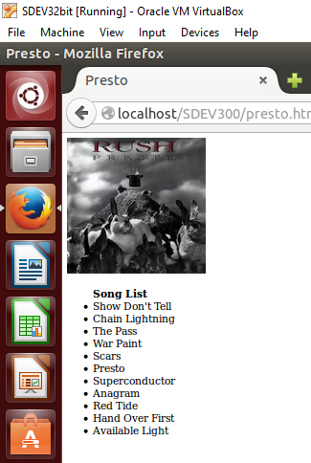 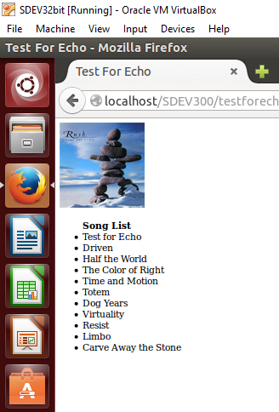 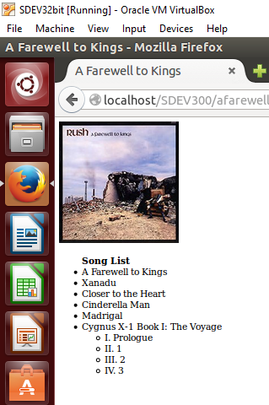 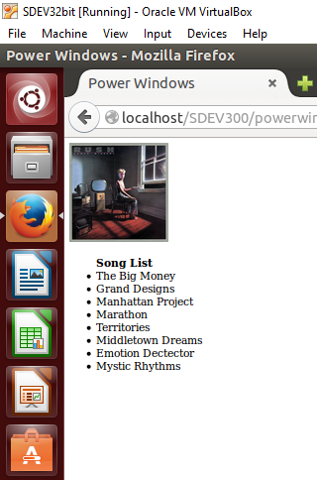

presto.html testforecho.html afarewelltokings.html powerwindows.html

The challenges faced when developing these little pages for the description of the albums were the pictures were about 50% .png and 50% .jpg, the other issue was the testforecho and powerwindow pictures were full sized and not thumbnails. To fix the first issue, attention had to be given during the coding process not to to mistype the picture type. The second issue, I had to use width and height attributes within the img tag to limit the size of the images.

**Review of access.log**

A review of the access.log shows a couple 404 errors where I do not have a favicon.ico for the website. There are a few 304 messages stating that these files were referenced before and were referenced again. Most of my errors while building the site were 404 errors due to mistyping the extension of the picture or building in links to pages I have not yet built. For instance I built a powerwindows.html which was referenced in the index.html and wasn’t quite saved yet. For some reason the errors weren’t captured in this access.log. The passing of variables was captured from the order.html submit button. Evidence of everything I entered on the form was captured in the log. This occurred on lines 49 and 50 of the access.log file. The timeline as I tested was a bit short since I have had experience building html web sites in the past. My main concern was the location of features and some refreshes occurred while constructing the index and order html files. I built the index.html first and order.html was built second then, the sub-pages were built in a random order. Full testing was completed on the Ubuntu Apache2 system and all links were sucessful and buttons, radio buttons and textareas worked as intended.

**Lessons Learned**

Overall the lesson on trying to keep all the naming and picture formats the same makes for an easier to handle web site. The different size pictures and formats caused an increased coding time. The use of <ul> within a <ul> allowed to break out the portions of a bullet item in the song lists and the index.html listing. The Virtual Box runs very sluggish on my current computer setup and adjustments had to be made to move the project along. Since I have two web server systems in a similar setup I can use GitHub version control system to pass the code back and forth between the two systems to ensure functionality works on both browsers and both servers. The GitHub version control system also allows for me to pass the access.log files from OS to OS in an efficient fashion. I would say this was a Best Practice for this assignment.