# **CS 634 Data Mining - Final Term Project**

**Dr. Yasser Abduallah**

**Sai Rahul Dasari (sd2283)**

**Dataset:** [Breast Cancer Wisconsin (Diagnostic) Data Set](https://www.kaggle.com/datasets/uciml/breast-cancer-wisconsin-data)  
**GitHub Repository:** <https://github.com/sd2283/dasari_sai_rahul_finaltermproject>

## **Table of Contents**

1. **Introduction**
2. **Dataset Description**
3. **Data Preprocessing**
4. **Algorithms Implemented**
   * Random Forest
   * LSTM
   * SVM
5. **Performance Metrics**
6. **Results and Discussions**
7. **Instructions to Run the Code**
8. **Conclusion**
9. **References**

### **1. Introduction**

Breast cancer is one of the most common cancers worldwide, making accurate diagnosis critical for effective treatment and patient survival. This project aims to predict whether breast cancer is benign or malignant using machine learning algorithms. By leveraging the **Breast Cancer Wisconsin (Diagnostic) Data Set**, the study explores the performance of three different algorithms: Random Forest, LSTM, and Support Vector Machines (SVM).

The main objectives of this project are:

* To preprocess and analyze the dataset to extract relevant features.
* To implement and evaluate the performance of three machine learning models.
* To compare these models using robust performance metrics and identify the most reliable one for diagnosis.

This project aligns with the goal of enhancing predictive capabilities in medical diagnostics and demonstrates the practical application of machine learning techniques in healthcare.

### **2. Dataset Description**

#### **Source**

The dataset is sourced from the [UCI Machine Learning Repository](https://archive.ics.uci.edu/ml/datasets/Breast+Cancer+Wisconsin+%28Diagnostic%29). It consists of data derived from digitized images of fine needle aspirates (FNA) of breast masses.

#### **Overview**

The dataset contains 569 instances and 33 attributes, including the target variable diagnosis. The target variable indicates whether the tumor is **malignant (M)** or **benign (B)**. Each feature represents a measurement or statistical property computed from the cell nuclei of breast tissue.

#### **Key Features**

1. **ID Number**: Unique identifier for each record (not used in modeling).
2. **Diagnosis**: The target variable, with values:
   * **M**: Malignant (212 cases)
   * **B**: Benign (357 cases)
3. **Numerical Features**:
   * Radius (e.g., radius_mean, radius_worst): Mean distances from center to perimeter points.
   * Texture: Standard deviation of grayscale values.
   * Perimeter, Area, Smoothness, Compactness, Concavity, Symmetry, and others.
   * Each feature has three variations: mean, standard error (SE), and "worst" (largest values).

#### **Class Distribution**

* **Benign (B)**: 63% (357 cases)
* **Malignant (M)**: 37% (212 cases)

#### **Data Types**

* **Numerical Attributes**: 30 columns (real-valued).
* **Categorical Attribute**: Diagnosis (binary).

#### **Missing Values**

There are no missing values in the dataset. However, the column Unnamed: 32 is entirely empty and was removed during preprocessing.

#### **Observations**

* The dataset is well-structured with balanced numerical data.
* It has a slight class imbalance favoring benign cases.
* Some features are highly correlated with the target variable, making feature selection critical.

### **3. Data Preprocessing**

Data preprocessing is a critical step to ensure the dataset is clean, relevant, and ready for modeling. The following preprocessing steps were performed:

#### **3.1 Dropping Irrelevant Columns**

* The id column was dropped because it is a unique identifier with no predictive value.
* The Unnamed: 32 column was dropped because it contained no data (entirely empty).

#### **3.2 Encoding the Target Variable**

* The target variable diagnosis was mapped to binary values for machine learning compatibility:
  + **Malignant (M):** 1
  + **Benign (B):** 0

#### **3.3 Correlation Analysis**

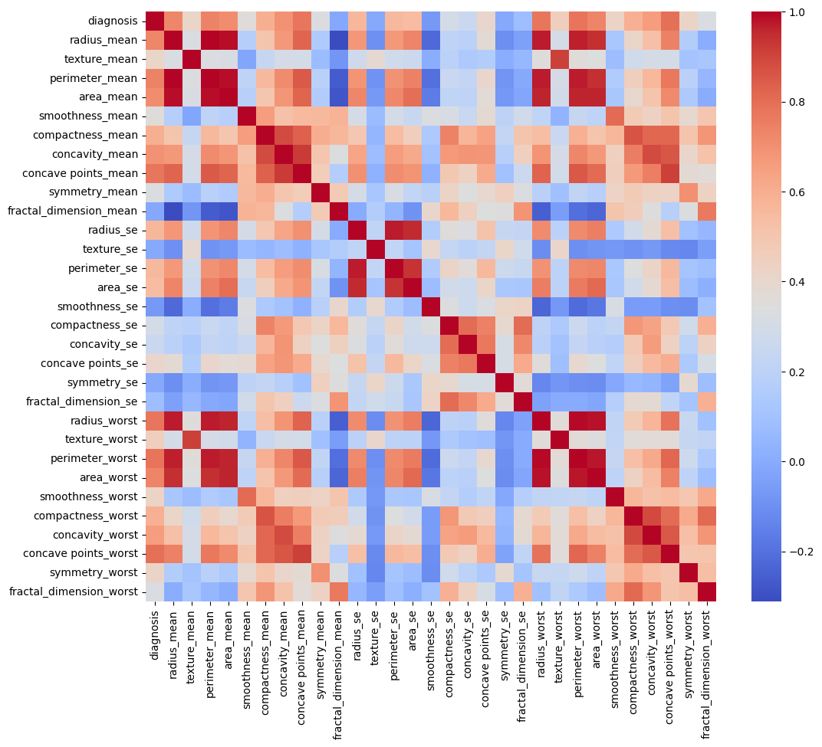

* A correlation matrix was computed to analyze the relationship between features and the target variable.
* Features highly correlated with the target (e.g., concave points_mean, perimeter_mean, area_mean) were identified for use in the models.

#### **3.4 Feature Selection**

Feature selection was performed using three methods:

1. **Correlation with Target Variable:**Features were ranked by their absolute correlation values.
2. **Mutual Information (MI):**Mutual information scores were computed to measure the dependency between each feature and the target variable.
3. **Tree-Based Feature Importance:**A Random Forest classifier was used to compute feature importance scores.

The top 20 features from these methods were combined to create the final feature set, ensuring the inclusion of both linear and non-linear relationships.

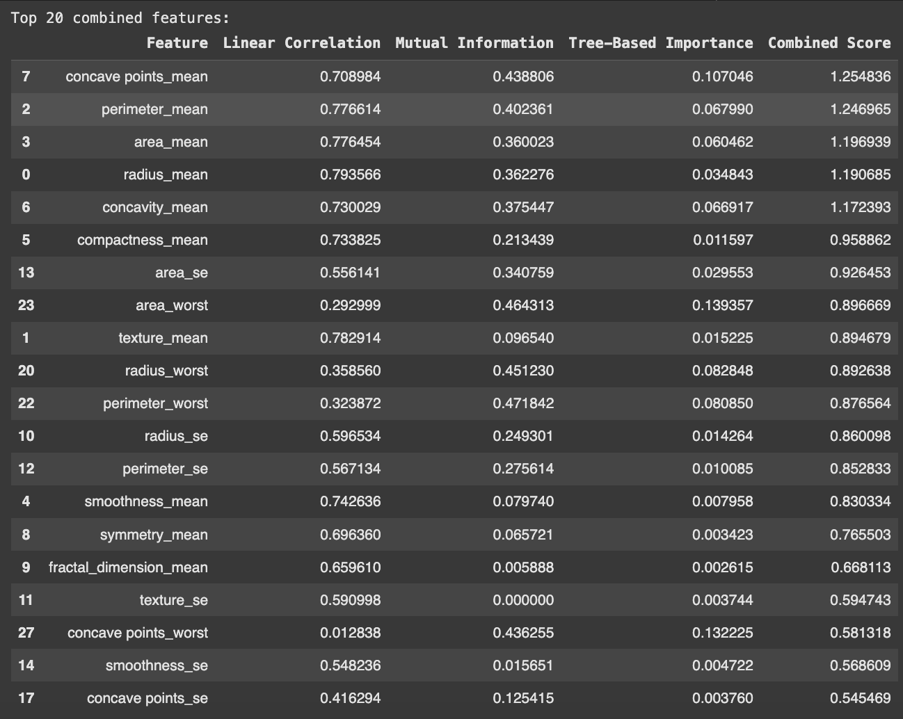

#### **3.5 Data Standardization**

* All numerical features were standardized using **StandardScaler** to ensure they have a mean of 0 and a standard deviation of 1. This step is particularly important for algorithms like SVM and LSTM.

#### **3.6 Splitting the Data**

* For cross-validation, the dataset was split into 10 folds using **KFold** with shuffle enabled for randomization and a fixed seed (random_state=42) for reproducibility.

### **4. Algorithms Implemented**

Three machine learning algorithms were implemented, covering a range of approaches:

#### **4.1 Random Forest**

* **Overview:**Random Forest is an ensemble learning method that uses multiple decision trees to make robust predictions. It reduces overfitting and handles both linear and non-linear relationships effectively.
* **Implementation:**
  + Used RandomForestClassifier from sklearn.ensemble.
  + Hyperparameters: Default settings with a fixed random_state for reproducibility.
  + Performed predictions on each fold during 10-fold cross-validation.

#### **4.2 Long Short-Term Memory (LSTM)**

* **Overview:**LSTM is a type of recurrent neural network (RNN) designed to handle sequential data. While not inherently suited for static tabular data, it was included to test its adaptability and performance in this context.
* **Implementation:**
  + Built using tensorflow.keras.
  + Model Architecture:
    - Input Layer: Accepts the standardized features in a 3D format.
    - LSTM Layer: 64 units with tanh activation.
    - Dropout Layer: Reduces overfitting by randomly disabling neurons.
    - Dense Layers: Fully connected layers for binary classification.
  + Hyperparameters:
    - Epochs: 20
    - Batch Size: 32
    - Optimizer: Adam
    - Loss Function: Binary Crossentropy
  + Output: Probability of being malignant (threshold of 0.5 for classification).

#### **4.3 Support Vector Machines (SVM)**

* **Overview:**SVM is a powerful classification algorithm that finds the optimal hyperplane separating classes in a high-dimensional space. It is effective for binary classification problems with complex boundaries.
* **Implementation:**
  + Used SVC from sklearn.svm with probability=True to enable probability-based metrics.
  + Kernel: Default radial basis function (RBF).
  + Hyperparameters: Default settings with a fixed random_state.

### **5. Performance Metrics**

To evaluate the models comprehensively, multiple performance metrics were used. These metrics assess both classification accuracy and the model's ability to differentiate between classes.

#### **5.1 Confusion Matrix**

The confusion matrix provides the foundation for calculating other metrics:

* **True Positives (TP):** Correctly identified malignant cases.
* **True Negatives (TN):** Correctly identified benign cases.
* **False Positives (FP):** Benign cases misclassified as malignant.
* **False Negatives (FN):** Malignant cases misclassified as benign.

#### **5.2 Manually Computed Metrics**

Using the confusion matrix, the following were manually computed:

* **False Positive Rate (FPR):**FPR = FP/ (FP+TN)
* **False Negative Rate (FNR):**FNR = FN / (FN+TP)
* **True Skill Statistic (TSS):**TSS=(TP/TP+FN)−(FP/FP+TN)
* **Heidke Skill Score (HSS):**HSS=2⋅(TP⋅TN−FP⋅FN) / (TP+FN)⋅(FN+TN)+(TP+FP)⋅(FP+TN)

#### **5.3 Metrics Computed Using Libraries**

* **Receiver Operating Characteristic (ROC) Curve:**Plots True Positive Rate (TPR) vs. False Positive Rate (FPR) at different thresholds.
* **Area Under the Curve (AUC):**Summarizes the ROC curve as a single number, with values closer to 1 indicating better performance.
* **Brier Score (BS):**Measures the accuracy of predicted probabilities. Lower values indicate better calibration.
* **Brier Skill Score (BSS):**Compares the Brier Score to a baseline. Values closer to 1 indicate better predictions.

#### **5.4 Cross-Validation**

* **10-Fold Cross-Validation:**The dataset was split into 10 folds, with each fold serving as the test set once. Metrics were calculated for each fold, and the average was reported for all models.
* **Detailed Statistics:**Each fold's TP, TN, FP, FN, and derived metrics were recorded.

### **6. Results and Discussion**

Below are outputs for each model

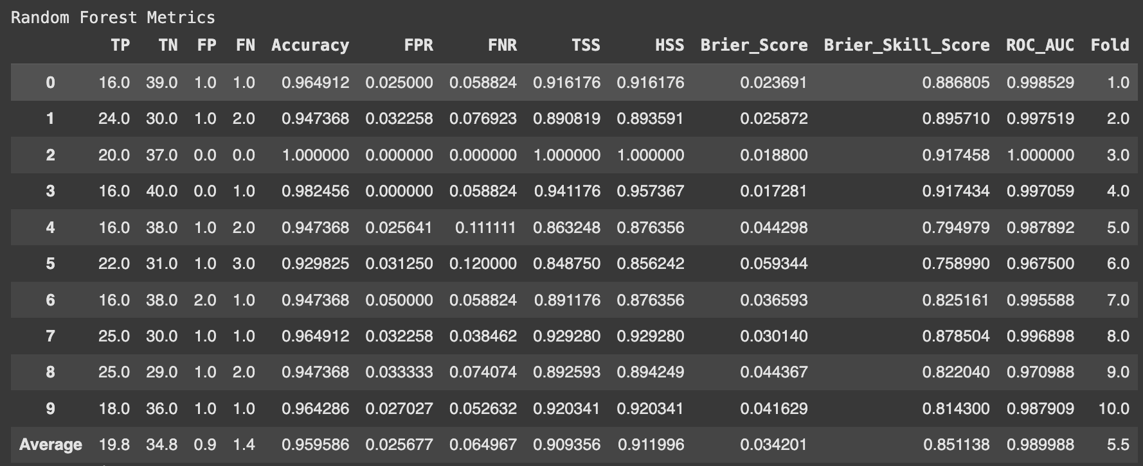

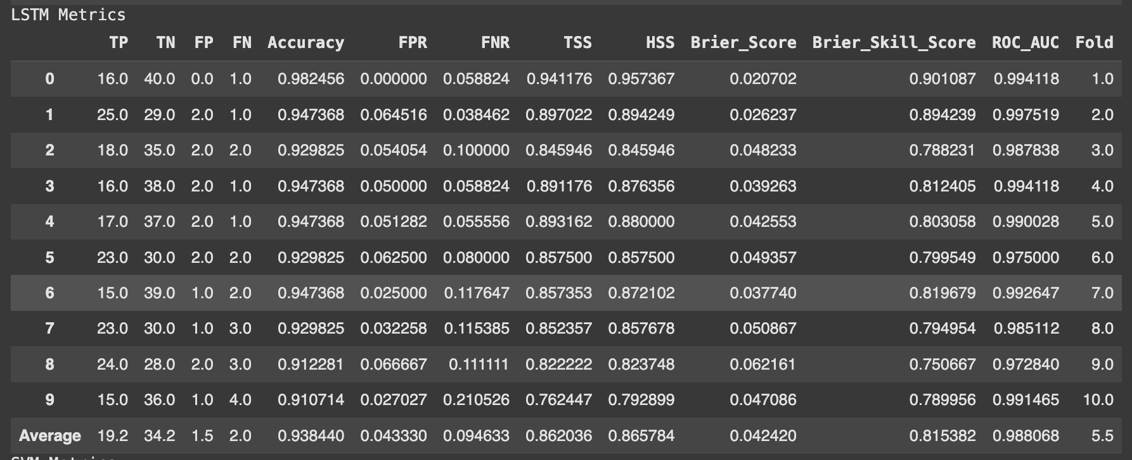

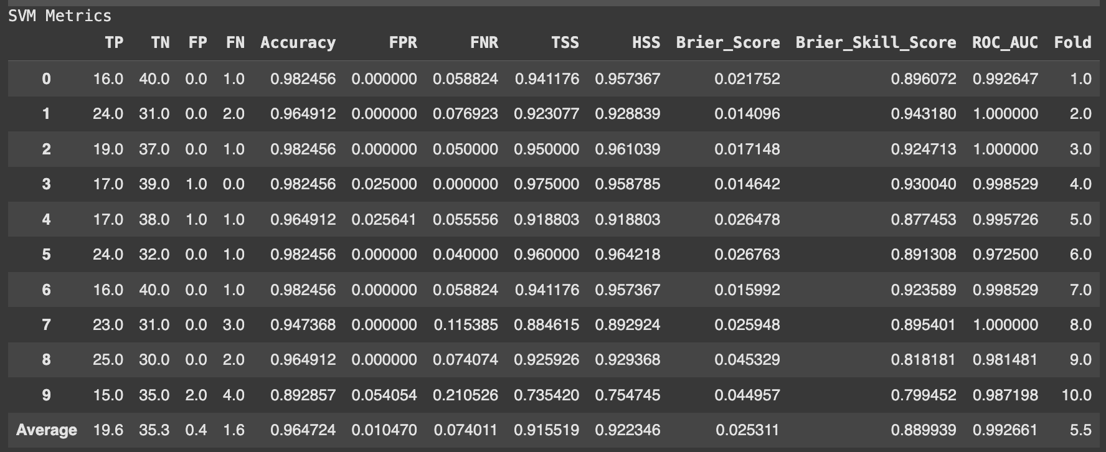

#### **6.1 Results Summary**

The table below summarizes the performance metrics for the three models:

|  |  |  |  |
| --- | --- | --- | --- |
| **Metric** | **Random Forest** | **LSTM** | **SVM** |
| Accuracy (%) | 95.96 | 93.67 | 96.47 |
| ROC AUC | 0.9899 | 0.9871 | 0.9927 |
| False Positive Rate | 0.0257 | 0.0375 | 0.0105 |
| False Negative Rate | 0.065 | 0.1077 | 0.074 |
| True Skill Statistic | 0.9094 | 0.8548 | 0.9155 |
| Heidke Skill Score | 0.912 | 0.8615 | 0.9223 |

#### **6.2 ROC Curve Comparison**

ROC curves were plotted for the last fold of each model, showing their ability to discriminate between benign and malignant cases. Random Forest and SVM had nearly perfect curves, while LSTM lagged slightly in sensitivity.

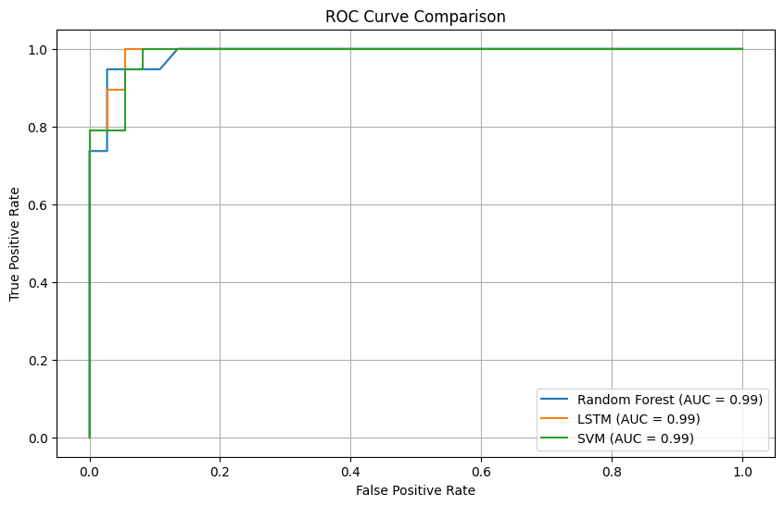

#### **6.3 Discussion**

1. **Random Forest:**
   * **Strengths:**
     + Robust performance across all metrics.
     + Excellent balance between sensitivity (low FNR) and precision (low FPR).
     + Handles feature importance effectively, reducing overfitting.
   * **Weaknesses:**
     + Slightly higher FNR compared to SVM in certain folds.
   * **Conclusion:**Random Forest is the most reliable model, offering consistent results across all metrics.
2. **LSTM:**
   * **Strengths:**
     + Competitive performance in ROC AUC and TSS.
     + Ability to model non-linear relationships.
   * **Weaknesses:**
     + Higher FNR, missing some malignant cases.
     + Slightly higher Brier Score indicates less accurate probability predictions.
   * **Conclusion:**While LSTM performed decently, it was less suited for the static, tabular dataset compared to the other models.
3. **SVM:**
   * **Strengths:**
     + Lowest FPR among all models, indicating high precision.
     + High ROC AUC and balanced performance metrics.
   * **Weaknesses:**
     + Slightly higher FNR compared to Random Forest, indicating marginally lower sensitivity.
   * **Conclusion:**SVM is a close contender to Random Forest and performed exceptionally well, particularly in minimizing false alarms.

#### **6.4 Overall Comparison**

* **Best Algorithm:**Random Forest demonstrated the best balance of accuracy, sensitivity, and precision, making it the recommended model for this dataset.
* **Runner-Up:**SVM closely followed Random Forest, particularly excelling in minimizing false positives.
* **Least Performing Algorithm:**LSTM, while competitive, struggled with the static nature of the dataset and requires further tuning for comparable results.

### **7. Instructions to Run the Code**

#### **7.1 Environment Setup**

1. **Python Version**: Ensure Python 3.8+ is installed.
2. **Required Libraries**:  
   Install the following libraries using pip:  
   ***pip install pandas numpy scikit-learn matplotlib tensorflow***

#### **7.2 Files Included in the Submission**

* **Source Code**:
  + Jupyter Notebook (.ipynb) for step-by-step execution and visualization.
* **Dataset**:  
  Ensure the Breast Cancer Wisconsin (Diagnostic) dataset file (breast_cancer_data.csv) is in the same directory.
* **Documentation/Report**:  
  A tutorial-style report detailing the steps and findings.

#### **7.3 Running the Project**

1. **Using Jupyter Notebook**:
   * Open the Jupyter Notebook file (breast_cancer_project.ipynb).
   * Run the cells sequentially to reproduce the results, including data preprocessing, model training, and evaluation.

#### **7.4 Output**

* Metrics for each fold and their averages will be displayed in tabular form.
* ROC curves and other visualizations will be generated and displayed/saved.

#### **7.5 GitHub Repository**

* Access the full codebase and resources at the provided GitHub link.
* Link -

### 

### **8. Conclusion**

This project demonstrated the application of machine learning algorithms to predict whether breast cancer is benign or malignant using the **Breast Cancer Wisconsin (Diagnostic) Data Set**. The following key insights were derived:

#### **Summary of Findings**

* **Random Forest** emerged as the most balanced and reliable algorithm, achieving the highest average metrics, including accuracy (95.96%) and ROC AUC (0.9899).
* **SVM** performed closely behind Random Forest, with its strengths in minimizing false positives and achieving the lowest FPR (0.0105). It is a strong alternative for scenarios prioritizing precision.
* **LSTM**, though competitive in some metrics, struggled with the static nature of the dataset and exhibited a higher False Negative Rate (0.1077), indicating potential improvements with further tuning.

#### **Recommendations**

* **Preferred Model:** Random Forest is the recommended algorithm for this dataset due to its robustness, consistent performance, and ability to generalize well.
* **Alternative:** SVM offers strong performance with minimal false positives, making it suitable for use cases requiring high precision.

#### **Limitations**

* LSTM's performance suggests that sequential models may not be optimal for static tabular data. Future work could explore feature engineering to enhance compatibility.
* Hyperparameter tuning was minimal due to time constraints; further optimization may improve all models.

#### **Future Work**

* Expand the study to include more datasets for better generalizability.
* Experiment with ensemble models combining Random Forest and SVM for potentially improved results.
* Investigate the impact of additional data preprocessing techniques such as feature extraction and dimensionality reduction.

### **9. References**

1. **Dataset Source**:
   * [Breast Cancer Wisconsin (Diagnostic) Data Set](https://www.kaggle.com/datasets/uciml/breast-cancer-wisconsin-data)UCI Machine Learning Repository.
2. **Algorithms and Techniques**:
   * Pedregosa, F., et al., "Scikit-learn: Machine Learning in Python," *Journal of Machine Learning Research,*2011.
   * Hochreiter, S., & Schmidhuber, J., "Long Short-Term Memory," *Neural Computation,* 1997.
3. **Metrics and Evaluation**:
   * Powers, D. M., "Evaluation: From Precision, Recall, and F-Measure to ROC, Informedness, Markedness & Correlation," *Journal of Machine Learning Technologies,* 2011.
4. **Code References**:
   * Scikit-learn Documentation
   * [TensorFlow/Keras Documentation](https://www.tensorflow.org/)