**Solution Brief - K3s installation**

K3s Installation – High Availabilty Cluster

Step by Step guide

Contents

Introduction 4

What is k3s? 4

What are the enhancements k3s comes with? 4

Architecture of HA k3s server cluster: 5

Prerequisites: 5

Supported architectures: 5

K3s: 6

Deployment Guide 6

Specifications for Host Machine We Used: 6

Installation 6

Figure 1 –Running installation script 6

Figure 2- Token for joining additional nodes 7

Figure 3 – HA k3s cluster nodes 7

Figure 4 - Pods running in all the nodes 8

# Introduction

## 

## What is k3s?

It is fully compliant lightweight kubernetes distribution. It is half the size of standard kubernetes (binary less than 100 MB).

## What are the enhancements k3s comes with?

## The control plane components is encapsulated in a single binary and process

## Sqlite3 as default storage.

1. Features such as: local storage provider
   * 1. service load balancer
     2. Helm controller
     3. Traefik ingress controller.

## Required dependencies have been included:

* + 1. containerd
    2. Flannel (CNI)
    3. CoreDNS
    4. Traefik (Ingress)
    5. Klipper-lb (Service LB)
    6. Embedded network policy controller
    7. Embedded local-path-provisioner
    8. Host utilities (iptables, socat, etc)

## Architecture of HA k3s server cluster:

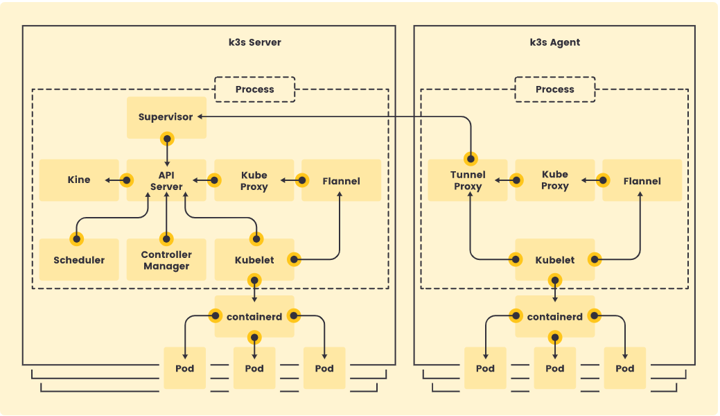

The above architectural diagram represents the k3s server cluster. K3s server node is a host with control-plane and datastore components whereas agent node is a host without any control-plane or datastore components. Kubelet, container runtime and CNI run on both type of nodes.

### Prerequisites:

1. 3 host machines/VMs – unique hostname.

## Supported architectures:

* 1. x86_64
  2. arm64/aarch64 - OS must use a 4k page size.
  3. s390x

1. All linux systems (certain steps need to be followed for Centos/RHEL.
2. Hardware – recommended 2vCPUs with 1 GB RAM.

## K3s:

### Deployment Guide

The following steps are performed to set up High Availabilty k3s clusters:

* Setting up VMs.
* Running installation script.

### Specifications for Host Machine We Used:

Host machine:

* CPU: 4 vCPUs
* Memory: 4 GB
* Storage: 50 GB
* OS: Ubuntu 22.04

## Installation

Step 1: Launch a server node with the cluster-init flag.

curl -sfL https://get.k3s.io | K3S_TOKEN=SECRET sh -s - server --cluster-init

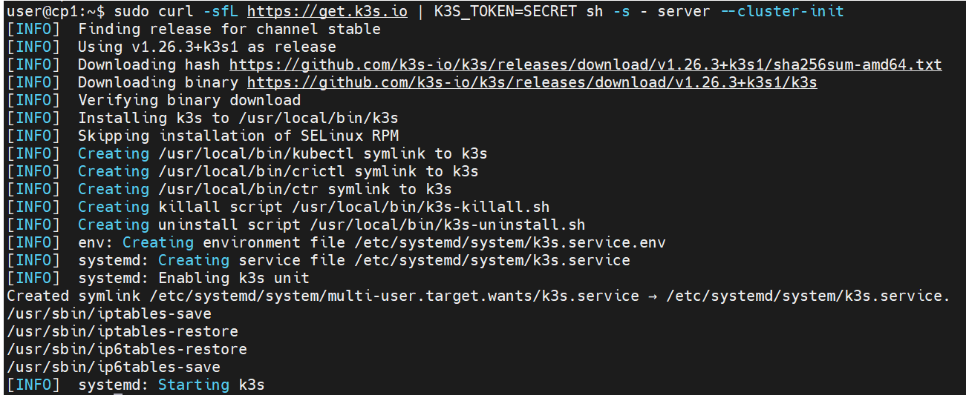

*Fig 1: running installation script*

Step 2: Join the second and third servers to the cluster using the shared secret

curl -sfL https://get.k3s.io | K3S_TOKEN=<token from first server> sh -s - server --server https://<ip or hostname of server1>:6443

The token can be retrieved from the file /var/lib/rancher/k3s/server/token.



*Fig 2: Token for joining additional nodes*

Step 3: Leverage Kubeconfig environment variable to access the cluster

export KUBECONFIG=/etc/rancher/k3s/k3s.yaml

OR

Cp /etc/rancher/k3s/k3s.yaml ~/.kube/config

And then change the IP in the server field to IP of k3s server.

Step 4: Check the status of the servers added

  kubectl get nodes

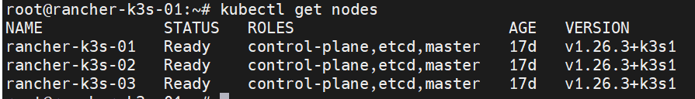

*Fig 3: HA k3s cluster nodes*

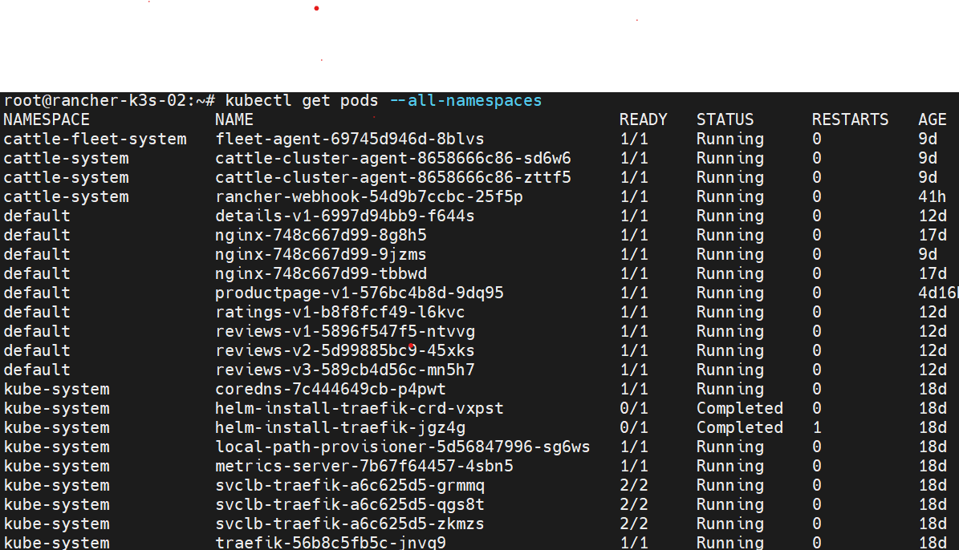

*Fig 4: Pods running in all the nodes*