Openstack: High-performance networking setup for network storages

Current Disk IOPS and Bandwidth

- One Region Deloyment
When both the Openstack instance and volume on the same region(server). 100GB disk storage attached to instance for better result and for this test 95GB is used. The following result for 1MB Block size.

- Write IOPS: 466
- Bandwidth: 489MB/s
- Completion latency: 0.2050.ms with standard deviation 328.07
- Latency: 0.2142 ms with standard deviation 331.98
- disk Utilization: 99.65%

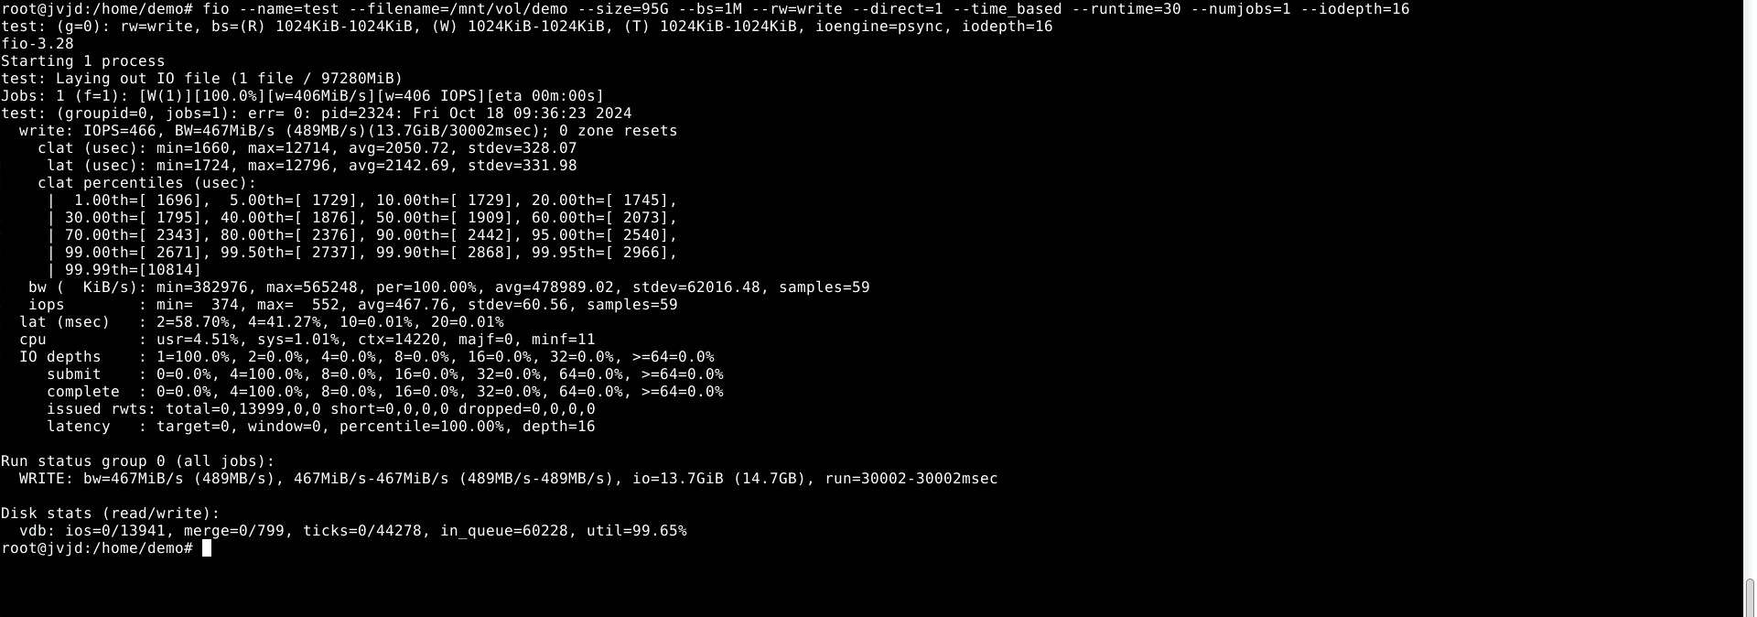

- Read IOPS: 4421
- Bandwidth: 6529MB/s
- Completion latency: 0.0152ms with standard deviation 241.75
- Latency: 0.0152ms with standard deviation 241.75
- disk Utilization: 70.88%

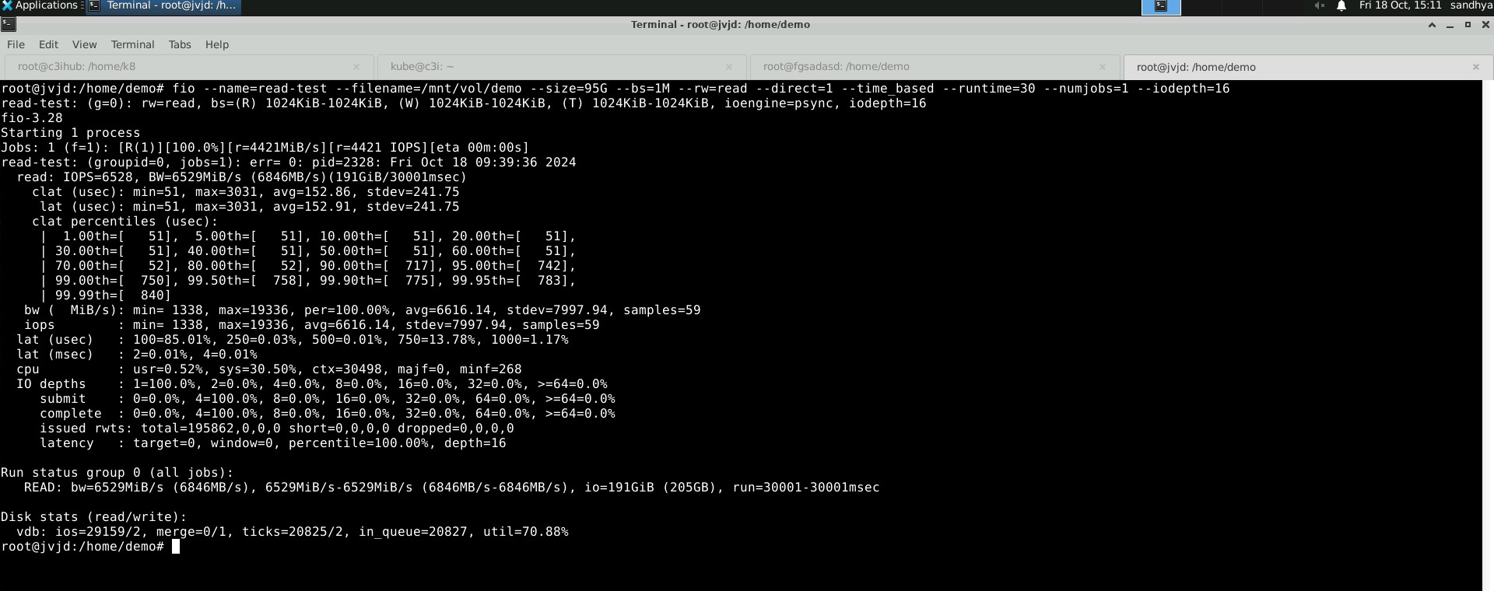

- Two Region Deployment
When both the Openstack instance and volume on the different region(server). 100GB disk storage attached to instance for better result and for this test 95GB is used. The following result for 1MB Block size.

- Write IOPS: 98
- Bandwidth: 102MB/s
- Completion latency: 10.252ms with standard deviation 539.85
- Latency: 10.277ms with standard deviation 539.85
- disk Utilization: 99.64%

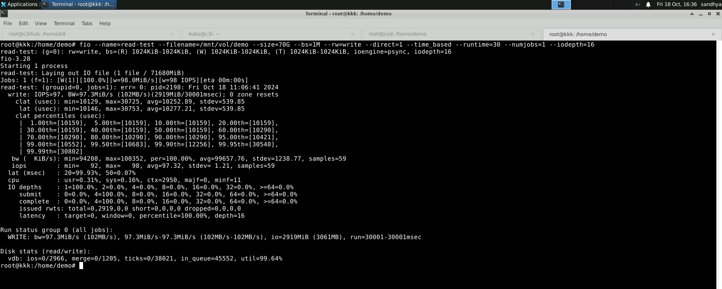
- Write IOPS: 1853
- Bandwidth: 1943MB/s
- Completion latency: 0.0539ms with standard deviation 2071.05
- Latency: 0.0539ms with standard deviation 2071.06
- disk Utilization: 90.88%

