Wazuh Setup on Kubernetes

Pre-requisites
- A Kubernetes cluster already deployed.
- The kubernetes cluster should have a non-default Storage Provisioner configured for Wazuh storages.
- The kubernetes cluster should have load balancer service installed for Wazuh services.

Resource Requirement
To deploy Wazuh on Kubernetes, the cluster should have at least the following resources available:
- 2 CPU units
- 3 Gi of memory
- 2 Gi of storage

Deployment
- NFS Deployment:
- On Kubernetes Worker Node:
    - apt install nfs-kernel-server
    - mkdir -p /srv/nfs/wazuh-data # create the nfs directory
    - chmod 777 /srv/nfs/wazuh-data
    - nano /etc/exports
/srv/nfs/wazuh-data *(rw,sync,no_subtree_check,no_root_squash)
    - exportfs -a
    - systemctl restart nfs-kernel
- On Kubernetes Master Node:
  - Install helm:
- curl https://baltocdn.com/helm/signing.asc | gpg --dearmor | sudo tee /usr/share/keyrings/helm.gpg > /dev/null
- sudo apt-get install apt-transport-https –yes
- echo "deb [arch=$(dpkg --print-architecture) signed-by=/usr/share/keyrings/helm.gpg] https://baltocdn.com/helm/stable/debian/ all main" | sudo tee /etc/apt/sources.list.d/helm-stable-debian.list
- sudo apt-get update
- sudo apt-get install helm
- Configure the NFS:
- helm repo add nfs-subdir-external-provisioner https://kubernetes-sigs.github.io/nfs-subdir-external-provisioner/
- helm install nfs-subdir-external-provisioner nfs-subdir-external-provisioner/nfs-subdir-external-provisioner --set nfs.server=<worker-ip-add> --set nfs.path=/srv/nfs/wazuh-data
- LoadBalancer Deployment:
The manifest will deploy MetalLB to the cluster, in metallb-system namespace. The components are:
- The metallb-system/controller deployment. A cluster-wide controller that handles IP assignments.
- The metallb-system/speaker which is a daemonset. That is the component to make the services reachable.
- The service accounts for the controller and speaker, along with the RBAC permissions that the components require.
- kubectl apply -f https://raw.githubusercontent.com/metallb/metallb/v0.13.7/config/manifests/metallb-native.yaml
Verify the deployment
- kubectl get all --namespace metallb-system
The installation manifest does not include a configuration file. MetalLB’s components although will start, they will remain idle until we provide the required configuration as an IpAddressPool, a new Kind introduced in this version and replaced the old way of provisioning address pool configuration with ConfigMap.
Let’s name it metallb-config.yaml
apiVersion: metallb.io/v1beta1
kind: IPAddressPool
metadata:
name: default-pool
namespace: metallb-system
spec:
addresses:
- 192.168.1.240-192.168.1.250
deploy these manifests:
- kubectl apply -f metallb-config.yaml
- Wazuh Deployment:
- Clone this repository to deploy the necessary services and pods.
- git clone https://github.com/wazuh/wazuh-kubernetes.git -b v4.9.2 --depth=1
- cd wazuh-kubernetes
2. Setup SSL certificates
- Can generate self-signed certificates for the Wazuh indexer cluster using the script at wazuh/certs/indexer_cluster/generate_certs.sh or provide your own.
- bash wazuh-kubernetes/wazuh/certs/indexer_cluster/generate_certs.sh

- Can generate self-signed certificates for the Wazuh dashboard cluster using the script at wazuh/certs/dashboard_http/generate_certs.sh or provide your own.
- bash wazuh-kubernetes/wazuh/certs/dashboard_http/generate_certs.sh

3.Change the storage provisioner for deployer with configured provisioner in the cluster.
- kubectl get sc
After that, edit file wazuh-kubernetes/envs/local-env/storage-class.yaml
- nano wazuh-kubernetes/envs/local-env/storage-class.yaml
4. (optional) Change the dashboard service configuration. Deploying the dashboard on Nodeport.
nano wazuh-kubernetes/wazuh/indexer_stack/wazuh-dashboard/dashboard-svc.yaml
apiVersion: v1
kind: Service
metadata:
name: dashboard
namespace: wazuh
labels:
app: wazuh-dashboard
# dns: route53
annotations:
# domainName: 'changeme'
# service.beta.kubernetes.io/aws-load-balancer-ssl-cert: 'changeme'
#service.beta.kubernetes.io/aws-load-balancer-ssl-ports: '443'
#service.beta.kubernetes.io/aws-load-balancer-backend-protocol: https
spec:
type: NodePort
selector:
app: wazuh-dashboard
ports:
- name: dashboard
port: 443
targetPort: 5601
nodePort: 30001
5. Also change the storage and cpu configuration of the pod from the yaml files listed on the path as follows:
- nano wazuh-kubernetes/wazuh/wazuh_managers/wazuh-master-sts.yaml
- nano wazuh-kubernetes/wazuh/wazuh_managers/wazuh-worker-sts.yaml
- nano wazuh-kubernetes/wazuh/indexer_stack/wazuh-indexer/cluster/indexer-sts.yaml
6. After that, apply the Wazuh kubernetes deployment kustomization for local kubernetes environment.
- kubectl apply -k wazuh-kubernetes/envs/local-env
7. Verifying the deployment
Namespace
- kubectl get namespaces | grep wazuh
Services
- kubectl get services -n wazuh
Deployments
- kubectl get deployments -n wazuh
Statefulset
- kubectl get statefulsets -n wazuh
Pods
- kubectl get pods -n wazuh

- Verifying the deployment.
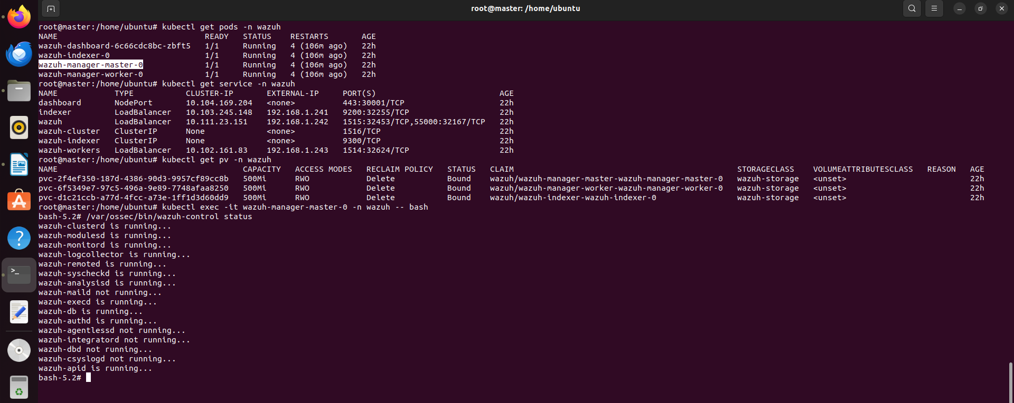
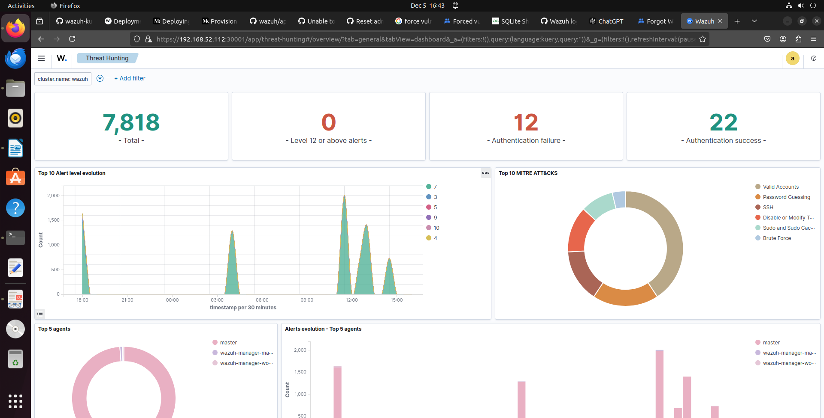

- Can check the alerts through NFS storage mounted on worker node.
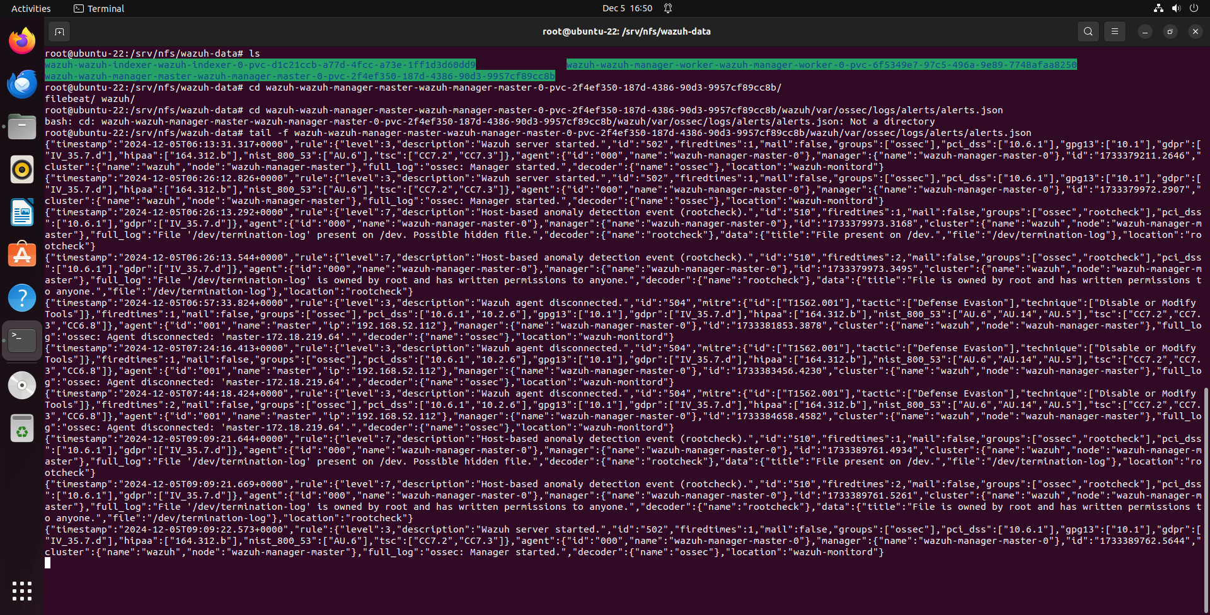

References
- https://akyriako.medium.com/load-balancing-with-metallb-in-bare-metal-kubernetes-271aab751fb8
- https://documentation.wazuh.com/current/deployment-options/deploying-with-kubernetes/kubernetes-deployment.html
- https://github.com/wazuh/wazuh-kubernetes/tree/master

