INTRODUCTION

'Fraud' in credit card transactions is unauthorized and unwanted usage of an account by someone other than the owner of that account. Necessary prevention measures can be taken to stop this abuse and the behaviour of such fraudulent practices can be studied to minimize it and protect against similar occurrences in the future.In other words, Credit Card Fraud can be defined as a case where a person uses someone else credit card for personal reasons while the owner and the card issuing authorities are unaware of the fact that the card is being used. Fraud detection involves monitoring the activities of populations of users in order to estimate, perceive or avoid objectionable behaviour, which consist of fraud, intrusion, and defaulting. This is a very relevant problem that demands the attention of communities such as machine learning and data science where the solution to this problem can be automated. This problem is particularly challenging from the perspective of learning, as it is characterized by various factors such as class imbalance. The number of valid transactions far outnumber fraudulent ones. Also, the transaction patterns often change their statistical properties over the course of time. These are not the only challenges in the implementation of a real-world fraud detection system, however. In real world examples, the massive stream of payment requests is quickly scanned by automatic tools that determine which transactions to authorize. Machine learning algorithms are employed to analyse all the authorized transactions and report the suspicious ones. These reports are investigated by professionals who contact the cardholders to confirm if the transaction was genuine or fraudulent. The investigators provide a feedback to the automated system which is used to train and update the algorithm to eventually improve the fraud-detection performance over time. Fraud detection methods are continuously developed to defend criminals in adapting to their fraudulent strategies.

These frauds are classified as:

• Credit Card Frauds: Online and Offline

• Card Theft

• Account Bankruptcy

• Device Intrusion

• Application Fraud

• Counterfeit Card

• Telecommunication Fraud

Some of the currently used approaches to detection of such fraud are:

• Artificial Neural Network

• Fuzzy Logic

• Genetic Algorithm

• Logistic Regression

• Decision tree

• Support Vector Machines

• Bayesian Networks

• Hidden Markov Model

• K-Nearest Neighbour

LITERATURE REVIEW

Fraud act as the unlawful or criminal deception intended to result in financial or personal benefit. It is a deliberate act that is against the law, rule or policy with an aim to attain unauthorized financial benefit. Numerous literatures pertaining to anomaly or fraud detection in this domain have been published already and are available for public usage. A comprehensive survey conducted by Clifton Phua and his associates have revealed that techniques employed in this domain include data mining applications, automated fraud detection, adversarial detection. In another paper, Suman, Research Scholar, GJUS&T at Hisar HCE presented techniques like Supervised and Unsupervised Learning for credit card fraud detection. Even though these methods and algorithms fetched an unexpected success in some areas, they failed to provide a permanent and consistent solution to fraud detection. A similar research domain was presented by Wen-Fang YU and Na Wang where they used Outlier mining, Outlier detection mining and Distance sum algorithms to accurately predict fraudulent transaction in an emulation experiment of credit card transaction data set of one certain commercial bank. Outlier mining is a field of data mining which is basically used in monetary and internet fields. It deals with detecting objects that are detached from the main system i.e. the transactions that aren’t genuine. They have taken attributes of customer’s behaviour and based on the value of those attributes they’ve calculated that distance between the observed value of that attribute and its predetermined value. Unconventional techniques such as hybrid data mining/complex network classification algorithm is able to perceive illegal instances in an actual card transaction data set, based on network reconstruction algorithm that allows creating representations of the deviation of one instance from a reference group have proved efficient typically on medium sized online transaction. There have also been efforts to progress from a completely new aspect. Attempts have been made to improve the alertfeedback interaction in case of fraudulent transaction. In case of fraudulent transaction, the authorised system would be alerted and a feedback would be sent to deny the ongoing transaction. Artificial Genetic Algorithm, one of the approaches that shed new light in this domain, countered fraud from a different direction. It proved accurate in finding out the fraudulent transactions and minimizing the number of false alerts. Even though, it was accompanied by classification problem with variable misclassification costs.

METHODOLOGY

The approach that this paper proposes, uses the latest machine learning algorithms to detect anomalous activities, called outliers.

The basic rough architecture diagram can be represented with the following figure:

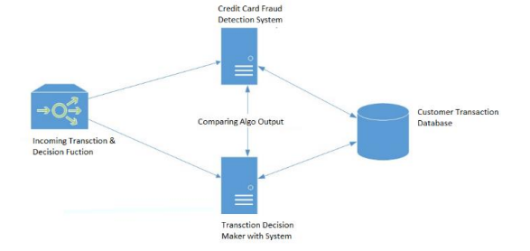

When looked at in detail on a larger scale along with real life elements, the full architecture diagram can be represented as follows:

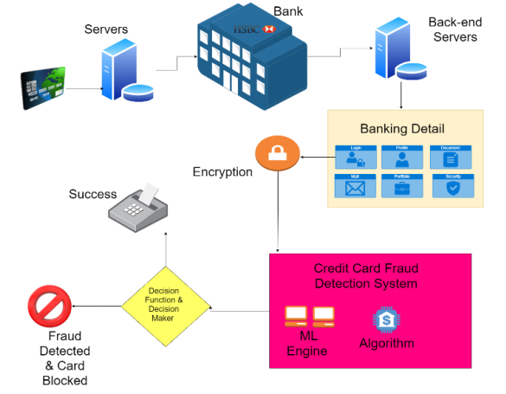

First of all, we obtained our dataset from Kaggle, a data analysis website which provides datasets. Inside this dataset, there are 31 columns out of which 28 are named as v1-v28 to protect sensitive data. The other columns represent Time, Amount and Class. Time shows the time gap between the first transaction and the following one. Amount is the amount of money transacted. Class 0 represents a valid transaction and 1 represents a fraudulent one.