REPORT: INT00065 [ATHENA] + [Product & Process development] + [Specifications] + [Specifications Overview]

Hi Botond / Shailender,

Botond is already aware of it, but I finally managed to really solve this issue with the Athena report: “Specifications overview”.

This report is using templates to define what data needs to be shown in the report. The problem was in these templates.

These templates can be created, by the end-user themselves, in Interspec.

For instance, the template used by Botond: “D-spec and General” is maintained in Interspec as specification: “Mask_PCR_INT00065” with description: “D-spec and General”.

Such a mask is created with the same frame as the specifications you want to show in the report. In this case: A_PCR frame.

**The problem was that the frame revision of the A_PCR frame was completely out of sync with the frame revision used by the template (mask).**

**Just updating the template to the latest frame revision was sufficient to get the report working again.**

**Once you know it, it is logical and easy.**

**Root cause/solution: template “specifications” need to be kept in sync with their “parent” frame’s revision.**

Regards,

Patrick

**Patrick Goossens**   
Project Manager

**From:** Botond Tar <[botond.tar@Apollotyres.com](mailto:botond.tar@Apollotyres.com)>   
**Sent:** Wednesday, September 6, 2023 15:43  
**To:** Patrick Goossens <[patrick.goossens@apollotyres.com](mailto:patrick.goossens@apollotyres.com)>  
**Cc:** Mahavir Annadate <[Mahavir.Annadate@Apollotyres.com](mailto:Mahavir.Annadate@Apollotyres.com)>; Péter Lőrincz <[Peter.Lorincz@apollotyres.com](mailto:Peter.Lorincz@apollotyres.com)>; Rashid Saadat <[rashid.saadat@Apollotyres.com](mailto:rashid.saadat@Apollotyres.com)>; Manish Kumar <[manish.kumar02@Apollotyres.com](mailto:manish.kumar02@Apollotyres.com)>; Kitti Tóth <[Kitti.Toth@apollotyres.com](mailto:Kitti.Toth@apollotyres.com)>; Róbert Marczis <[Robert.Marczis@apollotyres.com](mailto:Robert.Marczis@apollotyres.com)>  
**Subject:** I2309-1092 - Athena issue

Dear Mr. Goossens,

I’ve raised a ticket about Athena Specifications overview issue.

Ticket Nr.: [I2309-1092](https://ind01.safelinks.protection.outlook.com/?url=https%3A%2F%2Fsupport.apollotyres.com%2Ftas%2Fpublic%2Fssp%2Fcontent%2Fdetail%2Fincident%3Funid%3D28698adbf75543bab2b6855d100aebf5&data=05%7C01%7Cpeter.schepens%40apollotyres.com%7Cbb90691e93c24b00489a08dbe5d8a3b6%7Cf792002939f941b79c94ec73395d184d%7C0%7C0%7C638356490857410473%7CUnknown%7CTWFpbGZsb3d8eyJWIjoiMC4wLjAwMDAiLCJQIjoiV2luMzIiLCJBTiI6Ik1haWwiLCJXVCI6Mn0%3D%7C3000%7C%7C%7C&sdata=KfcdgALB1AdV%2B7mK5p8etpD81oVBup7WhgZwNoBdqEs%3D&reserved=0)

After downloading Spec. overview – D-spec and General Template excel file:

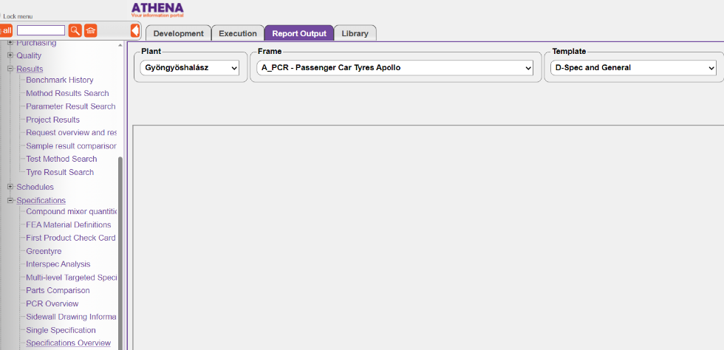

The file does not contain columns after “D” column “Bill of Materials”:

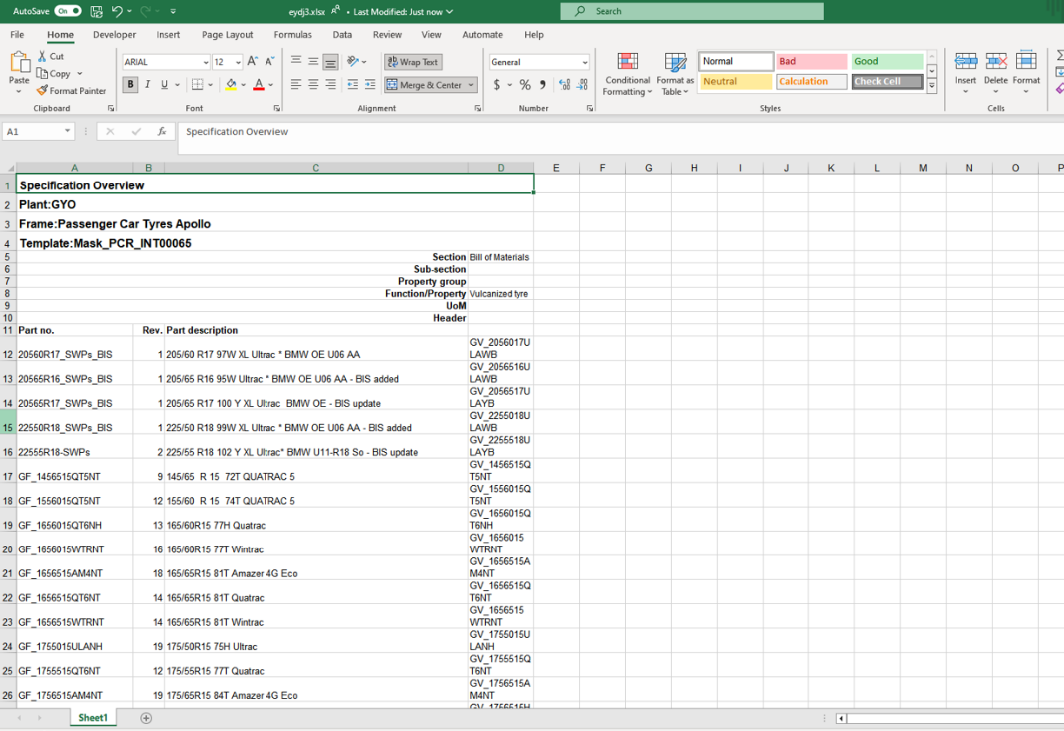

Comparing the overview file which was downloaded in August:

Could you please support us with high this priority issue?

We need it for New Product Industrialization calculations and other critical purposes (for e.g. comparing specs).

We’d much appreciate your help.

**Kind Regards,  
Botond Tar**  
Apollo Tyres (Hungary) Kft., H-3212 Gyöngyöshalász, Apollo Road 106.  
+36-20-317-3325  
Email ID  [botond.tar@apollotyres.com](mailto:botond.tar@apollotyres.com)