TARGETED-SPECIFICATION

[Product&Process Development] + [Specifications] + [Targeted Specifications]

XGG_BF66A17J1

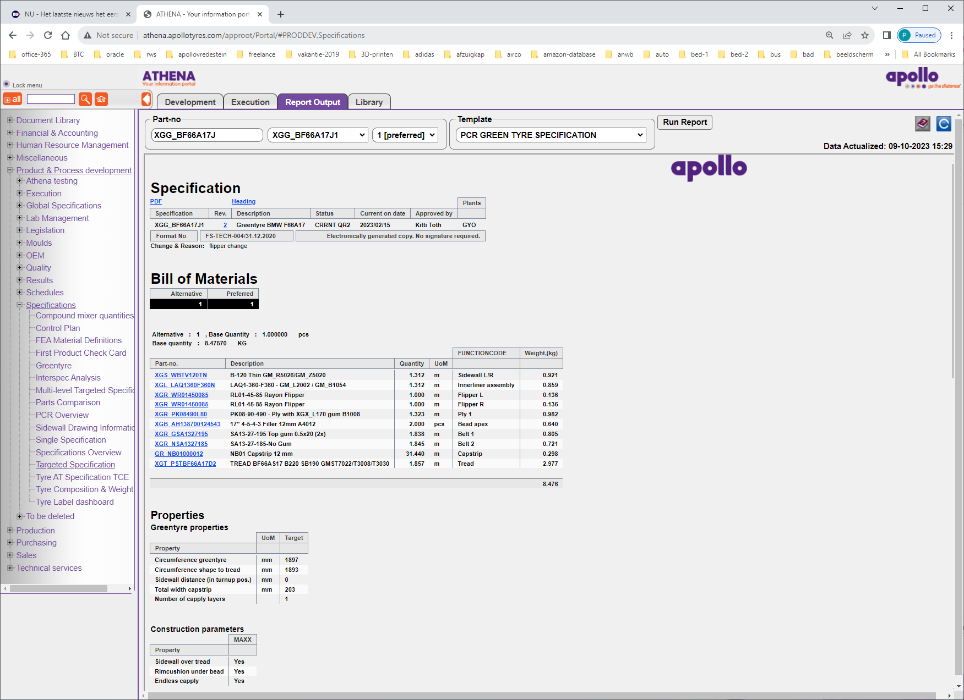

Hier zien we in de BOM wel de XGR_WR014500085 Flipper-R/L terug !!! Dit in tegenstelling to REPORT=MultiLevel-Targeted-Specification.

INT00039R_targetedSpecification

Part-no: GM_ST706003

Deze lukt met dit REPORT wel, met de Multi-Level niet !!!.

Hoe ziet query er in WEBFOCUS uit?

**Edit Procedure as Text: interspec/int00039r_targetedspecification**

INCLUDE INT00035R1_Sections

Open de INT00035R1:

-INCLUDE INT00035P10_header

-INCLUDE INT00035P13_BoM

-INCLUDE INT00035P11_property_group

-INCLUDE INT00035P14_single_property

-INCLUDE INT00035P16_object