Log in op MANAGEMENT-CONSOLE

https://ap-south-1.console.aws.amazon.com/console/home?region=ap-south-1

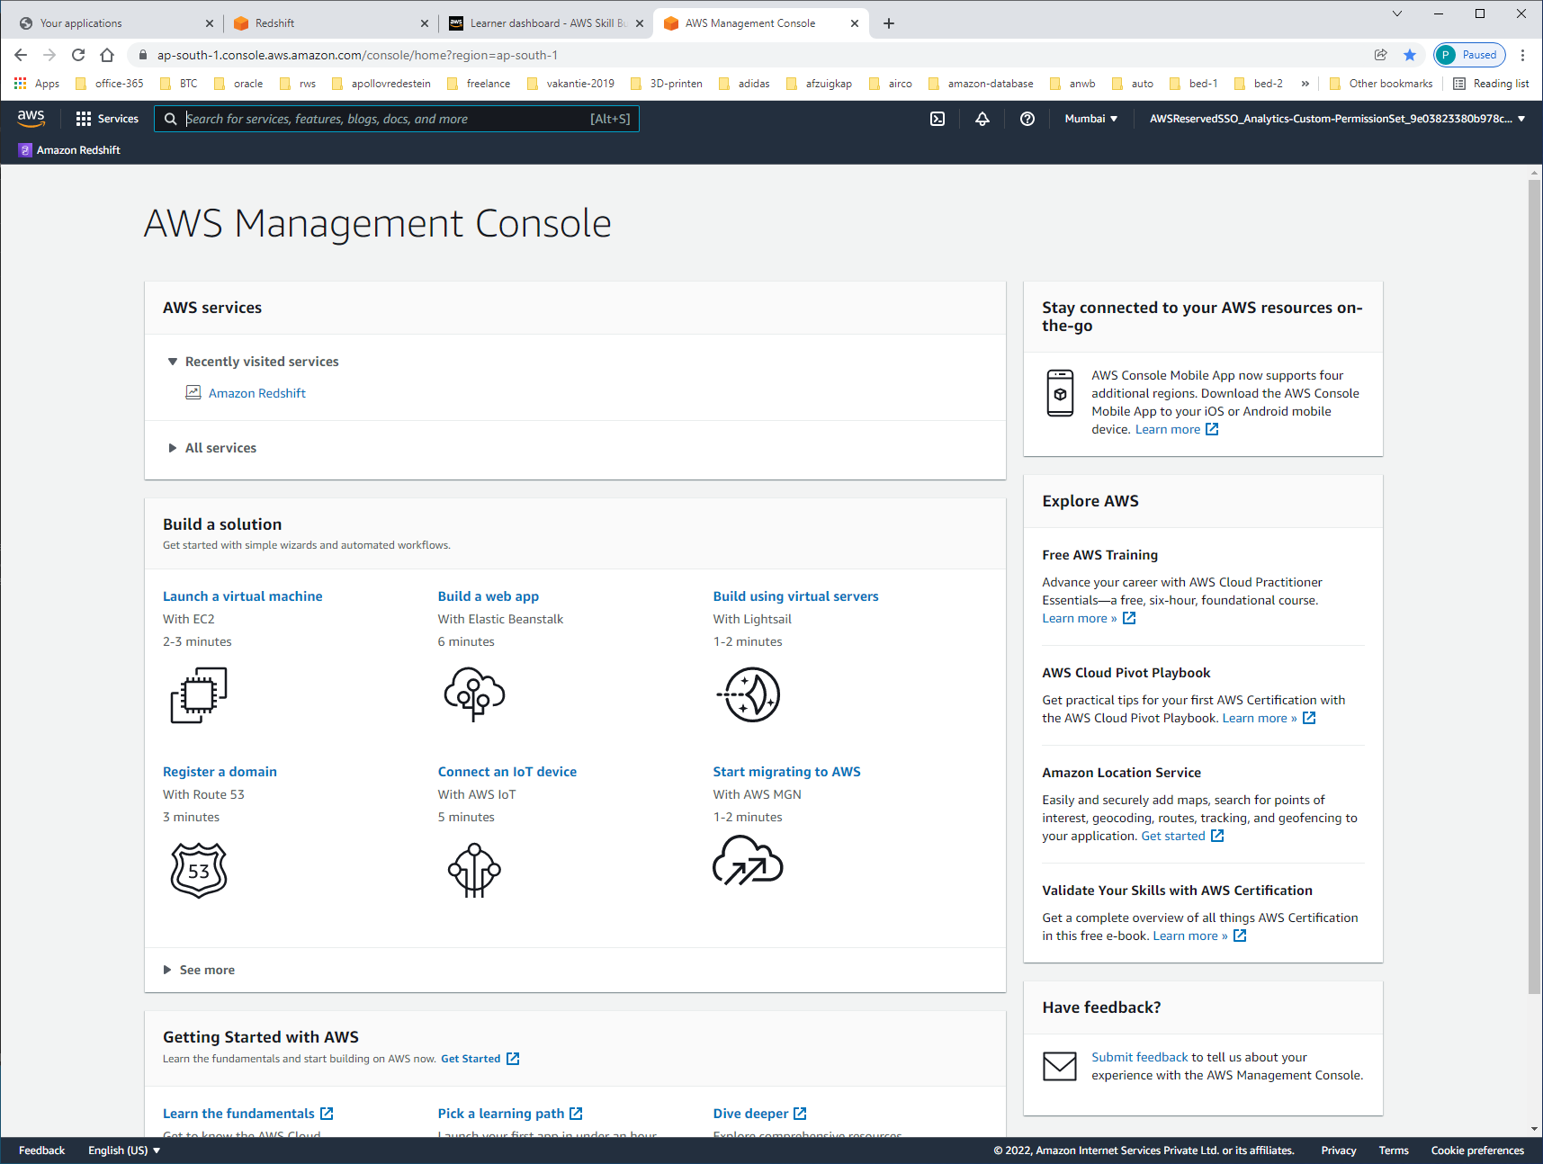

Klik rechts [free learning] aan

**LET OP: MET MIJN APOLLO-ACCOUNT KOM IK NIET IN HET LEARNING-CENTRE.**

**ECHTER MET MIJN AMAZON SD4S-ACCOUNT WEL !!!! KIES HIERVOOR LOG-IN MET AMAZON-ACCOUNT !!!**

https://explore.skillbuilder.aws/learn/course/134/AWS%2520Cloud%2520Practitioner%2520Essentials

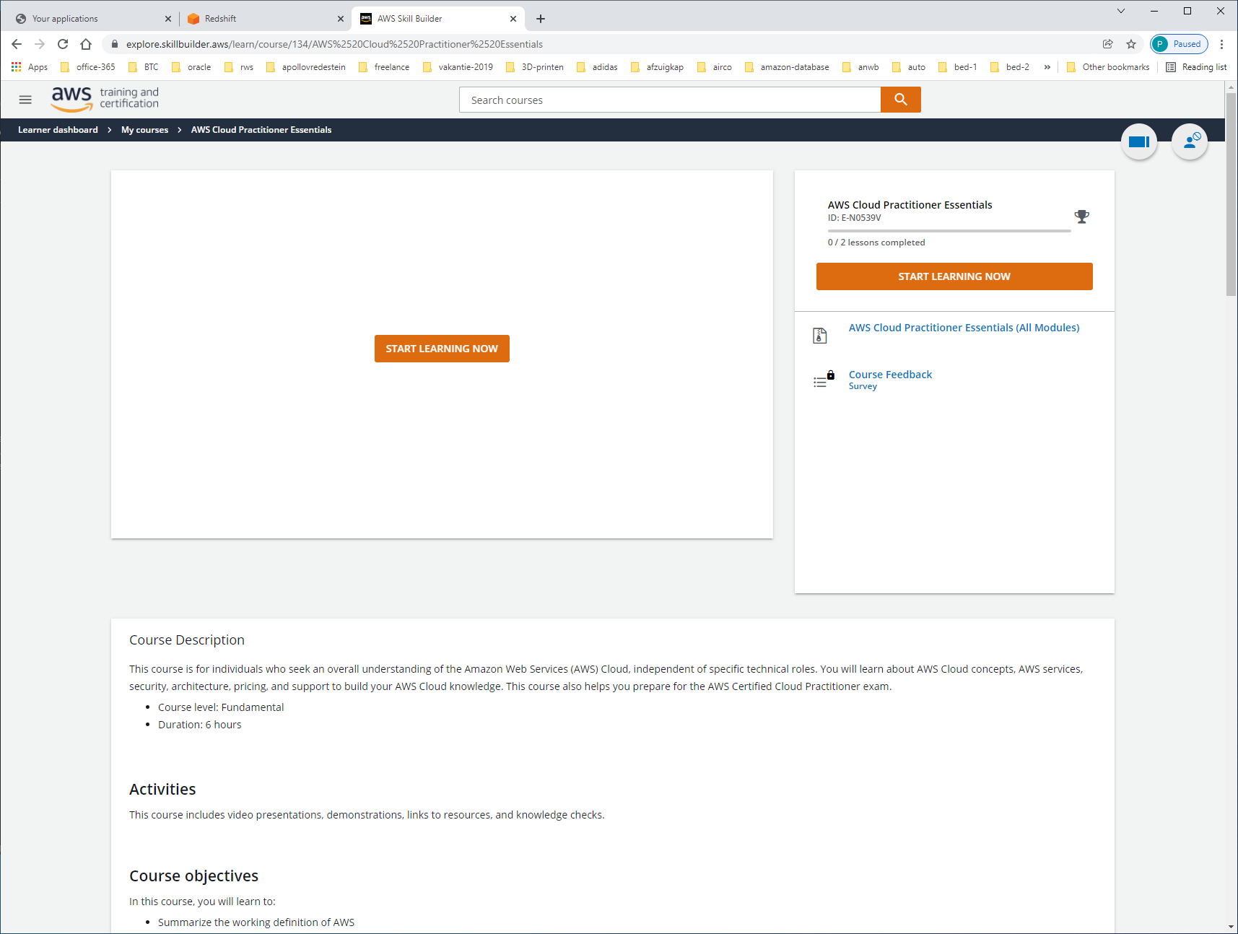

<https://explore.skillbuilder.aws/pages/16/learner-dashboard>

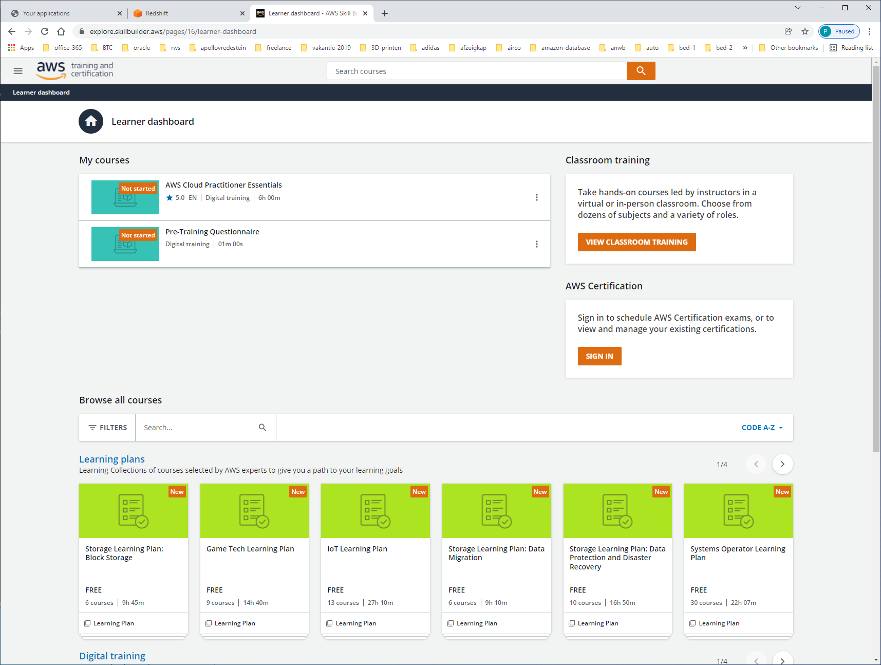

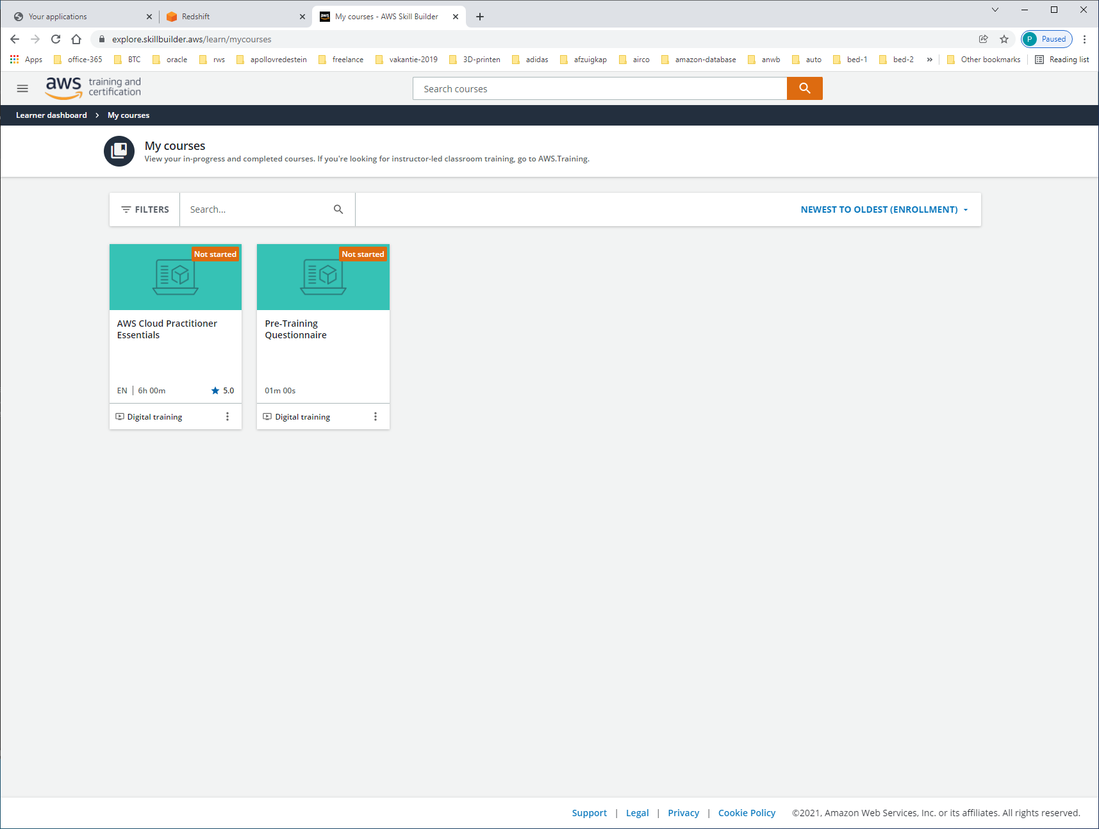

START COURSE

https://explore.skillbuilder.aws/learn/course/134/play/31418/aws-cloud-practitioner-essentials-all-modules

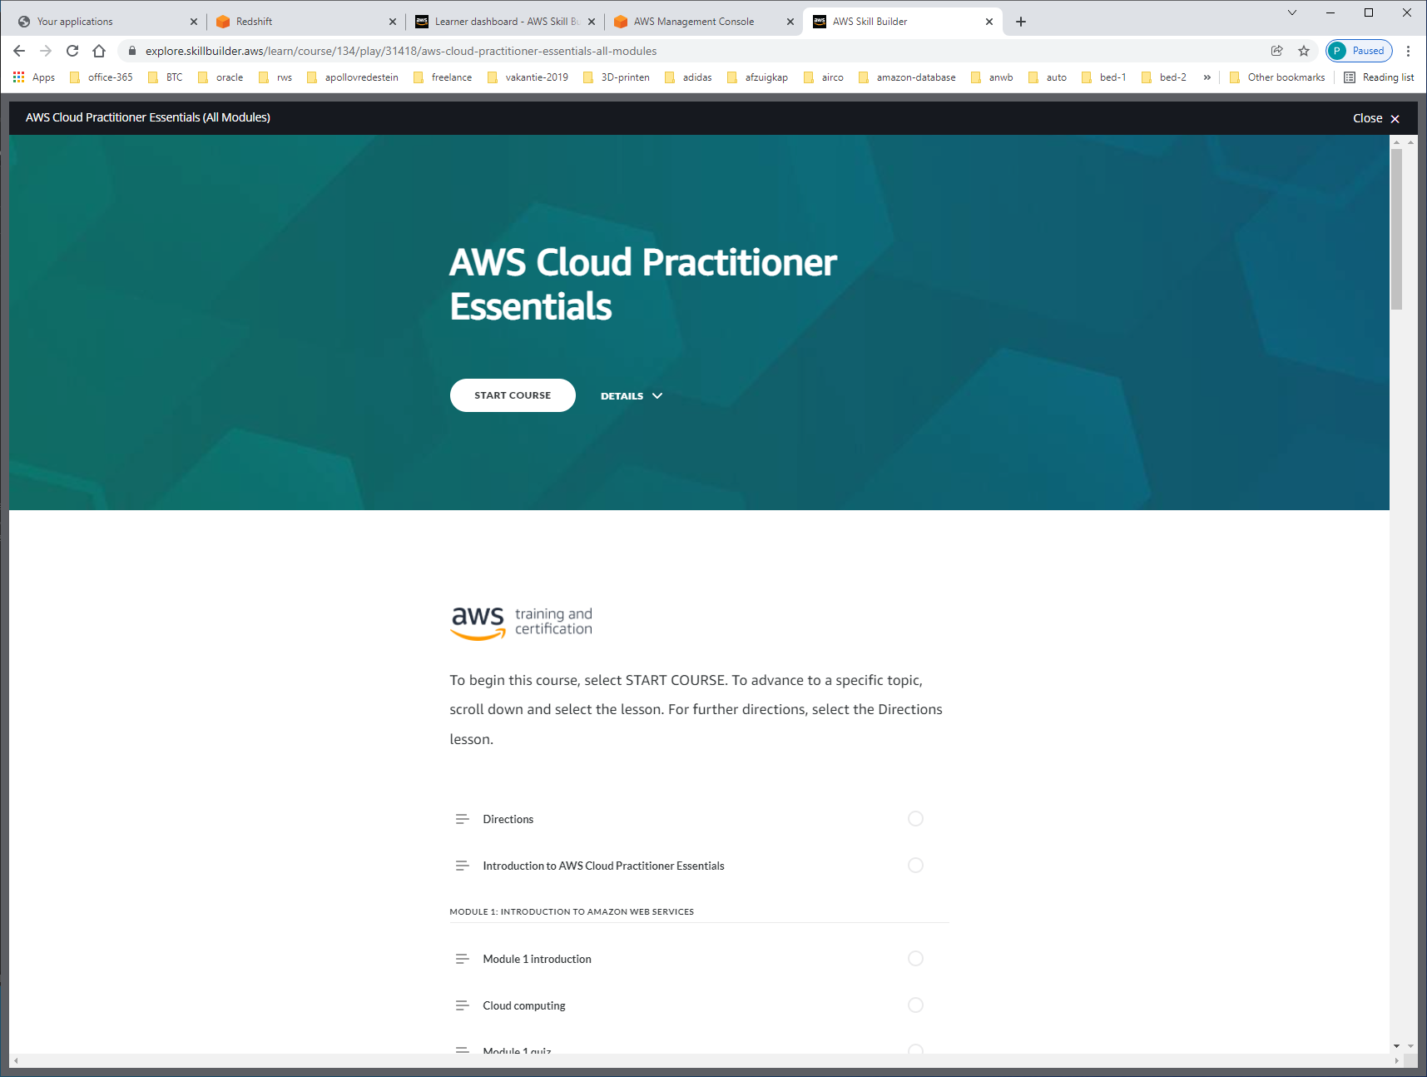

START COURSE

