Install SQL-WORKBENCH

Create directory C:\temp\SQL-Workbench

Save zip-files to C:\temp\SQL-Workbench "Workbench-Build127-with-optional-libs.zip"  
 "redshift-jdbc42-2.0.0.4.zip"

First, Unzip file "Workbench-Build127-with-optional-libs.zip" into directory C:\temp\SQL-Workbench

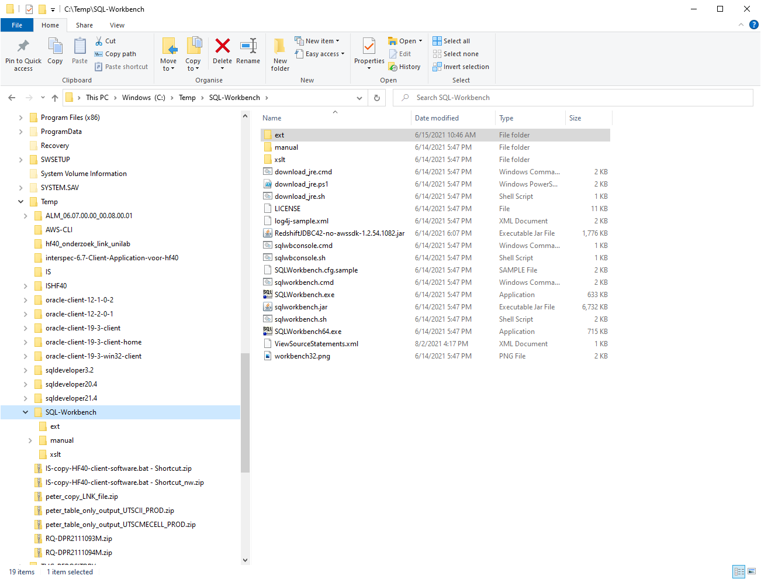

Next, Unzip file "redshift-jdbc42-2.0.0.4.zip" into directory C:\temp\SQL-Workbench\ext

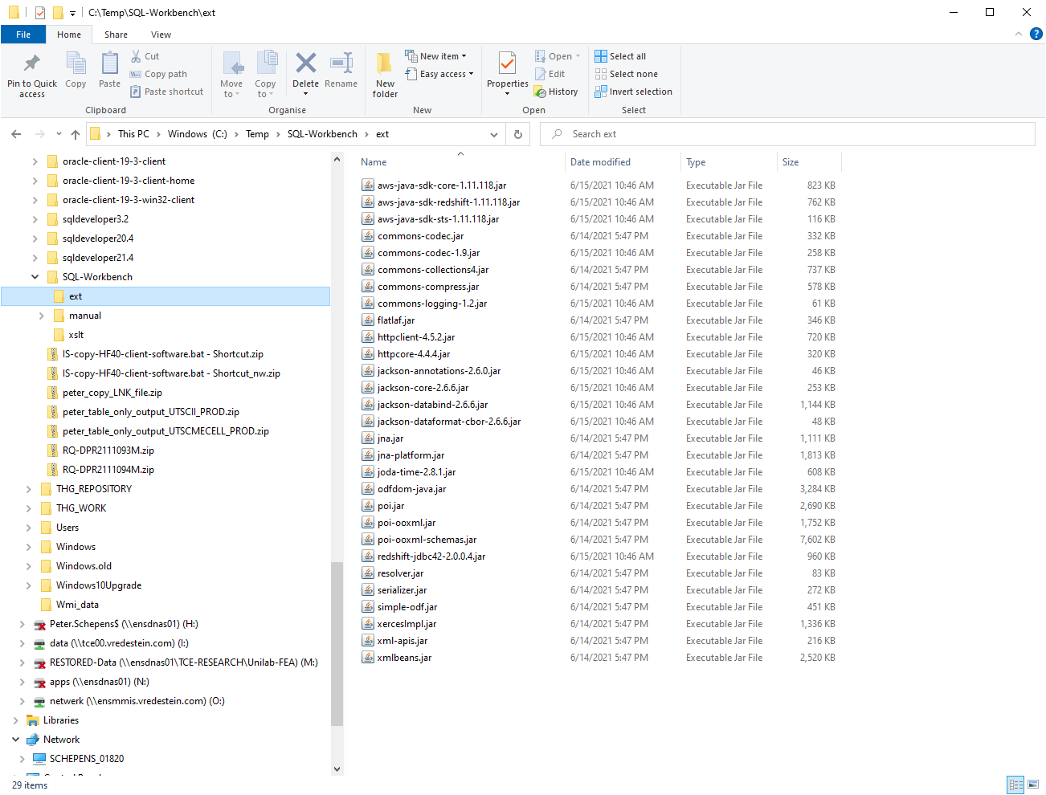

Done !

Start SQL-WORKBENCH

RUN/double-click: C:\Temp\SQL-Workbench\SQLWorkbench64.exe

Make a connection with REDSHIFT-CLUSTER AWS-CLOUD.

Enter

For the correct driver choose [Amazon Redshift (com.amazon.redshift.driver)  
If this option doesn't exists then to to [MANAGE DRIVERS] on the left bottom first to create the driver)  
(It is also possible from the Main-menu [FILE] and then to [MANAGE-DRIVERS] )

Create/install the Amazon-Redshift driver as follows:

jdbc:redshift://redshift-cluster-rna.csvpwdknrhzd.ap-south-1.redshift.amazonaws.com:5439/db_dev_lims

(new: jdbc:redshift://redshift-cluster-rna.csvpwdknrhzd.ap-south-1.redshift.amazonaws.com:5439/db_dev_lims)

After creating the Amazon-Redshift-driver return to the CONNECTION-PROFILE-window and select the new driver for this connection.

**CLASSNAME = com.amazon.redshift.Driver**

Fill in the following attributes for this connection:

URL: jdbc:redshift://redshift-cluster-rna.csvpwdknrhzd.ap-south-1.redshift.amazonaws.com:5439/db_dev_lims  
UN: lims_dev_user  
PW: a1dFR09mn!6lk (check item [save password] to store password for future use)

Leave rest of connection-attributes empty.

And press the [TEST] button to test the connection.

If OK, then click on [OK]-button to make the connection to this database.

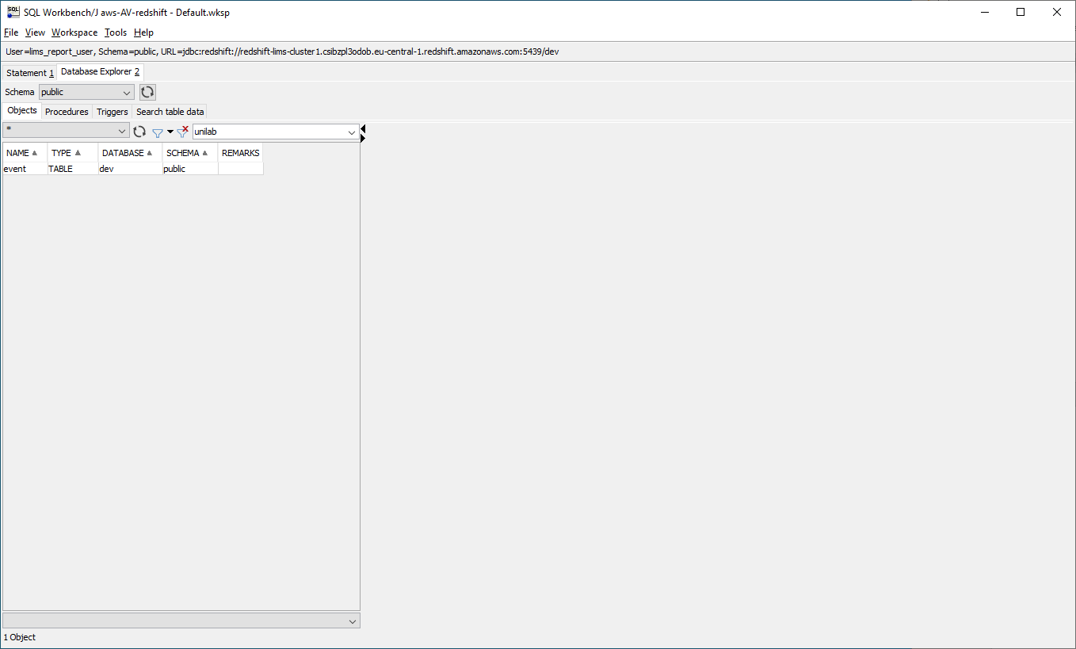

Default you are in the schema=public.

On the left site you can choose a specific schema, [sc_interspec_ens] or [sc_unilab_ens]

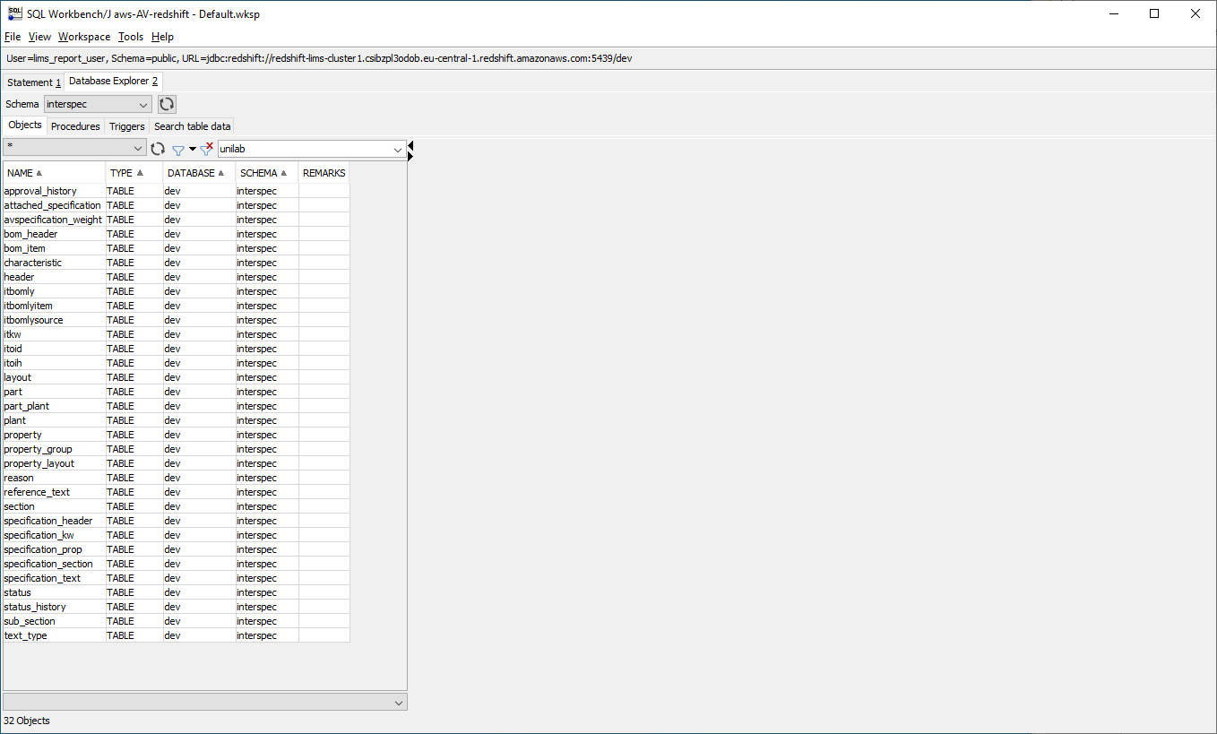

Here you see a list of redshift-tables within the schema.