Time-Interval i tried to login: 15:00 hr till 16:10 hr.

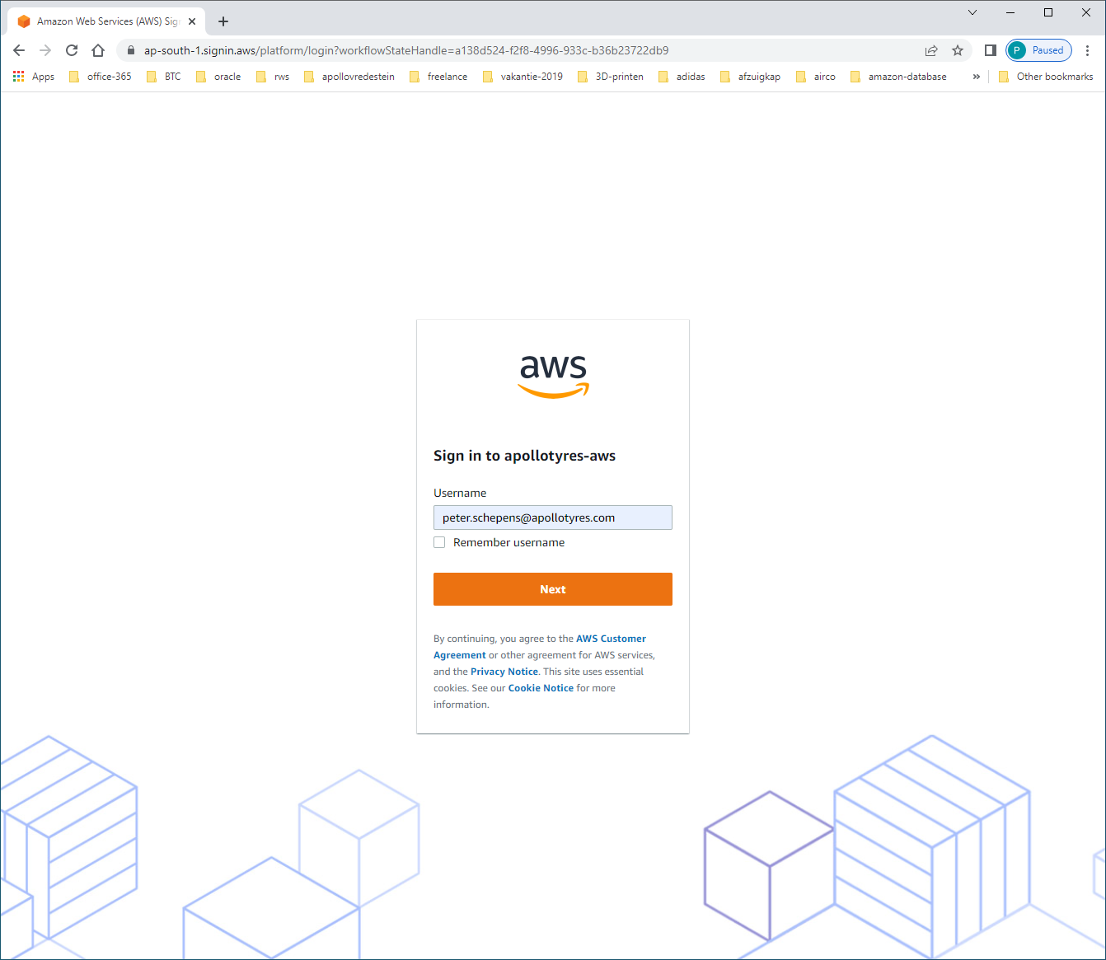

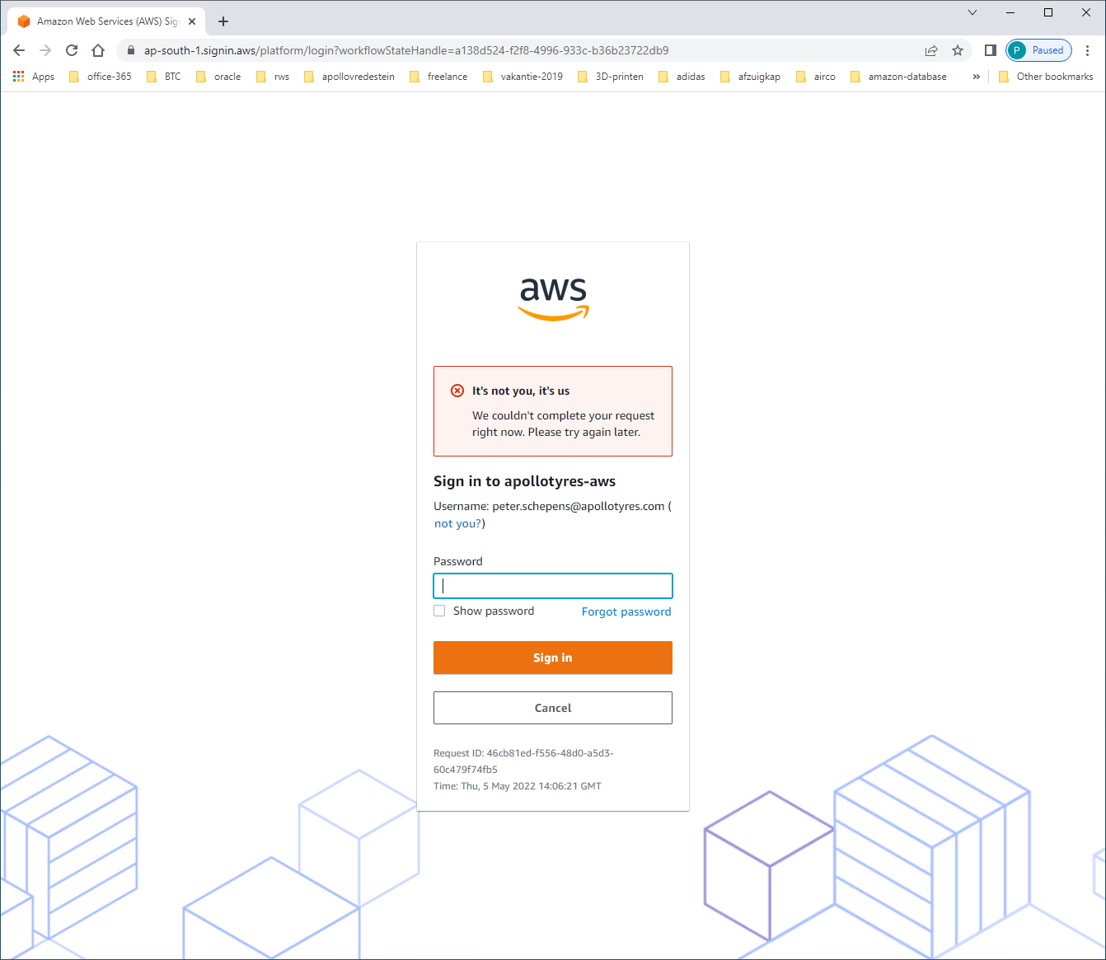

Last week, i changed my password on ApolloNetwork. Is that related to this issue?