AWS-INFRA LIMS CONTACT

AWS-Cloud - ACCOUNT

AWS-REGION **A (**AsianPacific MUMBAI (AP-SOUTH-1 **)**

AWS-VPC-A2

AWS-REGION B (AsianPacific MUMBAI (AP-SOUTH-1)

AWS-VPC-B1

AWS-VPC-B1

AWS-VPC-A1

Availability-Zone A ….

Availability-Zone: B…....

INTERNET  


VPC-2

PRIVATE-SUBNET A2A-DATABASE

PUBLIC-SUBNET-A1A

vpc-1

IGW: INTERNET-GATEWAY

igw-1

NGW=NATGateWay

**MAIN**-ROUTE-TABLE

rtb-

10.0.0.0/24

**DESTINATION TARGET**

**MAIN**-NETWORK-ACL

SECURITY-GROUPS

SECURITY-GROUPS-RULES

sg-082f5ea7ae797221d-default

sgr-04d9258a8d6f437ca

ELATIC-FILE-STORAGE  


ORACLE-RDS (19C) PRIMARY  
Multi-AZ Deployment  


S3-BLOCK-storage  
SSD



PRIVATE-SUBNET-A2A-LOAD-BALANCER

LOAD-BALANCER  
PRIMARY

LOAD-BALANCER  
STANDBY

Availability-Zone C ….

PUBLIC-SUBNET B1A

END-USER  


VPN  


INTERNET

DirectConnect-GATEWAY  




VPC-PEERING  


VPC-PEERING  
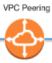

ORACLE-RDS (19C) STANDBY

S3-BLOCK-storage  
SSD



BYOL  
(enterprise edition tbv DG)

END-USER  


PRIVATE-SUBNET A2B-APPLICATIE

COMPUTE-INSTANCE  
EDGE-SERVICE

VPN  


ELATIC-FILE-STORAGE: LOCAL  


COMPUTE-INSTANCE  
APPLICATIESERVER-EDGE

DirectConnect-GATEWAY  


DirectConnect-GATEWAY  


ADMIN  


VPN  


PRIVATE-SUBNET: A2A-APPLICATIE

10.1.0.0/16

ROUTE-TABLE

rtb-X

**DESTINATION TARGET**

ACL-

COMPUTE-INSTANCE  
DCS-SERVER 3D RENDER

COMPUTE-INSTANCE  
FILE BLOB-STORAGE--SERVER

COMPUTE-INSTANCE  
APPLICATIESERVER

COMPUTE-INSTANCE  
ENTERPRISE SEARCH-SERVER

COMPUTE-INSTANCE  
FILE BLOB-STORAGE--SERVER

ROUTE-TABLE

rtb-X

**DESTINATION TARGET**

10.1.1.0/16

10.1.2.0/16

COMPUTE-INSTANCE  
DCS-SERVER 3D RENDER

COMPUTE-INSTANCE  
APPLICATIESERVER

COMPUTE-INSTANCE  
ENTERPRISE SEARCH-SERVER

-Current lantency between Mumbai and Europe is about 220ms, can be improved 50% (110ms) if using the global-aws-network instead of public internet.  
-LIMS-Application only reachable from the apollo-network. External-Developers will need a vpn-connection and apollo-network-account for this.

Contact-ARCHITECTUUR

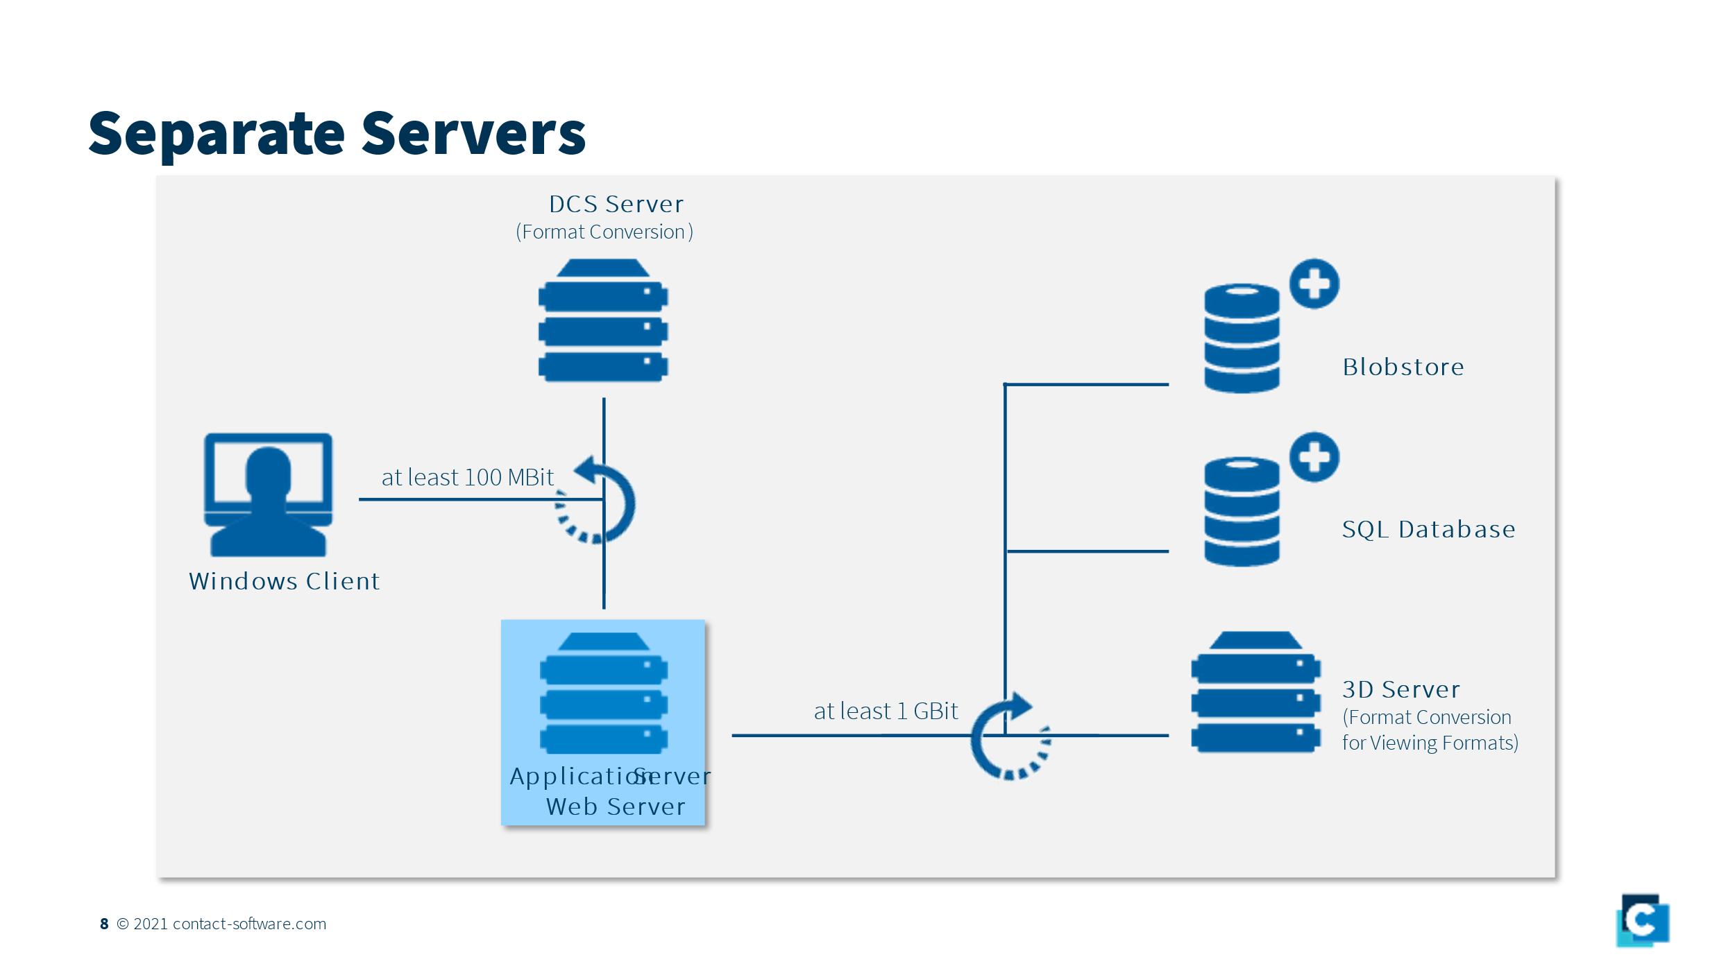 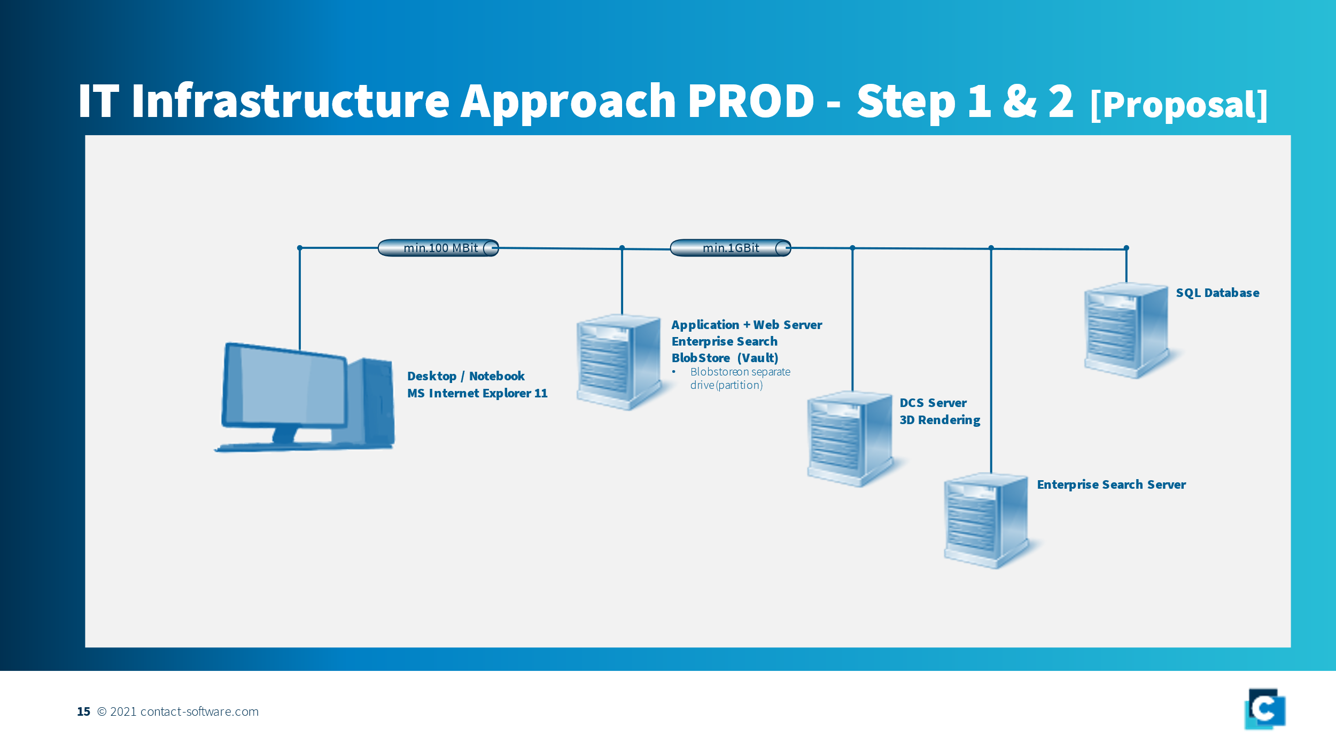

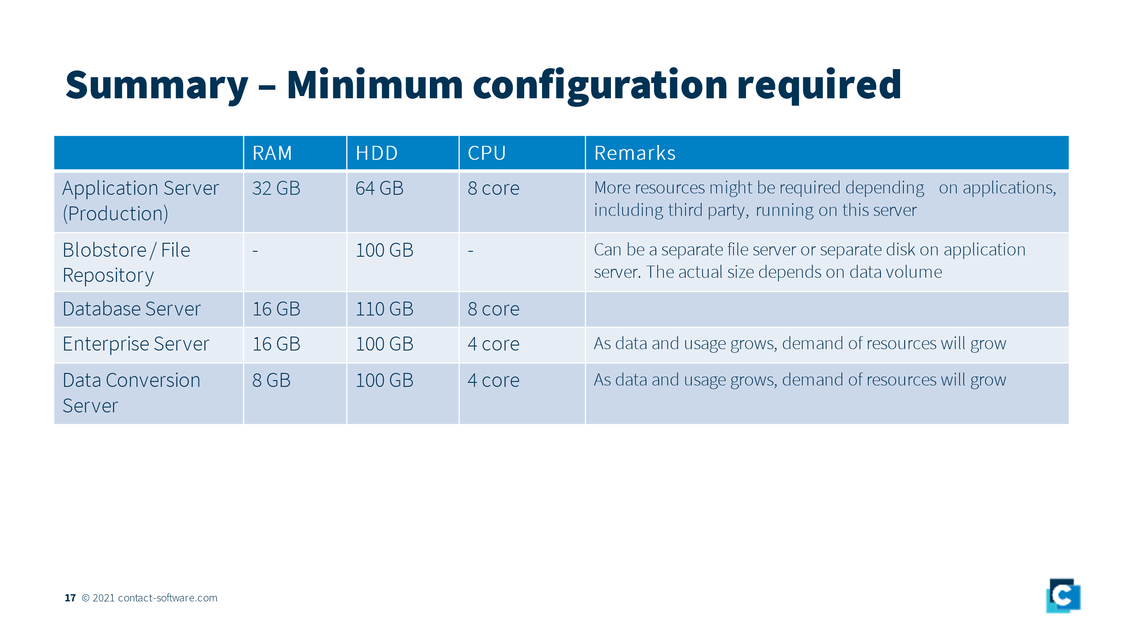 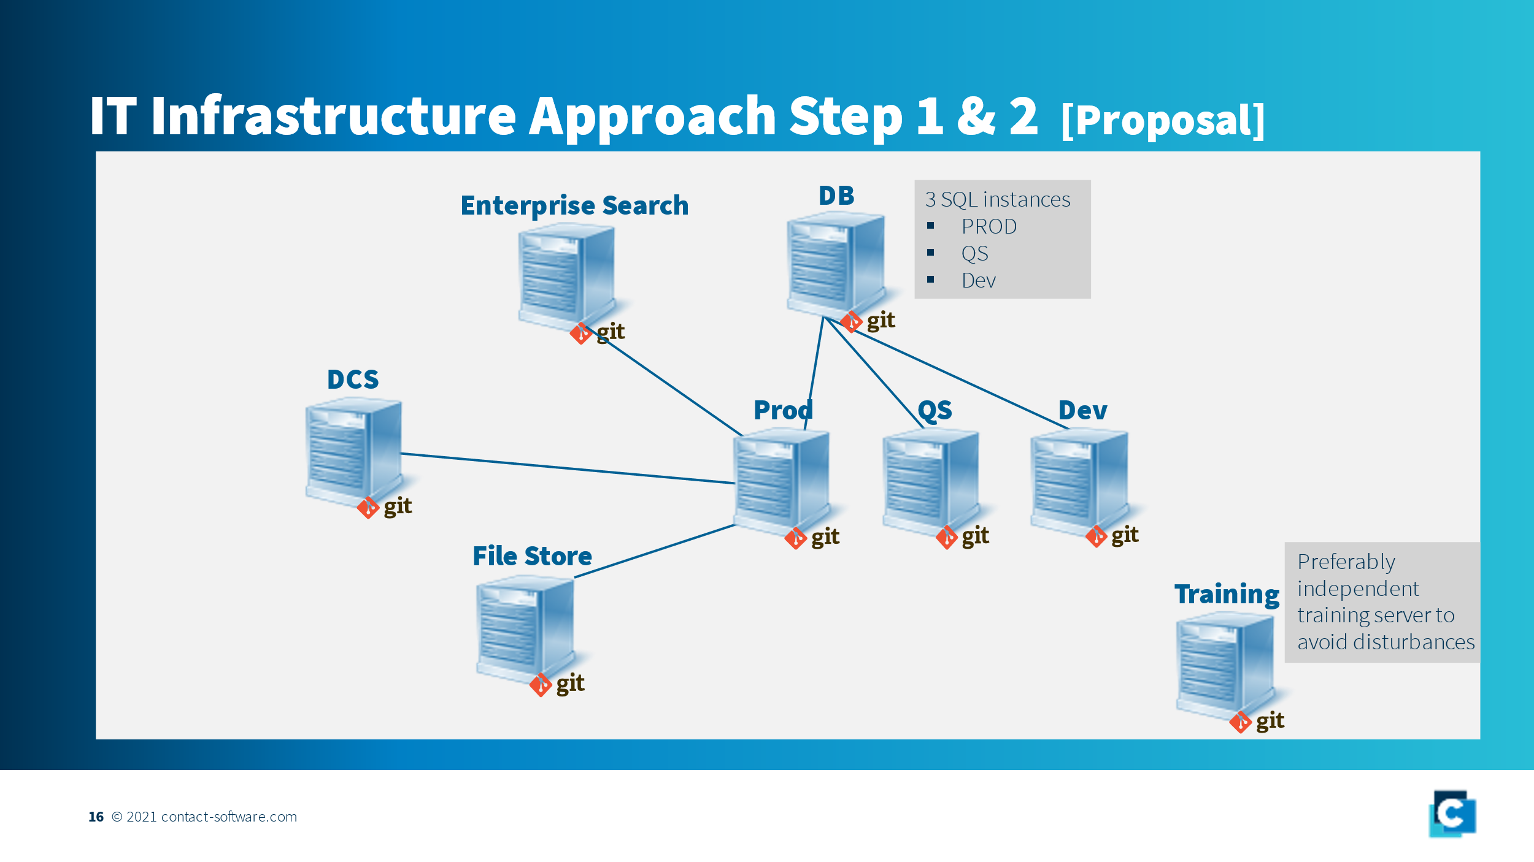

**Additional Questions Contact**

|  |  |
| --- | --- |
| **Questions / Comments from Apollo (24.02.2022)** | **Answers / Comments from CONTACT (28.02.2022)** |
| ***Is only the web/application-server necessary for making a connection for the end-users for all the functionality of LIMS? Or should they be able to reach other services/servers directly too? If so, what services are these, how are they calling these services?*** | Client/End-Users only connect to web/application server ("http daemon"). All other connections are taken care by the system internally. I will suggest to have a quick look into this documentation. Please check one of the subchapters to get an idea.  https://aloha.contact-software.com/docportal/15.5/en/admin/platform/arch-layout-variants |
| ***Is there an Open Internet-Connection necessary? If so for what reason/functionality?*** | There is no open internet connection necessary when its implemented on-primises. When implemented on "public" cloud then only client needs internet connectivity to connect to webserver. All the services in CONTACT Elements are routed through specific ports. These ports could be predefined based upon customer needs. In the link mentioned in first point, you will also find port related information for various services. |
| ***What kind of clients are connected to the Central-Site directly (as mentioned on page-3)?*** | Any user who has to access the functionality of CONTACT Elements. All the connections are directed through login page of CONTACT Elements. Obviously all the accesses are protected by various roles & rights. This enables the tight control on the data access.  Except system administrator, no one needs to access the machines/VMs physically. |
| *Are these only ADMIN-users or also regular users?* | see above |
| *What kind of tooling are they using connecting the Central-Site? What could be the reason to connect to the server directly?* | As mentioned above, connection to central site could be divided in two parts… '- Connection to physical machines -> This is only required by system / application admins - Connection to web/application server -> Since web/application server is hosted on central site, any user who needs the access of functionalities of CONTACT Elements, he needs to connect through HTTP(s) & login. Once user has successfully logged in all the interaction with other services (database, file repo etc) are managed by web server |
| ***How is the DCS working?*** | At higher level, different types of conversion services can be defined into the conversion server. These are responsible for data conversion from source format to target format. These services are running on the DCS server, whenever a file is uploaded by the user, based upon trigger conditions, a conversion job is created which is executed by the conversion server. Upon success of the conversion, the file converted file is attached as additional file with the original file. If any job fails, the information about it is stored in the job queue which could be monitored by admins anytime. In a nutshell, whenver a new entry/request is added in the conversion queue, the services picks the job->downloads the native format-> executes the conversion by calling right utility with its parameters ->stores/attaches the file along with the original file in the CONTACT Elements->cleans any conversion related cache from local disk space. Using CONTACT Elements conversion API's, custom conversion jobs can be created/writen. Please see following link about DCS -->  https://aloha.contact-software.com/docportal/15.5/en/admin/acs/ |
| *What kind of objects does it convert?* | It can convert any kind of data to other formats as long as conversion is possible & customer has licenses to convert those data into desired format. Based upon CONTACT technologies, customers can convert data from all the major CAD systems to neutral 2D or 3D formats. Conversion of MS-Office files are also possible to neutral formats along with conversion of JPG, TIFF etc. The conversions from CAD to other formats are available to customers when they are working with CAD and has specifically asked for data conversion because its a seperate module. The conversion of MS office files is default and supplied for Apollo also. as mentioned above, custom conversion could also be written as long as native application (generator of source file e.g. MS-Office) allows the conversion to other formats. |
| *Where Are the objects stored who has te be converted?* | Upon successful conversion, the converted files such as PDF are stored/attached back to original file. E.g. When a user saves a PPT file in CONTACT Elements and conversion is successful, user will see two files (PPT + PDF). Hence ultimately this file is also stored in the file repository. |
| *How are these objects retrieved, directly by a client-user or via an API of the application-server?* | Normally user can access it via usual client. No specific routine/service is required for the access. Obviously the access to generated files can be blocked by defining roles & rights in the CONTACT Elements |
| *Are the converted-objects somewhere stored/persisted again, or only temporarily for replying to the client-end-user?* | They are persitently stored in the file repository (vault/Blob-sotre). These are always available with original file. These files are reconverted when the defined trigger is activated such as modification in original file or release of file in the system. |
| *How are these users authenticated calling this service?* | Users don’t need to call the conversion. Usually they are automatically triggered based upon specific event/trigger such as save of file, release of file. At the same time user can trigger the on-demand conversion too (using option from right mouse click) |
| *With what instances has the DCS-server a DIRECT interface? Only with the application-server or also a database or storage (file/object/block) ? If so to what instances?* | It needs to interact with DB to update the relationships with original file and other related metadata.  It also interacts with file repository (blobstore/vault) because files are saved there. However we don’t need to take care of these interactions as they are automatically done by the application server. Only one time configuration during system setup is required. |
| *has the instance specific requirements about the GPU-capacity for complex calculations/rendering, or only CPU/MEMORY?* | GPU requirements shall be met as per requirements of the source system (CAD, MS Office or any thing else) |
| ***How is the BLOB/File-Storage working?*** | On a higher level,  User logins to the system -> uploads the file to CONTACT Elements -> Upon click OK/Save button, the data is stored in the repository. During this time any conversion or other service requests are made also enteries in database are added/updated. Please see here for all the details..  https://aloha.contact-software.com/docportal/15.5/en/admin/platform/blobstore |
| *Is this some kind of content-management-system, include also functionality or only storage?* | This service in itlsef is not a content management system. Its repository of all the files stored by a user in CONTACT Elements. These files are stored on regular disk and are organized in folder structures which is created by CONTACT Elements automatically.  These files can not be accessed directly without usage of CONTACT Elements login page or some specific custom services written in the context of customer project using APIs.  **It is advised that no one should have access to these folders directly.** |
| *In what kind of AWS-storage should these BLOB/FILES being stored? Is this a regular File/Object/Block-storage?* | This is a regular File storage so you are free to choose type of storage. As of today, we are using EFS for our cloud deployment. |
| *With what instances has the FILE-STORAGE-server a DIRECT interface?  And how is this interface realized?* | The end user has indirect access to the blobstore through CONTACT Element's login page. Ideally no othe access should be granted to anyone including CONTACT Elements admin. The primary interfacing is with Application server for accesses & DCS server so that converted documents are stored in blob store. |
| *Shoud thIs FileStorage a separate-server/instance or is this part of the application on the application-server? On page 15 it is part of the AS, but on page* | It is always better to keep it separate than Application server (as shown in slide.-16). However it could be part of Application server with high disk capacity as shown in slide-15; may be a separate disk drive. With the blobstore high I/O should be of consideration. We have to keep in mind the easy disk backup mecanism too. |
| ***How is the ENTERPRISE-SEARCH-server working?*** | The Enterprise Search (ES) system enables you to search across types in CONTACT Elements. It indexes all the readable files including files inside a ZIP enabling faster search. There are text extraction services which are running on ES. Please see here for all the details... https://aloha.contact-software.com/docportal/15.5/en/admin/platform/enterprisesearch |
| *On which data Is this server searching? Is this On data in the database, or the blob/documents in the OBJECT-storage?* | all the readable files stored in the blob store plus metadata in the databases. |
| *Is there a proces running periodically to index these objects, and where are these indexes build/stored?* | Yes. There are text extraction and index services running in the background. This link gives some information about it.. https://aloha.contact-software.com/docportal/15.5/en/admin/platform/esearch-architecture |
| *With what instances has the ENTERPRISE-SEARCH-server a DIRECT interface?  And how is this interface realized?* | The interaction with various services is automatic. It does interact with applicaton server, blobstore & database server to be able to read, index the contents. All the requests of client/user are sent through application server |

Added 28-02-2022:

6)How and where does the development/deployment of the application takes place? It should be able to deploy it automatically on a new-instance.

7)If we want to implement a High-Available infrastructure with a LoadBalancer, and duplicate Application-Servers, which underlying servers (search, file, render) can be duplicated too, working on the same DB and same EFS?

(we can imagine that it can be problem if two search-index-jobs running the same time could be causing a problem in de indexing/db)

8)What data should you replicate to an EDGE-server in another REGION? Most of the users will have to add files to the EFS when rendering files to another format, and will have to query/mutatie the db-metadata too.

9)What is de relation/difference of the EDGE-SERVICE from CONTACT and an EDGE-location from AWS (for example: do we need CloudFront?)

REMARKS:

1)How are components being developed/deployed on AWS-servers from ApolloTyres? What does Contact need to do this in our AWS-CLOUD/VPC ?

2)Can we implement HIGH-AVAILABILITY or do we have to limit the architecture in advance of lower-costs?

3)We need our own ORACLE-BYOL

4)What do we need for monitoring/security? (Certificate-Manager, Guard Duty, Cloud Watch, etc)

5)What do we need for monitoring costs/budgets (Cost-Explorer/Budgets)?