Hi All,

I’ve given you access to Athena code. Please be careful to not to edit any file or save any changes.

URL: [WebFOCUS 81M Server on ENSFOCUSWF8 (apollotyres.com)](https://ind01.safelinks.protection.outlook.com/?url=http%3A%2F%2Fensfocuswf8.apollotyres.com%3A8121%2Fwc%2Fbcstart.html&data=05%7C01%7Cpeter.schepens%40apollotyres.com%7C10fe6844a88d4355a75408daaffab7ed%7Cf792002939f941b79c94ec73395d184d%7C0%7C0%7C638015788611712824%7CUnknown%7CTWFpbGZsb3d8eyJWIjoiMC4wLjAwMDAiLCJQIjoiV2luMzIiLCJBTiI6Ik1haWwiLCJXVCI6Mn0%3D%7C3000%7C%7C%7C&sdata=MyvhU5afLV5NuQR5%2FesS%2BrwNhTVDxi46A%2FYrcXTf%2BzQ%3D&reserved=0)

Login using your Windows credentials and choose “ATL LDAP” from “Security Provider” dropdown.

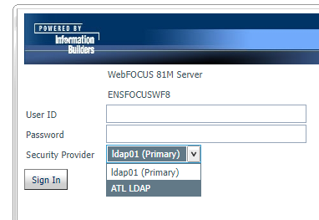

Expand Application directory to see code:

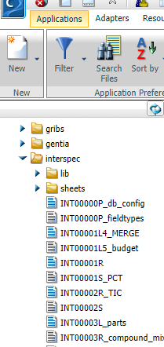

**Regards,**

**Shailender Gupta**

Head (CoE) - MDM, Reporting and Analytics

URL: [WebFOCUS 81M Server on ENSFOCUSWF8 (apollotyres.com)](https://ind01.safelinks.protection.outlook.com/?url=http%3A%2F%2Fensfocuswf8.apollotyres.com%3A8121%2Fwc%2Fbcstart.html&data=05%7C01%7Cpeter.schepens%40apollotyres.com%7C10fe6844a88d4355a75408daaffab7ed%7Cf792002939f941b79c94ec73395d184d%7C0%7C0%7C638015788611712824%7CUnknown%7CTWFpbGZsb3d8eyJWIjoiMC4wLjAwMDAiLCJQIjoiV2luMzIiLCJBTiI6Ik1haWwiLCJXVCI6Mn0%3D%7C3000%7C%7C%7C&sdata=MyvhU5afLV5NuQR5%2FesS%2BrwNhTVDxi46A%2FYrcXTf%2BzQ%3D&reserved=0)

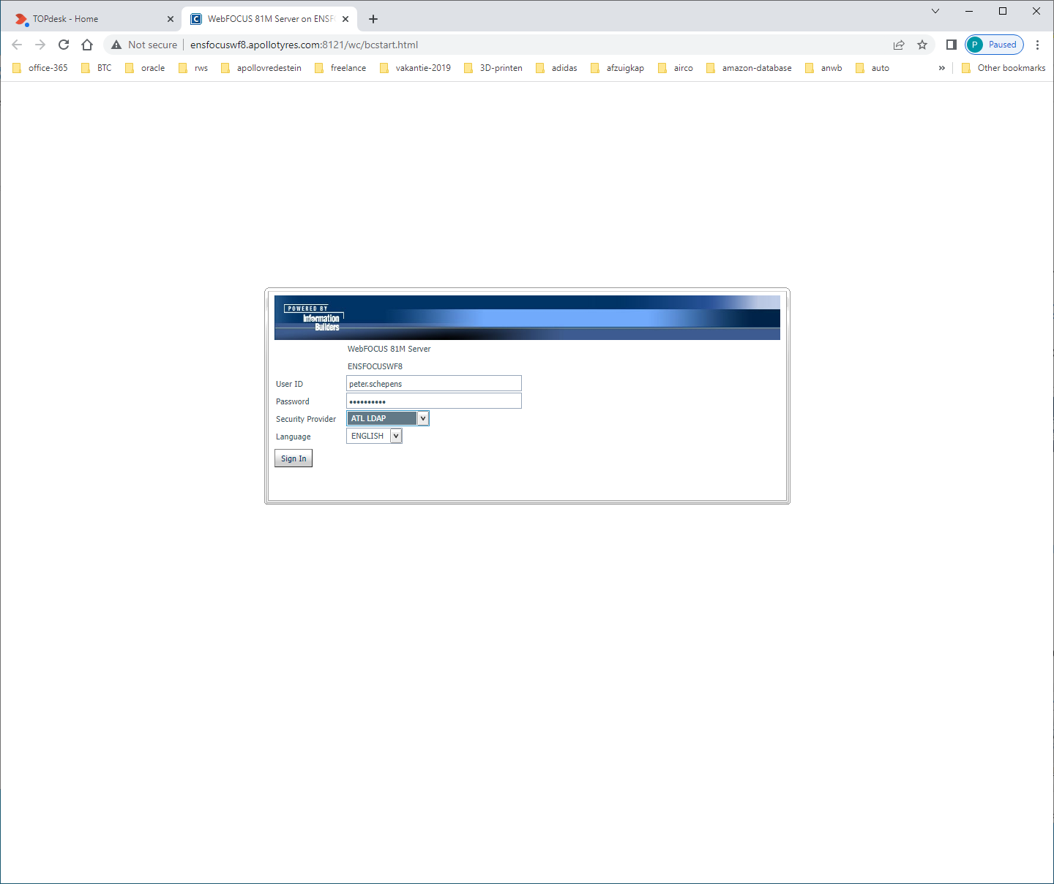

Log in met eigen Apollo-netwerk-credentials: peter.schepens  
 spat!al009  
En kies Security-provider = ATL LDAP

