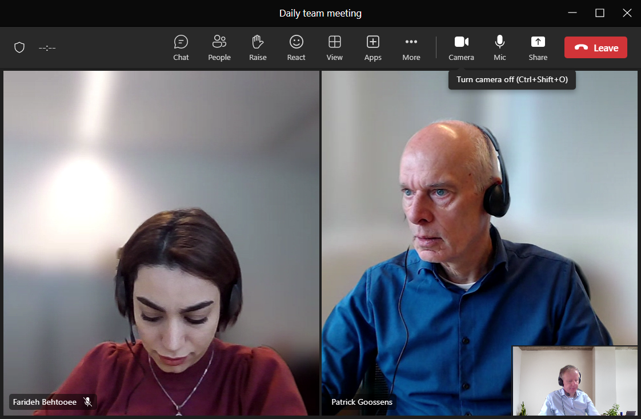

BUSINESS-APPLICATION-ANALIST