**https://www.ubackup.com/backup-restore/sync-network-folder-to-onedrive-6688.html**

**Case: How do I sync a folder to OneDrive?**

I am using OneDrive to store files but I cannot synchronize my network folder to OneDrive. I tried to sync the network folder to a local desktop, then, sync the network folder from the local desktop to OneDrive. This process is so cumbersome since I have to do it manually each time, and I have to repeat this operation daily or weekly. There must be a simpler way to sync network folder to OneDrive directly. I hope someone can help me! Thanks in advance!

[](https://www.ubackup.com/screenshot/en/others/backup-pc-to-onedrive/onedrive-logo.png)

**Why sync network folder to OneDrive automatically?**

In general, users would like to sync network folders to OneDrive (for business) for following reasons:

* Save your physical storage device space.
* Keep a copy of your files and folders to keep file safe.
* Share files with others easily with the built-in “Share” feature.
* Access files and folder on tablet and phone easily with Microsoft account.

**How to sync network folder to OneDrive**

OneDrive is a free online storage offered by Microsoft, which allows you to sync files between your computer and the cloud easily in Windows 7/8/10/11. It comes with Windows 11/10/8. For Windows 7 users, you have to download and install it. Sign up with a Microsoft account. When you sign in the OneDrive, you can choose to use it for personal or business (company or school).

After saying the basics, let's return to the topic, how to sync network folder to OneDrive. There are 2 ways to help you sync folder to OneDrive in Windows 7/8/10/11 directly.

* Create a symbolic link between network folder and OneDrive to sync folder using Command Prompt.
* Use a [free sync tool](https://www.ubackup.com/free-backup-software.html)-AOMEI Backupper Standard, which can help you sync folder between network and OneDrive easily. Also, it provides you more useful features, such as, [scheduled sync](https://www.ubackup.com/help/schedule-sync.html) like daily/weekly sync or real-time sync.

**Way 1. Sync network folder to OneDrive using Command Prompt**

Follow the steps below to add network folder to OneDrive using Command Prompt.

**1**. Install the OneDrive desktop application on your server and point it at a folder you can find easily, for example, C:\OneDrive (“OneDrive” is the folder name and this folder is on C drive).

**2**. Creating a subfolder in “OneDrive” called “Data” on C drive ( i.e C:\OneDrive\Data). The OneDrive desktop application will then sync this empty folder with the cloud.

**3**. Click **This PC/Computer** on your computer and click “**Map Network Drive**”, type the network path you would like to access, then, there will be a network drive on your computer with a drive letter.

[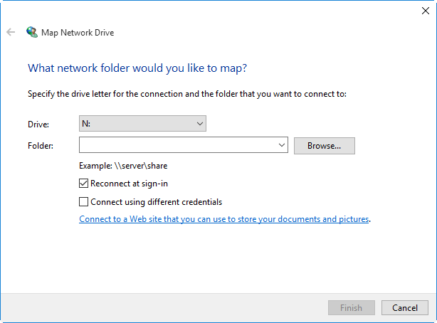](https://www.ubackup.com/screenshot/en/others/sync-folder-to-onedrive-cmd/map-network-drive.png)

**4**. Type **cmd** in the search box, click it and **run as administrator**. Type command below to create a symbolic link and press **Enter**. For example, I only wanted to sync the contents of N:\Data (Data is the folder name and N: is the drive letter of your network drive you map on your computer).

**mklink /D data E:\data**

[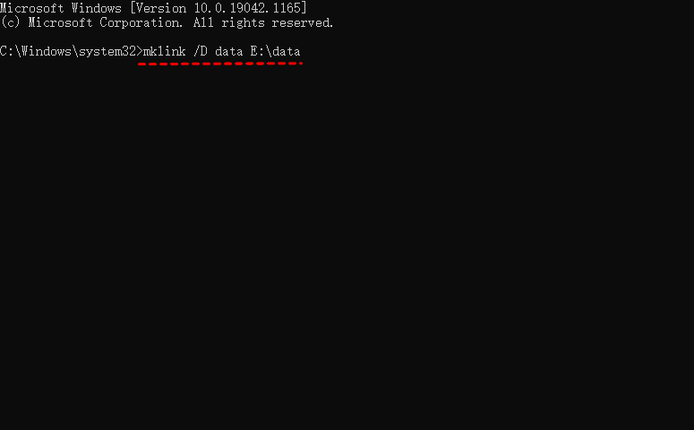](https://www.ubackup.com/screenshot/en/others/cmd/mklink.png)

This operation is actually creating a fake subfolder called C:\OneDrive\Data which actually points across the Network at N:\Data. When OneDrive syncs contents in C:\OneDrive\Data, it actually syncs the contents of N:\Data.

**Way 2. sync network folder to OneDrive with AOMEI Backupper**

AOMEI Backupper Standard is a free sync software for Windows 11/10/8/7. With its File Sync feature, you can sync network files and folders to OneDrive and other cloud drives like Dropbox, Google Drive and so on. Furthermore, this feature also allows you to [sync OneDrive to external hard drive](https://www.ubackup.com/synchronization/sync-onedrive-to-external-hard-drive-4348.html), USB flash drive, NAS, external hard drive, network, etc. In addition, you can set up “schedule sync” at daily, weekly, or monthly to automatically sync all files and folders to OneDrive.

Now, download AOMEI Backupper, install and launch it. Then, follow the steps below to sync network folder/drive to OneDrive. And it's still applicable to [sync network folder to Google Drive](https://www.ubackup.com/synchronization/sync-network-folder-to-google-drive.html) and Dropbox.

[**Download Freeware**Win 11/10/8.1/8/7/XP](https://www.ubackup.com/ss/download/adb/AOMEIBackupperStd.exe)

Secure Download

**1**. Click**Sync** and choose **Basic Sync**.

[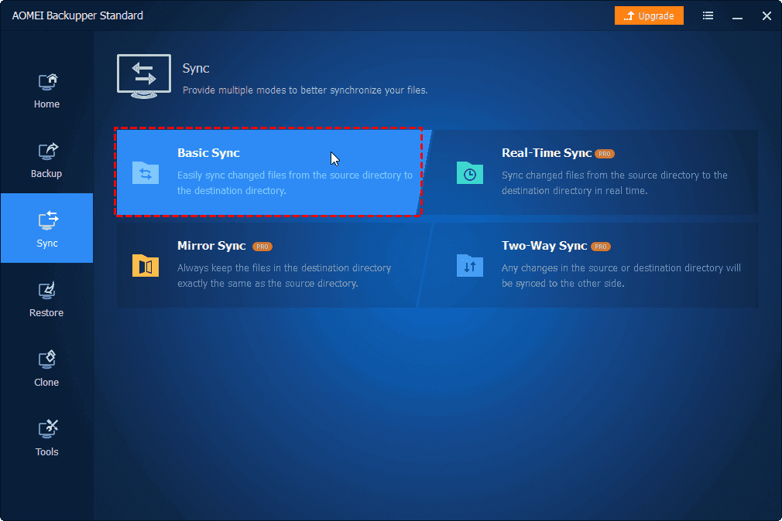](https://www.ubackup.com/screenshot/en/std/backup/file-sync/file-sync.png)

**2**. Click **Add Folder**>**Share/NAS**>**Add Network location** successively. Then, type display name, network path, and click**OK**to select the folder you need on network.

[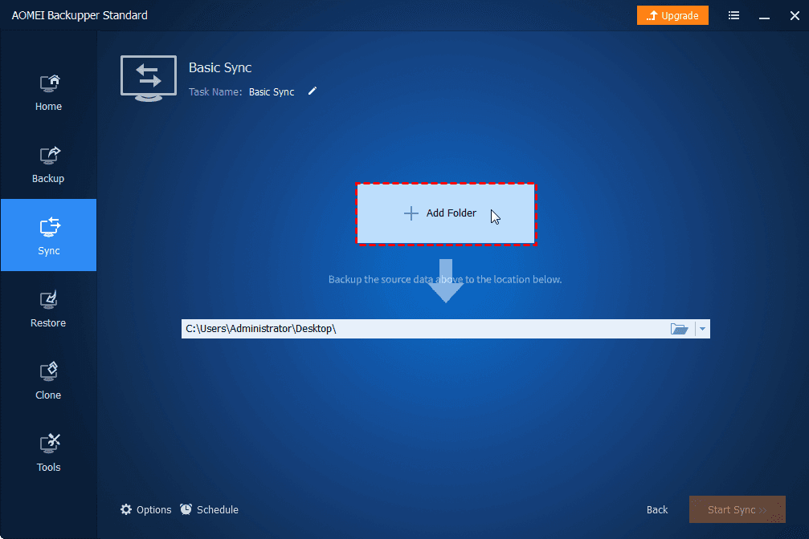](https://www.ubackup.com/screenshot/en/std/backup/file-sync/add-folder.png)

✎**Note:** You can click on the icon as shown below to open “Filter settings”. This feature allows you to select which file extension you want to keep and which you want to abandon.

[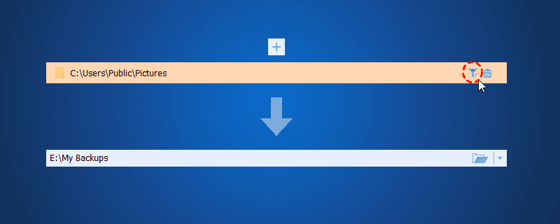](https://www.ubackup.com/screenshot/en/std/backup/file-sync/filter-settings.png)

[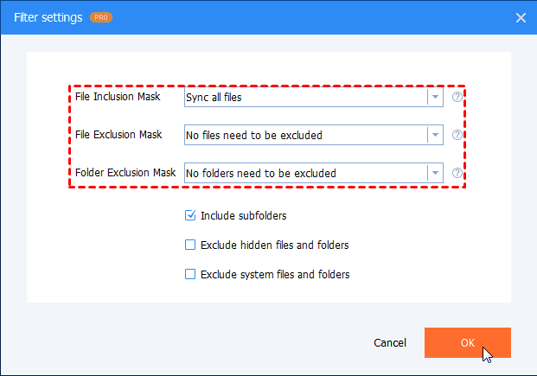](https://www.ubackup.com/screenshot/en/std/backup/file-sync/filter-settings.png)

**3**. Click the drop-down menu and choose **Select a cloud drive**, then choose OneDrive as the destination path.

[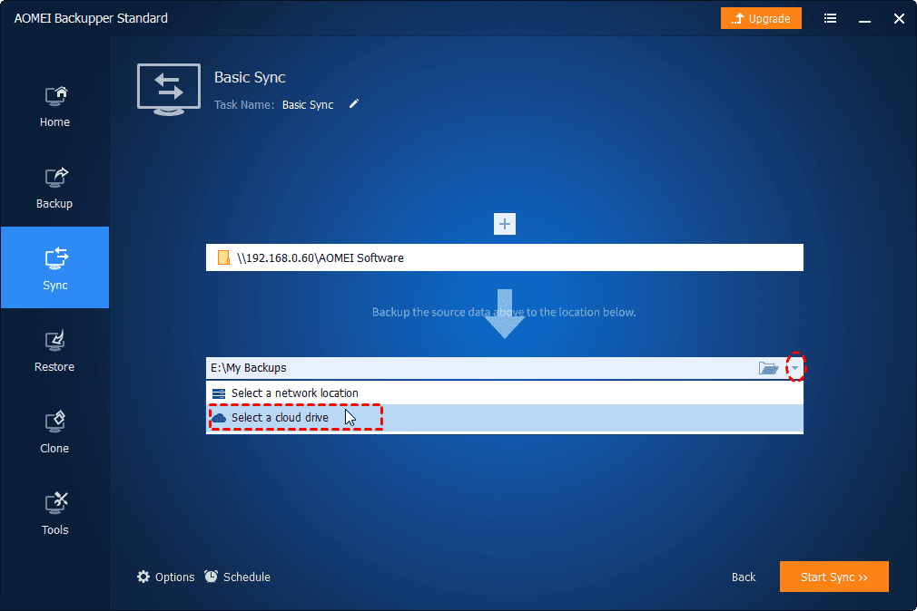](https://www.ubackup.com/screenshot/en/std/backup/file-sync/select-a-cloud-drive-2.png)

**4**. (**Optional**) You tick “Schedule” to sync files and folders in **Daily**/**Weekly**/**Monthly**, etc. automatically. Then, click **Start Sync**.

[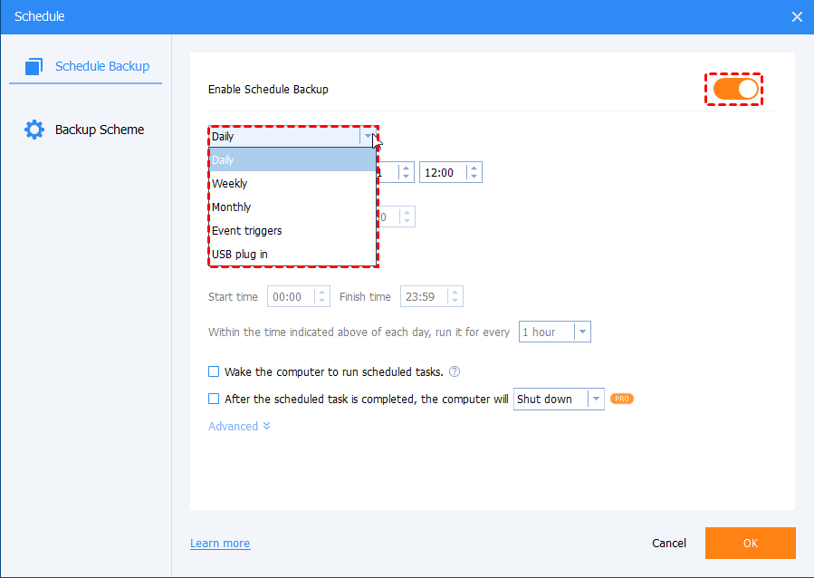](https://www.ubackup.com/screenshot/en/std/backup/schedule/schedule-settings-general.png)

✎**Note:** [Real-time sync](https://www.ubackup.com/features/real-time-file-sync.html) and Filter settings features are only available in [AOMEI Backupper Professional](https://www.ubackup.com/professional.html) edition, you can upgrade to enjoy it.

**★ How to backup files to AOMEI Cloud**

Apart from the cloud drives offered by third-party providers, you can also [backup files to AOMEI Cloud](https://www.ubackup.com/help/cloud-backup.html). It offers you 1TB free storage for 15 days after you sign up for an AOMEI account.

[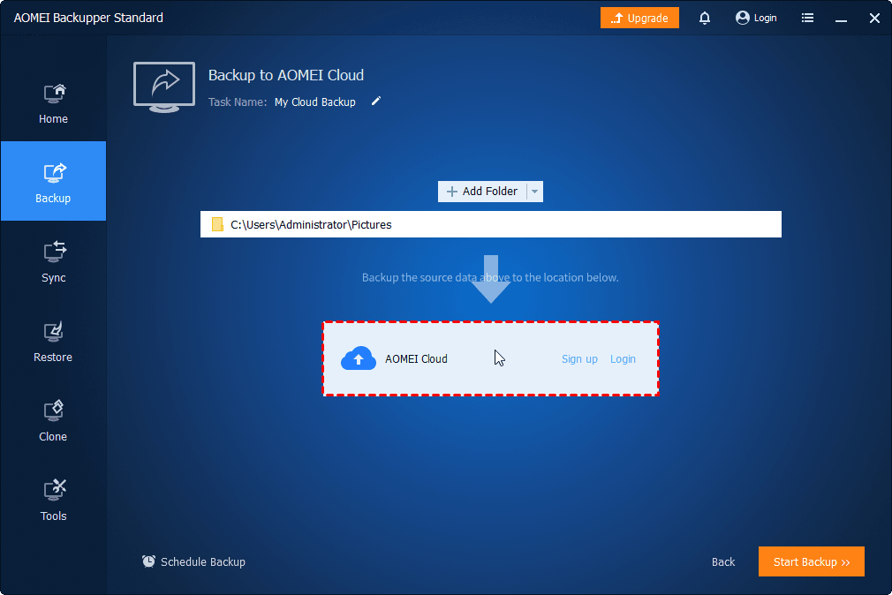](https://www.ubackup.com/screenshot/en/std/backup/cloud-backup/signup-or-login.png)

**Conclusion**

Actually, syncing network folder to OneDrive is really a good way to keep your data safe. And with the help of AOMEI Backupper, you can make syncing OneDrive with network drive much easier. With its useful features, you can set an automatic sync in daily/weekly/monthly or real-time mode. And these features can help you spare time and effort.