Save disk space with OneDrive Files On-Demand for Windows 10

*OneDrive for Business SharePoint Server Subscription Edition SharePoint Server 2019*[*More...*](javascript:)

**Productivity apps, 1 TB of OneDrive, and advanced security**

[Unlock now](https://www.microsoft.com/microsoft-365/try?ocid=oo_support_mix_marvel_ups_support_topbanner_onedrive_1000884)

OneDrive Files On-Demand helps you access all your [cloud storage](https://www.microsoft.com/microsoft-365/onedrive/online-cloud-storage?ocid=oo_support_mix_marvel_ups_support_smconedrive_inline_cloudstorage) in OneDrive without having to download all of them and use file storage space on your Windows device. This article is about Windows, but you can [use Files On-Demand on Mac](https://support.microsoft.com/en-us/office/save-disk-space-with-onedrive-files-on-demand-for-mac-529f6d53-e572-4922-a585-e7a318c135f0), too.

When you turn on Files On-Demand, you’ll see all your files in File Explorer and get new information about each file. New files created online or on another device appear as online-only files, which don’t take up space on your device. When you’re connected to the Internet, you’ll be able to use the files like every other file on your device.

**Notes:**

* You’ll know that Files On-Demand is turned on if you see the status icons next to your files in File Explorer. OneDrive Files On-Demand requires version 1709 or later, or Windows Server 2019, and OneDrive build 17.3.7064.1005 or later.
* Files On-Demand might not be compatible with some third-party antivirus solutions.
* [Why don’t I see the Files On-Demand options in OneDrive settings?](https://support.microsoft.com/en-us/office/save-disk-space-with-onedrive-files-on-demand-for-windows-10-0e6860d3-d9f3-4971-b321-7092438fb38e#bkmk_installonedrive)

Save space with OneDrive

With OneDrive Files On-Demand, you can:

* Save space on your device by making files online only
* Set files and folders to be always available locally on your device
* See important information about files, such as whether they are shared
* See thumbnails of over 300 different file types even if you don’t have the required application installed to open it

Your files will have these statuses in File Explorer:

|  |  |
| --- | --- |
| Blue cloud icon indicating an online-only OneDrive file | A blue cloud icon next to a OneDrive file or folder indicates that the file is only available online. *Online-only files* don’t take up space on your computer. You see a cloud icon for each online-only file in File Explorer, but the file doesn’t download to your device until you open it. You can’t open online-only files when your device isn’t connected to the Internet. |
| Green check icon indicating a locally available OneDrive file | When you open an online-only file, it downloads to your device and becomes a *locally available file*. You can open a locally available file anytime, even without Internet access. If you need more space, you can change the file back to online only. Just right-click the file and select “Free up space.”  With [Storage Sense turned on](https://support.microsoft.com/en-us/office/use-onedrive-and-storage-sense-in-windows-10-to-manage-disk-space-de5faa9a-6108-4be1-87a6-d90688d08a48), these files will become online-only files after the time period you've selected. |
| Green circle icon indicating an always-available OneDrive file | Only files that you mark as "Always keep on this device" have the green circle with the white check mark. These *always available files* download to your device and take up space, but they’re always there for you even when you’re offline. |

Turn on Files On-Demand

Files On-Demand works with all the apps you use today, including Windows desktop apps and apps from the Windows Store. Furthermore, Files On-Demand works with all your personal and work files from OneDrive, SharePoint in Microsoft 365, and SharePoint Server 2019 team sites.

1. Make sure you’re signed in to OneDrive on your device.
2. Select the white or blue **OneDrive** cloud icon in the Windows taskbar notification area.

OneDrive SyncClient with blue cloud and white cloud icons

(You might need to click the **Show hidden icons** arrow The Show hidden icons button. next to the notification area to see the **OneDrive** icon. If the icon doesn't appear in the notification area, OneDrive might not be running. Select **Start**, type **OneDrive** in the search box, and then select **OneDrive** in the search results.)

1. Select **OneDrive Help and Settings icon** > **Settings**.

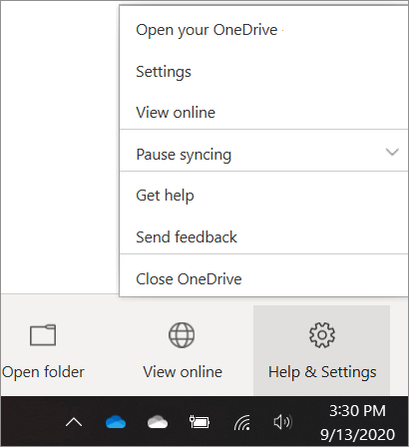

1. On the **Settings** tab, select the **Save space and download files as you use them** box.

**Notes:**

* Files On-Demand settings are unique to each device, so make sure you turn it on for each device where you want to use it.
* To learn how an admin can turn on Files On-Demand, see [OneDrive Files On-Demand for the Enterprise](https://techcommunity.microsoft.com/t5/OneDrive-Blog/OneDrive-Files-On-Demand-For-The-Enterprise/ba-p/117234).﻿

Mark a file or folder for offline use or as online-only

1. Right-click a file or folder.
2. Select **Always keep on this device** or **Free up space**.

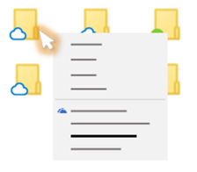

**Notes:**

* New files or folders created online or on another device appear as online-only to save maximum space. However, if you mark a folder as "Always keep on this device," new files in that folder download to your device as always available files.
* If a folder is online-only, you can still mark individual files within that folder as always available.
* Desktop search can search for online-only files by name, but it cannot search the contents within online-only files because they aren't stored on the device.

Choose a folder to hide on your device

Sometimes you might want to make sure a folder doesn't show up on a device for privacy reasons. For example, you might want to hide a personal folder on a work computer. Here's how you do that.

1. Select the white or blue **OneDrive** cloud icon in the Windows taskbar notification area.  
     
   OneDrive SyncClient with blue cloud and white cloud icons

(You might need to click the **Show hidden icons** arrow The Show hidden icons button. next to the notification area to see the **OneDrive** icon. If the icon doesn't appear in the notification area, OneDrive might not be running. Click **Start**, type **OneDrive** in the search box, and then click **OneDrive** in the search results.)

1. Select **OneDrive Help and Settings icon** > **Settings**.



1. Next to the location where you want to choose folders, select **Choose folders**.
2. Clear the check box next to the folder you want to keep off this device.

**Important:**Files On-Demand settings are unique to each device, so you may need to do this on each device where you want to keep a folder hidden.

Files On-Demand and deleting files

Can I move online-only files within my OneDrive folder?

Yes, you can move online-only files within your OneDrive folder for that OneDrive account. When you move files outside that OneDrive folder, the files download to the new folder and are removed from your OneDrive.

With your files and folders in the OneDrive [cloud backup](https://www.microsoft.com/microsoft-365/onedrive/pc-cloud-backup?ocid=oo_support_mix_marvel_ups_support_smconedrive_inline_cloudbackup), if you accidentally delete something, you can [restore them](https://support.microsoft.com/en-us/office/restore-deleted-files-or-folders-in-onedrive-949ada80-0026-4db3-a953-c99083e6a84f) from your OneDrive recycle bin.

What happens if I delete a file or move it to the trash?

When you delete an online-only file from your device, you delete it from your OneDrive on all devices and online. You can restore deleted files and folders from your OneDrive recycle bin on the web for up to 30 days for items stored in OneDrive personal (when you're signed in with a Microsoft account), or for up to 93 days for items stored in OneDrive for work or school or SharePoint in Microsoft 365 (when you're signed in with a work or school account). If you delete a locally available file, it also appears in your device recycle bin.

If you want to hide a folder on your device, see [Choose a folder to hide on your device](https://support.microsoft.com/en-us/office/save-disk-space-with-onedrive-files-on-demand-for-windows-10-0e6860d3-d9f3-4971-b321-7092438fb38e#bkmk_choosefoldertohide).

Does changing a file to online-only delete the file from my OneDrive?

No, changing a file to online-only doesn't delete it from your OneDrive. The file no longer takes up space on your device, and you will still be able to see the file from OneDrive mobile apps or on the website.

Why don’t I see the Files On-Demand options in OneDrive settings?

First, make sure you don't have Windows Information Protection (WIP), previously known as enterprise data protection (EDP) configured on your computer. Files On-Demand is not yet supported when WIP is enabled.

If you aren't seeing the Files On-Demand options, the latest version of OneDrive hasn't rolled out to you yet. Here's how to get the latest version of OneDrive.

1. Make sure you're running [Windows 10 Fall Creators Update](https://go.microsoft.com/fwlink/p/?linkid=859040) (version 16299.15 or later).
2. Download and install [the latest version of OneDrive](https://go.microsoft.com/fwlink/p/?linkid=851311) that's rolling out with the Windows 10 Fall Creators Update.
3. Restart your computer.
4. After your computer restarts, select the **Start** button, search for “OneDrive”, and then select the **OneDrive** desktop app.
5. When OneDrive Setup starts, enter your personal account, or your work or school account, and then select **Sign in**.

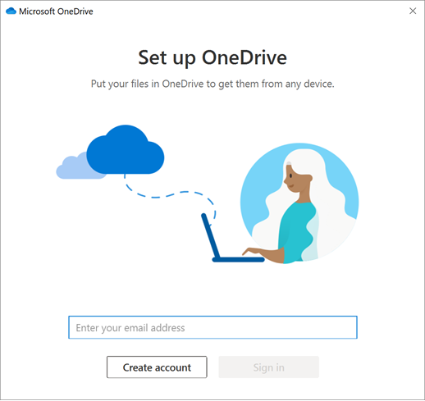

1. Follow the instructions to [Turn on Files On-Demand](https://support.microsoft.com/en-us/office/save-disk-space-with-onedrive-files-on-demand-for-windows-10-0e6860d3-d9f3-4971-b321-7092438fb38e#bkmk_turnonfond).

Learn more

* To learn more about notifications when Windows automatically downloads online-only files for your apps, see [Automatic file download notifications in Windows 10](https://go.microsoft.com/fwlink/p/?linkid=860258).
* [OneDrive disk space and file size don't match](https://support.microsoft.com/en-us/office/onedrive-disk-space-and-file-size-don-t-match-c42f93ad-f565-45e1-a91c-2491ef0dd138)
* [OneDrive storage plan and billing questions](https://support.microsoft.com/en-us/office/manage-your-onedrive-storage-and-limits-989fce19-ade6-4e2f-81fb-941eabefee28)