Lastly, we have also set up the automatic signatures for all users as we had previously on Lotus Notes. After sending an e-mail your personalized signature is added to your e-mails.

To check your e-mail signature please send an e-mail to yourself or login to : <https://me.crossware365.com> with your @apollotyres.com username.

If you find the information in your personal e-mail signature (telephone number, mobile-number or job title) is incorrect please send the correct information in an e-mail to [helpdesk.enschede@apollotyres.com](mailto:helpdesk.enschede@apollotyres.com)

(if you already have a e-mail signature defined in Outlook please remove that to avoid double signatures)

<https://me.crossware365.com>

MICROSOFT-USERNAME: [peter.schepens@apollotyres.com](mailto:peter.schepens@apollotyres.com)

Als je al met VPN bent ingelogd ga je direct door naar apollo-microsoft-site

Log hier in.

Krijg vervolgens onderstaande melding:

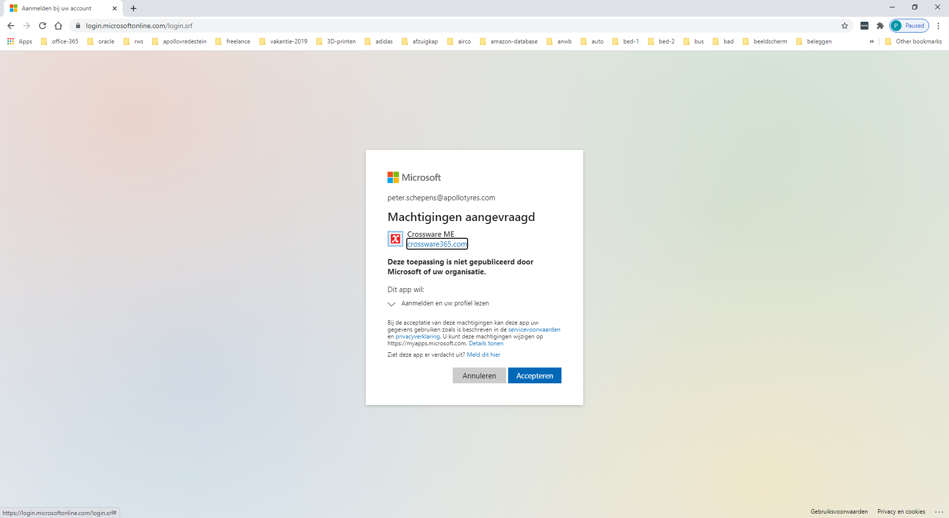

Dit is wel een vreemde melding. Lijkt er toch op dat deze te vertrouwen is…

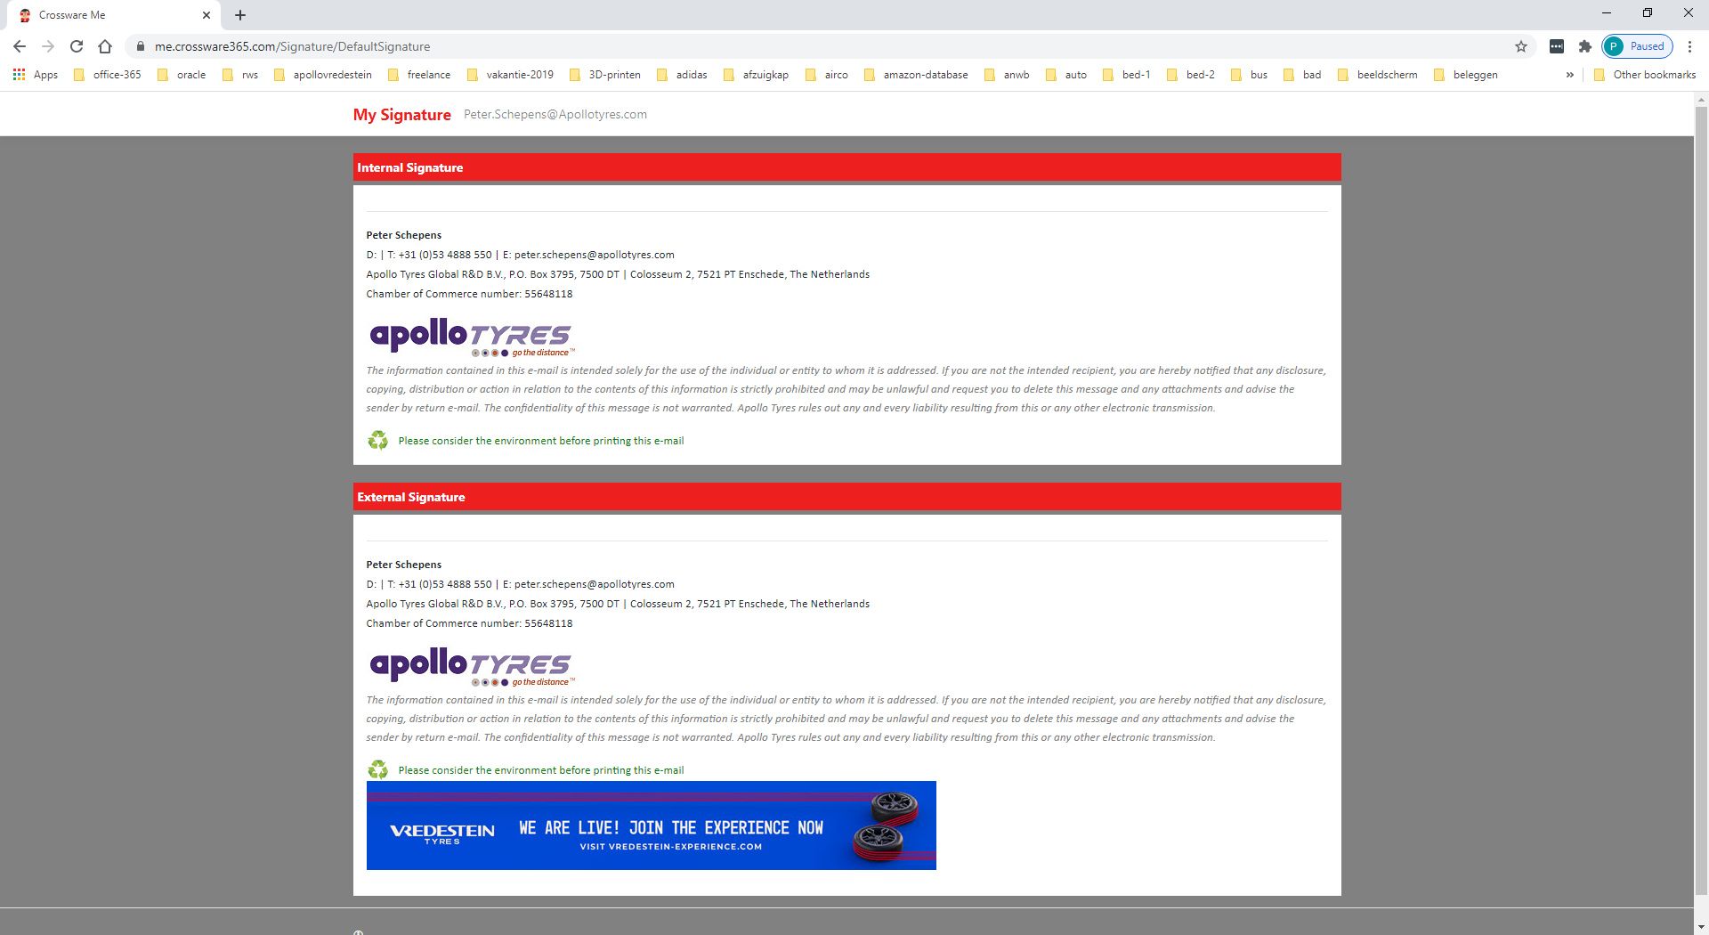

**Interne-handtekening:**

**Peter Schepens**  
D: | T: +31 (0)53 4888 550 | E: peter.schepens@apollotyres.com  
Apollo Tyres Global R&D B.V., P.O. Box 3795, 7500 DT | Colosseum 2, 7521 PT Enschede, The Netherlands  
Chamber of Commerce number: 55648118

|  |  |  |
| --- | --- | --- |
|  |  |  |

*The information contained in this e-mail is intended solely for the use of the individual or entity to whom it is addressed. If you are not the intended recipient, you are hereby notified that any disclosure, copying, distribution or action in relation to the contents of this information is strictly prohibited and may be unlawful and request you to delete this message and any attachments and advise the sender by return e-mail. The confidentiality of this message is not warranted. Apollo Tyres rules out any and every liability resulting from this or any other electronic transmission.*

|  |  |
| --- | --- |
|  | Please consider the environment before printing this e-mail |

**External-signature:**

**Peter Schepens**  
D: | T: +31 (0)53 4888 550 | E: peter.schepens@apollotyres.com  
Apollo Tyres Global R&D B.V., P.O. Box 3795, 7500 DT | Colosseum 2, 7521 PT Enschede, The Netherlands  
Chamber of Commerce number: 55648118

|  |  |  |
| --- | --- | --- |
|  |  |  |

*The information contained in this e-mail is intended solely for the use of the individual or entity to whom it is addressed. If you are not the intended recipient, you are hereby notified that any disclosure, copying, distribution or action in relation to the contents of this information is strictly prohibited and may be unlawful and request you to delete this message and any attachments and advise the sender by return e-mail. The confidentiality of this message is not warranted. Apollo Tyres rules out any and every liability resulting from this or any other electronic transmission.*

|  |  |
| --- | --- |
|  | Please consider the environment before printing this e-mail |

