https://www.itpromentor.com/teams-not-server-1/

Replacing your traditional file server with Microsoft Teams and OneDrive, part 1: Overcoming the hurdles

[by Alex](https://www.itpromentor.com/author/alexander-fieldsgmail-com/)  04. September 2018   [Opinion](https://www.itpromentor.com/category/opinion/), [Productivity](https://www.itpromentor.com/category/productivity/)   5

There is no doubt about it, more and more workloads are moving to the cloud these days, especially in the SMB space. Nevertheless, more often than not organizations (even small ones) remain completely disorganized when it comes to their legacy file servers, and this can be the most difficult piece to transition into the cloud. Nine times out of ten, trying to use a migration tool such as [this one by Microsoft](https://docs.microsoft.com/en-us/sharepointmigration/introducing-the-sharepoint-migration-tool), is just a big fat mistake in my opinion. Quickly, the three most common roadblocks to adoption of Teams and OneDrive as a new file sharing platform are:

1. There are just too many files, and it’s a giant mess

It can be overwhelming to sort through and decide which items to actually bring to a cloud platform, and which to leave behind. **Most providers have storage limits, or you begin to pay by the gigabyte after a certain point**, so why bring extraneous data? Beyond that, we often find that traditional file shares are over 80 percent clutter, while the most frequently accessed areas are like a dozen sub-directories containing the other 20% of files.

Ain’t nobody got time for sorting that mess out and reorganizing. And that makes sense: it wasn’t built overnight; it developed organically over many years of doing business. And after a while, like anything organic, it gets… a bit unruly. It’s only natural. But guess what, you don’t even have to migrate your old file server. Seriously. Just let people start using newer tools, and just like before, the new experience will grow up organically over time. So **think about this as a “fresh slate” opportunity**: re-creating your file structure from scratch, rather than trying to move everything you have right now as-is.

Bottom line: it is going to feel easier to keep using the same old garbage heap than it is to copy that garbage heap somewhere new, and sift through it there while trying to adopt the new platform. So don’t bother copying your garbage heap. Clean, fresh directories waiting for new content is the way to go. But you can use your own judgement here too, if you think I’m wrong. Just be sure you take a peek at the built-in limitations [here](https://docs.microsoft.com/en-us/microsoftteams/limits-specifications-teams), and know that a real file migration adds some time and complexity to the process. I think you’re probably better off avoiding that bullet–but that’s just my opinion.

2. Change can be difficult

Like anything new, right? Taking on a new file sharing system can be easy for an individual to do if they are motivated and possess a certain level of flexibility, but as you add more people and departments, this can get kind of tricky: everyone has to be willing to change, and sometimes it can be a bit like herding cats. **Unfortunately, a lot of people are attached to the old “mapped network drives” that they can browse in their familiar file explorer**.

But here is the thing, once you make Teams and OneDrive an available option to people, they will naturally start migrating there, because it is *easier* to use, and comes with more benefits (plus, now it can basically mimic your old network drive experience anyway). Legacy file shares will get ignored more and more once people realize that their cloud-hosted files are available everywhere, on any device, **without needing to use a Remote Desktop or VPN**.

3. The big pre-requisite: Windows 10 Creators Update

First thing is first, **don’t be afraid of making this change**. It isn’t that hard to do. Don’t think of it as a long drawn-out project–it certainly doesn’t have to be. It is a simple series of events, and it all begins just by making these new applications available. But, I do insist that if you have not already, now is the time to make the move to **Windows 10 Pro**; you will need at least the fall **Creator’s update** to take advantage of the [best sync capabilities](https://www.itpromentor.com/replace-my-file-server/) in OneDrive, so that you can browse your cloud-hosted files just like they were regular network drives.

Windows 10 runs so much better than Windows 7 or 8, and for those of you still clinging to Windows 7, just remember that eventually it will be out of support in early 2020, so you might as well get on with life, and try to get ahead of the game here (and truthfully, you might already be a bit behind–Windows 10 is already widely adopted and has reached a high level of maturity in the marketplace). Whatever your refresh cycle looks like, just do not be one of the thousand customers rushing at the last minute in Q4 of 2019 to make this change–you will find yourself begging for help from IT providers who are slammed with last minute upgrades.

Pro tip: if you sign up for a [Microsoft 365 Business](https://www.itpromentor.com/e3-v-m365b/) subscription, then in addition to your Office software, your upgrade from previous “Pro” versions of Windows will also be included, so you can download Windows 10 and get rolling easily.

Advice on setting up Teams

When you create a Team, the people who you invite will automatically be added to a “Group” in Office 365; as such, they will be able to share messages, files and other resources easily through a single “pane of glass”–the Teams application. You don’t want this application to look like a giant Charlie Foxtrot when users sign-in for the first time, **so don’t start off with too many Teams**.

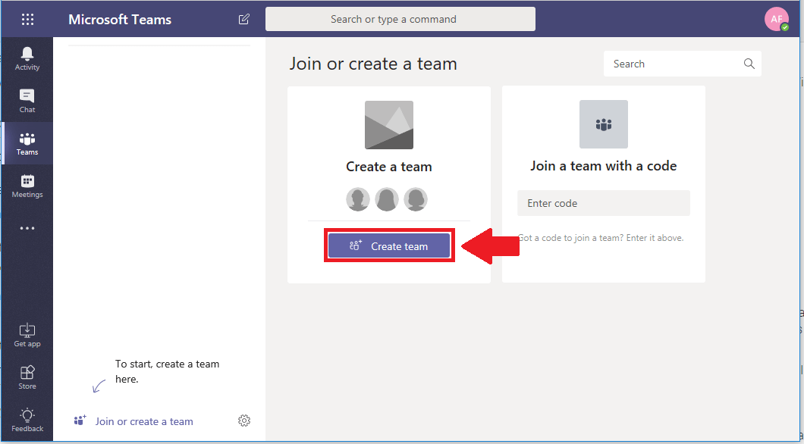

At first, keep it simple and create one Team per department or business unit in your organization. I bet you already have some network drives and security groups that roughly match-up to these departments anyway, so it might be easier to transition people into that kind of structure. The Executives have one, Accounting/Finance has one, Sales has one, etc. Every Team has a set of “channels” or threads underneath it, which can be sub-topics to that over-arching Team–so **use more channels, and less Teams** wherever possible.

You can’t always predict everything you will need in the beginning, and that is totally okay–it’s one of the beautiful things about this application: creating new teams and inviting people to it is a quick and easy process that any user can do, at any time in the future.

In the next post, I will show you a detailed example of setting up a Sales department on the Teams application, with OneDrive to sync the shared file libraries right into the familiar file explorer, just like it was a mapped drive. And the best part? It doesn’t even require guru-level IT knowledge to do it–a power user could help their department or small organization to make this transition–it’s actually pretty easy to do.

[**Part 2: How to make it happen fast**](https://www.itpromentor.com/teams-not-server-2/)

https://www.itpromentor.com/teams-not-server-2/

# Replacing your traditional file server with Microsoft Teams and OneDrive, part 2: How to make it happen fast

[by Alex](https://www.itpromentor.com/author/alexander-fieldsgmail-com/)  05. September 2018   [Productivity](https://www.itpromentor.com/category/productivity/), [Technical](https://www.itpromentor.com/category/tech/)   26

[As promised](https://www.itpromentor.com/teams-not-server-1/), today I am going to show you how easy it is to replace your legacy file server and network drive experience with Microsoft Teams and OneDrive. Seriously, anyone can set this up, and it takes just a few minutes. Pre-requisites are:

* Windows 10 Pro (Creators Update or later) – you will need this for the latest OneDrive client & [Files On-demand](https://www.itpromentor.com/replace-my-file-server/)
* A [Microsoft 365](https://www.itpromentor.com/e3-v-m365b/) or [Office 365](https://www.itpromentor.com/common-skus/) subscription that includes access to Microsoft Teams and OneDrive for Business
* Willingness to try new things

## **Let’s go Teams!**

Whether you are creating this team for your own department, or if you’re an IT admin like me, who will be provisioning all of the departments at first, we start in the same place (that is to say: this process is very accessible to non-technical folks). Go to [https://teams.microsoft.com](https://teams.microsoft.com/) and sign-in. From here, you can optionally get the app from a link on the left menu (recommended). Otherwise, just go ahead and click **Create team**!



Name the team for a specific business unit or department within the organization, in this case “Sales Department.” Click **Next**.

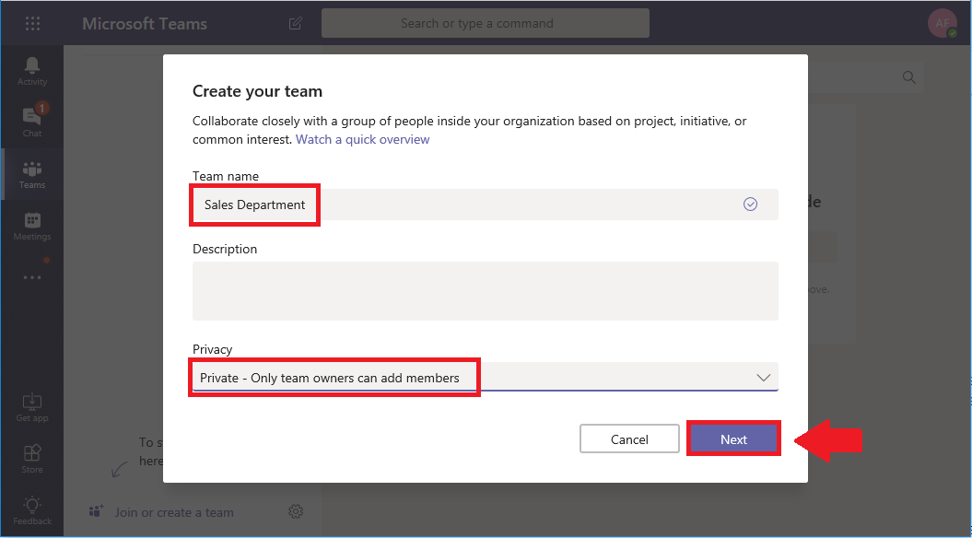

You can either add members individually, or, if your organization already has a distribution or security group containing all the department members (as many organizations do), then you can use that to invite all the members. Either way, everyone you add to this list is being added into a new Office 365 “Group” in the background, which will automatically grant them access to all of the shared resources within the Team.

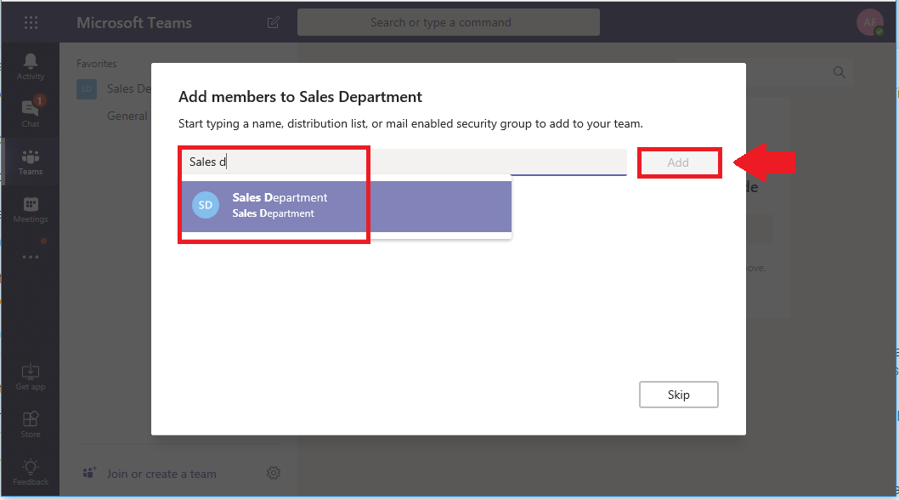

**Now we can populate some channels**. **I like to think of these as the major “sub folders” or “sub groups/functions**” within the department. Note: **every channel you create will automatically create a sub-folder under the “Team” document library within SharePoint**. In most any sales team, channels or “sub-folders” could be things like:

* Inside sales
* Outside sales
* Sales engineering
* Process and procedures
* Marketing materials
* Etc.

Click on the ellipses and choose **Add channel**.

Simply give it a name and click **Add**. Optionally, you can “**favorite**” the channel (so that everyone in the group sees it in their Teams application by default–this is recommended).

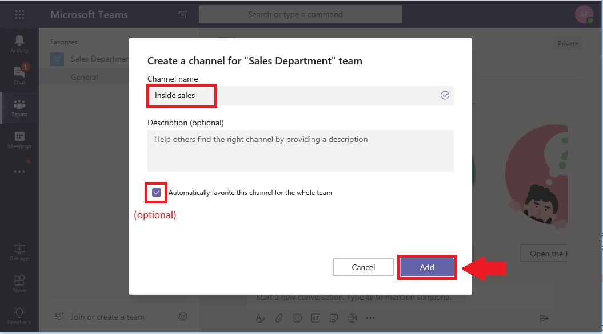

Once you have your channels created, go ahead and click on the **Files** tab within any given channel. Notice that you can Add cloud storage–this option includes third party clouds (not just Microsoft), so if your department already has a Dropbox folder they are using, no problem. You can link it up in here also. For the purposes of continuing with our demonstration, however, just go on to the ellipses and choose **Open in SharePoint**.

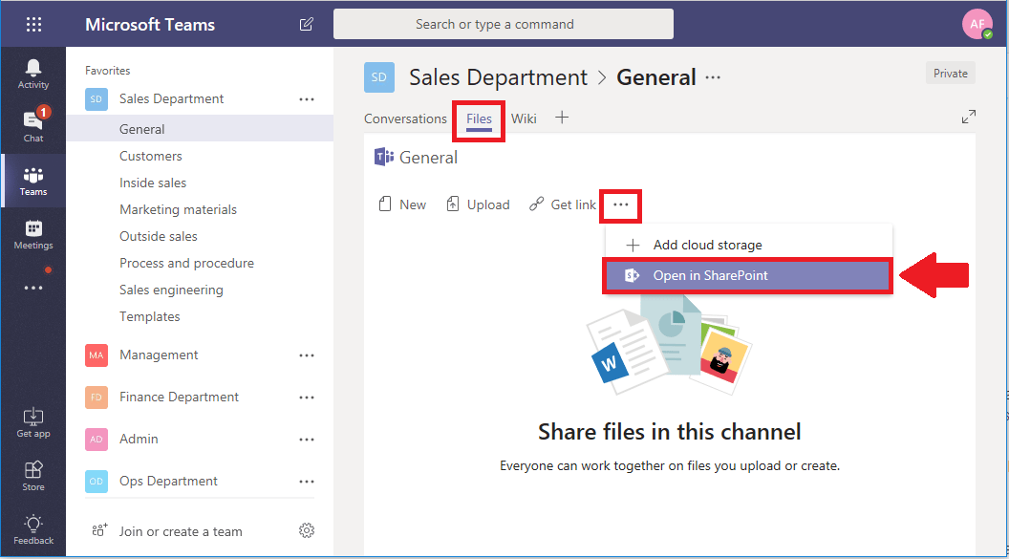

Here we are looking at the same file folder that we had inside Teams. Now, I launched this link to SharePoint from within a specific channel, which means I am already inside a “sub-folder” of my Team’s Documents library.  The “top level” is named “Documents,” and you can get to the top-most level just by clicking on **Documents**, on the left.

Notice how I can see sub-folders here for all of my channels. If you want to sync this entire file tree into your file explorer, just like a network drive, **simply click on Sync, in order to launch OneDrive**.

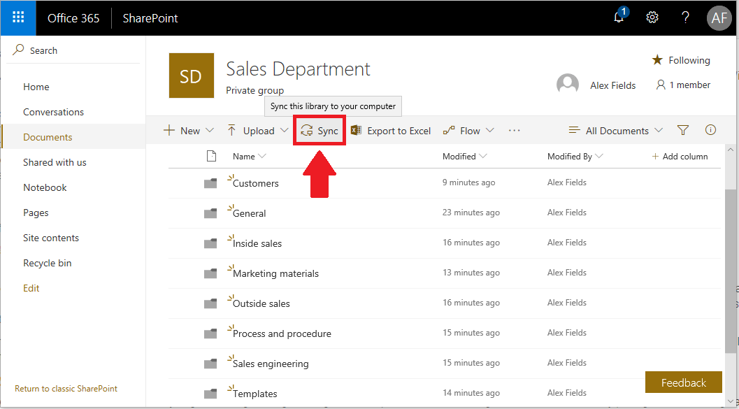

You will likely be prompted to switch applications, which is a security feature. Answer in the affirmative to proceed.

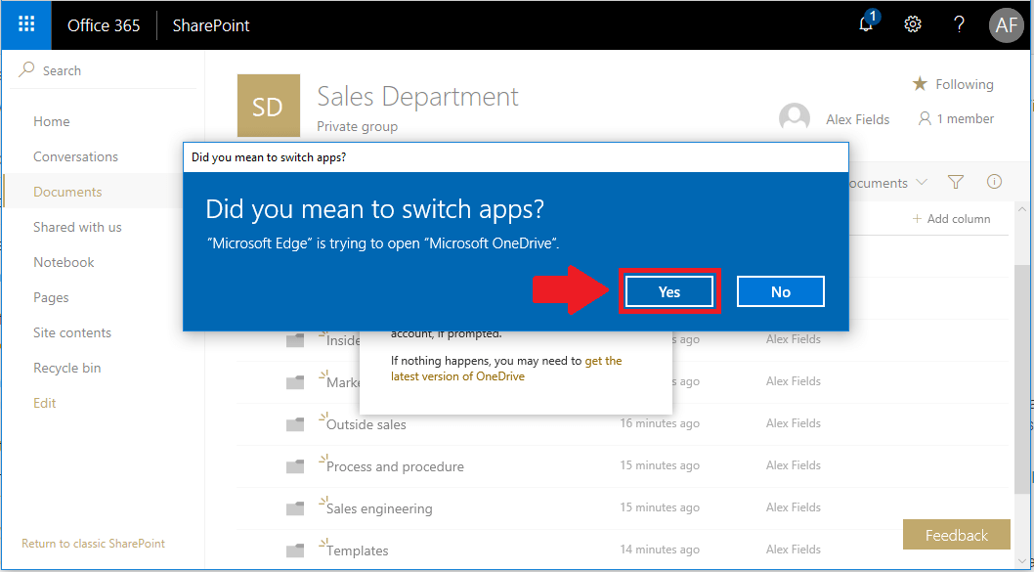

If you have not yet signed into OneDrive on this computer, you will be asked to at this point. Otherwise, you can fast forward the next couple of screens that I will go through here. Click **Sign in** to continue.

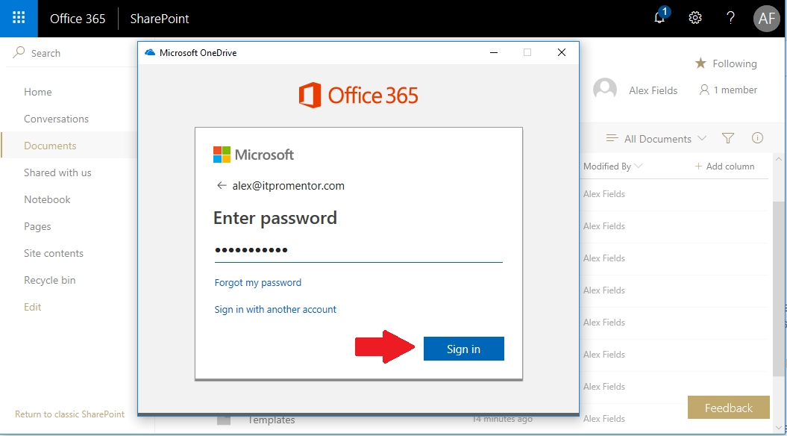

Once you have authenticated, you can optionally change the location where it will store files on your computer, I usually just accept defaults and **Next**.

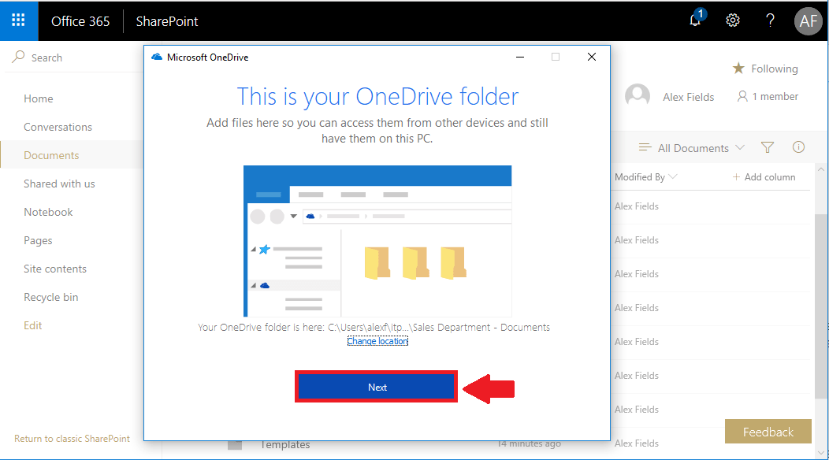

Now it will bring you through a few introductory screens to show you some examples of what is possible using OneDrive–highlighting some of its features such as Drag’n’drop (which should be familiar from using file explorer in general), [Files On-Demand](https://www.itpromentor.com/replace-my-file-server/), and of course the built-in sharing capabilities. Eventually you reach this point, and then will be taken to your familiar file explorer. Click **Open my OneDrive folder**.

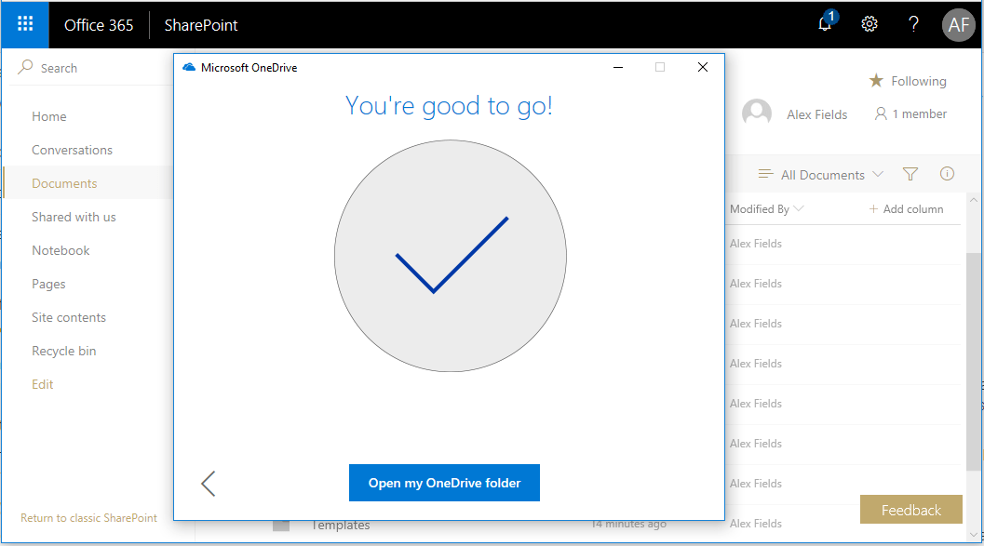

If you had already setup OneDrive previously, then you’re probably taken right to this screen from the get-go, or, it just happens in the background and you can switch to file explorer yourself to see the new directory structure show up. Your company’s name will appear as a work place, with any folders that you are syncing displaying below. From here, it is literally just drag-n-drop relevant files from legacy network drives. Don’t move too many files at once (the idea is less clutter, remember?), and you may occasionally have to rename a file with an “illegal” character.

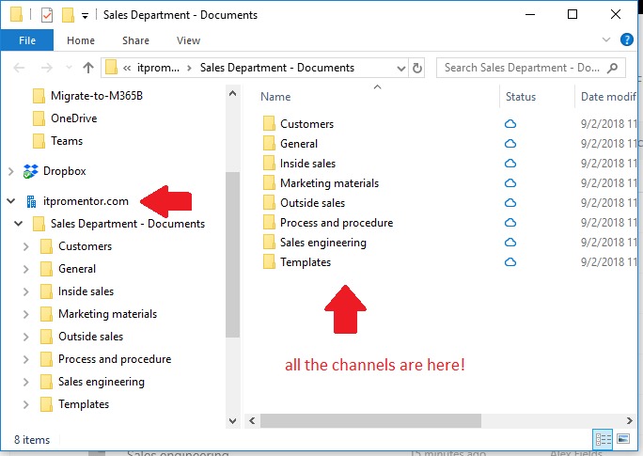

Under the status column you will notice that little cloud icon, meaning none of these files will actually live on the device by default. If you want to change that, to work on some files offline for example on a long flight, you can just right-click and choose the option **Always keep on this device**, and you end up with a green check mark icon, indicating that the file is synced. (If you change your mind later use “Free up space” which will shift it back to the cloud icon).

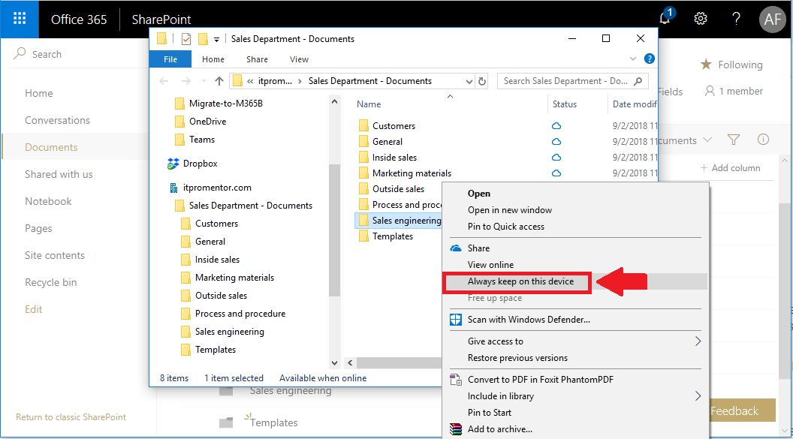

Ta-da! Synced.

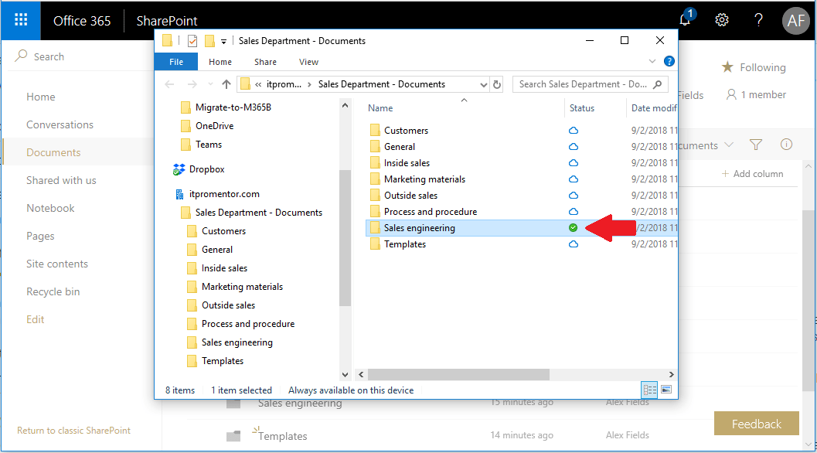

### Beyond file sharing–what else can Teams do for my organization?

So that was just an example of how you can use your Teams to create file structures that can ultimately replace those dumb, old legacy file servers. Teams and OneDrive can work together as one unit, to make access to company shared files a breeze. But, since Teams is much more than just a repository for documents, having that app will allow your departments to create organized channels for carrying on discussion threads. This goes way beyond email, folks. It is possible for example, for brand new hires who were just added to go back and review old discussion topics (try doing that with a distribution list).

AND, you can even record video conference meetings for future play back. Check it out, from inside a channel, start a meeting like this, just by clicking the video camera icon **Meet now**.

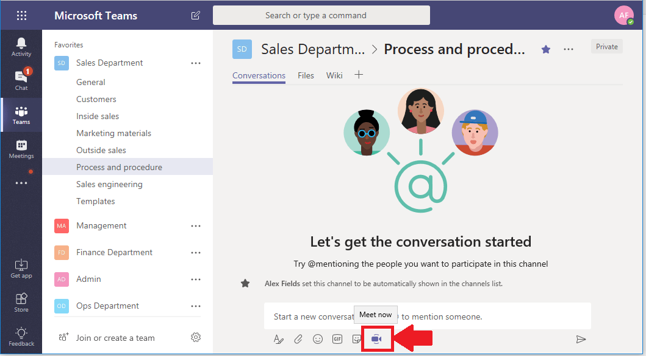

When you have started the meeting, choose the ellipses and pick **Start recording**.

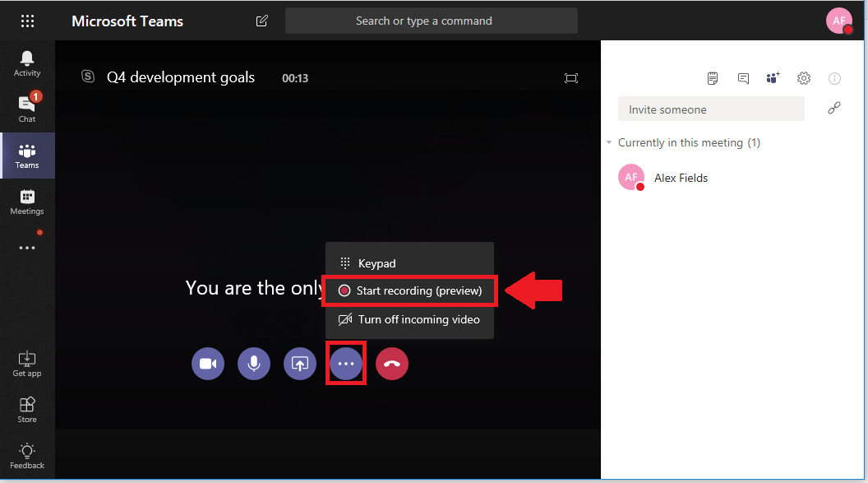

I’m telling you, my curls are insane. I don’t know why I was blessed with such amazing hair.

When you are done with the meeting, if you recorded it, then the playback will be available in this channel, so that people who were not able to attend can still watch it as though it were a broadcast later on.

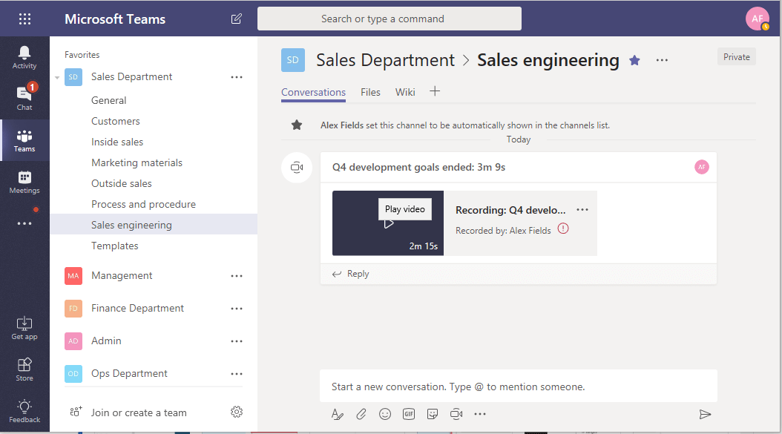

And that is just ONE of the cool features in Teams. If you want even more “mind = blown moments,” go click on the “plus” (**+**) icon at the top menu in any channel, and check out all of the items that you can pull into Teams–a whole gallery of goodies from the Microsoft universe, and indeed many other locations in the cloud multiverse! Add an RSS or Twitter feed for example, or connect to Adobe Creative Cloud, or if you just don’t like OneNote that much, try Evernote, or tons of other popular apps.

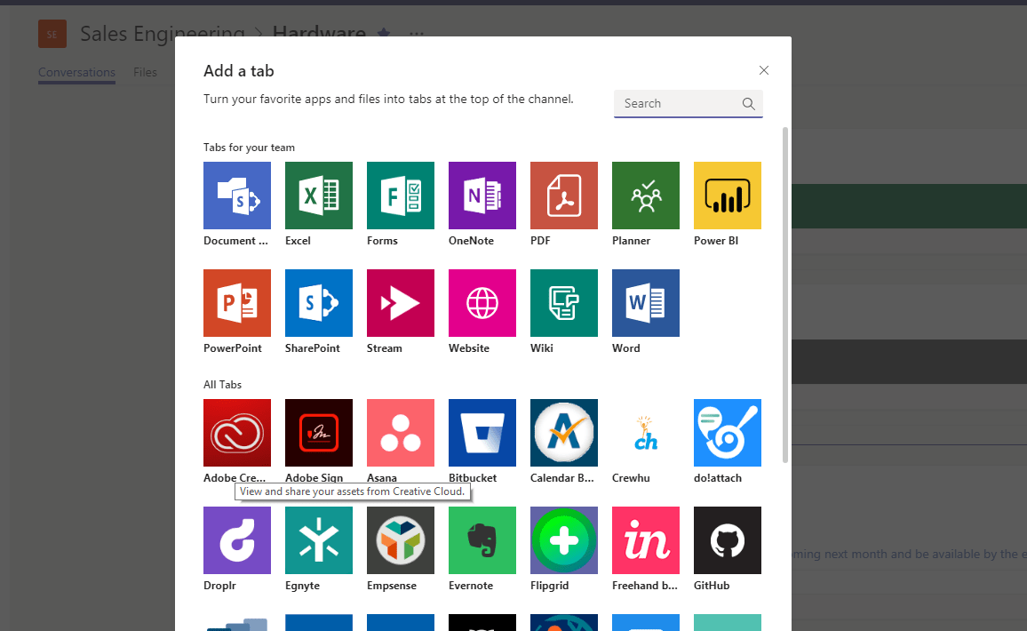

To be clear, this Teams app isn’t just a file sharing platform, or even a chat-based workspace. It is those things, but it is much more. So much more. Most organizations haven’t yet grasped everything that is possible with this platform–but those that figure it out will enjoy some nice competitive advantages (and a bit more [mobility](https://www.itpromentor.com/mobile-work-lifestyle/) to boot). I believe we could end up spending as much time working within Teams, eventually, as we do in Outlook today. Maybe even more so, moving into the future. Granted, there is a lot to learn once you get started, but setting up your basic Teams and channels, and getting into the file sharing aspect might be one of the easiest ways to start up your adoption quickly (and of course, to get off those legacy file servers).

### How to more aggressively drive adoption

If you want to really push people here, make it the easiest option. For this, I recommend two things:

1. **Do it for them**: get IT to touch every computer, and every other device they (the users) want you to (within reason of course). Specifically, install the Teams application on Windows 10, and setup the OneDrive sync option for them so they can see their Teams in file explorer right away. Additionally, install the Teams and OneDrive apps on iPhones, iPads, and Androids–so that users can sign-into their conversations and files on any of their favorite devices–as long as they are current enough, and “supportable” of course. I recommend registering all devices with MDM or Intune, so that they can also be managed effectively.
2. **At a certain date, shut down write-access on the file server**. I mean it–pull the plug, and make those directories read-only. Give users adequate heads up, of course. But explain that this is going to become a legacy/archive area only, and that the finance department is not budgeting to replace the server hardware in the next refresh cycle, so all new business will be conducted out of Teams and OneDrive.

I know that last point sounds scary, but it isn’t that bad. Plus, you can back old network files up to a NAS and/or other offsite cloud file repository if needed, and keep it for a few more years for reference, even after your server has long since gone on to server heaven (or server hell, as the case may be). Have fun with this, and when you’re ready to go all [Office Space](https://www.youtube.com/watch?v=N9wsjroVlu8) on your old file server, drop me a line, with a photo or link to a video so I can see how much fun you are having.