**Map a network drive from remote desktop back to local computer**

You are already most likely familiar with the process to “redirect” drives from your host computer over to your remote desktop session.  This is as simple as choosing your **local resources** in the settings of your RDP connect window.  Notice below the **More** button at the bottom which takes you to the **local devices and resources** section which allows resources to be chosen.

[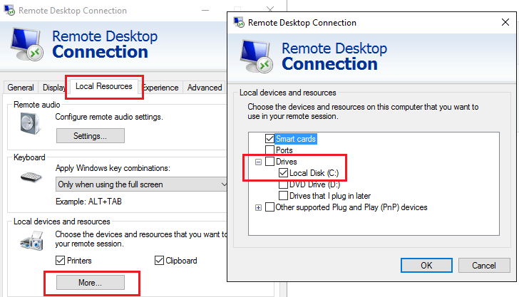](https://www.virtualizationhowto.com/wp-content/uploads/2016/07/mapdrivehost01.png)

On your target remote desktop connection, you will see these redirected drives underneath your **Devices and drives** area of Explorer.  They will be designated by **<drive letter>** on **<computername>** where computername is your host.

[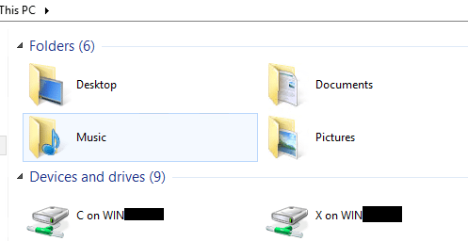](https://www.virtualizationhowto.com/wp-content/uploads/2016/07/mapdrivehost02.png)

**Mapping these to real network drives**

You may however have the need to map these redirected drives to real drive letters inside your [remote desktop session](https://www.virtualizationhowto.com/2014/10/access-local-drives-in-an-rdp-session/).  For instance developers may have the need to have access to source code in a lab environment which they may not have RPC or NETBIOS traffic allowed.  The traditional **map network drive** wouldn’t work as the ports required aren’t open.

The redirected drives however, **can be mapped to** which is awesome!  If you run a simple **net use** command inside of your RDP session, you will see the redirected drives appear.  Notice the format of the drive is in the form of a **special UNC path** represented by **\TSCLIENT<drive letter>** so these are mappable.

[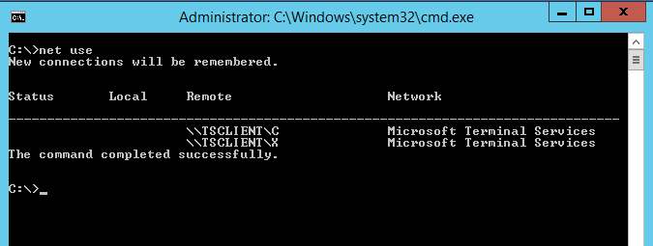](https://www.virtualizationhowto.com/wp-content/uploads/2016/07/mapdrivehost03.png)

Notice that all we have to do to map these in a true sense to a network drive letter is a simple **net use <drive letter> \tsclient<drive letter>** and voila, the drive is mapped!

**C:\ Net use Z: \\TSCLIENT\Z**

[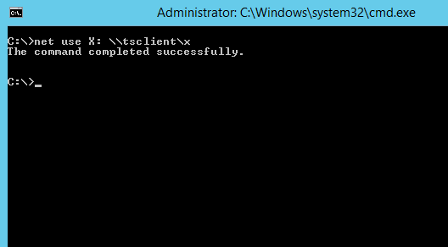](https://www.virtualizationhowto.com/wp-content/uploads/2016/07/mapdrivehost04.png)

Now if you look in Windows explorer, you will see a true network drive mapped under your **Network Locations**section.