[**How to easily shutdown or restart Windows over Remote Desktop Connection**](https://tinkertry.com/articles/how-to-shutdown-or-restart-windows-over-rdp)

Posted by [Paul Braren](https://tinkertry.com/about) on Apr 4 2016 (updated on Apr 6 2016) in

• [Windows](https://tinkertry.com/category:Windows)

• [Productivity](https://tinkertry.com/category:Productivity)

• [HomeLab](https://tinkertry.com/category:HomeLab)

• [HomeServer](https://tinkertry.com/category:HomeServer) [12 Comments](https://tinkertry.com/how-to-shutdown-or-restart-windows-over-rdp#disqus_thread)

[**Problem**](https://tinkertry.com/how-to-shutdown-or-restart-windows-over-rdp#problem)

The *Shut down* and *Restart* options are removed from the Start Menu when you’re connected using Remote Desktop (aka Terminal Services), as pictured above. These intentional omissions protect you from yourself, since there's a risk when doing such power operations remotely. If something goes wrong, you're presumably not there to fix it. That assumption isn't always true for home labs or VMs.

This article is for sysadmins who know better, wanting to *Shut down* or *Restart* (or even enter *Sleep*) over RDP anyway! ;-)

[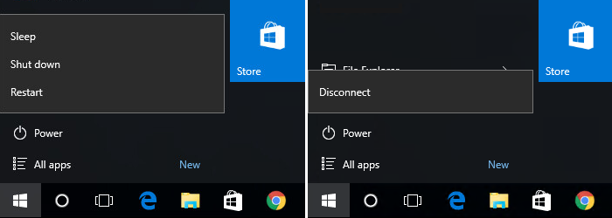](https://cdn.tinkertry.com/content/articles/737-how-to-shutdown-or-restart-windows-over-rdp/2016-04-04_17-08-07.png)At left, user clicked on Start, Power, then has three choices. Using RDP at right, choices are rather limited.

These two simple workarounds below are applicable to the following versions of Microsoft:

* Windows 7
* Windows 8/8.1
* Windows 10

whether it's installed on a PC, a server, or even in a VM (Virtual Machine)!

[**Solution A - GUI + keyboard**](https://tinkertry.com/how-to-shutdown-or-restart-windows-over-rdp#solution-a-gui-keyboard)

If your a keyboard shortcut fan, you may have already known that Alt+F4 closes the currently selected Windows application. When your desktop is selected, it stands to reason that typing Alt+F4 has the effect of telling Windows that you'd like to close Windows itself. Simple, elegant, and easy to remember!

1. Press ***Win+D*** to minimized all open Windows to show your desktop  
   (alternatively, you can left-click the lower-right corner)
2. **Press *Alt+F4*** to bring up the *Shut Down Windows - What do you want the computer to do?* dialog, where you can now choose any of the following list of actions:  
   *Disconnect*  
   *Sign out*  
   *Shut down*  
   *Restart*
3. Select which option you want, then press ***Enter*** (or click ***OK***), as pictured below.

[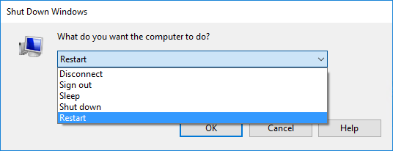](https://cdn.tinkertry.com/content/articles/737-how-to-shutdown-or-restart-windows-over-rdp/Shut-Down-Windows-RDP-dialogue.png)  
Looping video can be paused and un-muted, mouse-over to reveal controls.

Alternatively, here's the [same video on YouTube](https://youtu.be/JEYHa6XLIG8) for you to share.

[**Solution B - Command Prompt**](https://tinkertry.com/how-to-shutdown-or-restart-windows-over-rdp#solution-b-command-prompt)

[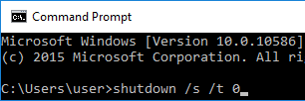](https://cdn.tinkertry.com/content/articles/737-how-to-shutdown-or-restart-windows-over-rdp/shutdown-command.png)

1. Open a Command Prompt  
   a. To initiate a **Shut down**, type:  
   shutdown /s /t 0 then press ***Enter***  
      
   OR  
    [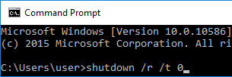](https://cdn.tinkertry.com/content/articles/737-how-to-shutdown-or-restart-windows-over-rdp/restart-command.png)

b. To initiate a **Restart**, type:  
shutdown /r /t 0 then press ***Enter***

Because of the 0 second delay you specified, you'll want to be very sure you really intend to do this immediately, *before* you press that ***Enter*** key!

Note: these techniques also work with Microsoft

* Windows Server 2008/2008 R2
* Windows Server 2012/2012 R2
* Windows Server 2016

but the start menu of those server OSs don't block access to the Shut down and Restart/Reboot options. This seems to indicate that Microsoft assumes only knowledgeable sysadmins would be using those OSs anyway.

[**RDP Tips**](https://tinkertry.com/how-to-shutdown-or-restart-windows-over-rdp#rdp-tips)

Courtesy of makeuseof's [5 Tips for Fixing Remote Desktop Screen Settings](http://www.makeuseof.com/tag/5-tips-fixing-remote-desktop-screen-settings/):

CTRL+ALT+PAUSE: Switches your Remote Desktop client between full-screen and windowed mode.  
CTRL+ALT+BREAK: Force the Remote Desktop into full-screen mode.  
CTRL+ALT+MINUS: Takes a screenshot of the active Remote Desktop window.  
CTRL+ALT+PLUS: Takes a screenshot of the entire Remote Desktop.  
CTRL+ALT+END: Reboots the remote computer.

[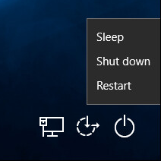](https://cdn.tinkertry.com/content/articles/737-how-to-shutdown-or-restart-windows-over-rdp/Ctrl-Al-End.png)  
Press CTRL+ALT+END, then click on the Power icon seen at bottom-right. These are the choices you may see, in Windows 10.

I have noticed that with Windows 10 over RDP, typing CTRL+ALT+END will bring up the usual choice of options you get when typing CTRL+ALT+DEL, but the power options at bottom-right don't always show Shut down and Restart, as discussed [below](https://tinkertry.com/how-to-shutdown-or-restart-windows-over-rdp#comment-2607549862). Not sure why just yet. Whatever the reason, it would seem this handy single keystroke would be great to recommend, if only it was just as universal as the two techniques I detailed above.

[**See also at TinkerTry**](https://tinkertry.com/how-to-shutdown-or-restart-windows-over-rdp#see-also-at-tinkertry)

* [**How to power off a PC remotely (over Terminal Services / Remote Desktop Connection)**](https://tinkertry.com/poweroff)  
  Aug 01 2011

I prefer the newer approach above, as it doesn't rely on any 3rd party software.

[**Sources**](https://tinkertry.com/how-to-shutdown-or-restart-windows-over-rdp#sources)

* [**How do you shutdown or restart a Windows computer over a Remote Desktop connection?**](http://superuser.com/questions/128051/how-do-you-shutdown-or-restart-a-windows-computer-over-a-remote-desktop-connecti)  
  Apr 06 2010 by [heavyd](http://superuser.com/users/820/heavyd) at StackExchange
* [**How to shutdown or restart Windows over a Remote Desktop connection**](http://www.fixedbyvonnie.com/2013/11/shutdown-restart-windows-remote-desktop-connection/)  
  Nov 20 2013 by [vonnie](http://www.fixedbyvonnie.com/about/) at fixedByVonnie.com
* [**"Logoff" and "Shutdown" Are Missing from the Start Menu When You Use Remote Desktop**](https://support.microsoft.com/en-us/kb/303070)

When you are using Remote Desktop and connect to a Windows XP Professional computer, the Log Off and Shutdown commands are missing from the Start menu.  
...  
To shut down a remote computer when you are using Remote Desktop, press CTRL+ALT+END, and then click Shutdown.