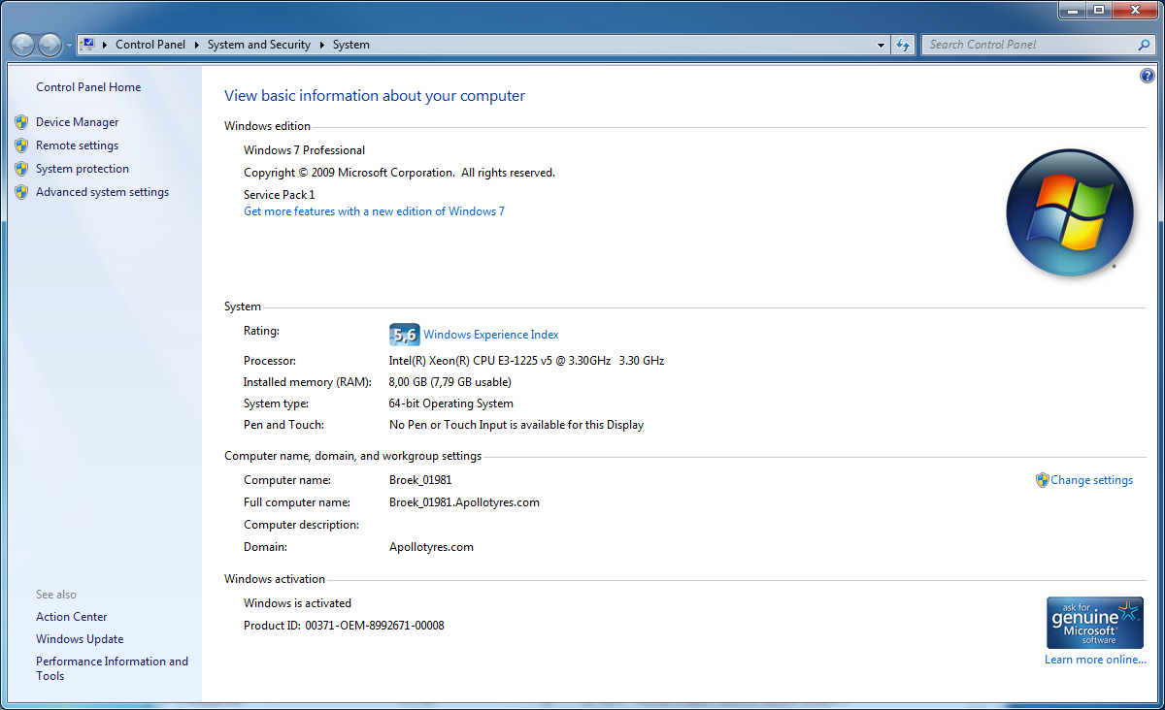

Computer-name: Broek_01981

Full-computer-name: Broek_01981.Apollotyres.com

Domain: Apollotyres.com