<https://www.oracle.com/nl/database/technologies/related/rdb.html>

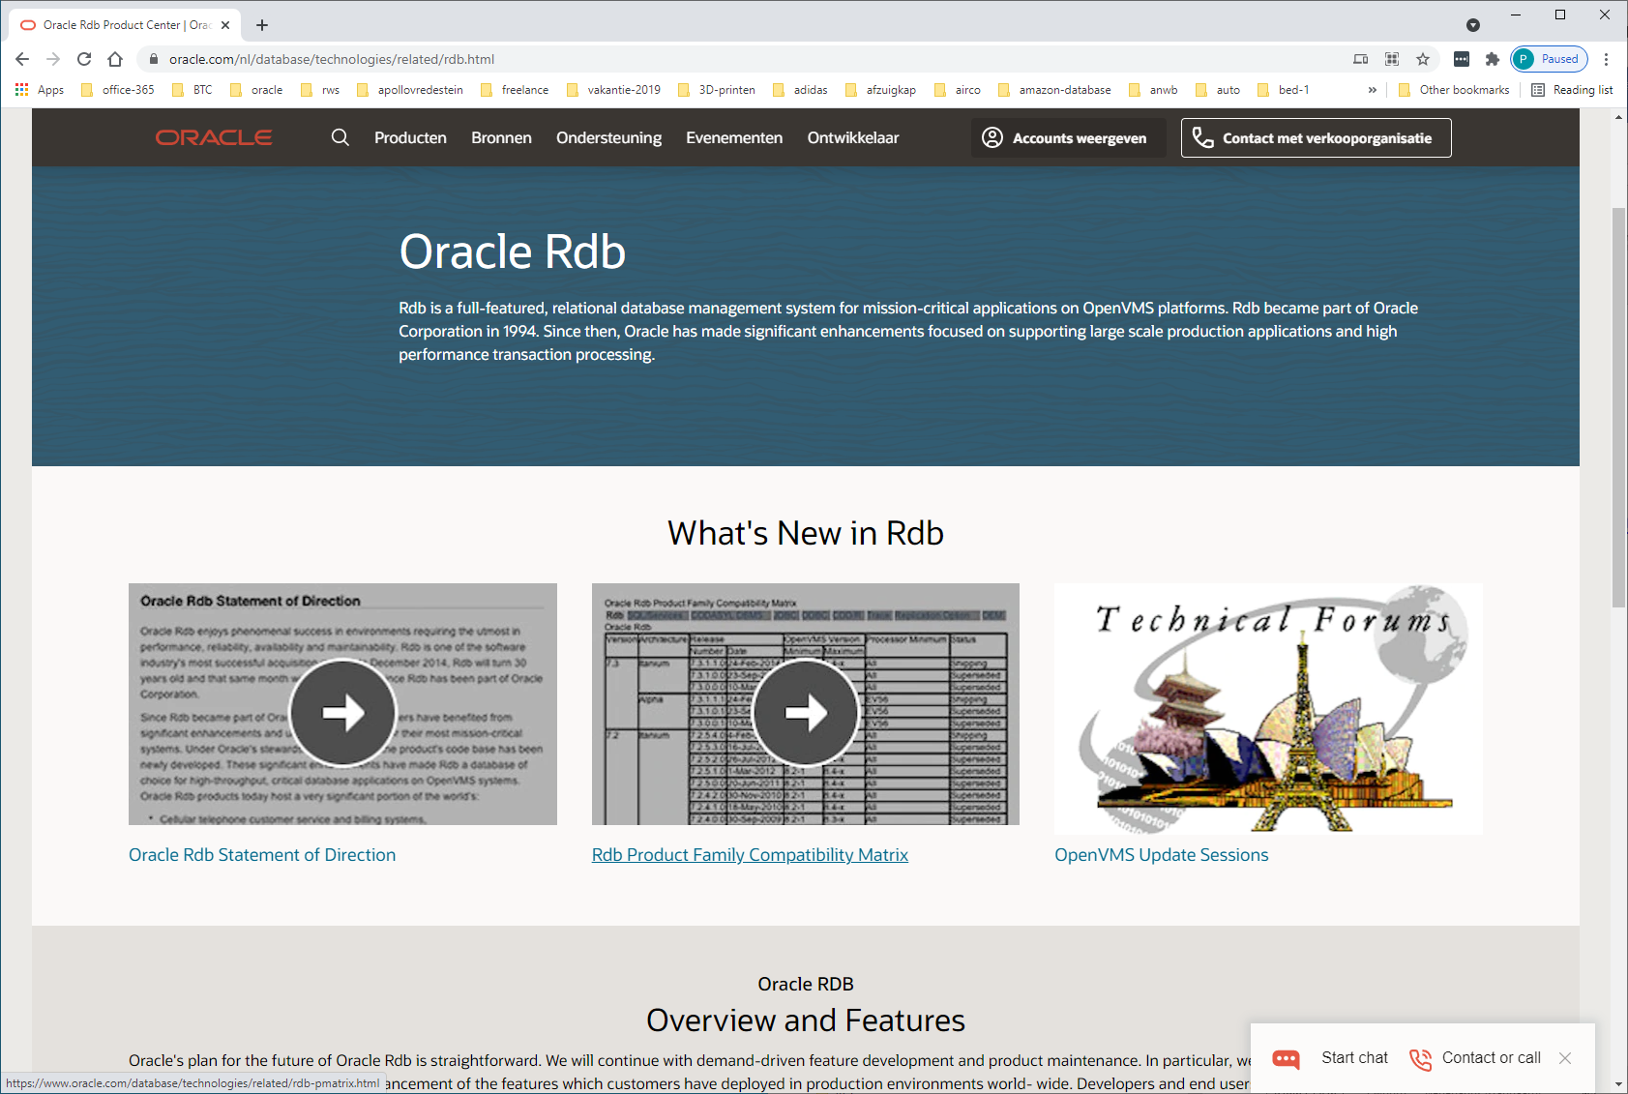

Oracle RDB

## Overview and Features

Oracle's plan for the future of Oracle Rdb is straightforward. We will continue with demand-driven feature development and product maintenance. In particular, we will maintain a relentless focus on high quality and stability and enhancement of the features which customers have deployed in production environments world- wide. Developers and end users are able to use Oracle tools for application development, ad hoc queries, decision support and internet application deployment.

Oracle Rdb Product Family Releases are built to run on HP OpenVMS Itanium and AlphaServer Systems. 7.4 is the latest release of the Oracle Rdb Product Family.

Oracle Rdb's technical strengths include:

* Very high performance to deliver extraordinary real-world throughput
* Extremely high reliability, providing both data security and database uptime
* Extremely high availability—requirements for scheduled maintenance downtime are minimal
* Easy maintainability
* Low cost per transaction

##### Resources

* [Oracle Rdb Product Compatibility Matrix](https://www.oracle.com/nl/database/technologies/related/rdb-pmatrix.html)
* [Oracle Rdb Lifetime Support Dates](https://www.oracle.com/nl/database/technologies/rdb-learnmore-orardb-lifesupport.html)  
  Oracle Rdb and Oracle CODASYL DBMS are covered by Oracle's Lifetime Support Policy.
* [Rdb Statement of Direction](https://www.oracle.com/nl/database/technologies/related/rdb-statement-of-direction.html)
* [Support for Alpha and VAX Emulators](https://www.oracle.com/nl/database/technologies/related/alpha-vax-emulators.html)
* [Oracle Rdb Technical Journal](https://www.oracle.com/nl/database/technologies/related/rdb-technical-journal-idx.html)
* [Oracle Rdb Technical Archive](https://www.oracle.com/nl/database/technologies/related/rdb-archive-index.html)
* [Education](https://www.oracle.com/nl/database/technologies/related/rdb-training.html)
* [Technical Forums](https://www.oracle.com/nl/database/technologies/related/technical-forums.html)

##### Documentation

* [Rdb Release 7.4](https://www.oracle.com/nl/database/technologies/related/rdb-doc.html)
* [Rdb Release 7.3](https://www.oracle.com/nl/database/technologies/related/rdb-doc.html)
* [Rdb Release 7.2](https://www.oracle.com/nl/database/technologies/related/rdb-doc.html)
* [Rdb Release 7.1](https://www.oracle.com/nl/database/technologies/related/rdb-doc.html)
* [Rdb Release 7.0](https://www.oracle.com/nl/database/technologies/related/rdb-doc.html)
* [Rdb Related Products](https://www.oracle.com/nl/database/technologies/related/rdb-doc-rlp.html)
* [Translations](https://www.oracle.com/nl/database/technologies/related/rdb-doc-jpn.html)

| **Product** | **Release** | **General Availability** | **Premier Support Ends** | **Extended Support Ends** | **Sustaining Support Ends** |
| --- | --- | --- | --- | --- | --- |
| Oracle Rdb | 7.0 | Oct 1996 | Aug 2007 | Aug 2009 | Indefinite |
|  | 7.1 | Jul 2001 | Dec 2007 | Dec 2010 | Indefinite |
|  | 7.2 | Jan 2006 | Jul 2015 | Jul 2017 | Indefinite |
|  | 7.3 | Mar 2011 | Sep 2020 | Sep 2023 | Indefinite |
|  | 7.4 | Aug 2020 | Sep 2023 | Not Available | Indefinite |