https://wethegeek.com/automatically-move-files-from-one-folder-to-another-on-windows-10/#:~:text=You%20can%20automatically%20move%20files,source%20and%20destination%20folder%20paths.

**Automatically Move Files From One Folder To Another On Windows 10**

Moving files between folders is a regular task performed on your computer. Sometimes, it is done to declutter a drive or archive important files, however, it could also be done for general cleaning purposes. Although, sorting files could take up a lot of time and also it is monotonous. To avoid getting sulked into the boredom of [moving files and folders](https://wethegeek.com/how-to-move-files-in-google-drive-and-transfer-it-to-another-account/)you can automate file transfer task. Yes, you heard it right! You can automatically move files from one folder to another by using a script that uses Robocopy, a command-line utility which comes with Windows 10.

To automated [file transfer](https://wethegeek.com/top-5-file-copy-utility-software-for-windows/), you need to use Robocopy script, add frequency in days, source and destination folder paths. You can set up a task in[Task Scheduler](https://wethegeek.com/how-to-delay-scheduled-tasks-in-task-scheduler-on-windows/) to execute the script every day at a certain time.

**Steps to Create a Script to Automatically Move Files From One Folder To Another On Windows 10**

If you want to perform automated file transfer, first you need to create a script.

Step 1: Go to the [search bar](https://wethegeek.com/tricks-to-fake-google-search-box-into-real-search-bar/) on the taskbar and type, Notepad and press Enter to launch it

Step:2 You will get a blank file, copy and paste the below-written script in Notepad.

Before finalizing, you need to make some changes such as a set number of days, source and destination folder

**echo off**  
**set X=<days>**  
**set "source=C:\<Source Folder Path>"**  
**set "destination=D:\<Destination Folder Path>"**  
**robocopy "%source%" "%destination%" /mov /minage:%X%**  
**exit /b**

toevoeging Peter:

I believe xxcopy isn't a free option for commercial use. It looks like a recursive copy on the Copy-Item commandlet can be achieved by using "-recurse".

[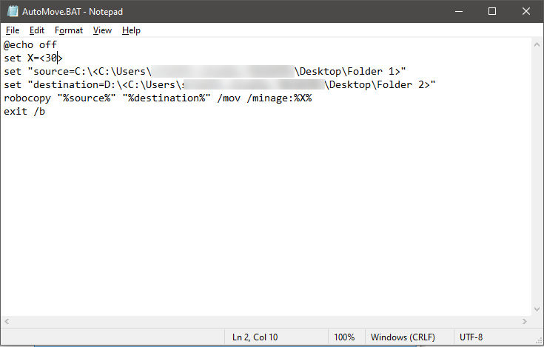](https://cdn.wethegeek.com/wp-content/uploads/2019/08/Automatically-Move-Files-from-One-Folder-to-Another-1.png)

Step 3: Go to File->Save to save the file.  
Step 4: While saving the file, you need to change the default file type from .txt file to All files.  
Step 5: Type <filename>.BAT beside Filename to save the file with . BAT file.  
Step 6: Now click Save to save the file.

**Steps To Create A Task To Run The File**

Once you have set specific and chosen the source and destination folder to move the files, let’s schedule the task to automatically move files from one folder to another on Windows 10

* In the search box on the taskbar, type Task Scheduler and press Enter to open Task Scheduler.  
  [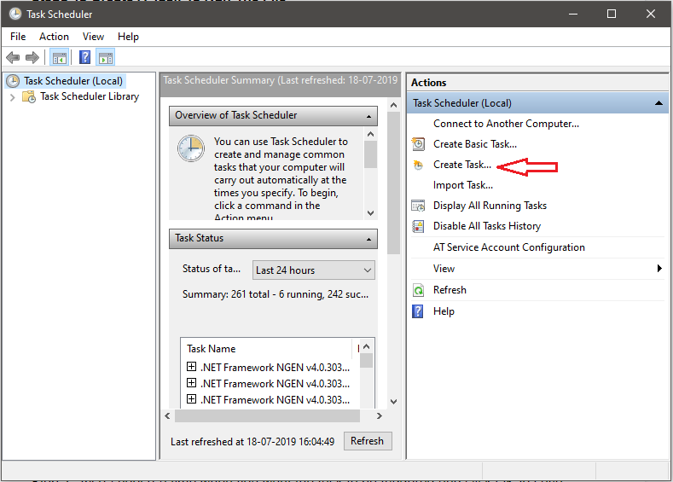](https://cdn.wethegeek.com/wp-content/uploads/2019/08/automatically-move-files-from-one-folder-to-another-2.png)
* On [Task Scheduler window](https://wethegeek.com/best-task-scheduling-software-for-windows/), from the right side of the window, locate and click Create Task.
* Type a suitable name for the task.  
  [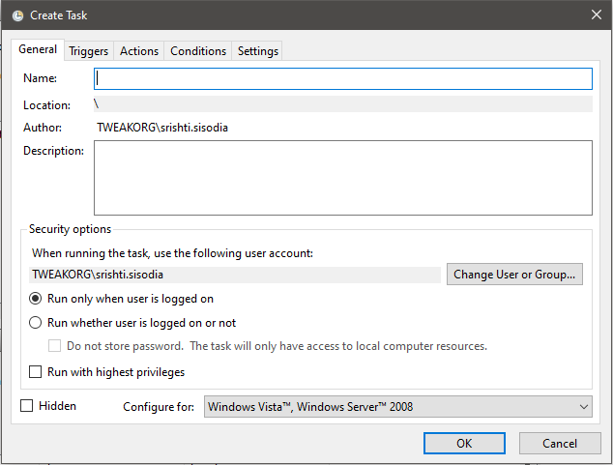](https://cdn.wethegeek.com/wp-content/uploads/2019/08/automatically-move-files-from-one-folder-to-another-3.png)
* On create Task window, click Triggers tab.

](https://cdn.wethegeek.com/wp-content/uploads/2019/08/automatically-move-files-from-one-folder-to-another4.png)

* Click New to create a Trigger.  
  [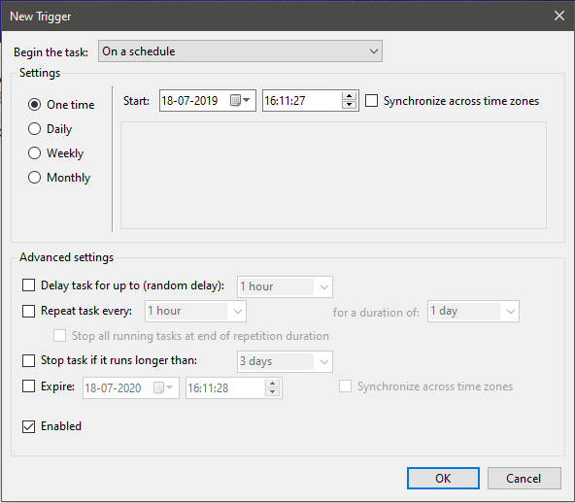](https://cdn.wethegeek.com/wp-content/uploads/2019/08/automatically-move-files-from-one-folder-to-another-5.png)
* Now, from the settings, choose the frequency to trigger. For example, you can choose Daily, One time, Monthly and Weekly.
* Also, choose a time when you want the task to be triggered and click OK to save the settings.

[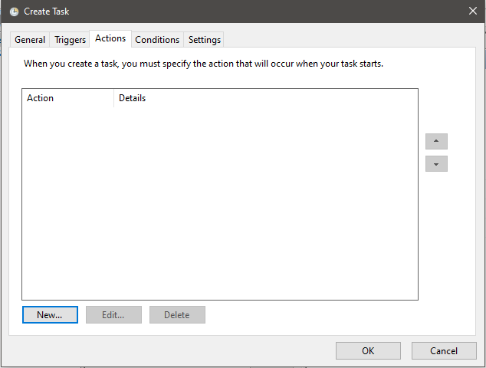](https://cdn.wethegeek.com/wp-content/uploads/2019/08/automatically-move-files-from-one-folder-to-another-6.png)

* Again from the Create Task window, Click Actions tab. This will connect an action to the trigger.
* Locate and Click New on Actions Tab.

[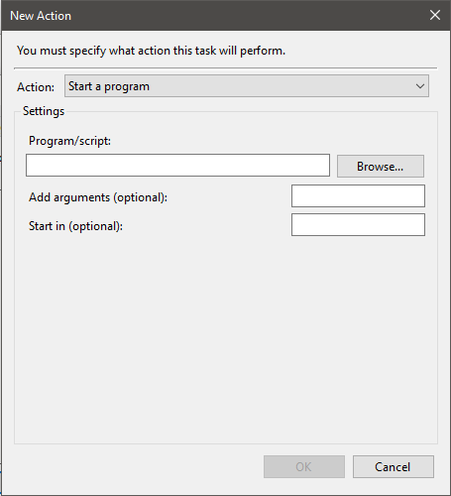](https://cdn.wethegeek.com/wp-content/uploads/2019/08/automatically-move-files-from-one-folder-to-another-7.png)

* From the following window, click browse and navigate to .BAT file that you created and click OK to complete. Now close the Task Scheduler.

So, that’s it! Now you don’t have to worry about moving files and folders from one folder to another, as now it will be an automated file transfer.

**Software To Organize Files And Folders**

This process can not only be done using Task Scheduler and Roboscript, but there are also software to perform automated file transfer to save your time and efforts.

One of the great software to [organize files and folders](https://wethegeek.com/how-to-manage-files-folders-with-windows-tags/) is EaseUS Todo Backup tool which is a backup tool, which has [File Backup](https://wethegeek.com/how-to-save-and-restore-data-in-windows-10-with-file-history/) feature which allows you to copy or move files from one folder to another by setting a schedule.

To use the function, the tool will create an image of your file to another folder weekly, daily or any set time you have scheduled. Preview the image anytime you want but before editing, you should make a copy.

Steps to Move Files from One Folder to Another With Software

* Download and Install **EaseUS backup software**

](https://order.easeus-software.com/505/purl-affstore?cart=230069&x-source=aff_cb&x-clickref=1100lhoi6pmu)

[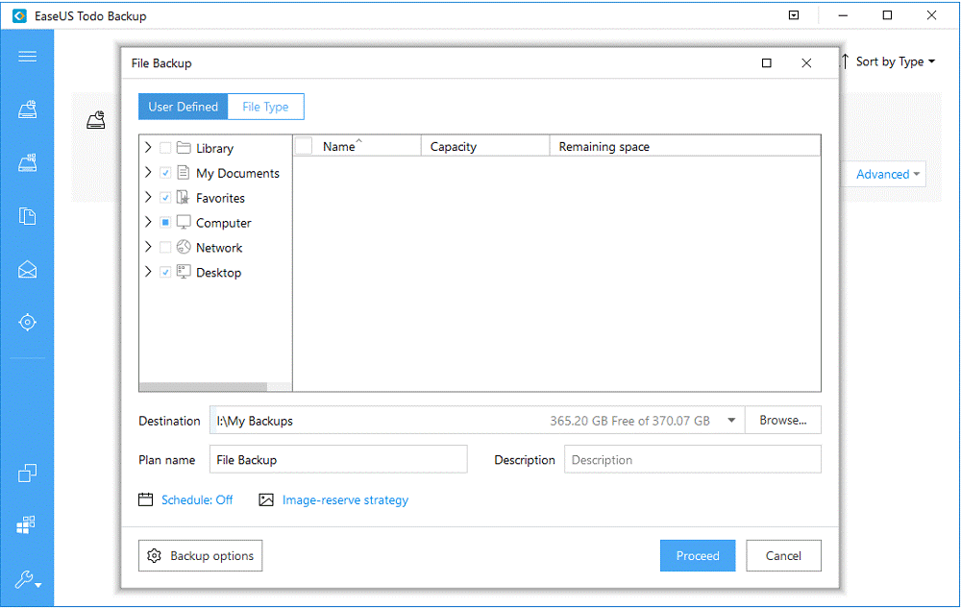](https://cdn.wethegeek.com/wp-content/uploads/2019/08/automatically-move-files-from-one-folder-to-another-8.png)

* Launch the tool and select “File Backup” to copy or move files from one folder to another.  
  [Afbeelding met tekst

  Automatisch gegenereerde beschrijving](https://cdn.wethegeek.com/wp-content/uploads/2019/08/automatically-move-files-from-one-folder-to-another-9.png)
* Choose the files and folders to copy or move. Click Destination to choose a preferred location where you want to copy. You can also choose Plan name and Description to further specify information related to file.  
  [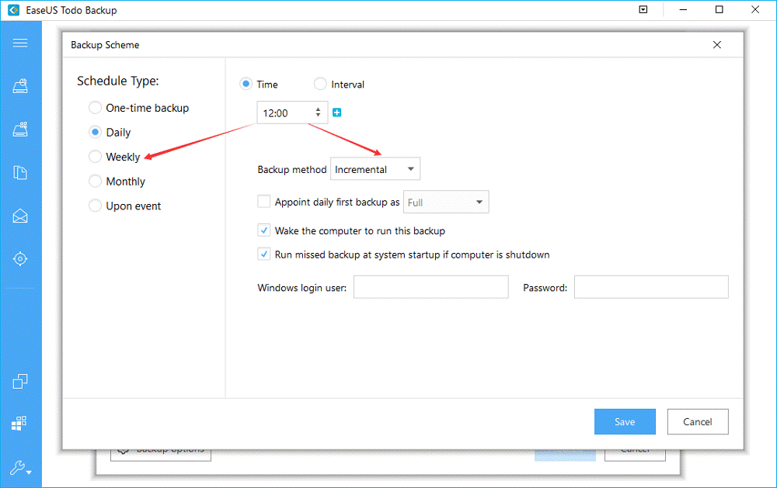](https://cdn.wethegeek.com/wp-content/uploads/2019/08/automatically-move-files-from-one-folder-to-another-10.png)
* Click Schedule to get Backup Scheme window. Now you can schedule backup plan to move files daily, weekly, monthly.

[](https://cdn.wethegeek.com/wp-content/uploads/2019/08/automatically-move-files-from-one-folder-to-another-11.png)

* Click Proceed to move files from one folder to another.