**dd. 29-04-2021**

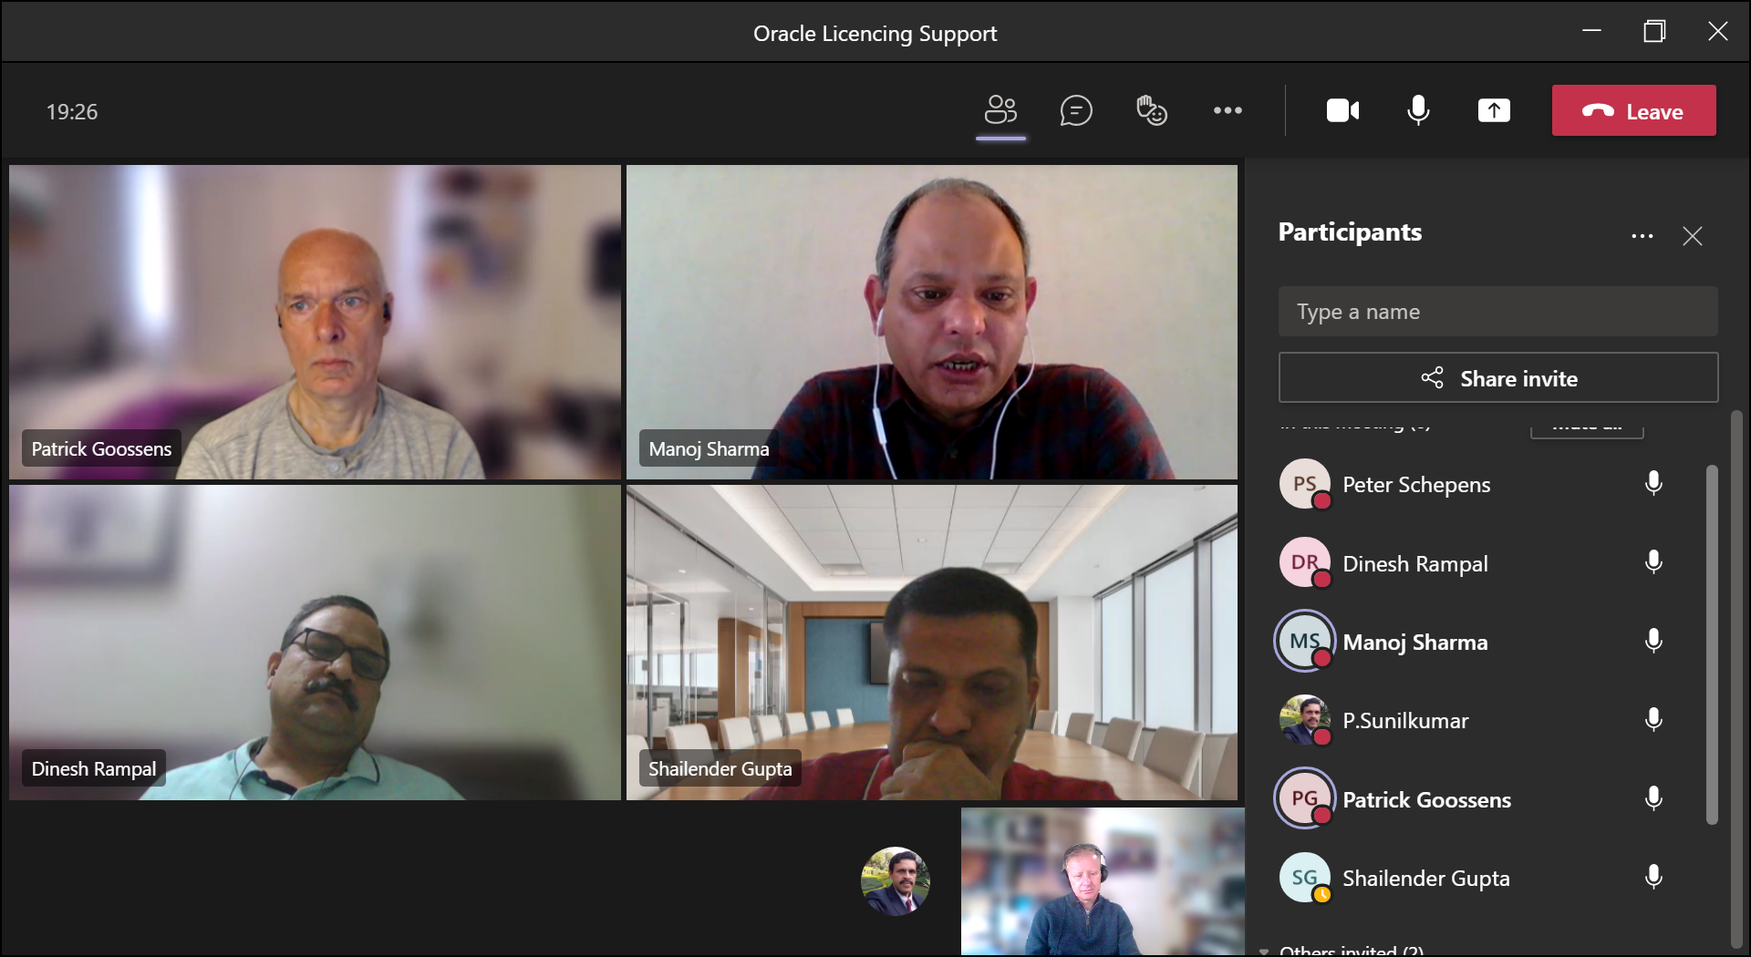

**Afspraken:**

1)verzamel alle oracle-license-info vanuit Europe/India

2)Sunilkumar verzamelt info uit India

3)Sunilkumar zoekt oracle-contact-info van oracle-sales/account-manager

**From:** P.Sunilkumar <[P.Sunilkumar@apollotyres.com](mailto:P.Sunilkumar@apollotyres.com)>

**Sent:** 24 April 2021 11:29  
**To:** Tee Patel <[Tee.Patel@apollotyres.com](mailto:Tee.Patel@apollotyres.com)>; Hizmy Hassen <[Hizmy.Hassen@apollotyres.com](mailto:Hizmy.Hassen@apollotyres.com)>; Shailender Gupta <[shailender.gupta@apollotyres.com](mailto:shailender.gupta@apollotyres.com)>; Manoj Sharma <[manoj.sharma@apollotyres.com](mailto:manoj.sharma@apollotyres.com)>  
**Cc:** Patrick Goossens <[patrick.goossens@apollotyres.com](mailto:patrick.goossens@apollotyres.com)>; Dinesh Rampal <[Dinesh.Rampal@apollotyres.com](mailto:Dinesh.Rampal@apollotyres.com)>; Bappaditya Desarkar <[b.desarkar@apollotyres.com](mailto:b.desarkar@apollotyres.com)>  
**Subject:** Re: Oracle licenses and AWS

Dear Tee ,

While negotiating the renewal of the Oracle subscription for VMS Platform (for PIBS Chennai ) remember we had interacted with Mekhla [Sharma@oracle.com](mailto:Sharma@oracle.com) but I think she is more from the Sales side but she was aware about all  the Apollo side pending (cancelled ) payments etc .

Other than I have interacted with their Tech support though their My Support portal -- Suresh Umapathy (who is the (only) Oracle expert on VMS  )  was the person who diagnosed /helped to solve the backup nothappening  related problem in PIBS Chennai -After lots of analysis online & checking  many logs on PIBS together with Maarten ,we identified the backups were getting aborted due to a script originally  written by Rossingh to stop any jobs taking up more cpu and free it up .We checked after stopping that script  and then found that the backup was running fine .

I think Dinesh may be able to tell us /add something as his id is given as the "Internal Admin"  for Oracle support and he might be able to tell more

Regards, Sunil

**From:** Tee Patel <[Tee.Patel@apollotyres.com](mailto:Tee.Patel@apollotyres.com)>  
**Sent:** 24 April 2021 13:14  
**To:** Hizmy Hassen <[Hizmy.Hassen@apollotyres.com](mailto:Hizmy.Hassen@apollotyres.com)>; Shailender Gupta <[shailender.gupta@apollotyres.com](mailto:shailender.gupta@apollotyres.com)>; Manoj Sharma <[manoj.sharma@apollotyres.com](mailto:manoj.sharma@apollotyres.com)>  
**Cc:** Patrick Goossens <[patrick.goossens@apollotyres.com](mailto:patrick.goossens@apollotyres.com)>; P.Sunilkumar <[P.Sunilkumar@apollotyres.com](mailto:P.Sunilkumar@apollotyres.com)>  
**Subject:** Re: Oracle licenses and AWS

Thanks Hizmy

We do not have internal Oracle expertise. We have hardware for the pibs but this is supported by oracle.

I will check with **Sunilkumar** how we managed to fix the issue we had recently with the back up for oracle.

Yours sincerely...

Tee

+447913331754

**From:** Hizmy Hassen <[Hizmy.Hassen@apollotyres.com](mailto:Hizmy.Hassen@apollotyres.com)>  
**Sent:** Friday, April 23, 2021 4:00 pm  
**To:** Shailender Gupta; Tee Patel; Manoj Sharma  
**Cc:** Patrick Goossens  
**Subject:** Re: Oracle licenses and AWS

Hi Shailender

This is a good question. I would suggest reaching out to **Tee / Akhilesh** who I believe are the Techno lead for Oracle.

Reg

Hizmy

**From:**Shailender Gupta <[shailender.gupta@apollotyres.com](mailto:shailender.gupta@apollotyres.com)>  
**Date:**Thursday, 22 April 2021 at 09:00  
**To:**Hizmy Hassen <[Hizmy.Hassen@apollotyres.com](mailto:Hizmy.Hassen@apollotyres.com)>  
**Cc:**Patrick Goossens <[patrick.goossens@apollotyres.com](mailto:patrick.goossens@apollotyres.com)>  
**Subject:**RE: Oracle licenses and AWS

Hi Hizmy,

We are trying to evaluate if we can run LIMS systems in AWS cloud. The pre-requisite is that we can use our existing license of Oracle on AWS (Bring your own license).

As we also use other products from Oracle – OTM, Oracle Cloud, there must be one account manager from Oracle we can talk to and negotiate a deal.

Can you please guide us whom to reach out to for Oracle account?

**Regards,**

**Shailender Gupta**

Divisional Head (CoE) - MDM, Reporting and Analytics

Tel: +91 124 2721377 | Mobile: +91 9871711334

E-mail: [shailender.gupta@apollotyres.com](mailto:shailender.gupta@apollotyres.com)

Apollo Tyres Ltd., 7, Institutional Area, Sector 32, Gurgaon 122001, India

**From:** Patrick Goossens <[patrick.goossens@apollotyres.com](mailto:patrick.goossens@apollotyres.com)>  
**Sent:** 22 April 2021 01:24 PM  
**To:** Shailender Gupta <[shailender.gupta@apollotyres.com](mailto:shailender.gupta@apollotyres.com)>  
**Subject:** Oracle licenses and AWS

Hi Shailender,

I am currently trying to find out from Oracle what their pre-requisites are for using our licenses in the cloud.

I already know that they do not accept running the Oracle licenses on a virtual server unless AWS can guarantee that the number of processors used is only 2 (or any number you pay Oracle for).

I do not expect much cooperation from Oracle side.

Could you investigate what options AWS has for us? I mean, if they can offer an Oracle server where the licensing has already been taken care of, that would make it much easier.

However we would need to be able to use some network shares at AVBV.

I hope you can help.

Regards,

Patrick

**Patrick Goossens     Project Manager**  
D: +31 (0)53 4888 714 |M:  |T: +31 (0)53 4888 888 | E: [patrick.goossens@apollotyres.com](mailto:patrick.goossens@apollotyres.com)  
Apollo Vredestein B.V.| Ir. E.L.C. Schiffstraat 370, 7547 RD Enschede, The Netherlands  
Chamber of Commerce number: 34223268

________________________________________________________________________________

Microsoft Teams meeting

**Join on your computer or mobile app**

[Click here to join the meeting](https://teams.microsoft.com/l/meetup-join/19%3ameeting_MWIzZmFmNmMtMzdhNS00YTM4LWFkYjgtY2U1NDBhNTc5MzQw%40thread.v2/0?context=%7b%22Tid%22%3a%22f7920029-39f9-41b7-9c94-ec73395d184d%22%2c%22Oid%22%3a%2250af3063-5d62-4cc5-a0b0-6d99a4f4480d%22%7d)

**Join with a video conferencing device**

[81199378@t.plcm.vc](mailto:81199378@t.plcm.vc)

Video Conference ID: 132 059 805 6

[Alternative VTC dialling instructions](https://dialin.plcm.vc/teams/?key=81199378&conf=1320598056)

[Learn more](https://aka.ms/JoinTeamsMeeting) | [Meeting options](https://teams.microsoft.com/meetingOptions/?organizerId=50af3063-5d62-4cc5-a0b0-6d99a4f4480d&tenantId=f7920029-39f9-41b7-9c94-ec73395d184d&threadId=19_meeting_MWIzZmFmNmMtMzdhNS00YTM4LWFkYjgtY2U1NDBhNTc5MzQw@thread.v2&messageId=0&language=en-GB)