Maak eerst met ORADIM een windows-service aan.

**set ORACLE_SID=IS61**

**oradim -NEW -SID IS61 -STARTMODE manual -PFILE "C:\oracle\admin\IS61\pfile\init.ora.120201420589"**

Door shutdown en opnieuw startup STARTEN we met SPFILE ipv met de PFILE op.

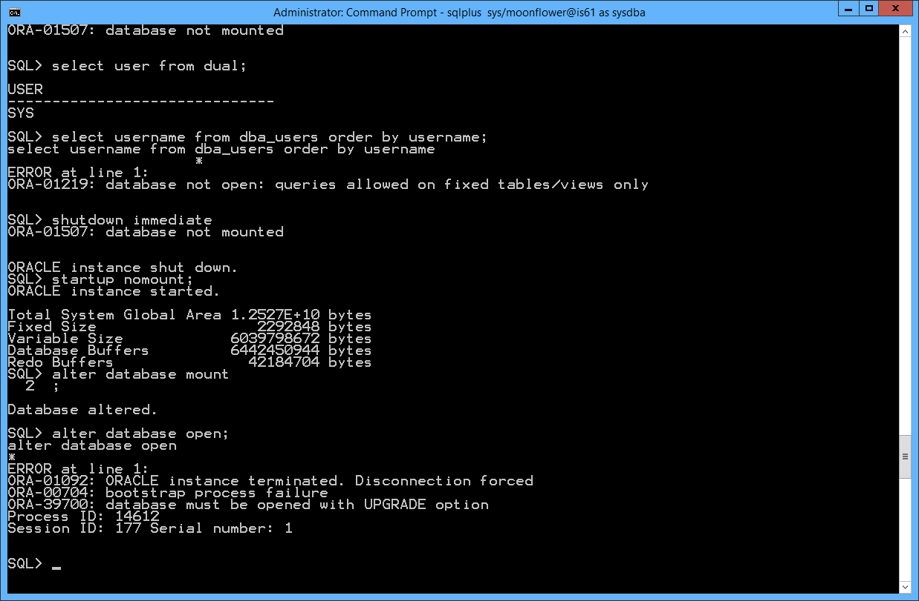

SQL> startup nomount;

ORACLE instance started.

Total System Global Area 1.2527E+10 bytes

Fixed Size 2292848 bytes  
Variable Size 6039798672 bytes  
Database Buffers 6442450944 bytes  
Redo Buffers 42184704 bytes

SQL> alter database mount  
 2 ;

Database altered.

SQL> alter database open;

alter database open

*

ERROR at line 1:

ORA-01092: ORACLE instance terminated. Disconnection forced

ORA-00704: bootstrap process failure

ORA-39700: database must be opened with UPGRADE option

Process ID: 14612

Session ID: 177 Serial number: 1

SQL>

UPGRADE

Starts the database in OPEN UPGRADE mode and sets system initialization parameters to specific values required to enable database upgrade scripts to be run. UPGRADE should only be used when a database is first started with a new version of the Oracle Database Server.

See the [*Oracle Database Upgrade Guide*](https://docs.oracle.com/cd/B28359_01/server.111/b28300/toc.htm) for details about preparing for, testing and implementing a database version upgrade.

When run, upgrade scripts transform an installed version or release of an Oracle database into a later version, for example, to upgrade an Oracle9*i* database to Oracle Database 10*g*. Once the upgrade completes, the database should be shut down and restarted normally.

SQL> alter database mount;  
Database altered.

SQL> select * from v$controlfile;

STATUS  
-------  
NAME  
--------------------------------------------------------------------------------  
IS_ BLOCK_SIZE FILE_SIZE_BLKS  
--- ---------- --------------

D:\DATABASE\IS61\CTL1\IS61\CONTROLFILE\O1_MF_9JG8DOTW_.CTL  
NO 16384 5050

D:\DATABASE\IS61\CTL2\IS61\CONTROLFILE\O1_MF_9JG8DOVD_.CTL  
NO 16384 5050

|  |
| --- |
| **ORA-01092: ORACLE instance terminated  *Oracle Database Tips by Donald Burleson*** |

The Oracle docs note details on the ORA-1092 error:

|  |  |
| --- | --- |
| **ORA-01092:** | ORACLE instance terminated. Disconnection forced |
| **Cause:** | The instance connected to was terminated abnormally, probably due to a SHUTDOWN ABORT. The current process was forced to disconnect from the instance. |
| **Action:** | Examine the alert log for more details. Contact the database administrator to determine when the instance is restarted. Attempt to reconnect after the instance is running again. |

The *ORA-01092: ORACLE instance terminated Disconnection forced.* is a generic error when Oracle detects a serious problem at database start time.

The ORA-01092: ORACLE instance terminated error can be caused by many factors, and I've seen there:

* A shutdown abort
* Bad permissions of BDUMP, CDUMP or UDUMP directories
* Missing datafiles
* Renaming files when Oracle is down
* and many other OS-related causes

Check your alert log for a more descriptive report of the exact startup problem

CONTROLE ALERT.LOG

C:\Oracle\diag\rdbms\u611\u611\trace

ORACLE-SUPPORT

**Ora-00704,Ora-39700: Database Must Be Opened With Upgrade Option (Doc ID 1349722.1)**

## SYMPTOMS

While opening a database, the following errors are observed in the alert log

ORA-00704: bootstrap process failure  
ORA-39700: database must be opened with UPGRADE option

The following is observed in the sqlplus session

SQL> startup;  
ORACLE instance started.  
  
Total System Global Area 1954160640 bytes  
Fixed Size                  2227752 bytes  
Variable Size            1325400536 bytes  
Database Buffers          620756992 bytes  
Redo Buffers                5775360 bytes  
Database mounted.  
ORA-01092: ORACLE instance terminated. Disconnection forced  
ORA-00704: bootstrap process failure  
ORA-39700: database must be opened with UPGRADE option  
Process ID: 22861  
Session ID: 1705 Serial number: 5

## CHANGES

The database was recently upgraded  from 11.2.0.1 to 11.2.0.2

## CAUSE

PATH variable was pointing to 11.2.0.1 ORACLE_HOME rather than 11.2.0.2 ORACLE_HOME during the upgrade. Hence, the wrong version of sqlplus was invoked

PATH=/oracle/product/11.2.0/bin:/usr/sbin:/usr/kerberos/bin:/usr/local/bin:/bin:/usr/bin:/oracle/product/11.2.0/bin:/sbin:/usr/sbin:/home/oracle/bin:/home/oracle/bin:/oracle/product/11.2.0.2//bin:/usr/lib64/qt-3.3/bin:/usr/kerberos/bin:/usr/local/bin:/bin:/usr/bin:/home/oracle/bin:/usr/java

sqlplus banner follows (note that sqlplus release is 11.2.0.1.0 whereas the database version is 11.2.0.2.0)

$ sqlplus / as sysdba  
SQL*Plus: Release 11.2.0.1.0 Production on Mon Aug 15 21:10:55 2011  
Copyright (c) 1982, 2009, Oracle. All rights reserved.  
Connected to:  
Oracle Database 11g Release 11.2.0.2.0 - 64bit Production  
Connected to an idle instance.

## SOLUTION

Correct the environment variables to point to the correct ORACLE_HOME, PATH etc and rerun catupgrd.sql

## REFERENCES

[NOTE:1276368.1](https://support.oracle.com/epmos/faces/DocumentDisplay?parent=DOCUMENT&sourceId=1349722.1&id=1276368.1) - Complete Checklist for out-of-Place Manual Upgrade from Previous 11.2.0.N Version to the Latest 11.2.0.N Patchset  
[NOTE:1152016.1](https://support.oracle.com/epmos/faces/DocumentDisplay?parent=DOCUMENT&sourceId=1349722.1&id=1152016.1) - Master Note For Oracle Database Upgrades and Migrations

Onderzoek eigen omgeving:

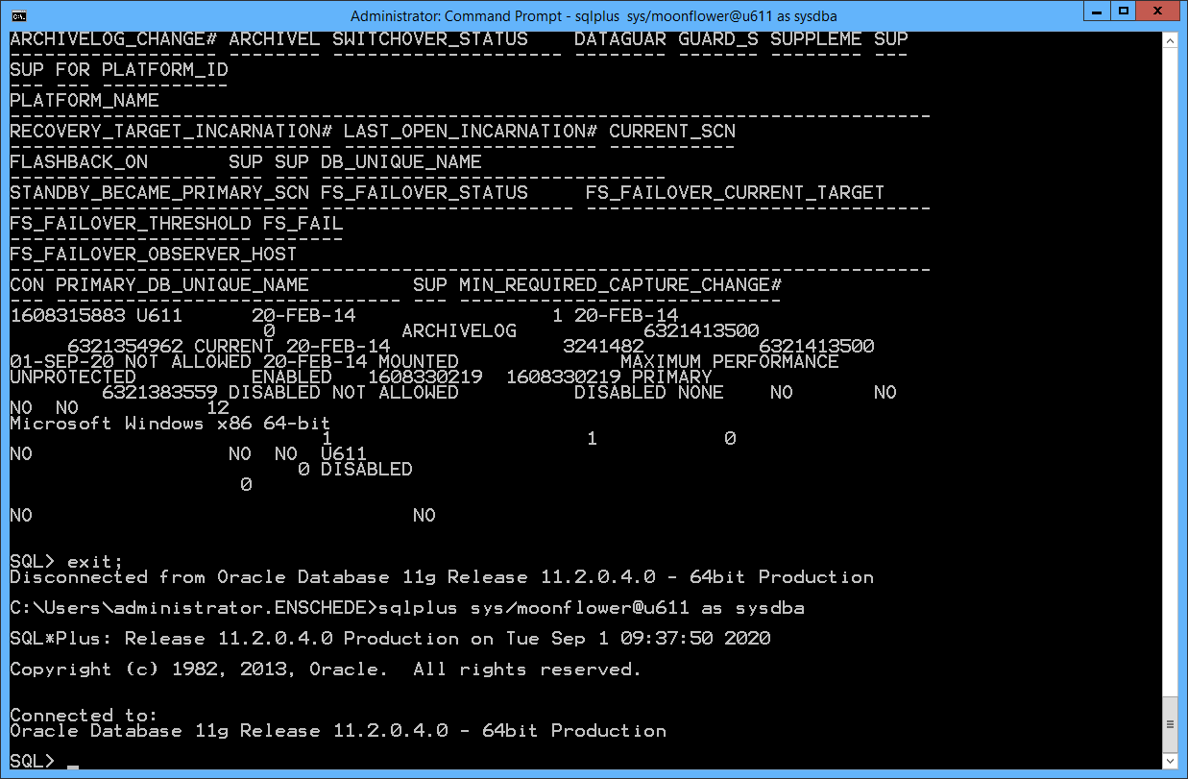

Server + sqlplus versie is gelijk aan elkaar, dus dat kan problem niet zijn !!!

Now how to check if there is really a mismatch? First we create a trace file with datafile header dump.

##### **SQL> alter session set tracefile_identifier=’datafile_hdr’; SQL> alter session set events ‘immediate trace name file_hdrs level 10’;**

From trace file, extract section “V10 STYLE FILE HEADER” & check the value “Compatibility Vsn”.

##### **V10 STYLE FILE HEADER: Compatibility Vsn = 123456789=0xb200400**

Current value b200400 <———> b 2 0 0 4 0 0 (Hex) – 11 2 0 4 0 0 (Decimal). Expected value was c100200.

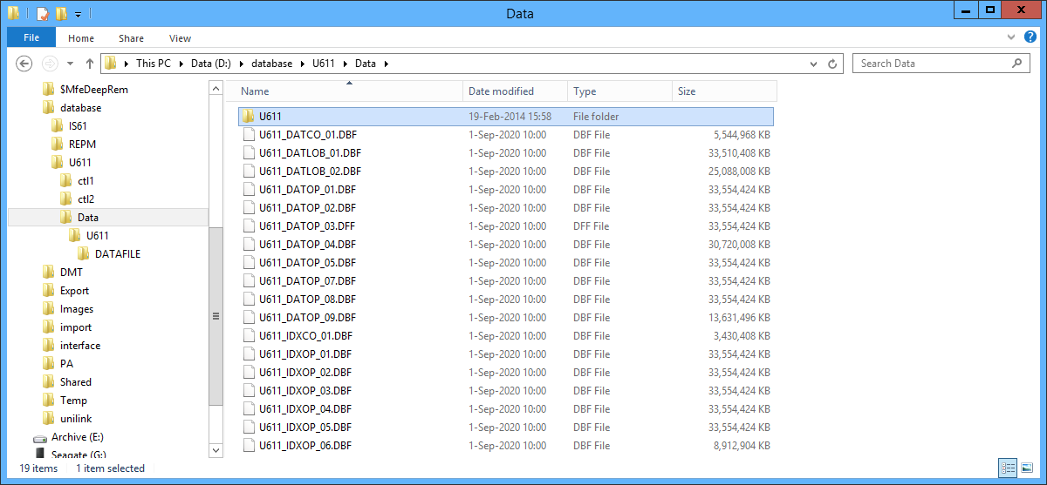

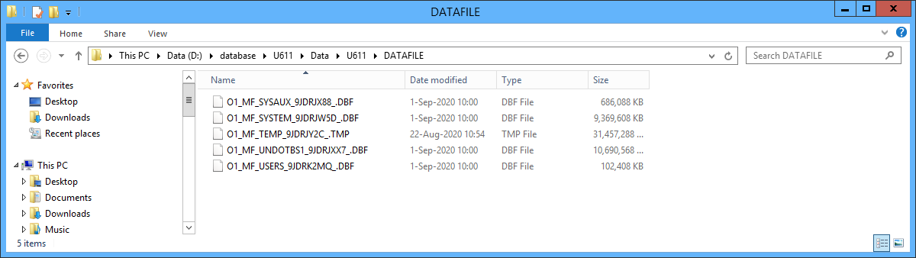

**Valt op dat DE TEMP-file NIET GEWIJZIGD is !!!!!!!!!**

Uit trc-file:

**DATA FILE #1:**

name #7: D:\DATABASE\U611\DATA\U611\DATAFILE\O1_MF_SYSTEM_9JDRJW5D_.DBF

V10 STYLE FILE HEADER:

Compatibility Vsn = 186646528=0xb200000

Db ID=1608315883=0x5fdcf3eb, Db Name='U611'

Activation ID=0=0x0

Control Seq=3241512=0x317628, File size=1171200=0x11df00

File Number=1, Blksiz=8192, File Type=3 DATA

Tablespace #0 - SYSTEM rel_fn:1

**DATA FILE #2:**

name #8: D:\DATABASE\U611\DATA\U611\DATAFILE\O1_MF_SYSAUX_9JDRJX88_.DBF

V10 STYLE FILE HEADER:

Compatibility Vsn = 186646528=0xb200000

Db ID=1608315883=0x5fdcf3eb, Db Name='U611'

Activation ID=0=0x0

Control Seq=3241512=0x317628, File size=85760=0x14f00

File Number=2, Blksiz=8192, File Type=3 DATA

**DATA FILE #3:**

name #9: D:\DATABASE\U611\DATA\U611\DATAFILE\O1_MF_UNDOTBS1_9JDRJXX7_.DBF

V10 STYLE FILE HEADER:

Compatibility Vsn = 186646528=0xb200000

Db ID=1608315883=0x5fdcf3eb, Db Name='U611'

Activation ID=0=0x0

Control Seq=3241512=0x317628, File size=1336320=0x146400

File Number=3, Blksiz=8192, File Type=3 DATA

Tablespace #2 - UNI_UNDO rel_fn:3

**DATA FILE #4:**

name #11: D:\DATABASE\U611\DATA\U611\DATAFILE\O1_MF_USERS_9JDRK2MQ_.DBF

V10 STYLE FILE HEADER:

Compatibility Vsn = 186646528=0xb200000

Db ID=1608315883=0x5fdcf3eb, Db Name='U611'

Activation ID=0=0x0

Control Seq=3241512=0x317628, File size=12800=0x3200

File Number=4, Blksiz=8192, File Type=3 DATA

Tablespace #4 - UNI_BO rel_fn:4

**DATA FILE #5:**

name #12: D:\DATABASE\U611\DATA\U611_DATCO_01.DBF

V10 STYLE FILE HEADER:

Compatibility Vsn = 186646528=0xb200000

Db ID=1608315883=0x5fdcf3eb, Db Name='U611'

Activation ID=0=0x0

Control Seq=3241512=0x317628, File size=693120=0xa9380

File Number=5, Blksiz=8192, File Type=3 DATA

Tablespace #5 - UNI_DATAC rel_fn:5

DATA FILE #6:

name #13: D:\DATABASE\U611\DATA\U611_DATOP_01.DBF

V10 STYLE FILE HEADER:

Compatibility Vsn = 186646528=0xb200000

Db ID=1608315883=0x5fdcf3eb, Db Name='U611'

Activation ID=0=0x0

Control Seq=3241512=0x317628, File size=4194302=0x3ffffe

File Number=6, Blksiz=8192, File Type=3 DATA

Tablespace #6 - UNI_DATAO rel_fn:6

DATA FILE #7:

name #14: D:\DATABASE\U611\DATA\U611_DATOP_02.DBF

V10 STYLE FILE HEADER:

Compatibility Vsn = 186646528=0xb200000

Db ID=1608315883=0x5fdcf3eb, Db Name='U611'

Activation ID=0=0x0

Control Seq=3241512=0x317628, File size=4194302=0x3ffffe

File Number=7, Blksiz=8192, File Type=3 DATA

Tablespace #6 - UNI_DATAO rel_fn:7

DATA FILE #8:

name #15: D:\DATABASE\U611\DATA\U611_DATOP_03.DFF

V10 STYLE FILE HEADER:

Compatibility Vsn = 186646528=0xb200000

Db ID=1608315883=0x5fdcf3eb, Db Name='U611'

Activation ID=0=0x0

Control Seq=3241512=0x317628, File size=4194302=0x3ffffe

File Number=8, Blksiz=8192, File Type=3 DATA

Tablespace #6 - UNI_DATAO rel_fn:8

DATA FILE #9:

name #16: D:\DATABASE\U611\DATA\U611_DATOP_04.DBF

V10 STYLE FILE HEADER:

Compatibility Vsn = 186646528=0xb200000

Db ID=1608315883=0x5fdcf3eb, Db Name='U611'

Activation ID=0=0x0

Control Seq=3241512=0x317628, File size=3840000=0x3a9800

File Number=9, Blksiz=8192, File Type=3 DATA

Tablespace #6 - UNI_DATAO rel_fn:9

DATA FILE #10:

name #17: D:\DATABASE\U611\DATA\U611_IDXCO_01.DBF

V10 STYLE FILE HEADER:

Compatibility Vsn = 186646528=0xb200000

Db ID=1608315883=0x5fdcf3eb, Db Name='U611'

Activation ID=0=0x0

Control Seq=3241512=0x317628, File size=428800=0x68b00

File Number=10, Blksiz=8192, File Type=3 DATA

Tablespace #7 - UNI_INDEXC rel_fn:10

DATA FILE #11:

name #18: D:\DATABASE\U611\DATA\U611_IDXOP_01.DBF

V10 STYLE FILE HEADER:

Compatibility Vsn = 186646528=0xb200000

Db ID=1608315883=0x5fdcf3eb, Db Name='U611'

Activation ID=0=0x0

Control Seq=3241512=0x317628, File size=4194302=0x3ffffe

File Number=11, Blksiz=8192, File Type=3 DATA

Tablespace #8 - UNI_INDEXO rel_fn:11

DATA FILE #12:

name #19: D:\DATABASE\U611\DATA\U611_IDXOP_02.DBF

V10 STYLE FILE HEADER:

Compatibility Vsn = 186646528=0xb200000

Db ID=1608315883=0x5fdcf3eb, Db Name='U611'

Activation ID=0=0x0

Control Seq=3241512=0x317628, File size=4194302=0x3ffffe

File Number=12, Blksiz=8192, File Type=3 DATA

Tablespace #8 - UNI_INDEXO rel_fn:12

DATA FILE #13:

name #20: D:\DATABASE\U611\DATA\U611_IDXOP_03.DBF

V10 STYLE FILE HEADER:

Compatibility Vsn = 186646528=0xb200000

Db ID=1608315883=0x5fdcf3eb, Db Name='U611'

Activation ID=0=0x0

Control Seq=3241512=0x317628, File size=4194302=0x3ffffe

File Number=13, Blksiz=8192, File Type=3 DATA

Tablespace #8 - UNI_INDEXO rel_fn:13

DATA FILE #14:

name #21: D:\DATABASE\U611\DATA\U611_DATLOB_01.DBF

V10 STYLE FILE HEADER:

Compatibility Vsn = 186646528=0xb200000

Db ID=1608315883=0x5fdcf3eb, Db Name='U611'

Activation ID=0=0x0

Control Seq=3241512=0x317628, File size=4188800=0x3fea80

File Number=14, Blksiz=8192, File Type=3 DATA

Tablespace #9 - UNI_LOB rel_fn:14

DATA FILE #15:

name #22: D:\DATABASE\U611\DATA\U611_DATOP_05.DBF

V10 STYLE FILE HEADER:

Compatibility Vsn = 186646528=0xb200000

Db ID=1608315883=0x5fdcf3eb, Db Name='U611'

Activation ID=0=0x0

Control Seq=3241512=0x317628, File size=4194302=0x3ffffe

File Number=15, Blksiz=8192, File Type=3 DATA

Tablespace #6 - UNI_DATAO rel_fn:15

DATA FILE #16:

name #23: D:\DATABASE\U611\U611_DATOP_06.DBF

V10 STYLE FILE HEADER:

Compatibility Vsn = 186646528=0xb200000

Db ID=1608315883=0x5fdcf3eb, Db Name='U611'

Activation ID=0=0x0

Control Seq=3241512=0x317628, File size=4194302=0x3ffffe

File Number=16, Blksiz=8192, File Type=3 DATA

Tablespace #6 - UNI_DATAO rel_fn:16

DATA FILE #17:

name #24: D:\DATABASE\U611\DATA\U611_IDXOP_04.DBF

V10 STYLE FILE HEADER:

Compatibility Vsn = 186646528=0xb200000

Db ID=1608315883=0x5fdcf3eb, Db Name='U611'

Activation ID=0=0x0

Control Seq=3241512=0x317628, File size=4194302=0x3ffffe

File Number=17, Blksiz=8192, File Type=3 DATA

Tablespace #8 - UNI_INDEXO rel_fn:17

DATA FILE #18:

name #25: D:\DATABASE\U611\DATA\U611_DATLOB_02.DBF

V10 STYLE FILE HEADER:

Compatibility Vsn = 186646528=0xb200000

Db ID=1608315883=0x5fdcf3eb, Db Name='U611'

Activation ID=0=0x0

Control Seq=3241512=0x317628, File size=3136000=0x2fda00

File Number=18, Blksiz=8192, File Type=3 DATA

Tablespace #9 - UNI_LOB rel_fn:18

DATA FILE #19:

name #26: D:\DATABASE\U611\DATA\U611_DATOP_07.DBF

V10 STYLE FILE HEADER:

Compatibility Vsn = 186646528=0xb200000

Db ID=1608315883=0x5fdcf3eb, Db Name='U611'

Activation ID=0=0x0

Control Seq=3241512=0x317628, File size=4194302=0x3ffffe

File Number=19, Blksiz=8192, File Type=3 DATA

Tablespace #6 - UNI_DATAO rel_fn:19

DATA FILE #20:

name #27: D:\DATABASE\U611\DATA\U611_IDXOP_05.DBF

V10 STYLE FILE HEADER:

Compatibility Vsn = 186646528=0xb200000

Db ID=1608315883=0x5fdcf3eb, Db Name='U611'

Activation ID=0=0x0

Control Seq=3241512=0x317628, File size=4194302=0x3ffffe

File Number=20, Blksiz=8192, File Type=3 DATA

Tablespace #8 - UNI_INDEXO rel_fn:20

DATA FILE #21:

name #28: D:\DATABASE\U611\DATA\U611_DATOP_08.DBF

V10 STYLE FILE HEADER:

Compatibility Vsn = 186646528=0xb200000

Db ID=1608315883=0x5fdcf3eb, Db Name='U611'

Activation ID=0=0x0

Control Seq=3241512=0x317628, File size=4194302=0x3ffffe

File Number=21, Blksiz=8192, File Type=3 DATA

Tablespace #6 - UNI_DATAO rel_fn:21

DATA FILE #22:

name #29: D:\DATABASE\U611\DATA\U611_IDXOP_06.DBF

V10 STYLE FILE HEADER:

Compatibility Vsn = 186646528=0xb200000

Db ID=1608315883=0x5fdcf3eb, Db Name='U611'

Activation ID=0=0x0

Control Seq=3241512=0x317628, File size=1114112=0x110000

File Number=22, Blksiz=8192, File Type=3 DATA

Tablespace #8 - UNI_INDEXO rel_fn:22

Creation at scn: 0x0001.49d1084d 01/10/2019 14:37:16

DATA FILE #23:

name #30: D:\DATABASE\U611\DATA\U611_DATOP_09.DBF

V10 STYLE FILE HEADER:

Compatibility Vsn = 186646528=0xb200000

Db ID=1608315883=0x5fdcf3eb, Db Name='U611'

Activation ID=0=0x0

Control Seq=3241512=0x317628, File size=1703936=0x1a0000

File Number=23, Blksiz=8192, File Type=3 DATA

Tablespace #6 - UNI_DATAO rel_fn:23

**DATA FILE #24:**

**name #31: C:\ORACLE\PRODUCT\11.2.0\DBHOME_1\DATABASE\TBS1_ATS_USERS.DBF**

**V10 STYLE FILE HEADER:**

**Compatibility Vsn = 186646528=0xb200000**

**Db ID=1608315883=0x5fdcf3eb, Db Name='U611'**

**Activation ID=0=0x0**

**Control Seq=3241512=0x317628, File size=131072=0x20000**

**File Number=24, Blksiz=8192, File Type=3 DATA**

**Tablespace #10 - ATS_USERS rel_fn:24**

TEMP FILE #1: External File #201

name #10: D:\DATABASE\U611\DATA\U611\DATAFILE\O1_MF_TEMP_9JDRJY2C_.TMP

V10 STYLE FILE HEADER:

Compatibility Vsn = 186646528=0xb200000

Db ID=1608315883=0x5fdcf3eb, Db Name='U611'

Activation ID=0=0x0

Control Seq=2874123=0x2bdb0b, File size=3932160=0x3c0000

File Number=1, Blksiz=8192, File Type=6 TEMP FILE

Tablespace #3 - TEMP rel_fn:1

Current value b200400 <———> b 2 0 0 4 0 0 (Hex) – 11 2 0 4 0 0 (Decimal). Expected value was c100200.

**Dus: hex: b 2 0 0 4 00 = dec: 11.2.0.4.0.0**

**En onze datafiles hebben code: b 2 0 0 0 0 0 => komt overeen met oracle 11.2.0.0. !!!!!!!!!!**

Also checked the restored control file from the backup before the upgrade — I restored it and mounted database then ran:

SQL>alter session set events 'immediate trace name controlf level 9';