<https://pages.awscloud.com/GLOBAL_GC_GS_avoiding-the-oracle-price-traps-whitepaper_20210312_7014z0000014S3v.html>

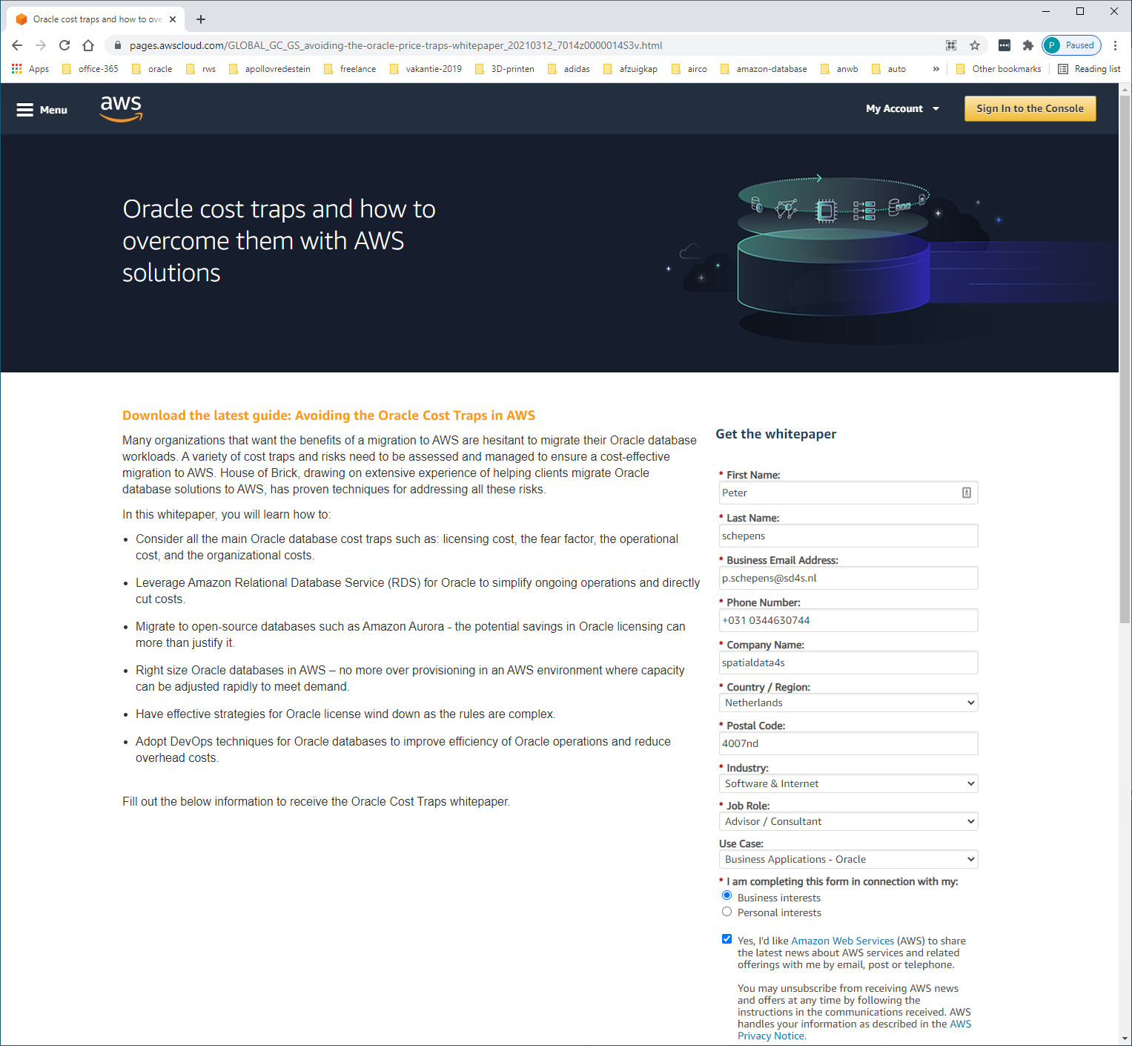

Oracle-versies op AMAZON-RDS

<https://docs.aws.amazon.com/AmazonRDS/latest/UserGuide/CHAP_Oracle.html>

Amazon RDS supports DB instances that run the following versions and editions of Oracle Database:

* Oracle Database 19c (19.0.0.0)
* Oracle Database 18c (18.0.0.0)
* Oracle Database 12c Release 2 (12.2.0.1)
* Oracle Database 12c Release 1 (12.1.0.2)

AWS EC2 op windows-server

<https://aws.amazon.com/windows/products/ec2/>

Oracle Standard Edition One and Standard Edition 2 may only be licensed on Authorized **Cloud** Environment instances **up to eight Amazon vCPUs (Each vCPU is a thread of a CPU core)**

**Conclusie: max 8 threads,   
bereiken via 8/2=4 cores obv 2 threads  
of via 8/1 = 8 cores obv 1 thread !!!**

**oracle-standard-edition-cpu-sockets.docx**

**Oracle Database SE2 can be licensed on servers with a maximum of 2 sockets**. However, the core counts per 2-socket server can increase over time without impacting customer license obligation. With Oracle Database SE2, customer license costs remain the same regardless of the number of cores in the socket.

**Userguide-instance-optimize-cpu.html**

https://docs.aws.amazon.com/AWSEC2/latest/UserGuide/instance-optimize-cpu.html

In most cases, there is an Amazon EC2 instance type that has a combination of memory and number of vCPUs to suit your workloads. However, you can specify the following CPU options to optimize your instance for specific workloads or business needs:

* **Number of CPU cores**: You can customize the number of CPU cores for the instance. You might do this to potentially optimize the licensing costs of your software with an instance that has sufficient amounts of RAM for memory-intensive workloads but fewer CPU cores.
* **Threads per core**: You can disable multithreading by specifying a single thread per CPU core. You might do this for certain workloads, such as high performance computing (HPC) workloads.

You can specify these CPU options during instance launch. There is no additional or reduced charge for specifying CPU options. You're charged the same as instances that are launched with default CPU options.