https://www.dincloud.com/blog/comparing-microsoft-sql-standard-vs-enterprise#:~:text=Security%20Features%20of%20Microsoft%20SQL%20Enterprise&text=Like%20the%20Standard%20edition%2C%20Enterprise,encryption%2C%20and%20extensible%20key%20management.

Comparing Microsoft SQL Standard vs. Enterprise

**Microsoft SQL Standard** and **Enterprise** share several features, but there are also many differences. From **pricing** and **scalability** to **performance** and **functionality**, each server is tailored to businesses with varying needs. To identify the right edition for your business, consider the following criteria.

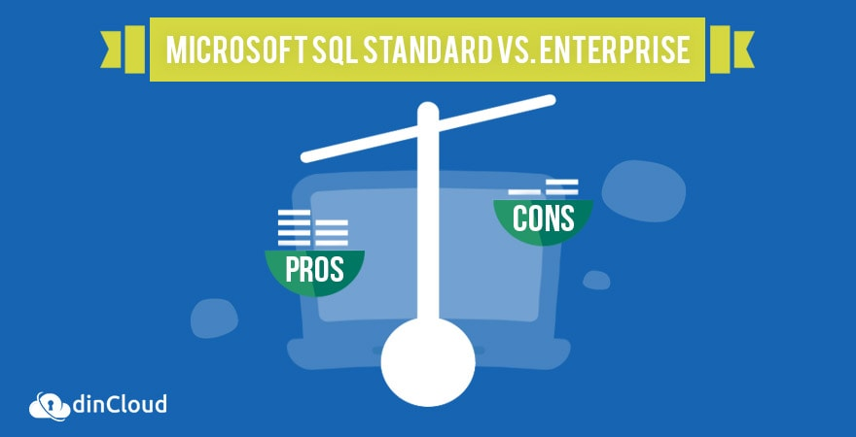

## **Microsoft SQL Standard**

Microsoft **SQL Server Standard** provides all the fundamental database, reporting, and analytics capabilities. It also includes basic availability features and disaster recovery. Microsoft SQL Server Standard can run non-mission critical applications, deliver standard reporting and analytics, and build rich content management applications.

| **Pros** | **Cons** |
| --- | --- |
| Free version available for development or the educational industry with minor limitations compared to the full version. | Can be costly if you don’t qualify for the free version. According to [Techwalla](https://www.techwalla.com/articles/advantages-disadvantages-of-microsoft-sql), the SQL Server Standard Edition costs **$7,171 per processor**, and the SQL Server Datacenter edition is **$54,990 per processor.** |
| Easy to configure | Limited Compatibility - The solution is designed to only run on Microsoft products, meaning if your business currently has little to no current Microsoft infrastructure already in place, you will need to make significant investments in the Microsoft ecosystem to utilize the technology. |
| Adaptability to future technology enhancements | Dependency - Once in place, users of Microsoft SQL will become dependent on the Microsoft technology stack and are reliant on the technology firm for any future features or improvements. This typically involves a 2-year cycle wait time for updates. |
| Reduced complexity | Installation and Operation of the server requires Internet Explorer (IE) 4.0 |
| Dynamic Resource Allocation - disk and memory usage can scale to meet the changing demands on the infrastructure. | No Cascading DRI - Triggers can be a workaround for this missing component, but since every other competitor includes this feature, this is a significant shortcoming. |
| Professional, enterprise-level database management, such as supporting triggers for Microsoft products and close integration with the .NET framework. | N/A |
| iSQL - this essential tool enables users to perform interactive queries and build stored procedures, then view them in a graphical representation to display the steps the processor will use to execute. | N/A |

PreviousNext

## **Microsoft SQL Enterprise**

Microsoft **SQL Server Enterprise** includes everything in the Standard edition, but has additional features. The Enterprise SQL Server is optimal for companies focusing on scalability and performance.

| **Pros** | **Cons** |
| --- | --- |
| Adaptability to future technology enhancements | No Cascading DRI - Triggers can be a workaround for this missing component, but since every other competitor includes this feature, this is a significant shortcoming. |
| Reduced complexity | Limited Compatibility - The solution is designed to only run on Microsoft products, meaning if your business currently has little to no current Microsoft infrastructure already in place, you will need to make significant investments in the Microsoft ecosystem to utilize the technology. |
| Professional, enterprise-level database management, such as supporting triggers for Microsoft products and close integration with the .NET framework. | Can be costly if you don’t qualify for the free version. According to [Techwalla](https://www.techwalla.com/articles/advantages-disadvantages-of-microsoft-sql), the SQL Server Standard Edition costs $7,171 per processor, and the SQL Server Datacenter edition is $54,990 per processor. |
| Easy to configure | Installation and Operation of the server requires Internet Explorer (IE) 4.0 |
| Dynamic Resource Allocation - disk and memory usage can scale to meet the changing demands on the infrastructure. | Dependency - Once in place, users of Microsoft SQL will become dependent on the Microsoft technology stack and are reliant on the technology firm for any future features or improvements. This typically involves a 2-year cycle wait time for updates. |
| Free version available for development or the educational industry with minor limitations compared to the full version. | N/A |
| iSQL - this essential tool enables users to perform interactive queries and build stored procedures, then view them in a graphical representation to display the steps the processor will use to execute. | N/A |

PreviousNext

## **SQL Server 2019 and Its Core Benefits**

[**SQL Server 2019**](https://www.dincloud.com/blog/sql-server-2019) is Microsoft’s latest iteration of world renowned database management platform. We are currently in the era of big data in which the ability of organizations to manage and process data effectively is becoming ever more important.

There are many factors that make database management truly a daunting challenge. In large and multinational organizations, data is being generated from multiple sources. The mere consolidation of this data is a big ask. The format of such data is also not uniform in many cases and this creates data integration issues.

Let’s highlight some of the major capabilities and benefits of SQL Server 2019 and how it fits as your go to database management tool.

* The database management tool is capable of accepting, storing, managing and analyzing data in a wide array of formats, which makes it a very versatile solution.
* SQL Server 2019 enables you to query across relational, non-relational, structured and unstructured data so that you can gain out of the box insights about your business or process.
* Use the language and platform that you feel comfortable with along with open source support.
* Enjoy industry leading performance and rapid scalability of your database.
* Get high availability for your database that is linked to all business critical applications.
* The impeccable track record of SQL Server in database security now spans over nine straight years.
* You get built-in features for data classification, protection, monitoring and alerts.
* Convert data into actionable information by leveraging the superior reporting capabilities of SQL Server 2019.
* The Power BI Report Server comes included with the package that delivers reports across multiple devices.

The SQL Server 2019 is yet another potent addition to the already established database management prowess of Microsoft. In this product, the company has not only improved the existing capabilities but also added a host of new features to attract more customers from a wide range of industries.

### **Performance Features of Microsoft SQL Enterprise**

The Standard edition only has three of the eleven features in scalability and performance included in the Enterprise edition. Enterprise is the edition of choice if a company plans to scale in the near future. Generally, Enterprise supports up to 524 petabytes, but it can also support the maximum amount of RAM and number of core processors that the host system offers, compared to the Standard’s 128 GB.

### **Security Features of Microsoft SQL Enterprise**

Another key component of Microsoft SQL Server Enterprise is security. Like the Standard edition, Enterprise includes basic auditing, contained databases, encryption and backups, and user-defined roles. It surpasses the Standard edition with its inclusion of fine grained auditing, transparent database encryption, and extensible key management. These are key tools to ensure maximum security.

### **Replication Features of Microsoft SQL Enterprise**

In discussing the feature of replication, the Standard edition has most of the features including SQL Server change tracking, merge replication, and snapshot replication. Microsoft SQL Enterprise outperforms the Standard edition in Oracle publishing and peer-to-peer transactional replication.

## **Choosing between SQL Enterprise and SQL Standard**

The two SQL Server editions both have similar features for management tools, RDBMS Manageability, Development Tools, and Programmability. Despite many similarities between the two editions, it is clear that Enterprise delivers more functionality than the other editions of SQL Server, including the Standard edition. A company that has a need for all the additional features and scalability of Microsoft SQL Enterprise, should opt for this edition. Whereas, smaller organizations may be able to utilize the foundation offered by SQL Server Standard edition.

For more information on this topic, and your cloud-hosted SQL Server options, visit our [**SQL Server webpage**](https://www.dincloud.com/hosted-sql-server).