**19c Container Database Data Guard Configuration**

**Purpose**

This note outlines the steps to create an Oracle 19c Container Database via DBCA and then use the RMAN DUPLICATE command to create a physical standby Container Database.

Data Guard Broker configuration steps are also shown in the note.

**Environment**

* Primary database host: db22
* Standby database host: db21
* Primary CDB ORACLE_SID: crsacdb
* Standby CDB ORACLE_SID: crsacdb
* Primary CDB DB_UNIQUE_NAME: crsacdb
* Standby CDB DB_UNIQUE_NAME: crsacdb_s
* Data file location for Primary and Standby database is the same
* Primary and Standby Listener: LISTENER_CRS on port 1512

**Create the Primary CDB via DBCA**

oracle@db22:~$ **cd $ORACLE_HOME/bin**

oracle@db22:/opt/oracle/product/19.0.0/dbhome_1/bin$ **./dbca**

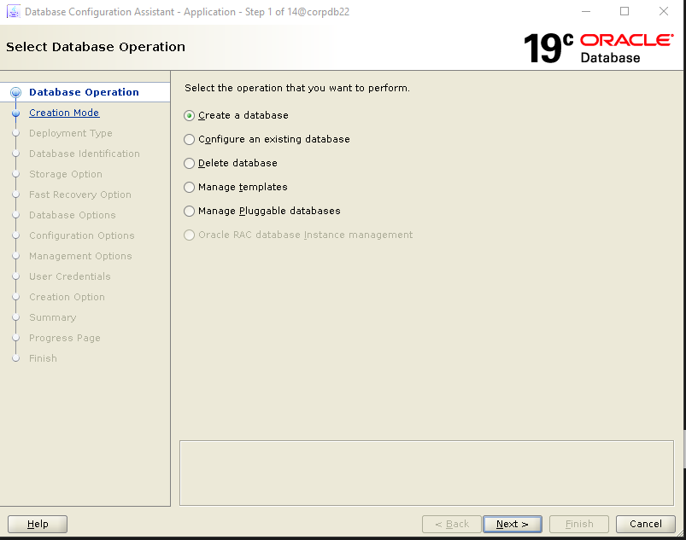

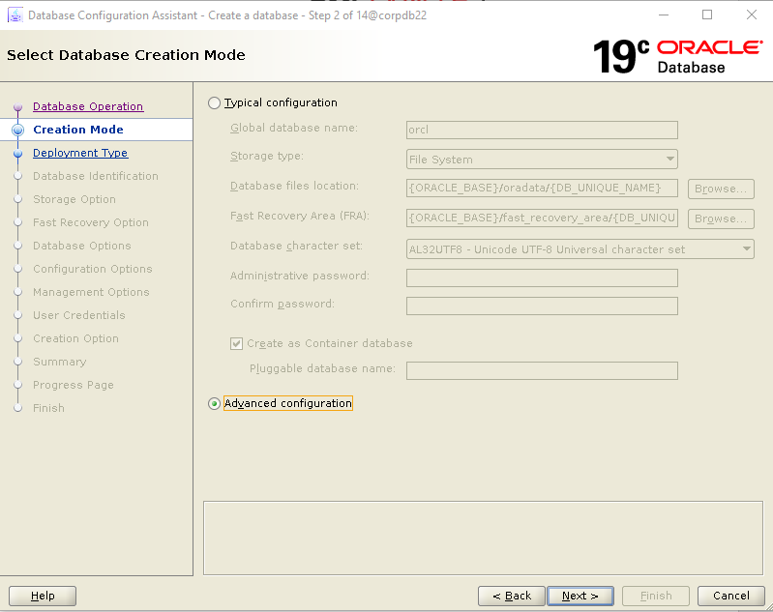

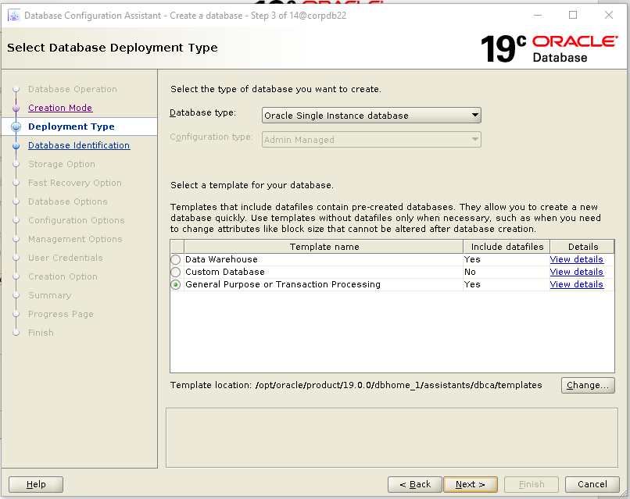

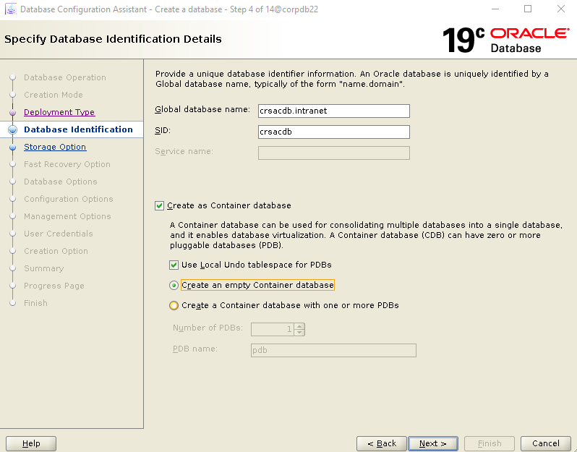

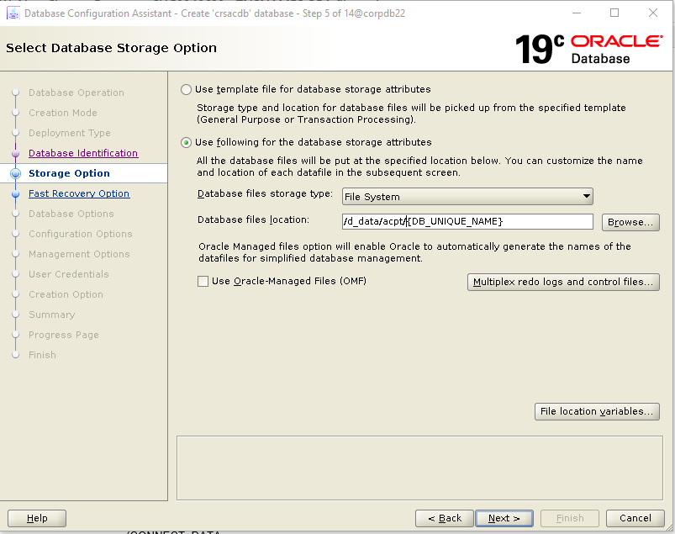

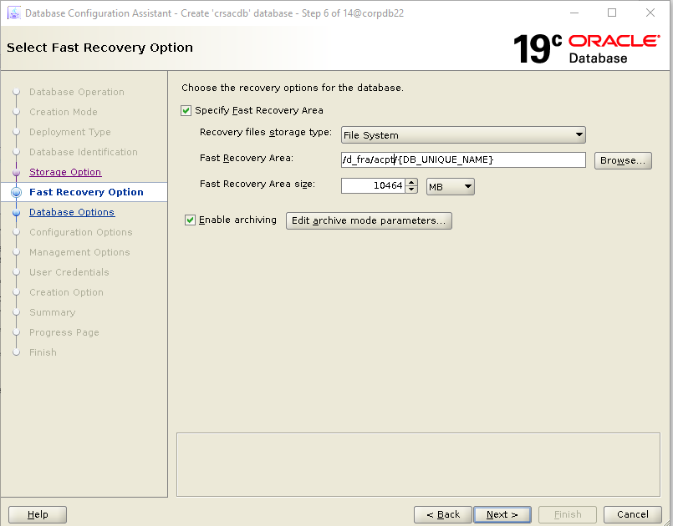

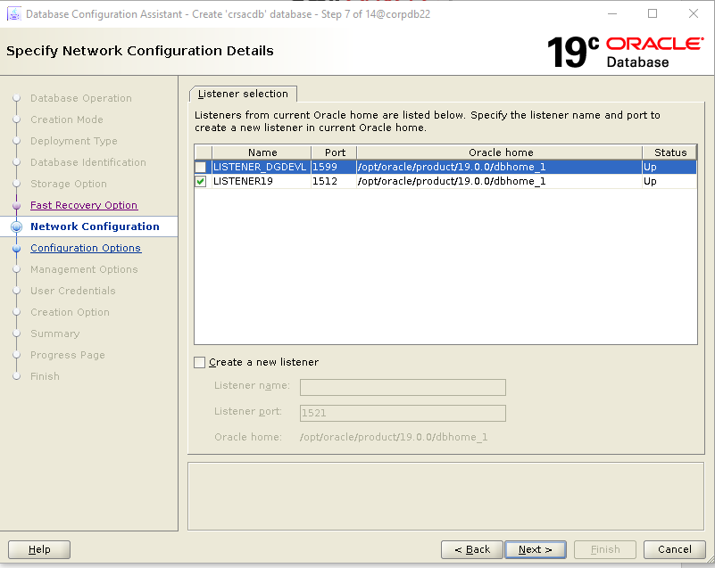

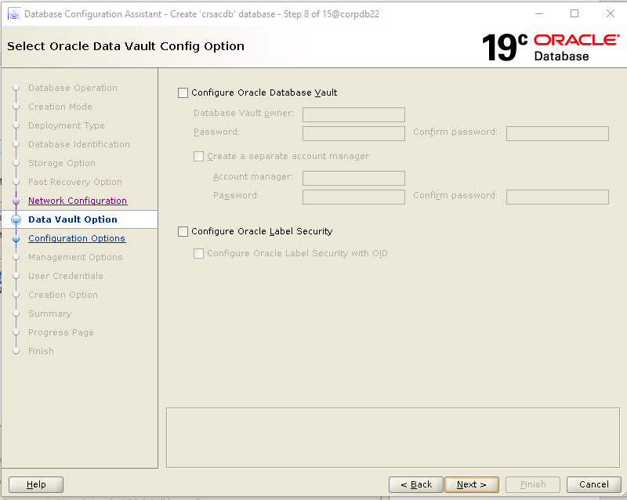

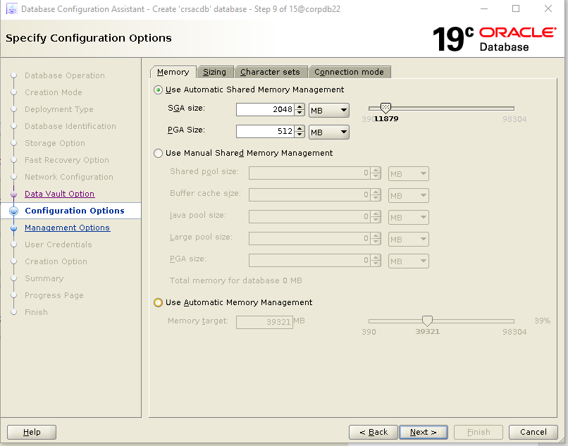

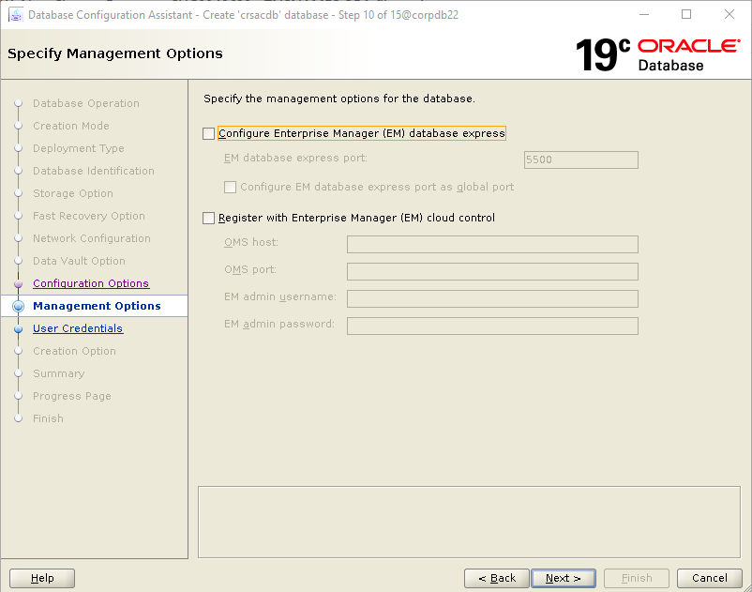

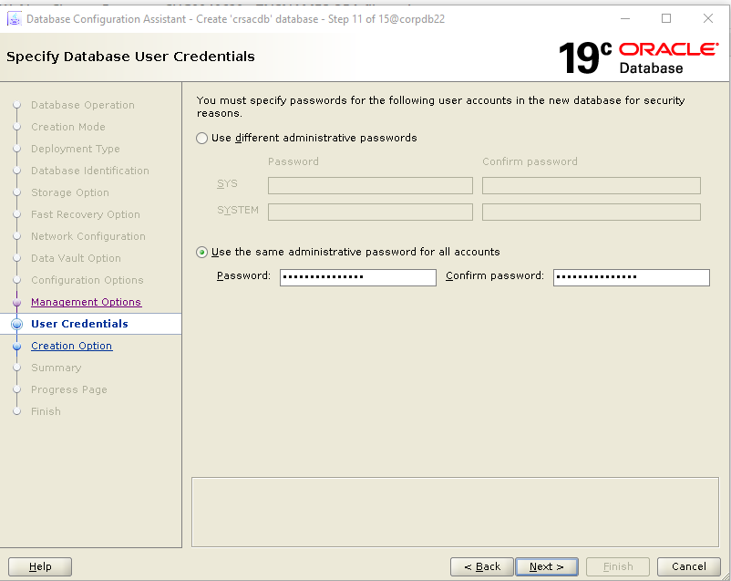

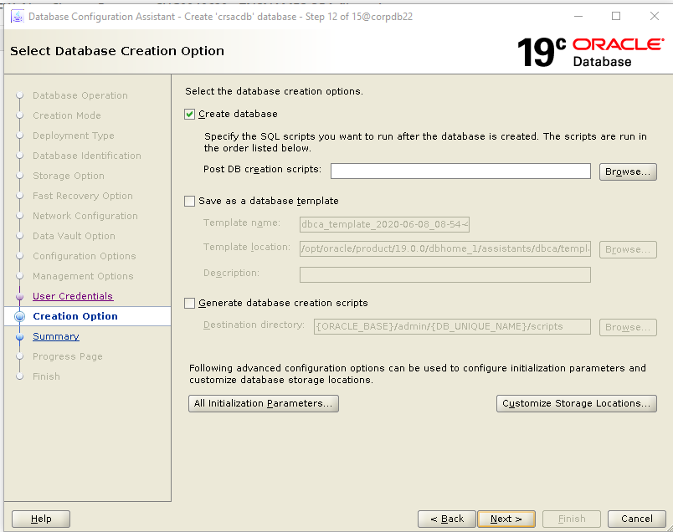

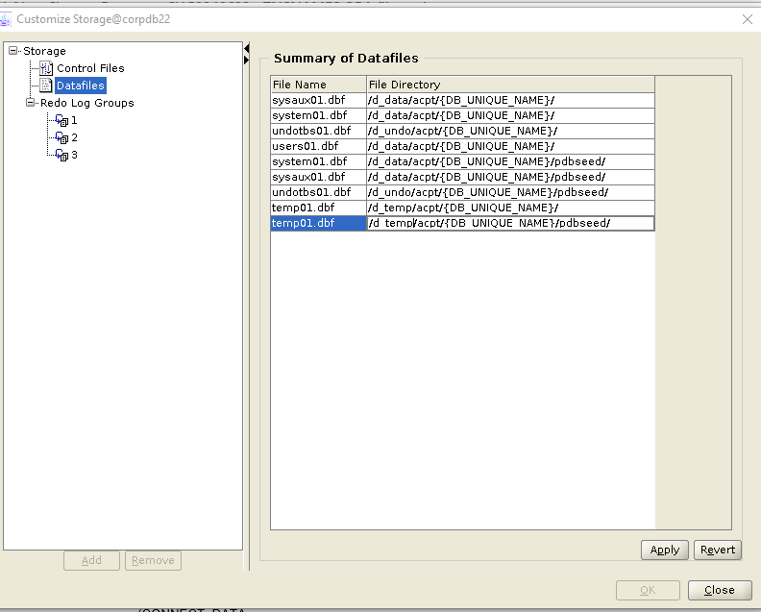

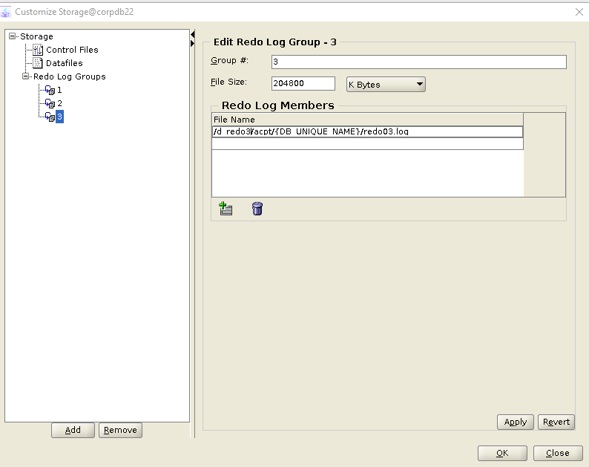

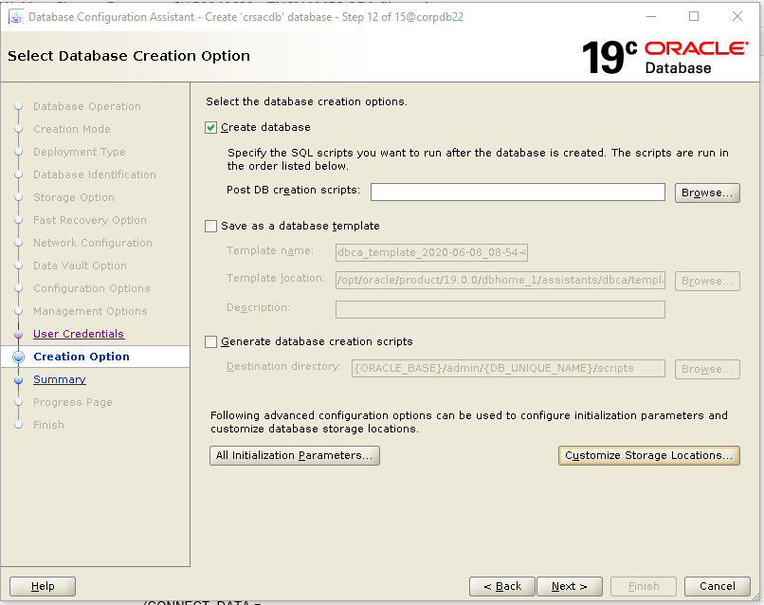

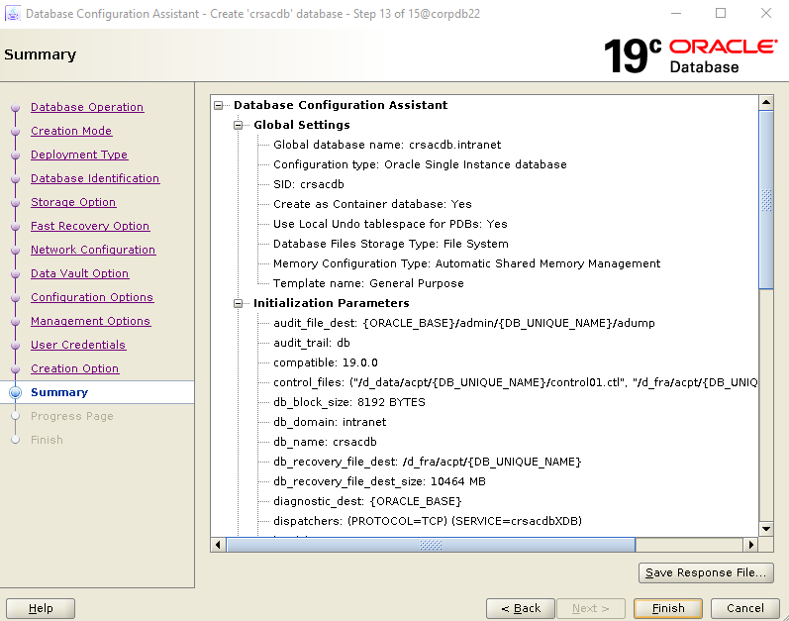

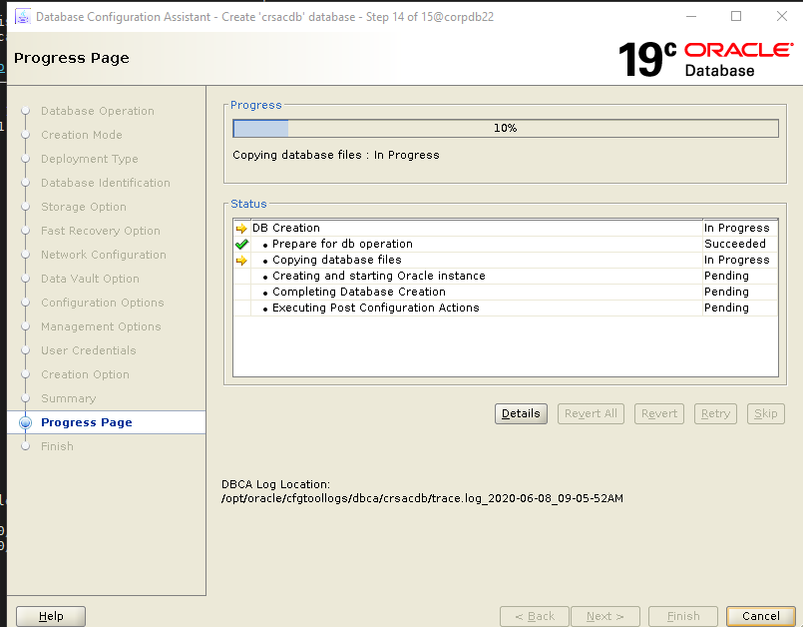

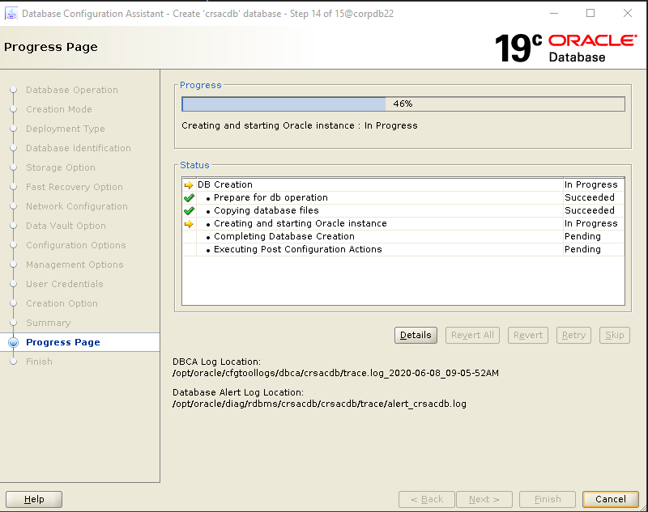

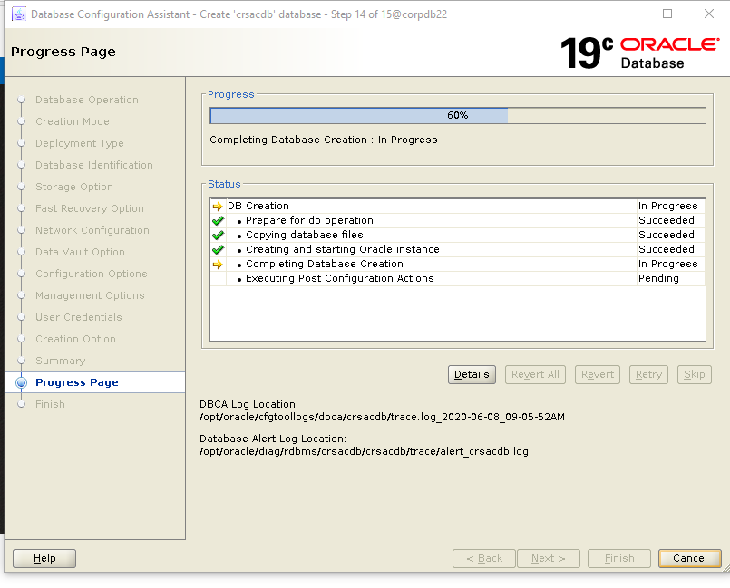

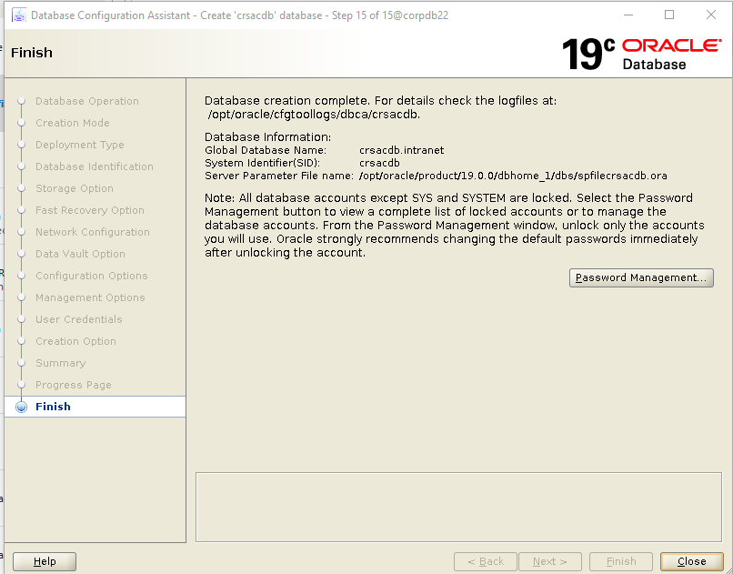

**Create PFILE**

oracle@db22:/opt/oracle/product/19.0.0/dbhome_1/bin$ **sqlplus sys as sysdba**

SQL*Plus: Release 19.0.0.0.0 - Production on Mon Jun 8 10:01:12 2020

Version 19.7.0.0.0

Copyright (c) 1982, 2020, Oracle. All rights reserved.

Enter password:

Connected to:

Oracle Database 19c Enterprise Edition Release 19.0.0.0.0 - Production

Version 19.7.0.0.0

SQL> **create pfile from spfile;**

File created.

**Copy password file and init.ora to standby server**

oracle@db22:/opt/oracle/product/19.0.0/dbhome_1/dbs$ **scp -rp orapwcrsacdb oracle@db21:/opt/oracle/product/19.0.0/dbhome_1/dbs**

Password:

orapwcrsacdb 100% 2048 2.2MB/s 00:00

oracle@db22:/opt/oracle/product/19.0.0/dbhome_1/dbs$ **scp -rp initcrsacdb.ora oracle@db21:/opt/oracle/product/19.0.0/dbhome_1/dbs**

Password:

initcrsacdb.ora

**Configure Standby Listener**

oracle@db21:/opt/oracle/product/19.0.0/dbhome_1/network/admin$ **vi listener.ora**

**LISTENER_CRS =**

**(DESCRIPTION_LIST =**

**(DESCRIPTION =**

**(ADDRESS = (PROTOCOL = TCP)(HOST = db21)(PORT = 1512))**

**)**

**)**

**SID_LIST_LISTENER_CRS =**

**(SID_LIST =**

**(SID_DESC =**

**(SID_NAME = crsacdb)**

**(ORACLE_HOME = /opt/oracle/product/19.0.0/dbhome_1)**

**(GLOBAL_DBNAME = crsacdb_s.intranet)**

**)**

**)**

oracle@db21:/opt/oracle/product/19.0.0/dbhome_1/network/admin$ **lsnrctl start listener_crs**

LSNRCTL for Solaris: Version 19.0.0.0.0 - Production on 08-JUN-2020 10:09:19

Copyright (c) 1991, 2019, Oracle. All rights reserved.

Starting /opt/oracle/product/19.0.0/dbhome_1/bin/tnslsnr: please wait...

TNSLSNR for Solaris: Version 19.0.0.0.0 - Production

System parameter file is /opt/oracle/product/19.0.0/dbhome_1/network/admin/listener.ora

Log messages written to /opt/oracle/diag/tnslsnr/db21/listener_crs/alert/log.xml

Listening on: (DESCRIPTION=(ADDRESS=(PROTOCOL=tcp)(HOST=db21)(PORT=1512)))

Connecting to (DESCRIPTION=(ADDRESS=(PROTOCOL=TCP)(HOST=db21)(PORT=1512)))

STATUS of the LISTENER

------------------------

Alias listener_crs

Version TNSLSNR for Solaris: Version 19.0.0.0.0 - Production

Start Date 08-JUN-2020 10:09:19

Uptime 0 days 0 hr. 0 min. 0 sec

Trace Level off

Security ON: Local OS Authentication

SNMP OFF

Listener Parameter File /opt/oracle/product/19.0.0/dbhome_1/network/admin/listener.ora

Listener Log File /opt/oracle/diag/tnslsnr/db21/listener_crs/alert/log.xml

Listening Endpoints Summary...

(DESCRIPTION=(ADDRESS=(PROTOCOL=tcp)(HOST=db21)(PORT=1512)))

Services Summary...

Service "crsacdb_s.intranet" has 1 instance(s).

Instance "crsacdb", status UNKNOWN, has 1 handler(s) for this service...

The command completed successfully

**Add entries to tnsnames.ora (on BOTH primary and standby database servers)**

CRSACDB.INTRANET =

(DESCRIPTION =

(ADDRESS_LIST =

(ADDRESS = (PROTOCOL = TCP)(HOST = db22.intranet)(PORT = 1512) (SEND_BUF_SIZE = 10485760) (RECV_BUF_SIZE = 10485760))

)

(SDU = 65535)

(CONNECT_DATA =

(SERVER = DEDICATED)

(SERVICE_NAME = CRSACDB.intranet)

)

)

CRSACDB_S.INTRANET =

(DESCRIPTION =

(ADDRESS_LIST =

(ADDRESS = (PROTOCOL = TCP)(HOST = db21.intranet)(PORT = 1512) (SEND_BUF_SIZE = 10485760) (RECV_BUF_SIZE = 10485760))

)

(SDU = 65535)

(CONNECT_DATA =

(SERVER = DEDICATED)

(SERVICE_NAME = CRSACDB_S.intranet)

)

)

**Update Standby Database init.ora with DB_UNIQUE_NAME**

oracle@db21:/opt/oracle/product/19.0.0/dbhome_1/dbs$ **vi initcrsacdb.ora**

**\*.db_unique_name='crsacdb_s'**

**Create required directories on standby server**

oracle@db21:/opt/oracle/product/19.0.0/dbhome_1/dbs$ **mkdir -p /opt/oracle/admin/crsacdb/adump**

**Start the standby database instance**

oracle@db21:/opt/oracle/product/19.0.0/dbhome_1/dbs$ **export ORACLE_SID=crsacdb**

oracle@db21:/opt/oracle/product/19.0.0/dbhome_1/dbs$ **sqlplus sys as sysdba**

SQL*Plus: Release 19.0.0.0.0 - Production on Mon Jun 8 10:28:21 2020

Version 19.6.0.0.0

Copyright (c) 1982, 2019, Oracle. All rights reserved.

Enter password:

Connected to an idle instance.

SQL> **startup nomount;**

ORACLE instance started.

Total System Global Area 2147482416 bytes

Fixed Size 9116464 bytes

Variable Size 654311424 bytes

Database Buffers 1476395008 bytes

Redo Buffers 7659520 bytes

**Create Standby Database via RMAN DUPLICATE command**

oracle@db21:/opt/oracle/product/19.0.0/dbhome_1/dbs$ **rman target sys/Dreamliner787##@crsacdb auxiliary sys/Dreamliner787##@crsacdb_s**

Recovery Manager: Release 19.0.0.0.0 - Production on Mon Jun 8 10:29:35 2020

Version 19.6.0.0.0

Copyright (c) 1982, 2019, Oracle and/or its affiliates. All rights reserved.

connected to target database: CRSACDB (DBID=2345870114)

connected to auxiliary database: CRSACDB (not mounted)

RMAN> **run {**

**allocate channel c1 type disk;**

**allocate channel c2 type disk;**

**allocate auxiliary channel c3 type disk;**

**allocate auxiliary channel c4 type disk;**

**allocate auxiliary channel c5 type disk;**

**allocate auxiliary channel c6 type disk;**

**duplicate target database for standby from active database nofilenamecheck dorecover;**

**}**

using target database control file instead of recovery catalog

allocated channel: c1

channel c1: SID=1219 device type=DISK

allocated channel: c2

channel c2: SID=1462 device type=DISK

allocated channel: c3

channel c3: SID=3 device type=DISK

allocated channel: c4

channel c4: SID=246 device type=DISK

allocated channel: c5

channel c5: SID=489 device type=DISK

allocated channel: c6

channel c6: SID=731 device type=DISK

Starting Duplicate Db at 08-JUN-20

current log archived

contents of Memory Script:

{

backup as copy reuse

passwordfile auxiliary format '/opt/oracle/product/19.0.0/dbhome_1/dbs/orapwcrsacdb' ;

}

executing Memory Script

Starting backup at 08-JUN-20

Finished backup at 08-JUN-20

duplicating Online logs to Oracle Managed File (OMF) location

contents of Memory Script:

{

restore clone from service 'crsacdb' standby controlfile;

}

executing Memory Script

Starting restore at 08-JUN-20

channel c3: starting datafile backup set restore

channel c3: using network backup set from service crsacdb

channel c3: restoring control file

channel c3: restore complete, elapsed time: 00:00:01

output file name=/d_data/acpt/CRSACDB/control01.ctl

output file name=/d_fra/acpt/CRSACDB/control02.ctl

Finished restore at 08-JUN-20

contents of Memory Script:

{

sql clone 'alter database mount standby database';

}

executing Memory Script

sql statement: alter database mount standby database

RMAN-05158: WARNING: auxiliary (datafile) file name /d_data/acpt/CRSACDB/system01.dbf conflicts with a file used by the target database

RMAN-05158: WARNING: auxiliary (datafile) file name /d_data/acpt/CRSACDB/sysaux01.dbf conflicts with a file used by the target database

RMAN-05158: WARNING: auxiliary (datafile) file name /d_data/acpt/CRSACDB/undotbs01.dbf conflicts with a file used by the target database

RMAN-05158: WARNING: auxiliary (datafile) file name /d_data/acpt/CRSACDB/pdbseed/system01.dbf conflicts with a file used by the target database

RMAN-05158: WARNING: auxiliary (datafile) file name /d_data/acpt/CRSACDB/pdbseed/sysaux01.dbf conflicts with a file used by the target database

RMAN-05158: WARNING: auxiliary (datafile) file name /d_data/acpt/CRSACDB/users01.dbf conflicts with a file used by the target database

RMAN-05158: WARNING: auxiliary (datafile) file name /d_data/acpt/CRSACDB/pdbseed/undotbs01.dbf conflicts with a file used by the target database

RMAN-05158: WARNING: auxiliary (tempfile) file name /d_data/acpt/CRSACDB/temp01.dbf conflicts with a file used by the target database

RMAN-05158: WARNING: auxiliary (tempfile) file name /d_data/acpt/CRSACDB/pdbseed/temp012020-06-08_09-39-23-298-AM.dbf conflicts with a file used by the target database

contents of Memory Script:

{

set newname for tempfile 1 to

"/d_data/acpt/CRSACDB/temp01.dbf";

set newname for tempfile 2 to

"/d_data/acpt/CRSACDB/pdbseed/temp012020-06-08_09-39-23-298-AM.dbf";

switch clone tempfile all;

set newname for datafile 1 to

"/d_data/acpt/CRSACDB/system01.dbf";

set newname for datafile 3 to

"/d_data/acpt/CRSACDB/sysaux01.dbf";

set newname for datafile 4 to

"/d_data/acpt/CRSACDB/undotbs01.dbf";

set newname for datafile 5 to

"/d_data/acpt/CRSACDB/pdbseed/system01.dbf";

set newname for datafile 6 to

"/d_data/acpt/CRSACDB/pdbseed/sysaux01.dbf";

set newname for datafile 7 to

"/d_data/acpt/CRSACDB/users01.dbf";

set newname for datafile 8 to

"/d_data/acpt/CRSACDB/pdbseed/undotbs01.dbf";

restore

from nonsparse from service

'crsacdb' clone database

;

sql 'alter system archive log current';

}

executing Memory Script

executing command: SET NEWNAME

executing command: SET NEWNAME

renamed tempfile 1 to /d_data/acpt/CRSACDB/temp01.dbf in control file

renamed tempfile 2 to /d_data/acpt/CRSACDB/pdbseed/temp012020-06-08_09-39-23-298-AM.dbf in control file

executing command: SET NEWNAME

executing command: SET NEWNAME

executing command: SET NEWNAME

executing command: SET NEWNAME

executing command: SET NEWNAME

executing command: SET NEWNAME

executing command: SET NEWNAME

Starting restore at 08-JUN-20

channel c3: starting datafile backup set restore

channel c3: using network backup set from service crsacdb

channel c3: specifying datafile(s) to restore from backup set

channel c3: restoring datafile 00001 to /d_data/acpt/CRSACDB/system01.dbf

channel c4: starting datafile backup set restore

channel c4: using network backup set from service crsacdb

channel c4: specifying datafile(s) to restore from backup set

channel c4: restoring datafile 00003 to /d_data/acpt/CRSACDB/sysaux01.dbf

channel c5: starting datafile backup set restore

channel c5: using network backup set from service crsacdb

channel c5: specifying datafile(s) to restore from backup set

channel c5: restoring datafile 00004 to /d_data/acpt/CRSACDB/undotbs01.dbf

channel c6: starting datafile backup set restore

channel c6: using network backup set from service crsacdb

channel c6: specifying datafile(s) to restore from backup set

channel c6: restoring datafile 00005 to /d_data/acpt/CRSACDB/pdbseed/system01.dbf

channel c3: restore complete, elapsed time: 00:00:08

channel c3: starting datafile backup set restore

channel c3: using network backup set from service crsacdb

channel c3: specifying datafile(s) to restore from backup set

channel c3: restoring datafile 00006 to /d_data/acpt/CRSACDB/pdbseed/sysaux01.dbf

channel c4: restore complete, elapsed time: 00:00:08

channel c4: starting datafile backup set restore

channel c4: using network backup set from service crsacdb

channel c4: specifying datafile(s) to restore from backup set

channel c4: restoring datafile 00007 to /d_data/acpt/CRSACDB/users01.dbf

channel c5: restore complete, elapsed time: 00:00:08

channel c5: starting datafile backup set restore

channel c5: using network backup set from service crsacdb

channel c5: specifying datafile(s) to restore from backup set

channel c5: restoring datafile 00008 to /d_data/acpt/CRSACDB/pdbseed/undotbs01.dbf

channel c6: restore complete, elapsed time: 00:00:08

channel c4: restore complete, elapsed time: 00:00:00

channel c3: restore complete, elapsed time: 00:00:03

channel c5: restore complete, elapsed time: 00:00:03

Finished restore at 08-JUN-20

sql statement: alter system archive log current

current log archived

contents of Memory Script:

{

restore clone force from service 'crsacdb'

archivelog from scn 2449709;

switch clone datafile all;

}

executing Memory Script

Starting restore at 08-JUN-20

channel c3: starting archived log restore to default destination

channel c3: using network backup set from service crsacdb

channel c3: restoring archived log

archived log thread=1 sequence=14

channel c4: starting archived log restore to default destination

channel c4: using network backup set from service crsacdb

channel c4: restoring archived log

archived log thread=1 sequence=15

channel c3: restore complete, elapsed time: 00:00:00

channel c4: restore complete, elapsed time: 00:00:01

Finished restore at 08-JUN-20

datafile 1 switched to datafile copy

input datafile copy RECID=4 STAMP=1042541489 file name=/d_data/acpt/CRSACDB/system01.dbf

datafile 3 switched to datafile copy

input datafile copy RECID=5 STAMP=1042541489 file name=/d_data/acpt/CRSACDB/sysaux01.dbf

datafile 4 switched to datafile copy

input datafile copy RECID=6 STAMP=1042541489 file name=/d_data/acpt/CRSACDB/undotbs01.dbf

datafile 5 switched to datafile copy

input datafile copy RECID=7 STAMP=1042541489 file name=/d_data/acpt/CRSACDB/pdbseed/system01.dbf

datafile 6 switched to datafile copy

input datafile copy RECID=8 STAMP=1042541489 file name=/d_data/acpt/CRSACDB/pdbseed/sysaux01.dbf

datafile 7 switched to datafile copy

input datafile copy RECID=9 STAMP=1042541489 file name=/d_data/acpt/CRSACDB/users01.dbf

datafile 8 switched to datafile copy

input datafile copy RECID=10 STAMP=1042541489 file name=/d_data/acpt/CRSACDB/pdbseed/undotbs01.dbf

contents of Memory Script:

{

set until scn 2449806;

recover

standby

clone database

delete archivelog

;

}

executing Memory Script

executing command: SET until clause

Starting recover at 08-JUN-20

starting media recovery

archived log for thread 1 with sequence 14 is already on disk as file /d_fra/acpt/CRSACDB_S/archivelog/2020_06_08/o1_mf_1_14_hfv9xj57_.arc

archived log for thread 1 with sequence 15 is already on disk as file /d_fra/acpt/CRSACDB_S/archivelog/2020_06_08/o1_mf_1_15_hfv9xjbl_.arc

archived log file name=/d_fra/acpt/CRSACDB_S/archivelog/2020_06_08/o1_mf_1_14_hfv9xj57_.arc thread=1 sequence=14

archived log file name=/d_fra/acpt/CRSACDB_S/archivelog/2020_06_08/o1_mf_1_15_hfv9xjbl_.arc thread=1 sequence=15

media recovery complete, elapsed time: 00:00:01

Finished recover at 08-JUN-20

contents of Memory Script:

{

delete clone force archivelog all;

}

executing Memory Script

deleted archived log

archived log file name=/d_fra/acpt/CRSACDB_S/archivelog/2020_06_08/o1_mf_1_15_hfv9xjbl_.arc RECID=2 STAMP=1042541488

Deleted 1 objects

deleted archived log

archived log file name=/d_fra/acpt/CRSACDB_S/archivelog/2020_06_08/o1_mf_1_14_hfv9xj57_.arc RECID=1 STAMP=1042541488

Deleted 1 objects

Finished Duplicate Db at 08-JUN-20

released channel: c1

released channel: c2

released channel: c3

released channel: c4

released channel: c5

released channel: c6

**Restart the standby database**

SQL> **select database_role,open_mode from v$database;**

DATABASE_ROLE OPEN_MODE

---------------- --------------------

PHYSICAL STANDBY MOUNTED

SQL> **create spfile from pfile;**

File created.

SQL> **shutdown immediate;**

ORA-01109: database not open

Database dismounted.

ORACLE instance shut down.

SQL> **startup mount;**

ORACLE instance started.

Total System Global Area 2147482416 bytes

Fixed Size 9116464 bytes

Variable Size 654311424 bytes

Database Buffers 1476395008 bytes

Redo Buffers 7659520 bytes

Database mounted.

**Configure Data Guard related parameters (on standby)**

SQL> **alter system set log_archive_config='dg_config=( CRSACDB, CRSACDB_S)' scope=both sid='*';**

System altered.

SQL> **alter system set log_archive_dest_1='location=USE_DB_RECOVERY_FILE_DEST valid_for=(all_logfiles,all_roles) db_unique_name=CRSACDB_S' scope=both sid='*';**

System altered.

SQL> **alter system set log_Archive_dest_2='service=CRSACDB async noaffirm reopen=15 valid_for=(all_logfiles,primary_role) db_unique_name=CRSACDB' scope=both sid='*';**

System altered.

SQL> **alter system set fal_server='CRSACDB' scope=both sid='*';**

System altered.

SQL> **alter system set fal_client='CRSACDB_S' scope=both sid='*';**

System altered.

SQL> **alter system set standby_file_management=auto scope=both;**

System altered.

**Configure Data Guard related parameters (on primary)**

SQL> **alter system set log_archive_config='dg_config=( CRSACDB, CRSACDB_S)' scope=both sid='*';**

System altered.

SQL> **alter system set log_archive_dest_1='location=USE_DB_RECOVERY_FILE_DEST valid_for=(all_logfiles,all_roles) db_unique_name=CRSACDB' scope=both sid='*';**

System altered.

SQL> **alter system set log_Archive_dest_2='service=CRSACDB_S async noaffirm reopen=15 valid_for=(all_logfiles,primary_role) db_unique_name=CRSACDB_S' scope=both sid='*';**

System altered.

SQL> **alter system set fal_server='CRSACDB_S' scope=both sid='*';**

System altered.

SQL> **alter system set fal_client='CRSACDB' scope=both sid='*';**

System altered.

SQL> **alter system set standby_file_management=auto scope=both;**

System altered.

**Create standby redo log files (on primary)**

SQL> **select group#,thread#,bytes/1048576 from v$log;**

GROUP# THREAD# BYTES/1048576

---------- ---------- -------------

1 1 200

2 1 200

3 1 200

SQL> **alter database add standby logfile thread 1 group 4 size 200m;**

Database altered.

SQL> **alter database add standby logfile thread 1 group 5 size 200m;**

Database altered.

SQL> **alter database add standby logfile thread 1 group 6 size 200m;**

Database altered.

SQL> **alter database add standby logfile thread 1 group 7 size 200m;**

Database altered.

**Create standby redo log files (on standby)**

SQL> **alter database add standby logfile thread 1 group 4 size 200m;**

Database altered.

SQL> **alter database add standby logfile thread 1 group 5 size 200m;**

Database altered.

SQL> **alter database add standby logfile thread 1 group 6 size 200m;**

Database altered.

SQL> **alter database add standby logfile thread 1 group 7 size 200m;**

Database altered.

**Verify Standby Database connectivity from Primary Database**

SQL> **alter system set log_archive_dest_state_2=defer;**

System altered.

SQL> **alter system set log_archive_dest_state_2=enable;**

System altered.

SQL> **alter system switch logfile;**

System altered.

SQL> **select destination,status,error from v$archive_dest_status where rownum < 3;**

DESTINATION

--------------------------------------------------------------------------------

STATUS ERROR

--------- -----------------------------------------------------------------

VALID

CRSACDB_S

VALID

**Configure parameters for Data Guard Broker (on BOTH primary and standby databases)**

SQL> **alter system set dg_broker_start=TRUE scope=both;**

System altered.

SQL> **alter system set log_archive_dest_2='' scope=both;**

System altered.

**Add Data Guard Broker static entry to listener.ora (on standby)**

oracle@db21:/opt/oracle/product/19.0.0/dbhome_1/network/admin$ **vi listener.ora**

LISTENER_CRS =

(DESCRIPTION_LIST =

(DESCRIPTION =

(ADDRESS = (PROTOCOL = TCP)(HOST = db21)(PORT = 1512))

)

)

SID_LIST_LISTENER_CRS =

(SID_LIST =

(SID_DESC =

(SID_NAME = crsacdb)

(ORACLE_HOME = /opt/oracle/product/19.0.0/dbhome_1)

(GLOBAL_DBNAME = crsacdb_s.intranet)

)

**(SID_DESC =**

**(GLOBAL_DBNAME = CRSACDB_S_DGMGRL.intranet)**

**(ORACLE_HOME = /opt/oracle/product/19.0.0/dbhome_1)**

**(SID_NAME = crsacdb)**

**)**

)

oracle@db21:/opt/oracle/product/19.0.0/dbhome_1/network/admin$ **lsnrctl reload listener_crs**

LSNRCTL for Solaris: Version 19.0.0.0.0 - Production on 08-JUN-2020 11:14:35

Copyright (c) 1991, 2019, Oracle. All rights reserved.

Connecting to (DESCRIPTION=(ADDRESS=(PROTOCOL=TCP)(HOST=db21)(PORT=1512)))

The command completed successfully

**Add Data Guard Broker static entry to listener.ora (on primary)**

oracle@db22:/opt/oracle/product/19.0.0/dbhome_1/network/admin$ **vi listener.ora**

LISTENER_CRS =

(DESCRIPTION_LIST =

(DESCRIPTION =

(ADDRESS = (PROTOCOL = TCP)(HOST = db22.intranet)(PORT = 1512))

)

)

**SID_LIST_LISTENER_CRS =**

**(SID_LIST =**

**(SID_DESC =**

**(GLOBAL_DBNAME = CRSACDB_DGMGRL.intranet)**

**(ORACLE_HOME = /opt/oracle/product/19.0.0/dbhome_1)**

**(SID_NAME = crsacdb)**

**)**

**)**

oracle@db22:/opt/oracle/product/19.0.0/dbhome_1/network/admin$ **lsnrctl reload listener_crs**

LSNRCTL for Solaris: Version 19.0.0.0.0 - Production on 08-JUN-2020 11:12:17

Copyright (c) 1991, 2019, Oracle. All rights reserved.

Connecting to (DESCRIPTION=(ADDRESS=(PROTOCOL=TCP)(HOST=db22.intranet)(PORT=1512)))

The command completed successfully

**Create Data Guard Broker Configuration**

oracle@db22:/opt/oracle/product/19.0.0/dbhome_1/network/admin$ **dgmgrl**

DGMGRL for Solaris: Release 19.0.0.0.0 - Production on Mon Jun 8 11:15:30 2020

Version 19.7.0.0.0

Copyright (c) 1982, 2019, Oracle and/or its affiliates. All rights reserved.

Welcome to DGMGRL, type "help" for information.

DGMGRL> **connect / as sysdg**

Connected to "crsacdb"

Connected as SYSDG.

DGMGRL> **create configuration 'CRSACDB_DG'**

> **as primary database is 'CRSACDB'**

> **connect identifier is 'CRSACDB';**

Configuration "CRSACDB_DG" created with primary database "CRSACDB"

DGMGRL> **add database 'CRSACDB_S'**

> **as connect identifier is 'CRSACDB_S';**

Database "CRSACDB_S" added

DGMGRL> **enable configuration;**

Enabled.

DGMGRL> **show configuration;**

Configuration - CRSACDB_DG

Protection Mode: MaxPerformance

Members:

CRSACDB - Primary database

CRSACDB_S - Physical standby database

Fast-Start Failover: Disabled

Configuration Status:

SUCCESS (status updated 24 seconds ago)

**Validate Data Guard Broker Configuration**

DGMGRL> **connect sys/Dreamliner787##**

Connected to "crsacdb"

Connected as SYSDBA.

DGMGRL> **validate network configuration for all;**

Connecting to instance "crsacdb" on database "CRSACDB" ...

Connected to "crsacdb"

Checking connectivity from instance "crsacdb" on database "CRSACDB to instance "crsacdb" on database "CRSACDB_S"...

Succeeded.

Connecting to instance "crsacdb" on database "CRSACDB_S" ...

Connected to "crsacdb_s"

Checking connectivity from instance "crsacdb" on database "CRSACDB_S to instance "crsacdb" on database "CRSACDB"...

Succeeded.

Oracle Clusterware is not configured on database "CRSACDB".

Connecting to database "CRSACDB" using static connect identifier "(DESCRIPTION=(ADDRESS=(PROTOCOL=TCP)(HOST=db22)(PORT=1512))(CONNECT_DATA=(SERVICE_NAME=crsacdb_DGMGRL.intranet)(INSTANCE_NAME=crsacdb)(SERVER=DEDICATED)(STATIC_SERVICE=TRUE)))" ...

Succeeded.

The static connect identifier allows for a connection to database "CRSACDB".

Oracle Clusterware is not configured on database "CRSACDB_S".

Connecting to database "CRSACDB_S" using static connect identifier "(DESCRIPTION=(ADDRESS=(PROTOCOL=tcp)(HOST=db21)(PORT=1512))(CONNECT_DATA=(SERVICE_NAME=crsacdb_s_DGMGRL.intranet)(INSTANCE_NAME=crsacdb)(SERVER=DEDICATED)(STATIC_SERVICE=TRUE)))" ...

Succeeded.

The static connect identifier allows for a connection to database "CRSACDB_S".

**Test Switchover Operation**

DGMGRL> **switchover to 'CRSACDB_S'**

Performing switchover NOW, please wait...

Operation requires a connection to database "CRSACDB_S"

Connecting ...

Connected to "crsacdb_s"

Connected as SYSDBA.

New primary database "CRSACDB_S" is opening...

Operation requires start up of instance "crsacdb" on database "CRSACDB"

Starting instance "crsacdb"...

Connected to an idle instance.

ORACLE instance started.

Connected to "crsacdb"

Database mounted.

Connected to "crsacdb"

Switchover succeeded, new primary is "CRSACDB_S"

DGMGRL> **switchover to 'CRSACDB';**

Performing switchover NOW, please wait...

Operation requires a connection to database "CRSACDB"

Connecting ...

Connected to "crsacdb"

Connected as SYSDBA.

New primary database "CRSACDB" is opening...

Operation requires start up of instance "crsacdb" on database "CRSACDB_S"

Starting instance "crsacdb"...

Connected to an idle instance.

ORACLE instance started.

Connected to "crsacdb_s"

Database mounted.

Connected to "crsacdb_s"

Switchover succeeded, new primary is "CRSACDB"