**https://blogs.oracle.com/dataintegration/done-cancel-v12**

**Oracle GoldenGate 19.1 on OCI Marketplace**

We are happy to announce the general availability of GoldenGate 19c on OCI Marketplace.

Oracle GoldenGate 19c on Oracle Cloud Infrastructure Marketplace brings high-performance data replication as a customer managed solution that is easily deployed within the Oracle Cloud Infrastructure (OCI). This software enables all data capture, delivery, and replication for on-premise and cloud; yet managed from a fast-central location on OCI.

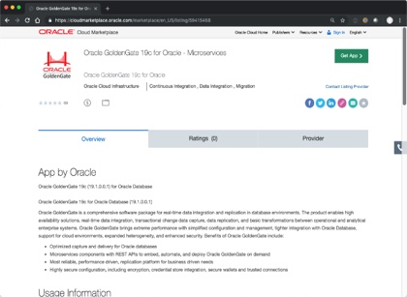

GoldenGate 19.1 on Marketplace Features:

All features of Oracle GoldenGate for Oracle 19.1 Microservices Edition are available on these marketplace solutions. This includes Capture and Delivery support for Oracle Database versions 11g, 12c, 18c, 19c, cloud and on-premises. New cross-endian features also allow remote capture from any Oracle Database platform and operating system.  
Automated deployment of GoldenGate topology with default configuration of the newest generation of web-based, easy to use GoldenGate Microservices – this is the recommended path for all new deployments of GoldenGate.  
Here is a quick summary of the difference in functionalities of GoldenGate on Marketplace versus   
**GGCS (=GOLDENGATE-CLOUD-SERVICE) and DIPC (=DATA INTEGRATION PLATFORM CLOUD)**

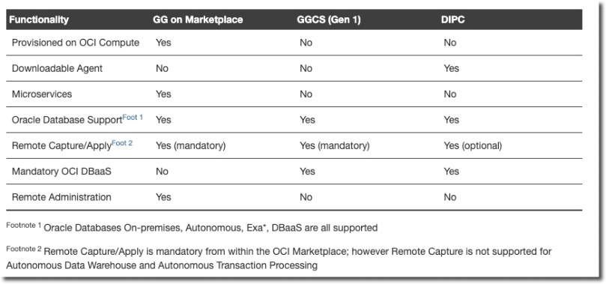

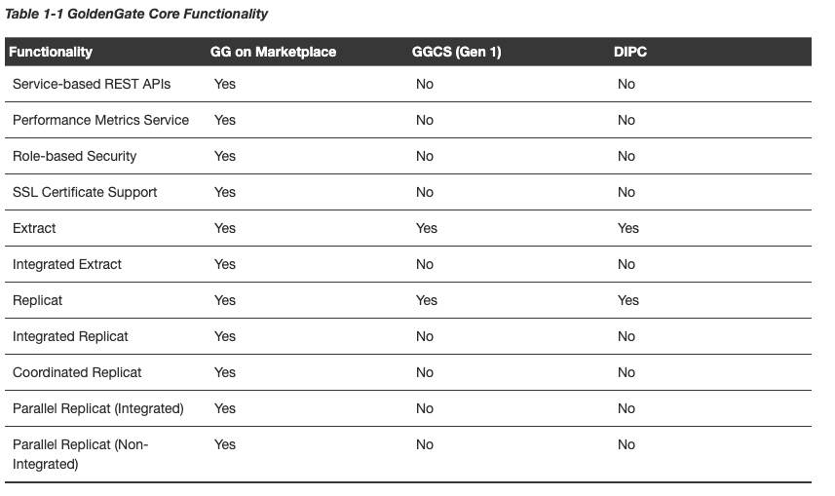

Steps for Launching GoldenGate on OCI Marketplace

1. Navigate to <https://cloudmarketplace.oracle.com/> and search for “Oracle GoldenGate”

2. Choose “Launch App” and click through ~4 pages of forms (existing OCI account is required)

3. Access GoldenGate Microservices (Web Apps) from public IP Address given via OCI confirmation page

Documentation and Certification Details:

* GoldenGate Marketplace documentation  
  <https://docs.oracle.com/en/middleware/goldengate/core/19.1/oggmp/>
* GoldenGate 19.1 Product Documentation is available at:   
  <https://docs.oracle.com/en/middleware/goldengate/core/19.1/index.html>
* Certification Matrix:   
  <https://www.oracle.com/technetwork/middleware/ias/downloads/fusion-certification-100350.html>

Let us now see how to upgrade the classic capture to an integrated capture.

To recap, the main difference between the classic caoture and integrated capture modes is that in the classic capture the extract reads the Oracle database online (and archved as the case may be) redo log files to capture changes while in the integrated capture mode the database log mining server reads the redo log files and captures changes in the form of LCR’s (Logical Change Records) which are then accessed by the Golden Gate extract process.

Let us see an example of this upgrade process.

## https://docs.oracle.com/en/cloud/paas/data-integration-platform-cloud/using/what-is-dipc.html#GUID-5DDC01CA-91EE-4A82-98C8-905936ACFE76

## What is Oracle Data Integration Platform Cloud?

Oracle Data Integration Platform Cloud (DIPC) is a unified platform for real-time data replication, data transformation, data quality, and data governance. Learn about Oracle Data Integration Platform Cloud features, its common use cases, and the different components of its architecture. Understand what features are available in different types of Data Integration Platform Cloud instances and editions, and choose the ones that are most suitable for your data integration needs.

### **Why Use Oracle Data Integration Platform Cloud?**

Data Integration Platform Cloud Data Integration Platform Cloud helps migrate and extract value from data by bringing together capabilities of a complete Data Integration, Data Quality and Data Governance solution into a single unified cloud based platform. You can use Data Integration Platform Cloud to move, transform, cleanse, integrate, replicate, analyze, and govern data.

With Data Integration Platform Cloud you can:

* Perform seamless batch and real-time data movement among cloud and on-premises data sources.
* Synchronize an entire data source or coup high volumes of data in batches to a new Oracle Database Cloud deployment. You can then access, profile, transform, and cleanse your data.
* Stream data in real time to new data sources, perform data analysis on streaming data, and keep any number of data sources synchronized.
* Perform bulk transformation by importing and executing Oracle Data Integrator scenarios.
* Copy or move data from flat files or on-premises data sources to Oracle Data Lake. This is applicable only on the Data Integration Platform Cloud Classic instance.
* Integrate with big data technologies.

The most common uses of Data Integration Platform Cloud are:

* Accelerate Data Warehouses
* Automate Data Mart generation
* Migrate data without any down time (zero down time migration)
* Support redundancy through active-active model
* Integrate Big Data
* Synchronize data
* Replicate data to Kafka and bootstrap stream analytics.
* Monitor data health
* Profile and validate data

https://jinyuwang.weebly.com/cloud-service/oracle-goldengate-cloud-service-supported-source-and-targets

[**Oracle GoldenGate Cloud Service Supported Source and Targets**](https://jinyuwang.weebly.com/cloud-service/oracle-goldengate-cloud-service-supported-source-and-targets)

10/20/2017

[0 Comments](https://jinyuwang.weebly.com/cloud-service/oracle-goldengate-cloud-service-supported-source-and-targets#comments)

This blog discusses what sources and targets supported by Oracle GoldenGate Cloud Service (GGCS).    
  
**1. Background Information**  
Let me give some background information to help you understand the support discussion later.   
  
**1.1 What is GGCS?**  
GGCS is now an unmanaged PaaS service, which means GGCS provides a virtual machine hosting the software, and you as a user need to configure and to maintain the software execution. GGCS now has the following Oracle GoldenGate software installed on the virtual machine by default:

* Oracle GoldenGate for Oracle DB 12.2
* Oracle GoldenGate for Big Data 12.3.0.1
* Oracle GoldenGate for MySQL 12.2

The operating system is LINUX x64 6.6. The operating system is LINUX x64 6.6. You can installed Oracle GoldenGate12.2 certified on LINUX x64 6.6 on GGCS.   
  
**1.2 What is Oracle GoldenGate Remote Capture and Delivery?**  
Oracle GoldenGate 12.2 now supports remote capture and delivery for  the following databases/servers:

* Oracle Database (capture/delivery)
* MySQL (delivery)
* DB2 LUW (capture/delivery)
* Informix (capture/delivery)
* Big Data (delivery)
* Teradata (delivery)
* DB2 for iSeries (delivery)
* Microsoft SQL Server (delivery)
* JMS (capture/delivery)

GoldenGate for DB2 LUW, Informix, Teradata and JMS all has packages for LINUX. Therefore, you can install them on GGCS to perform remote capture and delivery. However, the source/target database has to be in the same endian as the LINUX where GGCS runs.    
  
**2. What is Supported?**  
Let's talk about what's supported.   
  
**2.1 GGCS Supported Sources and Targets on Oracle Public Cloud**  
When running Oracle GoldenGate Cloud Service (GGCS), the following sources and targets are certified on **Oracle Public Cloud:**

* **Capture and Delivery**
  + Oracle Database Cloud Service and Oracle Database Cloud Exadata Service: Oracle Database 11g and 12.1 (Delivery only support for DB 12.2) ​
* **Delivery Only**
  + Oracle Big Data Cloud Service: HIVE, HBASE, HDFS, Flume, and Kafka
  + ​Oracle  MySQL Cloud Service

**​2.2. GGCS Supported Source and Target On-Premises and 3rd Party Cloud**  
GGCS can be configured to perform **Remote Capture and Delivery for the On-Premises Databases and Databases running on the 3rd Party Cloud**and the following sources and targets are the supported**:**

* **Remote Capture and Delivery**  
  Note that the operating system running the database has to have the same endian as LINUX.
  + Oracle Database 11g and 12.1 (No 12.2 capture support) (Oracle Database Cloud Service on Oracle Cloud Machine, Oracle Exadata Cloud Machine)
  + Informix, Sybase ASE, DB2 LUW *  
    ​(Additional software installations are needed on GGCS.)
* **Remote Delivery Only**  
  Note that the operating system running the database has to have the same endian as LINUX.
  + Big Data Repositories:  Apache Hadoop, HBase, Hive, Flume and Kafka; Storm, Spark, Oracle NoSQL,MongoDB,Cassandra; Amazon Redshift, IBM PureData System for Analytics (Netezza)
  + ​MySQL and MySQL Cluster
  + TimesTen,PosgreSQL, File Adapter, Teradata(Additional software installations are needed on GGCS)
* **Working with Oracle GoldenGate**  
  Oracle GoldenGate Cloud Service (GGCS) can communicate with all of the supported on-premise Oracle GoldenGate. Therefore, if you have Oracle GoldenGate on-premise installs, you can set up the replication with GGCS.

For databases running on on-premise and in the 3rd party cloud, customer needs to make sure GGCS can have a secure connection with the source/target database. VPN connection is recommended in general.