Meeting dd. 26-01-2021

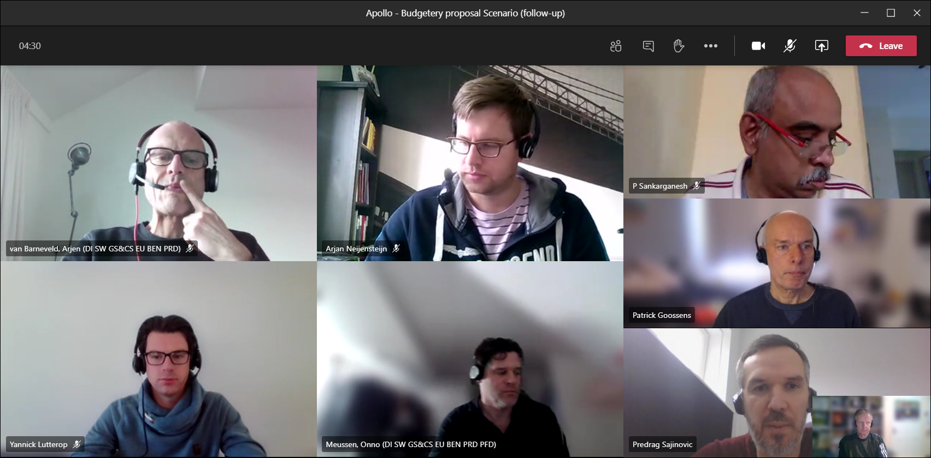

Scenario-2: global implementation

Extra work:  
Several Workshop-face to RD&L: how and what to do !

Interfacing to ERP.

Connections to instruments

Maar ook:

Licensing, global approach (nl, hongarije, india)

Time-frame between now and 5 years

Business:

Training, processes should be redesigned.

Scenario-1: unilab-6.7 in india.

Afspraak: lever concept-voorstel donderdag 28/01 op, en vrijdag plannen we een meeting in om het eea. verder te bespreken.