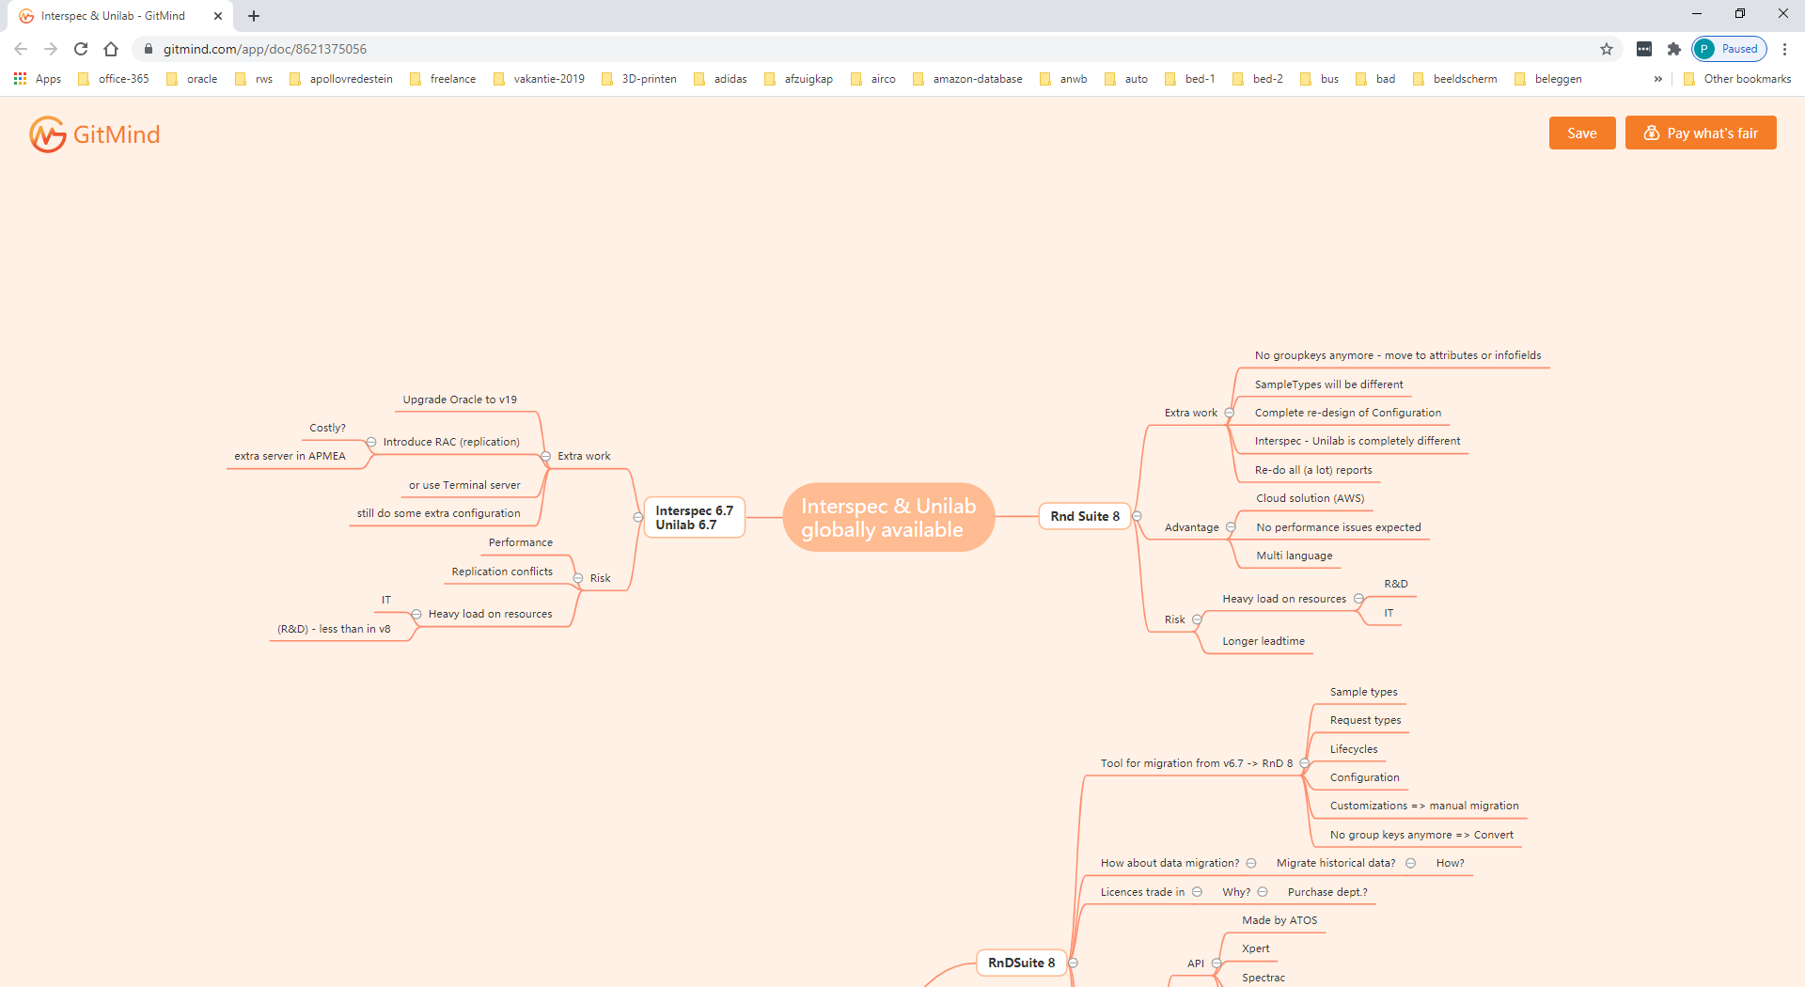

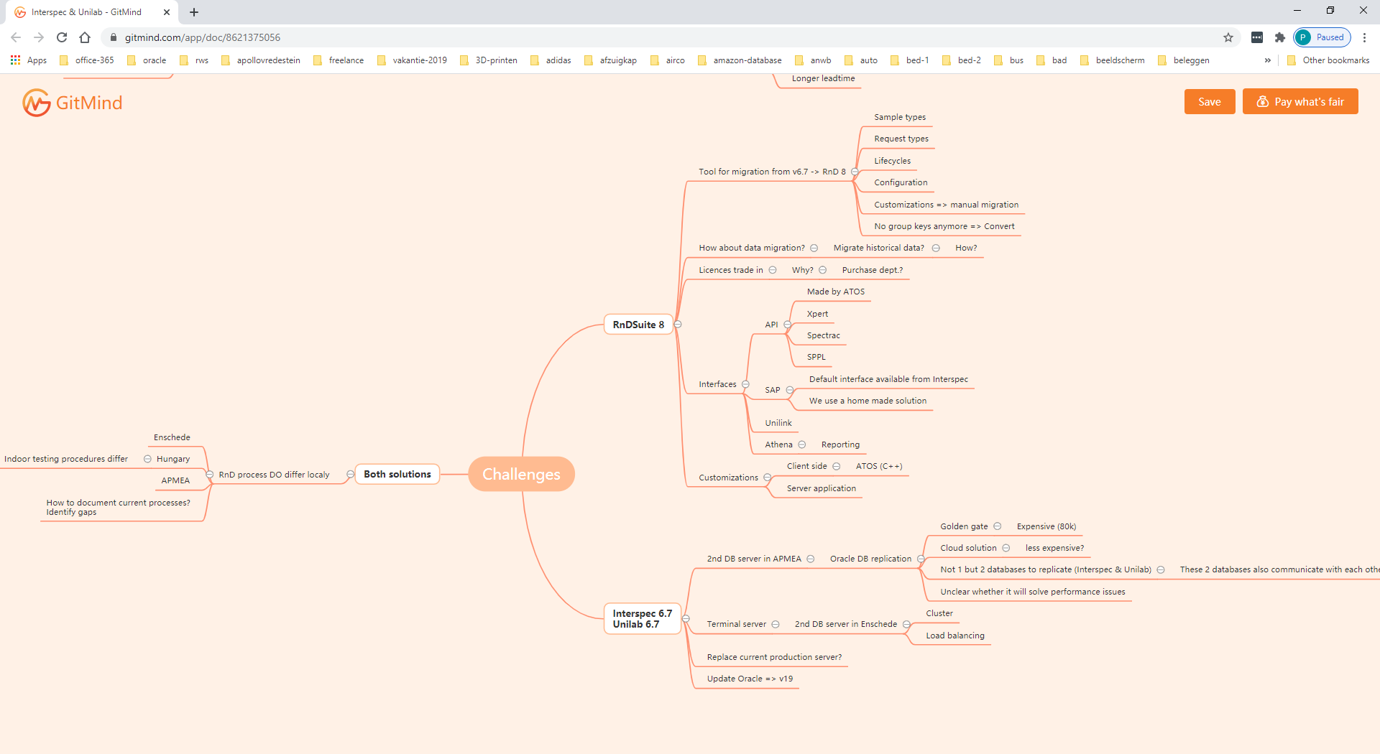

Most important question:

-does Apollo want all the plants work in the same way?

-can all the plants work in the same way, or are processes/equipment/culture so different that is not doable?

Depending on the answers of these questions:

WE SHOULD CONSIDER EXTRA OPTION:

3TH-option no-REAL-TIME-replication, 2 stand-alone-DB’s

-Implement management-reports via integration of different interspec/unilab

-PRE: support is locally arranged

-no-replication necessary

-no heavy load on resources

-try to find a way of best way interfacing specs between the 2 systems !!

-try to sync way of working with Enschede.

CHALLENGES:

-RND-SUITE-8

-Implementation: -complex migration / implementation project (different plants / processes )

-it takes a very long time before APMEA can start using RNDSUITE-8

-how to implement (big bang -> large acceptance-test, department-related -> learn from mistakes, small downtime in case of functional/technical-issues)

-many resources from business needed.

-interface: -only with secure-connections / service-interfaces / no-direct connections

-rebuild maintenance-tooling

-INTERSPEC-6.7

-2nd server in apmea: -goldengate/replication-issues to solve (not sure if it is manageable !!)

-large amount of tables to replicate.

-update oracle 19c. -needed for support & security

-prerequisite for replication

-changes needed in INTERSPEC/UNILAB (supported?)

-changes needed in all interfaces INTERSPEC/UNILAB (SAP / DWH / xpert/spectrac etc)

-terminal-server: -is performance really too slow?

-faster internet possible? This is real-problem of investigating all the other options !!!