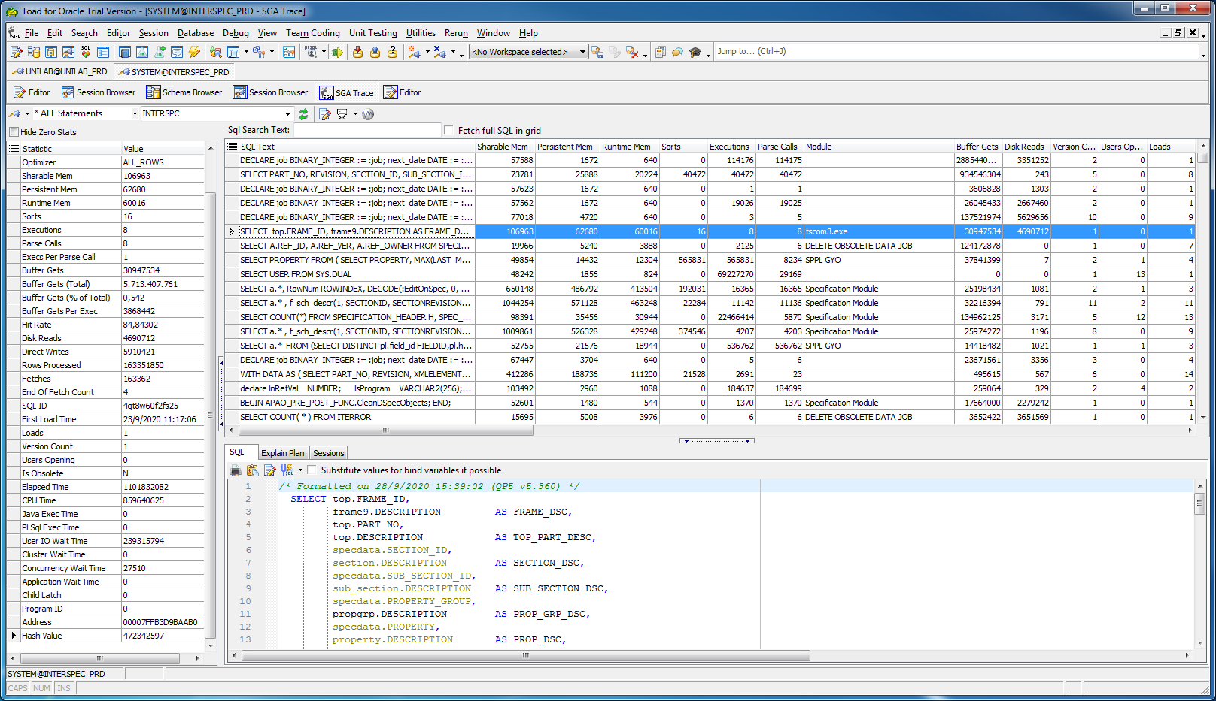

/* Formatted on 28/9/2020 15:39:02 (QP5 v5.360) */

SELECT top.FRAME_ID,

frame9.DESCRIPTION AS FRAME_DSC,

top.PART_NO,

top.DESCRIPTION AS TOP_PART_DESC,

specdata.SECTION_ID,

section.DESCRIPTION AS SECTION_DSC,

specdata.SUB_SECTION_ID,

sub_section.DESCRIPTION AS SUB_SECTION_DSC,

specdata.PROPERTY_GROUP,

propgrp.DESCRIPTION AS PROP_GRP_DSC,

specdata.PROPERTY,

property.DESCRIPTION AS PROP_DSC,

specdata.VALUE_S AS PROP_VALUE,

specdata.SEQUENCE_NO AS PROP_SEQ_NO,

header.HEADER_ID,

header.DESCRIPTION AS HEADER_DSC,

uom.DESCRIPTION AS UOM,

CASE

WHEN EXISTS

(SELECT 1

FROM specdata cr_par

WHERE header_id = 700503

AND cr_par.part_no = specdata.part_no

AND cr_par.revision = specdata.revision

AND cr_par.section_id = specdata.section_id

AND cr_par.sub_section_id =

specdata.sub_section_id

AND cr_par.property_group =

specdata.property_group

AND cr_par.property = specdata.property

AND cr_par.value_s <> 'N')

THEN

1

ELSE

0

END AS is_crit_param

FROM specification_header top

INNER JOIN frame_header frame9 ON (top.FRAME_ID = frame9.FRAME_NO)

INNER JOIN status stat ON (top.STATUS = stat.STATUS AND stat.STATUS_TYPE = 'CURRENT')

INNER JOIN specdata ON ( specdata.PART_NO = top.PART_NO

AND specdata.REVISION = top.REVISION)

INNER JOIN section ON (specdata.SECTION_ID = section.SECTION_ID)

INNER JOIN sub_section ON (specdata.SUB_SECTION_ID = sub_section.SUB_SECTION_ID)

INNER JOIN property_group propgrp ON (specdata.PROPERTY_GROUP = propgrp.PROPERTY_GROUP)

INNER JOIN property ON (specdata.PROPERTY = property.PROPERTY)

INNER JOIN header ON (specdata.HEADER_ID = header.HEADER_ID)

LEFT OUTER JOIN uom ON (specdata.UOM_ID = uom.UOM_ID)

WHERE 1 = 1

AND top.FRAME_ID = 'A_PCR'

AND specdata.SECTION_ID IN ('700835')

AND section.DESCRIPTION <> 'Bill of Materials'

AND value_s IS NOT NULL

AND specdata.HEADER_ID <> 700503

AND EXISTS

(SELECT 1

FROM part_plant

WHERE part_plant.PART_NO = top.PART_NO

AND PLANT = 'ENS')

ORDER BY top.FRAME_ID,

top.PART_NO,

specdata.SECTION_ID,

specdata.SUB_SECTION_ID,

specdata.PROPERTY_GROUP,

specdata.PROPERTY,

specdata.SEQUENCE_NO

;

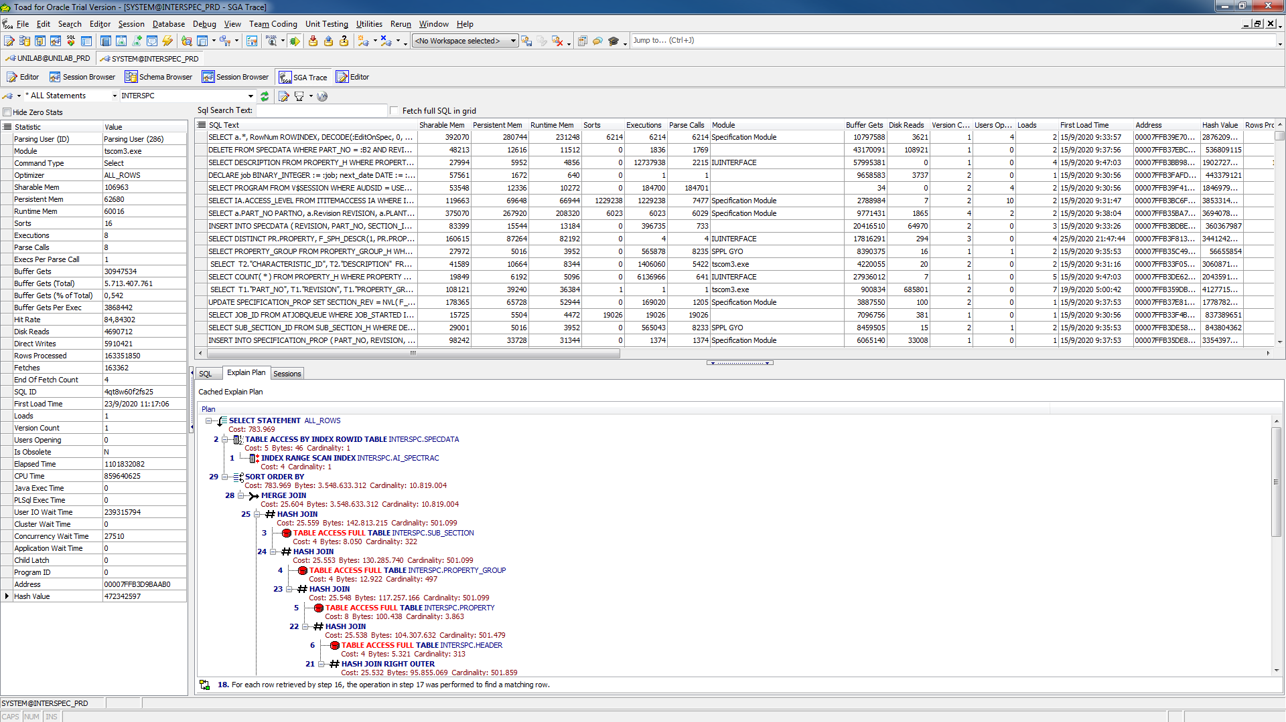

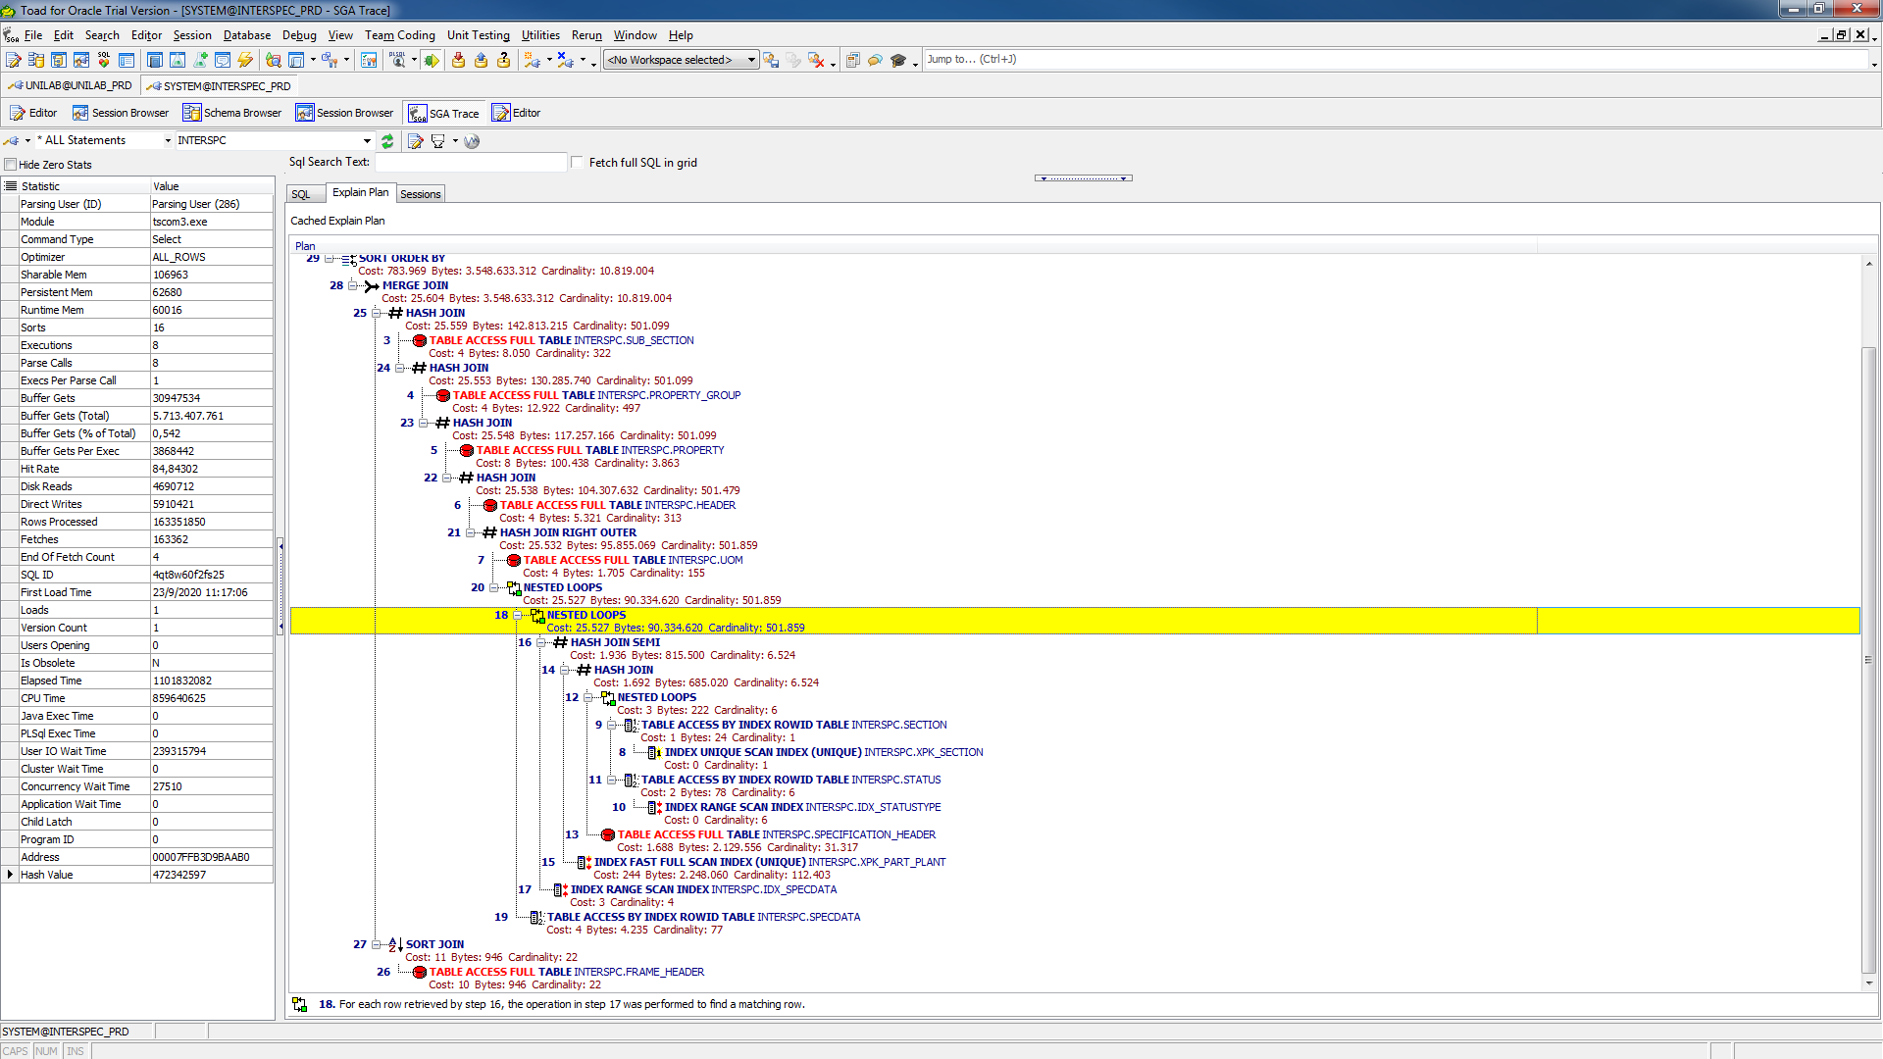

/* Formatted on 29/9/2020 10:28:59 (QP5 v5.360) */

SELECT T1."PART_NO",

T1."REVISION",

T3."SECTION_ID",

T3."SUB_SECTION_ID",

T4."TYPE",

T3."PROPERTY_GROUP",

T3."PROPERTY",

T5."FIELD_ID",

MAX (T1."PART_NO")

FROM (

(((INTERSPC.SPECIFICATION_HEADER T1

INNER JOIN

INTERSPC.STATUS T2

ON (T2."STATUS" = T1."STATUS"))

LEFT OUTER JOIN

INTERSPC.SPECIFICATION_PROP T3

ON T3."PART_NO" = T1."PART_NO" AND T3."REVISION" = T1."REVISION")

INNER JOIN

INTERSPC.SPECIFICATION_SECTION T4

ON (T4."PART_NO" = T1."PART_NO")

AND (T4."REVISION" = T1."REVISION")

AND (T4."SECTION_ID" = T3."SECTION_ID")

AND (T4."SECTION_REV" = T3."SECTION_REV")

AND (T4."SUB_SECTION_ID" = T3."SUB_SECTION_ID")

AND (T4."SUB_SECTION_REV" = T3."SUB_SECTION_REV")

AND ( ((T4."TYPE" = 1) AND (T4."REF_ID" = T3."PROPERTY_GROUP"))

OR ((T4."TYPE" = 4) AND (T4."REF_ID" = T3."PROPERTY"))))

INNER JOIN

INTERSPC.PROPERTY_LAYOUT T5

ON (T5."LAYOUT_ID" = T4."DISPLAY_FORMAT")

AND (T5."REVISION" = T4."DISPLAY_FORMAT_REV"))

WHERE (T1."PART_NO" = 'Mask_PCR_INT00003')

AND (T2."STATUS_TYPE" = 'CURRENT')

AND ( ((T5."FIELD_ID" = 1) AND (T3."NUM_1" IS NOT NULL))

OR ((T5."FIELD_ID" = 2) AND (T3."NUM_2" IS NOT NULL))

OR ((T5."FIELD_ID" = 3) AND (T3."NUM_3" IS NOT NULL))

OR ((T5."FIELD_ID" = 4) AND (T3."NUM_4" IS NOT NULL))

OR ((T5."FIELD_ID" = 5) AND (T3."NUM_5" IS NOT NULL))

OR ((T5."FIELD_ID" = 6) AND (T3."NUM_6" IS NOT NULL))

OR ((T5."FIELD_ID" = 7) AND (T3."NUM_7" IS NOT NULL))

OR ((T5."FIELD_ID" = 8) AND (T3."NUM_8" IS NOT NULL))

OR ((T5."FIELD_ID" = 9) AND (T3."NUM_9" IS NOT NULL))

OR ((T5."FIELD_ID" = 10) AND (T3."NUM_10" IS NOT NULL))

OR ((T5."FIELD_ID" = 11) AND (T3."CHAR_1" IS NOT NULL))

OR ((T5."FIELD_ID" = 12) AND (T3."CHAR_2" IS NOT NULL))

OR ((T5."FIELD_ID" = 13) AND (T3."CHAR_3" IS NOT NULL))

OR ((T5."FIELD_ID" = 14) AND (T3."CHAR_4" IS NOT NULL))

OR ((T5."FIELD_ID" = 15) AND (T3."CHAR_5" IS NOT NULL))

OR ((T5."FIELD_ID" = 16) AND (T3."CHAR_6" IS NOT NULL))

OR ((T5."FIELD_ID" = 17) AND (T3."BOOLEAN_1" <> 'N'))

OR ((T5."FIELD_ID" = 18) AND (T3."BOOLEAN_2" <> 'N'))

OR ((T5."FIELD_ID" = 19) AND (T3."BOOLEAN_3" <> 'N'))

OR ((T5."FIELD_ID" = 20) AND (T3."BOOLEAN_4" <> 'N'))

OR ((T5."FIELD_ID" = 21) AND (T3."DATE_1" IS NOT NULL))

OR ((T5."FIELD_ID" = 22) AND (T3."DATE_2" IS NOT NULL))

OR ((T5."FIELD_ID" = 23) AND (T3."UOM_ID" IS NOT NULL))

OR ((T5."FIELD_ID" = 25) AND (T3."TEST_METHOD" IS NOT NULL))

OR ((T5."FIELD_ID" = 26) AND (T3."CHARACTERISTIC" IS NOT NULL))

OR ((T5."FIELD_ID" = 30) AND (T3."CH_2" IS NOT NULL))

OR ((T5."FIELD_ID" = 31) AND (T3."CH_3" IS NOT NULL)))

GROUP BY T1."PART_NO",

T1."REVISION",

T3."SECTION_ID",

T3."SUB_SECTION_ID",

T4."TYPE",

T3."PROPERTY_GROUP",

T3."PROPERTY",

T5."FIELD_ID"

ORDER BY T1."PART_NO",

T1."REVISION",

T3."SECTION_ID",

T3."SUB_SECTION_ID",

T4."TYPE",

T3."PROPERTY_GROUP",

T3."PROPERTY",

T5."FIELD_ID"

Dit is zeer vreemde constructie !! Waarom nog een MAX(PART-NO) + GROUP-BY indien PART-NO altijd GELIJK is aan MAX(part-no) en je er met een specifieke PART-NO mee naar binnen gaat !!!  
EN: OOK HIER WEER EEN FULL-TABLES-SCAN OP SPECDATA-SERVER !!!!!!  
(we moeten echt een of meerdere indexen toevoegen….)

Conclusie:

1)De eerste query uit dit document duurt ongeveer 5 minuten met flink wat RESOURCE-verbruik !!!

2)Algemeen SAP: Geen gebruik van BIND-variabelen !!!. Levert iedere keer nieuwe PARSE op !!! En dus onnodige belasting van de databases.

3)Vreemde structuur in queries soms !! Vraag me af of dat zo nodig is?

4)Er ontbreekt INDEX op SPECIFICATION-HEADER.FRAME-ID

5)Er wordt relatie gelegd met FRAME-HEADER alleen op basis van FRAME-NO en niet incl. REVISION/OWNER (=PK)

6)Index op SPECDATA frame ontbreekt.