## Uitgangssituatie

Locale C-schijf is opnieuw geinstalleerd met nieuwe windows-omgeving. De bestanden op de D-/E-schijf zijn handmatige ge-DE-crypt.   
Hierna is alleen de software van ORACLE 11.2.0.4 opnieuw geinstalleerd. Er is GEEN nieuwe database aangemaakt, omdat we de bestaande databases van D/E nog willen her-gebruiken.

Vervolgens zijn de PFILES en SPFILES/PW-files uit de c:\oracle ook gedecrypt en over de de nieuwe oracle-installatie op de C-schijf gekopieerd.

Hierna is LISTENER-ora, TNSNAMES-ora gekopieerd, en aangepast (services IS61 en U611 toegevoegd), en is LSNRCTL gestart.

Met ORADIM zijn de ORACLE-SERVICES aangemaakt, en is het mogelijk om met sqlplus mbv user SYS een connectie met een database te maken.

## Using the Pre-Upgrade Information Tool

After you have installed the software for Oracle Database 11*g* Release 2 (11.2) and any required patches, Oracle recommends that you analyze your database before upgrading it to the new release. This is done by running the Pre-Upgrade Information Tool from the environment of the database you are to upgrade. The Pre-Upgrade Information Tool is a SQL script included with Oracle Database 11*g* Release 2 (11.2) software. This is a required step if you are upgrading manually; otherwise, the catupgrd.sql script terminates with errors. Running the Pre-Upgrade Information Tool is also recommended if you are upgrading with DBUA, so that you can preview the items that DBUA checks.

These topics contain additional information about the Pre-Upgrade Information Tool:

* [About the Output of the Pre-Upgrade Information Tool](https://docs.oracle.com/cd/E11882_01/server.112/e23633/upgrade.htm#CHDJGEDB)
* [Pre-Upgrade Information Tool Miscellaneous Warnings](https://docs.oracle.com/cd/E11882_01/server.112/e23633/upgrade.htm#BABDBDCD)

**See Also:**

Note 884522.1 "How to Download and Run Oracle's Database Pre-Upgrade Utility" available from My Oracle Support at [https://support.oracle.com](https://support.oracle.com/), which contains the latest version of the Pre-Upgrade Information Tool. Oracle strongly recommends that you use the latest version of this script available in Note 884522.1.

**To run the Pre-Upgrade Information Tool**

1. Log in to the system as the owner of the environment of the database being upgraded.

**Important:**

**The Pre-Upgrade Information Tool must be copied to and must be run from the environment of the database being upgraded.**

1. Start SQL*Plus.
2. Connect to the database instance as a user with SYSDBA privileges.
3. Set the system to spool results to a log file for later analysis:
4. SQL> SPOOL *upgrade_info*.log
5. Run the Pre-Upgrade Information Tool:
6. SQL> @$11g_ORACLE_HOME/rdbms/admin/utlu112i.sql

**@C:\oracle\product\11.2.0\dbhome_1\RDBMS\ADMIN\utlu112i.sql**

1. Turn off the spooling of script results to the log file:
2. SQL> SPOOL OFF

Check the output of the Pre-Upgrade Information Tool in upgrade_info.log.

#### --recyclebin

#### PURGE DBA_RECYCLEBIN;

Oracle recommends gathering dictionary statistics prior to

upgrading the database.

To gather dictionary statistics execute the following command

while connected as SYSDBA:

EXECUTE dbms_stats.gather_dictionary_stats;

* **DEZE LEIDT TOT EEN CRASH VAN MIJN SESSIE “END-OF-COMMUNICATION-CHANNEL” !!!**

#### Identifying Invalid Objects

Any invalid SYS/SYSTEM objects found before upgrading the database are stored in the table named registry$sys_inv_objs. Any invalid non-SYS/SYSTEM objects found before upgrading the database are stored in registry$nonsys_inv_objs.

**To identify any new invalid objects due to the upgrade**

* **After the upgrade, run *ORACLE_HOME*/rdbms/admin/utluiobj.sql**

Oracle recommends removing all hidden parameters prior to upgrading.

To view existing hidden parameters execute the following command

while connected AS SYSDBA:

SELECT name,description from SYS.V$PARAMETER WHERE name LIKE '\_%' ESCAPE '\'

Changes will need to be made in the init.ora or spfile.

**NAME DESCRIPTION**

**---------- ---------------------------**

**_undo_autotune enable auto tuning of undo_retention**

**_system_trig_enabled are system triggers enabled**

Oracle recommends reviewing any defined events prior to upgrading.

To view existing non-default events execute the following commands

while connected AS SYSDBA:

Events:

SELECT (translate(value,chr(13)||chr(10),' ')) FROM sys.v$parameter2

WHERE UPPER(name) ='EVENT' AND isdefault='FALSE'

* **No-rows-selected**

Trace Events:

SELECT (translate(value,chr(13)||chr(10),' ')) from sys.v$parameter2

WHERE UPPER(name) = '_TRACE_EVENTS' AND isdefault='FALSE'

* **No-rows-selected**

Done.

Upgrade

(na restore actie eerst de LISTENER weer actief krijgen (listener.ora aanpassen) om connective met DB te kunnen maken…)

**To manually upgrade the database**

1. Shut down the instance:
2. SQL> SHUTDOWN IMMEDIATE
3. If your operating system is Windows, then complete the following steps:
   1. Stop the OracleService*SID* Oracle service of the database you are upgrading, where *SID* is the instance name. For example, if your *SID* is ORCL, then enter the following at a command prompt:
   2. C:\> NET STOP OracleServiceORCL
   3. Delete the Oracle service at a command prompt using ORADIM.

If your *SID* is ORCL, then enter the following command:

C:\> ORADIM -DELETE -SID ORCL

* 1. Create the Oracle Database 11*g* Release 2 (11.2) service at a command prompt using the ORADIM command of the new Oracle Database release:
  2. C:\> ORADIM -NEW -SID *SID* -SYSPWD *PASSWORD* -MAXUSERS *USERS*

-STARTMODE AUTO -PFILE *ORACLE_HOME*\DATABASE\INIT*SID*.ORA

1. At a system prompt, change to the ORACLE_HOME/rdbms/admin directory.
2. Start SQL*Plus.
3. Connect to the database instance as a user with SYSDBA privileges.

**Sqlplus sys/moonflower@u611 as sysdba**

1. Start the instance by issuing the following command:

SQL> STARTUP UPGRADE

1. Set the system to spool results to a log file for later verification of success:
2. SQL> SPOOL upgrade.log

SPOOL c:\temp\peter-upgrade-is61.log

1. Run the catupgrd.sql script:
2. SQL> @catupgrd.sql

The catupgrd.sql script determines which upgrade scripts must be run, runs them, and then shuts down the database. You must run the script in the Oracle Database 11*g* Release 2 (11.2) environment. The upgrade script creates and alters certain data dictionary tables. It also upgrades or installs the following database components in the new Oracle Database 11*g* Release 2 (11.2) database:

**Restart the instance** to reinitialize the system parameters for normal operation.

SQL> STARTUP

This restart, following the database shutdown performed as part of the catupgrd.sql script, flushes all caches, clears buffers, and performs other housekeeping activities. These measures are an important final step to ensure the integrity and consistency of the newly upgraded Oracle Database software.

Run utlu112s.sql, **the Post-Upgrade Status** Tool, which provides a summary of the upgrade at the end of the spool log. You can run utlu112s.sql any time after completing the upgrade. See ["About the Post-Upgrade Status Tool"](https://docs.oracle.com/cd/E11882_01/server.112/e23633/upgrade.htm#CHDFGJCH) for more information. @utlu112s.sql

Run utlu112s.sql to display the results of the upgrade as follows:

SQL> @utlu112s.sql

If the Post-Upgrade Status Tool returns errors or shows components that are not VALID or not the most recent release, then see ["Troubleshooting the Upgrade of Oracle Database"](https://docs.oracle.com/cd/E11882_01/server.112/e23633/upgrade.htm#i1012368) for more information.

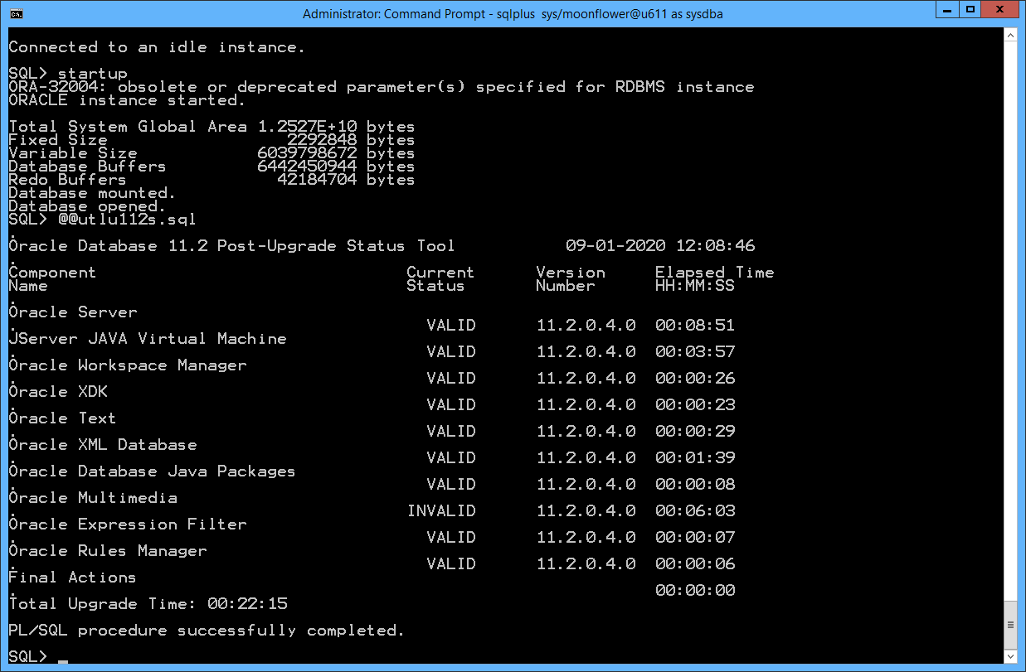

**De multimedia is INVALID !!! Is op UNILAB + INTERSPEC !!!**

Run catuppst.sql to perform upgrade actions that do not require the database to be in UPGRADE mode:

SQL> @catuppst.sql

Check the following log file for errors:

C:\oracle\cfgtoollogs\catbundle\catbundle_PSU_U611_APPLY_2020Sep01_12_10_06.log

SQL> PROMPT Updating registry...

Updating registry...

SQL> INSERT INTO registry$history

2 (action_time, action,

3 namespace, version, id,

4 bundle_series, comments)

5 VALUES

6 (SYSTIMESTAMP, 'APPLY',

7 SYS_CONTEXT('REGISTRY$CTX','NAMESPACE'),

8 '11.2.0.4',

9 0,

10 'PSU',

11 'Patchset 11.2.0.2.0');

1 row created.

Run utlrp.sql to recompile any remaining stored PL/SQL and Java code.

SQL> @utlrp.sql

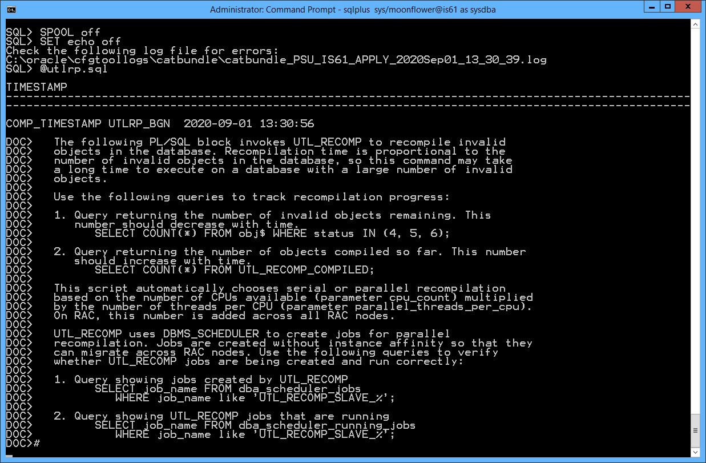

Verify that all expected packages and classes are valid:

SQL> SELECT count(*) FROM dba_invalid_objects;

SQL> SELECT distinct object_name FROM dba_invalid_objects;

SQL> SELECT count(*) FROM dba_invalid_objects;

COUNT(*)

----------

16

SQL> SELECT distinct object_name FROM dba_invalid_objects;

OBJECT_NAME

--------------------------------------------------------------

AAPOBLOB

RVITREPTEMPLATE

AV_SPECIFICATION_HEADER

WF_SPECIFICATION_HEADER

RPMV_ITREPTEMPLATE

RPMV_STATUS_TYPE

APAO_WATSON

RPMV_OBJECT_TC_ITEM

RPMV_SPECIFICATION_TC_ITEM

9 rows selected.