Start TOAD

Maak connectie met SYSTEM of schema-owner UNILAB/INTERSPC

Ga via hoofdmenu [DATABASE] + [ADMINISTER] + [TABLESPACES]

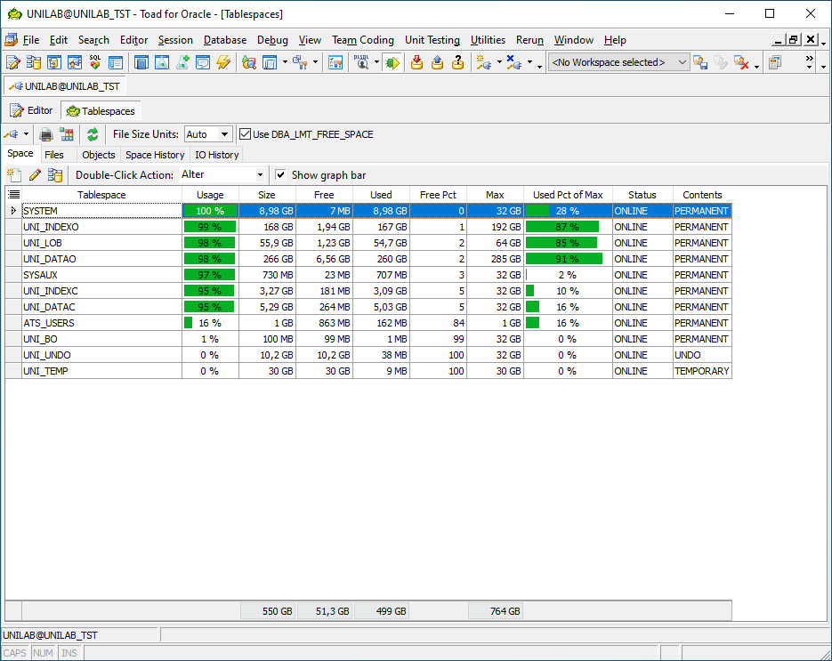

Klik in midden (net boven tablespace-overzicht) op tabblad [SPACE HISTORY]

Bij de eerste keer benaderen van dit overzicht krijg je onderstaande melding:

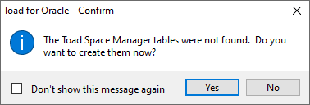

Kik hier [yes]

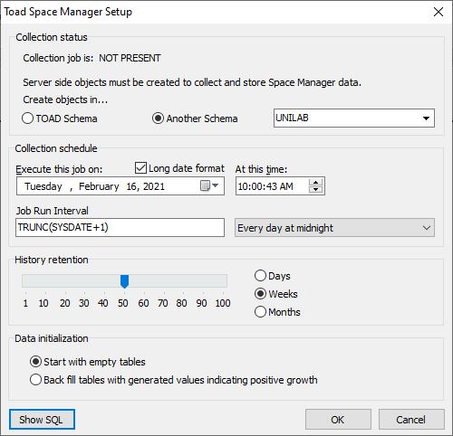

Als je hier op [SHOW SQL] klikt krijg je eerst volgende melding:

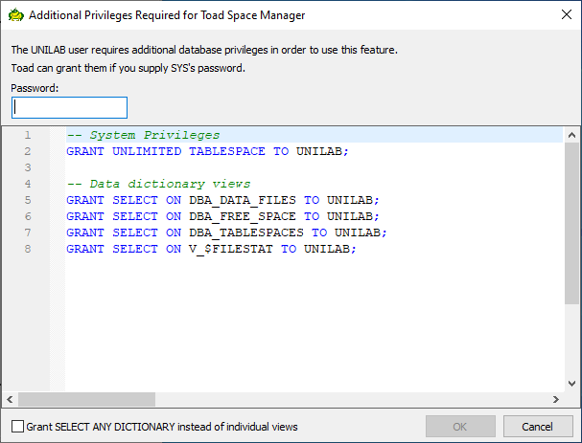

-- System Privileges

GRANT UNLIMITED TABLESPACE TO UNILAB;

-- Data dictionary views

GRANT SELECT ON DBA_DATA_FILES TO UNILAB;

GRANT SELECT ON DBA_FREE_SPACE TO UNILAB;

GRANT SELECT ON DBA_TABLESPACES TO UNILAB;

GRANT SELECT ON V_$FILESTAT TO UNILAB;

Als je vinkje [grant select ANY DICTIONARY instead of inidividual views] aanzet:

-- System Privileges + Data dictionary views:

GRANT UNLIMITED TABLESPACE TO UNILAB;

GRANT SELECT ANY DICTIONARY TO UNILAB;

--

GRANT UNLIMITED TABLESPACE TO INTERSPC;

GRANT SELECT ANY DICTIONARY TO INTERSPC;

Geef UNILAB-user deze rechten mbv SYS-user !

Vul vervolgens het SYS-password in en druk op [OK]

En krijgen we het SQL-statement te zien wat gedraaid gaat worden als we doorgaan:

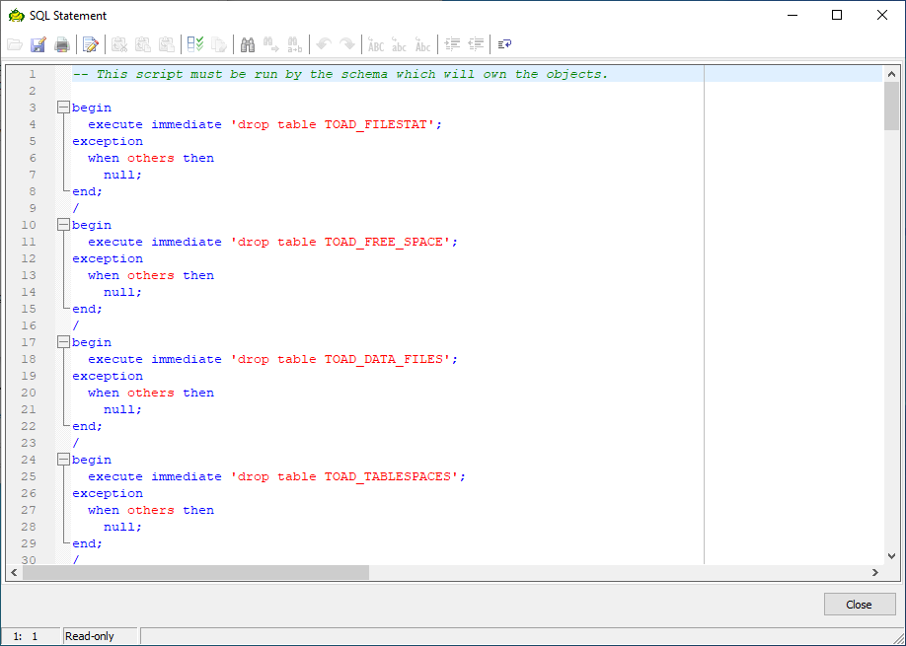

-- This script must be run by the schema which will own the objects.

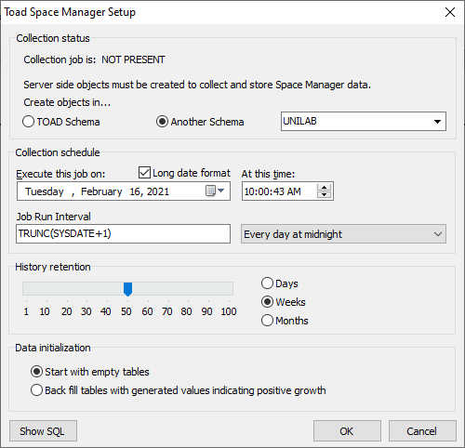

Druk nu [OK]

BIJLAGE: toad-script tbv aanmaken objecten

begin

execute immediate 'drop table TOAD_FILESTAT';

exception

when others then

null;

end;

/

begin

execute immediate 'drop table TOAD_FREE_SPACE';

exception

when others then

null;

end;

/

begin

execute immediate 'drop table TOAD_DATA_FILES';

exception

when others then

null;

end;

/

begin

execute immediate 'drop table TOAD_TABLESPACES';

exception

when others then

null;

end;

/

begin

execute immediate 'drop table TOAD_REF';

exception

when others then

null;

end;

/

CREATE TABLE TOAD_REF (Name Varchar2(30), Value Number);

INSERT INTO TOAD_REF VALUES ('Space Manager History Limit', 350);

INSERT INTO TOAD_REF VALUES ('Space Manager History Unit', 1);

INSERT INTO TOAD_REF VALUES ('Space Manager JobID', -1);

CREATE TABLE TOAD_TABLESPACES (

TABLESPACE_NAME VARCHAR2(30) NOT NULL,

MON_DATE DATE NOT NULL,

CONSTRAINT TOAD_TABLESPACES_PK PRIMARY KEY (TABLESPACE_NAME, MON_DATE)

USING INDEX PCTFREE 5)

PCTFREE 5 PCTUSED 94;

CREATE TABLE TOAD_DATA_FILES (

FILE_ID NUMBER NOT NULL,

MON_DATE DATE NOT NULL,

TABLESPACE_NAME VARCHAR2(30) NOT NULL,

FILE_NAME VARCHAR2(257) NOT NULL,

BYTES NUMBER,

CONSTRAINT TOAD_DATA_FILES_PK PRIMARY KEY (FILE_ID, MON_DATE)

USING INDEX PCTFREE 5,

CONSTRAINT TOAD_DATA_FILES_FK FOREIGN KEY (TABLESPACE_NAME, MON_DATE)

REFERENCES TOAD_TABLESPACES ON DELETE CASCADE)

PCTFREE 5 PCTUSED 94;

CREATE UNIQUE INDEX TOAD_DATA_FILES_UK ON TOAD_DATA_FILES (TABLESPACE_NAME, FILE_NAME, MON_DATE) PCTFREE 5;

CREATE TABLE TOAD_FILESTAT (

FILE_ID NUMBER NOT NULL,

MON_DATE DATE NOT NULL,

PHYRDS CHAR(18) NOT NULL,

PHYWRTS CHAR(18) NOT NULL,

PHYBLKRD CHAR(18) NOT NULL,

PHYBLKWRT CHAR(18) NOT NULL,

READTIM CHAR(18) NOT NULL,

WRITETIM CHAR(18) NOT NULL,

CONSTRAINT TOAD_FILESTAT_PK PRIMARY KEY (FILE_ID, MON_DATE)

USING INDEX PCTFREE 5,

CONSTRAINT TOAD_FILESTAT_FK FOREIGN KEY (FILE_ID, MON_DATE)

REFERENCES TOAD_DATA_FILES ON DELETE CASCADE

) PCTFREE 5 PCTUSED 94;

CREATE TABLE TOAD_FREE_SPACE (

FILE_ID NUMBER NOT NULL,

MON_DATE DATE NOT NULL,

BYTES NUMBER NOT NULL,

CONSTRAINT TOAD_FREE_SPACE_PK PRIMARY KEY (FILE_ID, MON_DATE)

USING INDEX PCTFREE 5,

CONSTRAINT TOAD_FREE_SPACE_FK FOREIGN KEY (FILE_ID, MON_DATE)

REFERENCES TOAD_DATA_FILES ON DELETE CASCADE

) PCTFREE 5 PCTUSED 94;

CREATE OR REPLACE FORCE VIEW TOAD_SPACE

(TABLESPACE, FREE_MEGS, USED_MEGS, ALLOC_MEGS, PCT_FREE, PCT_USED)

AS

SELECT tdf.tablespace_name,

ROUND(SUM(NVL(tfs.bytes,0))/1048576),

ROUND((SUM(tdf.bytes)-SUM(NVL(tfs.bytes,0)))/1048576),

SUM(tdf.BYTES)/1048576,

ROUND(SUM(NVL(tfs.bytes,0))/SUM(tdf.bytes),2),

1-ROUND(SUM(NVL(tfs.bytes,0))/SUM(tdf.bytes),2)

FROM toad_data_files tdf, toad_free_space tfs

WHERE tdf.file_id = tfs.file_id (+)

AND tdf.mon_date = tfs.mon_date (+)

AND tdf.mon_date <= SYSDATE

GROUP BY tdf.tablespace_name;

CREATE OR REPLACE FORCE VIEW TOAD_SPACE_HIST

(file_id, tablespace, mdate, usedspace)

AS

SELECT a.file_id, a.tsp, a.mdate, GREATEST(ROUND(SUM(a.space)/1048576), 0)

FROM (SELECT tdf.file_id file_id,

tdf.tablespace_name tsp,

tdf.mon_date mdate,

SUM(tdf.bytes) - SUM(NVL(tfs.bytes,0)) space

FROM toad_data_files tdf, toad_free_space tfs

WHERE tdf.file_id = tfs.file_id (+)

AND tdf.mon_date = tfs.mon_date (+)

GROUP BY tdf.file_id,

tdf.tablespace_name,

tdf.mon_date ) a

GROUP BY file_id, tsp, mdate;

CREATE OR REPLACE PUBLIC SYNONYM TOAD_FILESTAT FOR TOAD_FILESTAT;

CREATE OR REPLACE PUBLIC SYNONYM TOAD_FREE_SPACE FOR TOAD_FREE_SPACE;

CREATE OR REPLACE PUBLIC SYNONYM TOAD_DATA_FILES FOR TOAD_DATA_FILES;

CREATE OR REPLACE PUBLIC SYNONYM TOAD_TABLESPACES FOR TOAD_TABLESPACES;

CREATE OR REPLACE PUBLIC SYNONYM TOAD_REF FOR TOAD_REF;

CREATE OR REPLACE PUBLIC SYNONYM TOAD_SPACE_HIST FOR TOAD_SPACE_HIST;

CREATE OR REPLACE PUBLIC SYNONYM TOAD_SPACE FOR TOAD_SPACE;

GRANT SELECT, INSERT, UPDATE, DELETE ON TOAD_FILESTAT TO PUBLIC;

GRANT SELECT, INSERT, UPDATE, DELETE ON TOAD_FREE_SPACE TO PUBLIC;

GRANT SELECT, INSERT, UPDATE, DELETE ON TOAD_DATA_FILES TO PUBLIC;

GRANT SELECT, INSERT, UPDATE, DELETE ON TOAD_TABLESPACES TO PUBLIC;

GRANT SELECT, INSERT, UPDATE, DELETE ON TOAD_SPACE_HIST TO PUBLIC;

GRANT SELECT, INSERT, UPDATE, DELETE ON TOAD_SPACE TO PUBLIC;

GRANT SELECT, INSERT, UPDATE, DELETE ON TOAD_REF TO PUBLIC;

CREATE OR REPLACE PACKAGE TOAD_SPACEMAN IS

PROCEDURE CAPTURE;

PROCEDURE RESET;

END;

/

CREATE OR REPLACE PACKAGE BODY TOAD_SPACEMAN IS

PROCEDURE RESET AS

BEGIN

/* DELETE DATA FROM ALL TABLES */

DELETE FROM TOAD_TABLESPACES;

/* LOAD REAL DATA FOR TODAY */

TOAD_SPACEMAN.CAPTURE;

/* LOAD DUMMY DATA FOR 60 DAYS */

FOR I IN 1..60 LOOP

INSERT INTO TOAD_TABLESPACES

SELECT TABLESPACE_NAME, TRUNC(MON_DATE-I)

FROM TOAD_TABLESPACES WHERE TRUNC(MON_DATE) = TRUNC(SYSDATE);

INSERT INTO TOAD_DATA_FILES

SELECT FILE_ID, TRUNC(MON_DATE-I), TABLESPACE_NAME, FILE_NAME, ROUND(BYTES*(1-I/100))

FROM TOAD_DATA_FILES WHERE TRUNC(MON_DATE) = TRUNC(SYSDATE);

INSERT INTO TOAD_FREE_SPACE

SELECT FILE_ID, TRUNC(MON_DATE-I), ROUND(BYTES*(1+I/100))

FROM TOAD_FREE_SPACE WHERE TRUNC(MON_DATE) = TRUNC(SYSDATE);

INSERT INTO TOAD_FILESTAT

SELECT FILE_ID, TRUNC(MON_DATE-I), PHYRDS, PHYWRTS,

PHYBLKRD, PHYBLKWRT, READTIM, WRITETIM

FROM TOAD_FILESTAT WHERE TRUNC(MON_DATE) = TRUNC(SYSDATE);

END LOOP;

COMMIT;

END RESET;

PROCEDURE CAPTURE AS

V_MON_DATE DATE := NULL;

V_ROW_SIZE INTEGER := 100000;

NumDaysToRemove NUMBER;

CURSOR History_Cur IS

SELECT Value

FROM TOAD_REF

WHERE Name = 'Space Manager History Limit';

BEGIN

/* SAVE TODAYS DATE */

V_MON_DATE := SYSDATE; -- removed Trunc() to allow interval less than one day

/* RETRIEVE THE NUMBER OF DAYS TO REMOVE */

OPEN History_Cur;

FETCH History_Cur INTO NumDaysToRemove;

/* DELETE DATA OLDER THAN USER SPECIFIED DAYS */

DELETE FROM TOAD_TABLESPACES WHERE MON_DATE < V_MON_DATE - NumDaysToRemove;

/* DELETE PRE-EXISTING DATA FOR CURRENT DATE AND TIME */

DELETE FROM TOAD_TABLESPACES WHERE MON_DATE = V_MON_DATE;

/* DELETE DATA FOR NONEXISTENT TABLESPACES */

DELETE FROM TOAD_TABLESPACES X

WHERE NOT EXISTS (SELECT 1 FROM DBA_TABLESPACES D

WHERE X.TABLESPACE_NAME = D.TABLESPACE_NAME);

--/* DELETE DATA FOR NONEXISTENT DATA FILES */

--DELETE FROM TOAD_DATA_FILES X

-- WHERE NOT EXISTS (SELECT 1 FROM DBA_DATA_FILES D

-- WHERE X.TABLESPACE_NAME = D.TABLESPACE_NAME

-- AND X.FILE_NAME = D.FILE_NAME);

/* INSERT NEW TABLESPACES FOUND */

INSERT INTO TOAD_TABLESPACES

SELECT TABLESPACE_NAME, V_MON_DATE

FROM DBA_TABLESPACES;

/* INSERT NEW DATA FILES FOUND */

INSERT INTO TOAD_DATA_FILES

SELECT FILE_ID, V_MON_DATE, TABLESPACE_NAME, FILE_NAME, BYTES

FROM DBA_DATA_FILES;

/* COLLECT CURRENT FREE SPACE DATA */

INSERT INTO TOAD_FREE_SPACE

SELECT FILE_ID, V_MON_DATE, SUM(BYTES)

FROM DBA_FREE_SPACE

GROUP BY FILE_ID, TRUNC(SYSDATE);

/* COLLECT CURRENT IO RATE DATA */

INSERT INTO TOAD_FILESTAT

SELECT FILE#, V_MON_DATE, PHYRDS, PHYWRTS,

PHYBLKRD, PHYBLKWRT, READTIM, WRITETIM

FROM V$FILESTAT;

COMMIT;

END CAPTURE;

END TOAD_SPACEMAN;

/

CREATE OR REPLACE PUBLIC SYNONYM TOAD_SPACEMAN FOR TOAD_SPACEMAN;

GRANT EXECUTE ON TOAD_SPACEMAN TO PUBLIC;

UPDATE TOAD_REF SET Value = 1

WHERE Name = 'Space Manager History Unit';

UPDATE TOAD_REF SET Value = 350

WHERE Name = 'Space Manager History Limit';

DECLARE

X NUMBER;

BEGIN

**SYS.DBMS_JOB.SUBMIT**

(

job => X

,what => 'BEGIN

TOAD_SPACEMAN.CAPTURE;

END;'

,next_date => to_date('16/02/2021 10:00:43','dd/mm/yyyy hh24:mi:ss')

,interval => 'TRUNC(SYSDATE+1)'

,no_parse => TRUE

);

UPDATE TOAD_REF SET Value = to_char(x)

WHERE Name = 'Space Manager JobID';

END;

/

COMMIT;