ORA-20000: ORA-01654: unable to extend index INTERSPC.IDX_PROP by 8192 in tablespace SPECI

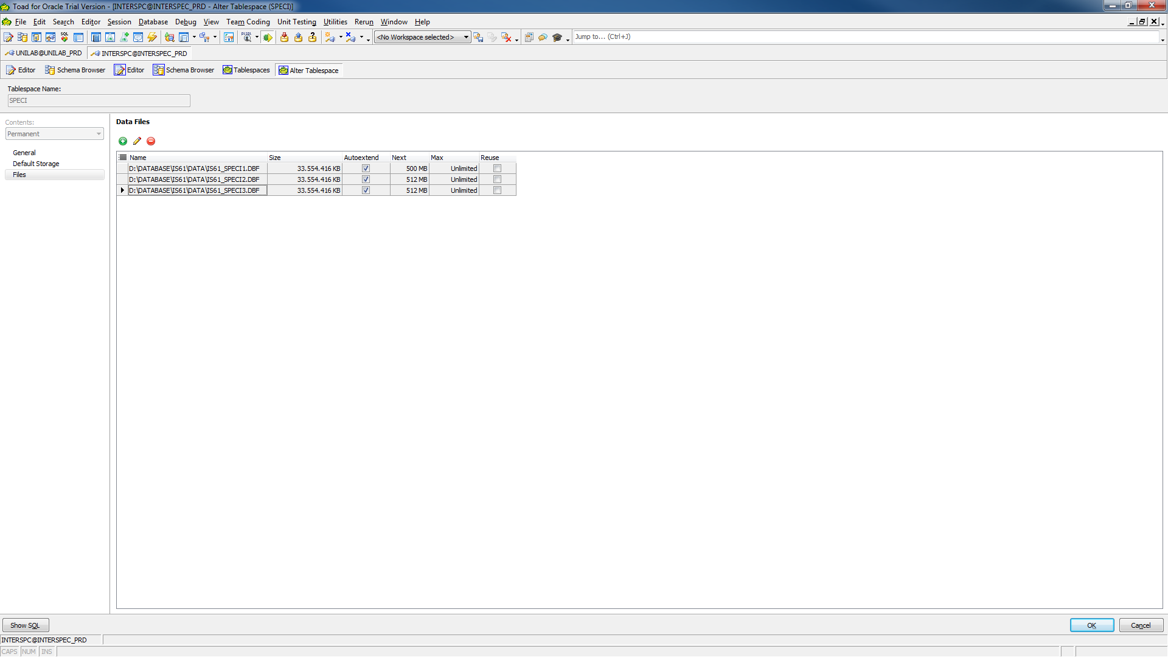

DROP TABLESPACE SPECI INCLUDING CONTENTS AND DATAFILES;

CREATE TABLESPACE SPECI DATAFILE

'D:\DATABASE\IS61\DATA\IS61_SPECI1.DBF' SIZE 33554416K AUTOEXTEND ON NEXT 500M MAXSIZE UNLIMITED,

'D:\DATABASE\IS61\DATA\IS61_SPECI2.DBF' SIZE 33554416K AUTOEXTEND ON NEXT 512M MAXSIZE UNLIMITED,

'D:\DATABASE\IS61\DATA\IS61_SPECI3.DBF' SIZE 33554416K AUTOEXTEND ON NEXT 512M MAXSIZE UNLIMITED

LOGGING  
ONLINE  
EXTENT MANAGEMENT LOCAL AUTOALLOCATE  
BLOCKSIZE 8K  
SEGMENT SPACE MANAGEMENT AUTO  
FLASHBACK ON;

If you would like to use alter tablespace to add a datafile, use the following syntax:

ALTER TABLESPACE SPECI ADD DATAFILE 'D:\DATABASE\IS61\DATA\IS61_SPECI4.DBF' size 33554416K AUTOEXTEND ON NEXT 512M MAXSIZE UNLIMITED;

>> ALTER TABLESPACE SPECI ADD DATAFILE 'D:\DATABASE\IS61\DATA\IS61_SPECI4.DBF' size 32G AUTOEXTEND ON NEXT 512M MAXSIZE UNLIMITED

Error at line 1

ORA-01144: Bestandsgrootte (4194304 blokken) overschrijdt maximum van 4194303 blokken.

**Ik kan dus vreemd genoeg niet direct 32G aanmaken, maar alleen datafile van 33554416K groot !!!**